Supplementary Material

Non covalent interactions in the monohydrated complexes of 1,2,3,4 –tetrahydroisoquinoline in S₀

Santu Das^{a,b} and Abhijit Chakraborty^{b*}
ª Department of Physics, Government General Degree College, Singur, Hooghly-712409, INDIA
^{b}Department of Physics, The University of Burdwan, Golapbag Campus, Burdwan – 713104, West Bengal, INDIA

* E-mail :achakraborty.buphys@gmail.com, achakraborty@phys.buruniv.ac.in

List of Tables and Figures
Tables:
Table T1. Comparison of the change of NBO charges (a.u) and bond lengths (Å) of involved atoms due to formation of secondary h-bond from its bare molecules
Table T2. Atomic properties (in a.u) of the hydrogen atom which is involved in hydrogen bonding in different THIQ:H₂O complexes and the change of atomic properties (Δ) arising due to the formation of complexes. Calculated from the structures as obtained from M06-2X / 6-311 ++G (2d, 3p) level of theory.

Figures :
Figure. F1: XYZ coordinates of two low energy complexes, TAW1b and BAW1b complexes. Optimized with M06-2X/ 6-311++G(2d,3p).
Figure. F2: Variation of hydrogen bond length (N-H···O/ O-H···N) with electron density ($ρ_{c}$) at Bond Critical Point (BCP) for all the hydrogen bonded monohydrates of THIQ. Computations has been performed from the optimized geometry as obtain with M06-2X/6-311++G(2d,3p) basis sets.
Figure. F3: Variation of (a) Hydrogen bond(HB) length and HB angle, (b) Laplacian ($∇^{2}ρ_{c}$) and Total electron Energy Density (H_{C}) and (c) Electron Kinetic Energy Density (G_{C}) and Electron Potential Energy Density (V_{C}) with electron density ($ρ_{c}$) at O-H···N and N-H···O Bond Critical Point (BCP) which are obtained by scanning primary HB lengths of TEW1a where N of THIQ acts as a HB acceptor (indicated by ● and ● ) and TAW1b where O of H₂O acts as a HB acceptor (indicated by ■ and ■). Fig (d), (e) and (f) correspond to the same plot for O-H···π type of Hydrogen bonds.

Table T1.: Comparison of the change of NBO charges (a.u) and bond lengths (Å) of involved atoms due to formation of secondary H-bond
Method | Complexes | Change of charge at C₅ / C₉ | Change of charge at C₁₀ | Change of  C₁₀-C₅/ C₉  bond length | Change of  charge at O
M06-2X/6-311++G(2d,3p) | TAW1b | -0.00923 | -0.00799 | 0.00153 | -0.02149
M06-2X/6-311++G(2d,3p) | BAW1b | -0.01313 | -0.00441 | 0.00111 | -0.02055
M06-2X /aug-cc-pVDZ | TAW1b | -0.01178 | -0.00825 | 0.00153 | -0.02079
M06-2X /aug-cc-pVDZ | BAW1b | -0.01384 | -0.00769 | 0.00103 | -0.01943
MP2/ 6-311++G(2d,3p) | TAW1b | -0.01397 | -0.00550 | 0.00186 | -0.02414
MP2/ 6-311++G(2d,3p) | BAW1b | -0.01644 | -0.00668 | 0.00153 | -0.02383

1. TAW1b complex:

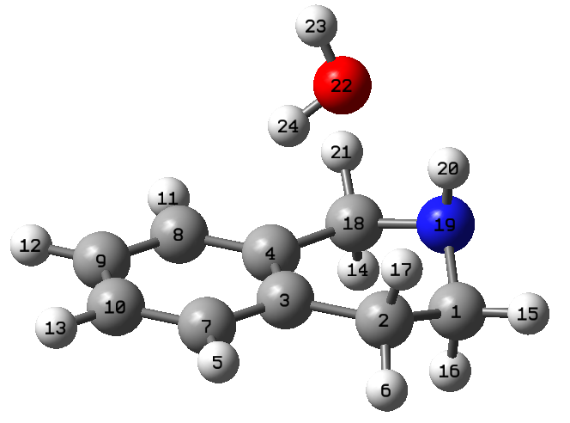

Tag Symbol X Y Z

1 C -2.2043570 0.8702700 -0.7205280
2 C -1.0611800 1.5537980 0.0281980
3 C 0.2348500 0.7877970 -0.1141860
4 C 0.2303540 -0.5404230 -0.5474420
5 H 1.4514450 2.4163260 0.5556490
6 H -0.9231330 2.5777430 -0.3227090
7 C 1.4507040 1.3873790 0.2173800
8 C 1.4368800 -1.2329620 -0.6460390
9 C 2.6394140 -0.6284330 -0.3162710
10 C 2.6455670 0.6923430 0.1197500
11 H 1.4248440 -2.2634980 -0.9806570
12 H 3.5651990 -1.1810420 -0.3937610
13 H 3.5763410 1.1759490 0.3804850
14 H -1.1328410 -1.3355470 -1.9886470
15 H -3.1561340 1.3332880 -0.4646300
16 H -2.0667250 0.9874490 -1.7982300
17 H -1.3183890 1.6094040 1.0895050
18 C -1.0733910 -1.2343630 -0.9006790
19 N -2.2761280 -0.5594610 -0.4371160
20 H -2.3449530 -0.6898210 0.5669710
21 H -1.0637440 -2.2452570 -0.4932170
22 O -0.8943640 -0.8061880 2.3898720
23 H -0.6364460 -1.2980170 3.1717180
24 H -0.0807030 -0.6536680 1.8972650

2. BAW1b complex:

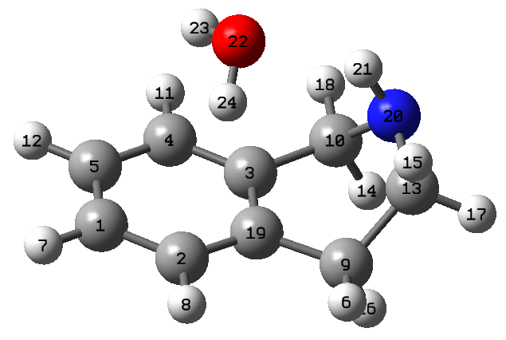

Tag Symbol X Y Z
1 C 2.4416710 0.7906700 0.1409320
2 C 1.2311430 1.4684320 0.2640660
3 C 0.1004070 -0.3476010 -0.8480590
4 C 1.3089750 -1.0185790 -0.9714300
5 C 2.4816940 -0.4490730 -0.4820680
6 H -1.2664030 2.4429640 0.4877840
7 H 3.3485650 1.2303740 0.5313080
8 H 1.1979770 2.4361950 0.7486450
9 C -1.2900850 1.5570550 -0.1448570
10 C -1.2387790 -0.9455560 -1.1977550
11 H 1.3347360 -1.9953590 -1.4387140
12 H 3.4211370 -0.9748800 -0.5798520
13 C -2.3686160 0.5622760 0.3582380
14 H -1.6867620 -0.4338480 -2.0533990
15 H -2.4032570 0.5814340 1.4466140
16 H -1.5731740 1.8925060 -1.1453440
17 H -3.3413820 0.9013430 -0.0005870
18 H -1.1369660 -1.9951420 -1.4690810
19 C 0.0608380 0.9101750 -0.2345820
20 N -2.1525600 -0.8299870 -0.0573490
21 H -1.7217370 -1.3199080 0.7176150
22 O 0.1731200 -1.2534070 2.2639840
23 H 0.7522410 -1.7548260 1.6835500
24 H 0.3945040 -0.3404680 2.0541200

Figure. F1: XYZ coordinates of two low energy complexes, TAW1b and BAW1b complexes. Optimized with M06-2X/ 6-311++G(2d,3p).

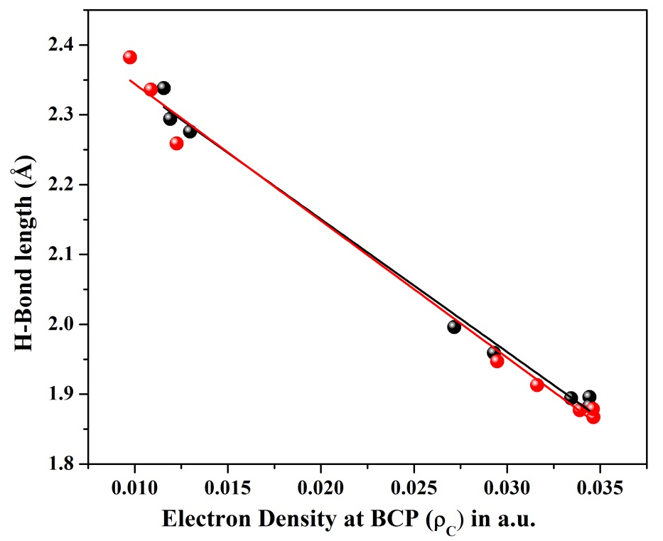

Figure. F2: Variation of hydrogen bond length (N-H···O/ O-H···N) with electron density ($ρ_{c}$) at Bond Critical Point (BCP) for all the hydrogen bonded monohydrates of THIQ. Computations has been performed from the optimized geometry as obtain with M06-2X/6-311++G(2d,3p) (black circle ) and MP2/6-311++G(2d,3p) (red circle ) basis sets.

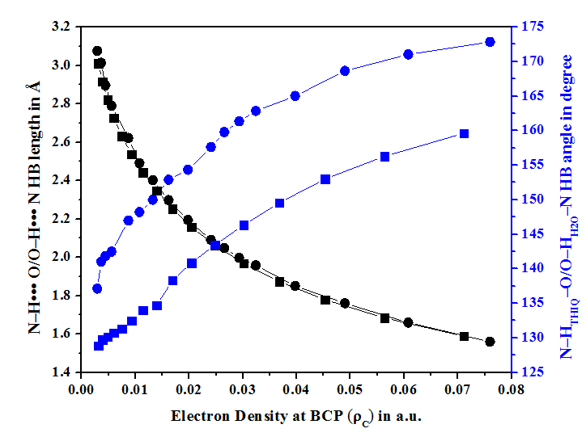 | 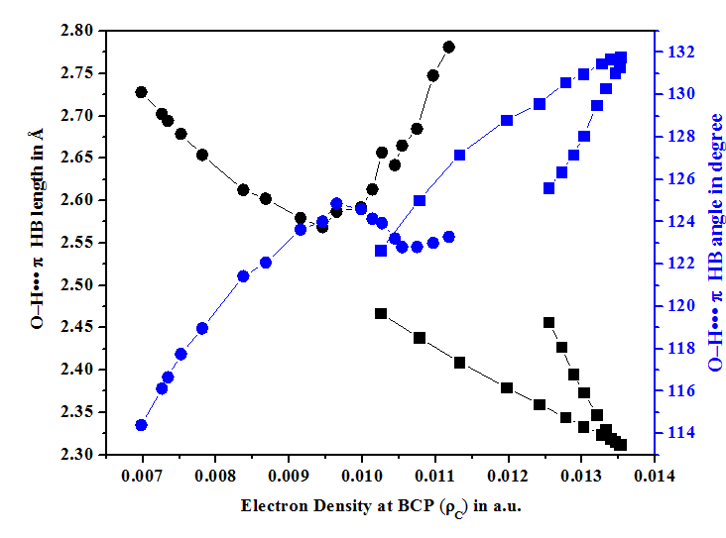
(a) | (d)
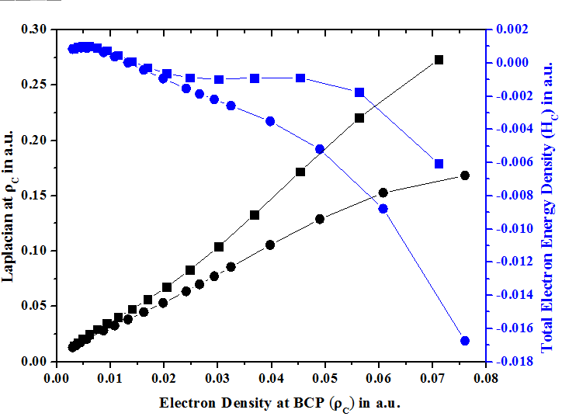 | 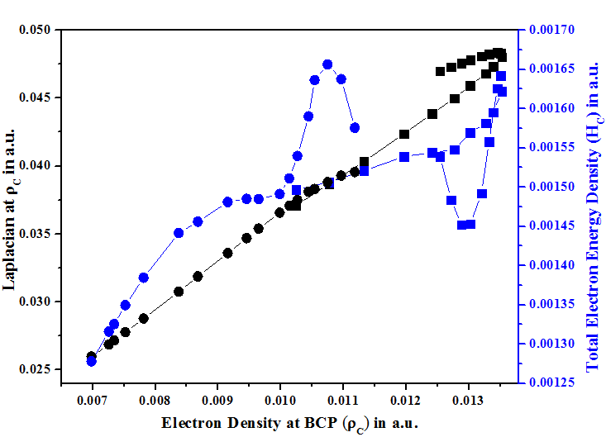
(b) | (e)
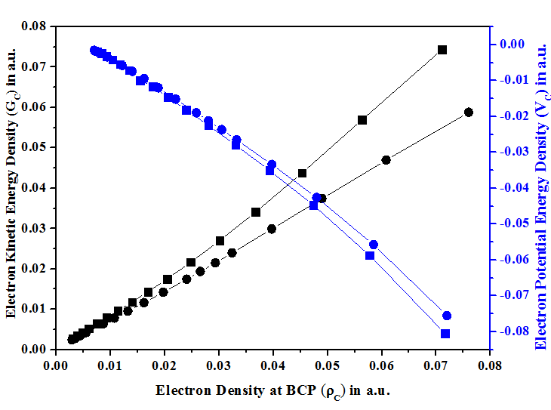 | 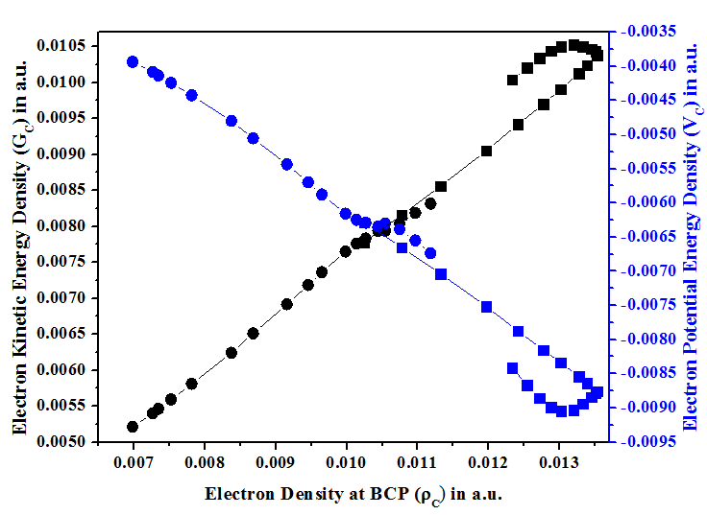
(c) | (f)

Figure. F3: Variation of (a) Hydrogen bond(HB) length and HB angle, (b) Laplacian ($∇^{2}ρ_{c}$) and Total electron Energy Density (H_{C}) and (c) Electron Kinetic Energy Density (G_{C}) and Electron Potential Energy Density (V_{C}) with electron density ($ρ_{c}$) at O-H···N and N-H···O Bond Critical Point (BCP) which are obtained by scanning primary HB lengths of TEW1a where N of THIQ acts as a HB acceptor (indicated by ● and ● ) and TAW1b where O of H₂O acts as a HB acceptor (indicated by ■ and ■). Fig (d), (e) and (f) correspond to the same plot for O-H···π type of Hydrogen bonds.

Table T2. Atomic properties (in a.u) of the hydrogen atom which is involved in hydrogen bonding in different THIQ:H₂O complexes and the change of atomic properties (Δ) arising due to the formation of complexes. Calculated from the structures as obtained from M06-2X / 6-311 ++G (2d, 3p) level of theory.
H-Atom involved with | Complexes | Charge |  |  | volume |  |  | first moment |  |  | energy
H-Atom involved with | Complexes | m* | c* | Δ* | m | c | Δ | m | c | Δ | m | c | Δ
Lone pare of N  (O-H···N) | TEW1a | 0.568 | 0.612 | 0.045 | 23.007 | 14.024 | -8.983 | 0.189 | 0.156 | -0.034 | -0.431 | -0.288 | 0.143
Lone pare of N  (O-H···N) | TAW1a | 0.568 | 0.620 | 0.052 | 23.007 | 13.742 | -9.265 | 0.189 | 0.153 | -0.036 | -0.431 | -0.303 | 0.128
Lone pare of N  (O-H···N) | BAW1a | 0.568 | 0.620 | 0.052 | 23.007 | 13.742 | -9.265 | 0.189 | 0.153 | -0.036 | -0.431 | -0.303 | 0.128
Lone pare of N  (O-H···N) | BAW1a* | 0.568 | 0.619 | 0.052 | 23.007 | 13.807 | -9.200 | 0.189 | 0.152 | -0.037 | -0.431 | -0.336 | 0.095
Lone pare of N  (O-H···N) | BEW1a | 0.568 | 0.611 | 0.043 | 23.007 | 13.780 | -9.227 | 0.189 | 0.154 | -0.036 | -0.431 | -0.269 | 0.162
Lone pare of O (N-H···O) | TEW1b | 0.302 | 0.341 | 0.038 | 34.138 | 28.158 | -5.980 | 0.213 | 0.185 | -0.028 | -0.431 | -0.430 | 0.001
Lone pare of O (N-H···O) | TAW1b | 0.295 | 0.336 | 0.041 | 34.963 | 28.653 | -6.310 | 0.218 | 0.188 | -0.030 | -0.470 | -0.464 | 0.006
Lone pare of O (N-H···O) | BAW1b | 0.301 | 0.336 | 0.035 | 34.207 | 28.739 | -5.468 | 0.216 | 0.190 | -0.026 | -0.456 | -0.446 | 0.010
With pi electron cloud | TEW1a | 0.568 | 0.556 | -0.012 | 23.006 | 23.926 | 0.920 | 0.189 | 0.195 | 0.005 | -0.431 | -0.431 | -0.001
With pi electron cloud | TEW1c(H_{a}) | 0.568 | 0.572 | 0.004 | 23.006 | 20.945 | -2.061 | 0.189 | 0.185 | -0.005 | -0.431 | -0.396 | 0.035
With pi electron cloud | TEW1c(H_{b}) | 0.568 | 0.567 | -0.001 | 23.007 | 22.672 | -0.335 | 0.189 | 0.191 | 0.001 | -0.431 | -0.411 | 0.020
With pi electron cloud | TAW1b | 0.568 | 0.590 | 0.023 | 23.007 | 19.667 | -3.340 | 0.189 | 0.179 | -0.011 | -0.431 | -0.426 | 0.005
With pi electron cloud | TAW1c | 0.568 | 0.576 | 0.009 | 23.007 | 19.758 | -3.249 | 0.189 | 0.181 | -0.008 | -0.431 | -0.359 | 0.072
With pi electron cloud | BAW1b | 0.568 | 0.577 | 0.009 | 23.007 | 20.902 | -2.105 | 0.189 | 0.184 | -0.005 | -0.431 | -0.390 | 0.041
With pi electron cloud | BAW1c(H_{a}) | 0.568 | 0.568 | 0.001 | 23.006 | 22.080 | -0.926 | 0.189 | 0.189 | -0.001 | -0.431 | -0.405 | 0.026
With pi electron cloud | BAW1c(H_{b}) | 0.568 | 0.572 | 0.004 | 23.007 | 21.497 | -1.510 | 0.189 | 0.187 | -0.003 | -0.431 | -0.403 | 0.028
With pi electron cloud | BEW1a | 0.568 | 0.558 | -0.009 | 23.006 | 23.887 | 0.881 | 0.189 | 0.194 | 0.005 | -0.431 | -0.422 | 0.009
C-H···O | TEW1b | -0.046 | -0.068 | -0.022 | 51.883 | 52.296 | 0.413 | 0.185 | 0.188 | 0.003 | -0.432 | -0.464 | -0.032
C-H···O | TAW1c | -0.027 | -0.015 | 0.012 | 49.399 | 49.229 | -0.170 | 0.166 | 0.161 | -0.005 | -0.448 | -0.443 | 0.006
*m = monomer, c = complexes & Δ = (c-m)

