Operando NMR Spectroscopy Reveals an Oxygen Blocking Mechanism in Formate Electrosynthesis
Bei Bei Xu,^{1‡} Ying Liu,^{2‡} Yuanwei Liu,³ Xiaomeng You,¹ Hang Zhou,¹ Yi Ning Xu,³ Peng Fei Liu,³* Hai Feng Wang,²* Hua Gui Yang,³ Xue Lu Wang,¹* Ye Feng Yao¹

¹Physics Department & Shanghai Key Laboratory of Magnetic Resonance, School of Physics and Electronic Science, East China Normal University, North Zhongshan Road 3663, Shanghai 200062, P. R. China
²Key Laboratory for Advanced Materials, Centre for Computational Chemistry and Research Institute of Industrial Catalysis, East China University of Science and Technology, Shanghai, 200237, China
³Key Laboratory for Ultrafine Materials of Ministry of Education, Shanghai Engineering Research Center of Hierarchical Nanomaterials, School of Materials Science and Engineering, East China University of Science and Technology, Shanghai 200237, China
Supporting Information

Corresponding Authors
pﬂiu@ecust.edu.cn; hfwang@ecust.edu.cn; xlwang@phy.ecnu.edu.cn

Material synthesis
Nano Cu precatalyst.
The monometallic Cu electrocatalyst (Nano Cu) was purchased from Aldrich Co., Ltd., with a 25 nm nanoparticle size and used without any further process.
Bi₂CuO₄ precatalyst was synthesized by a modified sol-gel method. The specific synthesis steps were as follows: (1) 2.5 mmol bismuth nitrate pentahydrate and 1.25 mmol copper nitrate trihydrate were dispersed in 0.1 M HNO₃ solution with high-speed stirring. Then 5.6 mmol DL-tartaric acid, 22.2 mmol glucose and 33.8 mmol acrylamide were added dropwise. Stir the above solution at 80 ℃ on the heating table until the gel was formed; (2) Place the gel obtained in step (1) in a 150 ℃ oven for 6 h, and cool it naturally to room temperature; (3) The material obtained in step (2) was transferred to a crucible and placed in a muffle furnace, calcined at 300 ℃ for 2 h, and then naturally cooled to room.
In₂Cu₂O₅ precatalyst was also synthesized by a modified sol-gel chemical method. The specific synthesis steps were as follows: (1) 2.5 mmol Cu(NO₃)₂·3H₂O and 2.5 mmol In(NO₃)₃·5H₂O were dispersed in 20 ml deionized water. Then, double molar amount of citric acid (CA) with that of metal ions was added as the chelating agent. The ammonium hydroxide was added to neutralize the solutions until pH value is 7.4; (2) Moderate polyvinylalcohol (PVA) solutions were added with constant stirring until it became viscous; (3) The sticky solutions obtained from step (2) were sprayed on the glass substrates to form thin films; (4) The dried films was transferred to a muffle furnace, calcined at 850 ℃ for 2 h, and then naturally cooled to get the final In₂Cu₂O₅ nanoparticles.

Electrochemical measurements
All the electrochemical experiments were performed on the CHI660E electrochemical workstation (Chenhua, Shanghai, China). The electrochemical device consists of a three-electrode H-type cell separated by a Nafion 115 proton exchange membrane, a piece of Pt foil (1 cm × 1 cm) and a Ag/AgCl electrode (KCl sat.), which server as counter and reference electrode. Before the CO₂ reaction test, 0.1 M KHCO₃ electrolyte in the cathode compartment was saturated with CO₂ by bubbling CO₂ gas for 30 min and the gas flow rate was 50 mL min⁻¹. The pH value of the CO₂ saturated 0.1 M KHCO₃ electrolyte is around 6.81. Carbon paper loading with catalysts were used as working electrode. Catalyst loaded method: 5 mg of catalyst and 40 μL nafion solution were dispersed in 500 μL iso-propyl alcohol and then treated with ultrasound for 30 min to form the ink. 50 μL of ink was dropped on both sides of carbon paper and dried naturally, the loading amount of catalyst was approximately 1 mg cm^{–2}. The area of catalyst loading was fixed at 1 cm² by shading the carbon paper with Scotch tape. For operando electrode of carbon microfibers (0.5 cm), drop 2ul vertically and dry at 80 ℃ for 10 min, repeat this step for 20 times. Before the operando experiment, it is necessary to rinse with deuterium water for three times to remove the residual solvent, and then dry the loading carbon microfibers electrode for use. Electrode potentials in the study were converted to the reversible hydrogen electrode (RHE) according to the following equation, E (vs. RHE) = E (vs. Ag/AgCl) + 0.059 V × pH + 0.205 V.
Calibration method of homemade reference electrode (palladium wire): (1) Prepare saturated KCl aqueous solution and put 20 mL into a two necked flask; (2) Connect the commercial Ag/AgCl to the sensing line of reference electrode, connect the homemade reference electrode (palladium wire) to the sensing line of working electrode, and place them in the above flask together; (3) The CHI660E electrochemical workstation was used to perform the Open Circuit Potential (OCP) experiment. The test time was set up tp 15 min, and 10000 points were taken for analysis; (4) At room temperature, repeat the OCP experiment for 5 times, and it is found that its fluctuation range does not exceed 5 mV. Finally, the averaged potential of the homemade reference electrode was determined to be 0.212 ± 0.005 V vs. a commercial Ag/AgCl reference electrode.
The linear sweep voltammetry (LSV) was obtained in CO₂ saturated 0.1 M KHCO₃ solution with a scan rate of 10 mV s⁻¹. The gas and liquid products obtained from catalytic CO₂ were separately analyzed using different methods. The gas products of CO₂ reduction were detected through gas chromatography (Beijing China Education AuLight Technology (CEAuLight) and Equipment Co., Ltd., GC7920). The liquid product was distinguished using ¹H nuclear magnetic resonance (NMR) spectra obtained from 700-MHz Agilent NMR spectrometers at a magnetic field strength of 16.4 T. The test solution of H-cell experiments used was a mixture of 100 µL of electrolyte, 400 µL of deuterium substitute water.

Measurement of maximum CO₂ solubility
Place 10 mL of 0.1 M KHCO₃ electrolyte solution in 15 mL open glass bottle, then 10 mL/min speed of CO₂ bubbles into electrolyte solution, continue to weigh and record the maximum mass of dissolving CO₂. After five repetitions, the average value of the maximum dissolved mass of CO₂ is 15.20 mg. After conversion, the maximum dissolved value of CO₂ in 500 μL 0.1 M KHCO₃ electrolyte solution is 17.27 μmol, thus the number of oxygen atoms is 34.55 μmol.

Quantitative analysis of operando ¹⁷O NMR
The quantitative analysis of operando ¹⁷O NMR spectrum is achieved through external standard method: keeping the total volume of 0.1 M KHCO₃ electrolyte solution at 500 μL, 4.17 μmol H₂¹⁷O, 8.33 μmol H₂¹⁷O, 16.67 μmol H₂¹⁷O, and 33.3 μmol H₂¹⁷O are introduced respectively. Under the same operando electrocatalytic NMR conditions, the ¹⁷O NMR signals of gradient concentrations are carefully integrated, and the correlation coefficient is 0.99896 and R-square is 0.99688 by a linear fitting of the integrated values and gradient concentrations. Under the same operando electrocatalytic conditions, integrate every signal in the operando ¹⁷O spectrum, and then bring the integral values into the linear fitting curve to obtain the actual quantitative results.

Calculation methods
All the spin polarized calculations were performed with Perdew-Burke-Ernzerhof (PBE) functional and generalized gradient approximation (GGA) exchange¹ within the framework of plan-wave pseudo-potential DFT method, implemented in the Vienna Ab Initio Simulation Package (VASP) code^{2, 3}. The project-augmented wave (PAW)⁴ method was used to represent the core-valance electron interaction and the valance electronic states were expanded in plane wave basis set with the energy cutoff of 450 eV⁵. The constrained optimization scheme was applied to search the configurations of the transition states (TSs).⁶⁻⁹ Convergence of force for all geometries was set to 0.05 eV / Å.¹⁰⁻¹²
For Bi₂CuO₄ precatalyst, the calculated BiOCu model was built by the analysis of TEM and XRD. The system has a layered structure along z direction, Slabs were separated by a vacuum of 15 Å with the lattice a = 13.61 Å, b = 14.12 Å, c = 28.23 Å, and a corresponding (1×2×1) k-point mesh was used for all structural optimization. To calculation the CO₂ adsorption in the actual reaction environment, the multi-point averaging molecular dynamics (MPA-MD) method was applied, which has been demonstrated in our previous study to give very similar results to the advanced constrained MD method¹³, in which lattice-matching bulk ice (containing 48 H₂O molecules) was applied above the surface as an initial aqueous network at the liquid/solid interface. A 0.5 fs movement was set for each step in the canonical (NVT) ensemble employing Nosé-Hoover thermostats with the simulation temperature of 300K (experimental temperature) over 10 ps. MD simulations were performed and all the simulations reach the equilibrium plateau after 5 ps. Then, 5 samples are selected every 0.2 ps from the equilibrium structure and further optimized to obtain the total energy of each structure (E_{tot}). Considering the effect of water networks in different samples, the contribution of these water structures was deduced but still considered the solvation effect for each sample. The obtained solution-induced energy of all the samples in the intermediate state was averaged.
The adsorption energy of X specious (E_{ads}*) were defined as follows:
${ E}_{ad}^{X}= E_{total}-E_{surface}-E_{X}$
where E_{total}, E_{surface} and E_{x} are the energies for the total energies of X binding the surface, the clean surface and X specious in the gas, respectively. Notably, for the adsorption/desorption process, the entropy contribution of gaseous molecules was to be considered including the vibrational, rotational and translational entropies at the temperature of 298 K. The reaction enthalpy was approximated by the total energy difference without considering the small zero-point energy correction, heat capacity correction and ∆pv term.¹⁴ The adsorption energy of OH and H were calculated by putting them away from the surface. The more negative of the adsorption energy is, the stronger of binding strength is.
Table S1: Adsorption energies (E_{ads}) of CO₂ and H₂O on Cu (111) surface and Bi-O-Cu surface in the gas. (unit : eV)

 | Bi-O-Cu |  |  | Cu (111)
Site | CO₂ |  | H₂O |  | CO₂ |  | H₂O
Site | line | bend |  |  | line | bend | H₂O
Bi | -0.08 | － | -0.21 |  | － | － | －
Bi-Bi | -0.04 | － | － |  | － | － | －
Bi-Cu | -0.08 | － | -0.37 |  | － | － | －
Cu | -0.23 | 0.21 | -0.14 |  | -0.06 | 0.71 | -0.18

Table S2. Quantitative results obtained from operando ¹H NMR spectra and ¹⁷O NMR spectra. Working condition: 450 µL D₂O + 50 µL H₂¹⁷O (¹⁷O content is 37.5%) + 5 mg KHCO₃ under 1.5 mL/min CO₂ bubbing and -1.2 V potential.

Time(h) | Quantitative results of ¹HCOO (µmol) | Quantitative results of HC¹⁷OO& HC¹⁷O¹⁷O (µmol)
0 | 0 | 0
0.5 | 5.31 | 0.1723
1.0 | 10.34 | 0.3893
1.5 | 18.6 | 0.654
2.0 | 26.31 | 0.921

Table S3. Multiple verifications of quantitative NMR experiments confirm that the mole number of ¹⁷O in the C=¹⁷O structure is the same as the mole number of formic acid molecule.
Solution components | 500 μl D₂O+ 100 μl HCOOH | 500 μl D₂O+ 50 μl HCOOH | 500 μl D₂O+ 20 μl HCOOH | 500 μl D₂O+ 10 μl HCOOH
Moles of  D₂O/HCOOH | 25/2.65 | 25/1.32 | 25/0.53 | 25/0.26
Mole ratio of  HCOOH/D₂O | 0.106 | 0.0528 | 0.0212 | 0.0104
¹⁷O NMR integrals ratio of HCOOH/D₂O | 0.117 | 0.0551 | 0.0222 | 0.01101
(¹⁷O NMR integrals ratio of HCOOH/D₂O)* (Mole of  D₂O) | 2.925 | 1.3775 | 0.555 | 0.27525

Table S4: Adsorption energies (E_{ads}) of key species on Bi-O-Cu surface and Cu (111) surface. (unit: eV)

 | Sites | CO | COOH | HCOO | OH
Bi-O-Cu | Bi | 0.03 | － | － | –2.34
Bi-O-Cu | Bi-Bi | － | － | –1.70 | –2.08
Bi-O-Cu | Bi-Cu | － | － | –1.97 | –2.22
Bi-O-Cu | Cu | –0.98 | –1.72 | － | –2.15
Cu (111) | top | － | –1.77 | － | –2.57
Cu (111) | bridge | － | － | － | –3.09
Cu (111) | hollow | –0.91 | － | － | －

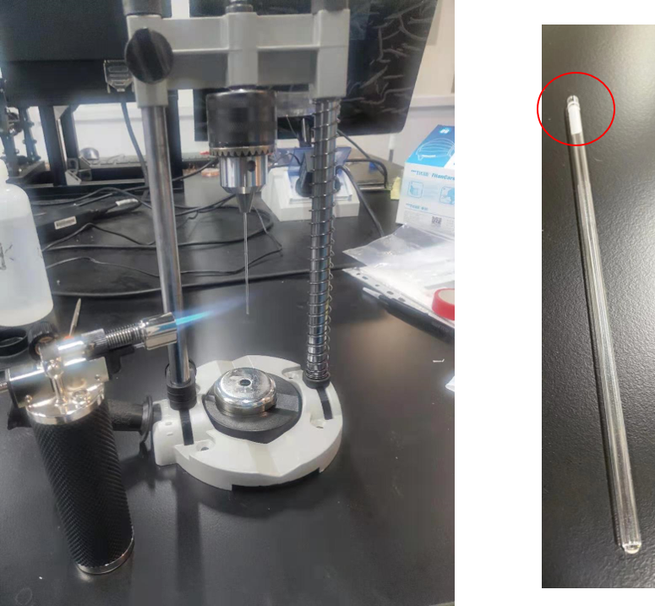

Figure S1. Pictures of hot-melting method and counter electrode tube. After the bottom of the hollow glass tube (1.2 mm diameter) sealed with proton exchange membrane, the platinum wire (0.3 mm diameter) is inserted in the tube and filled with electrolyte solution.

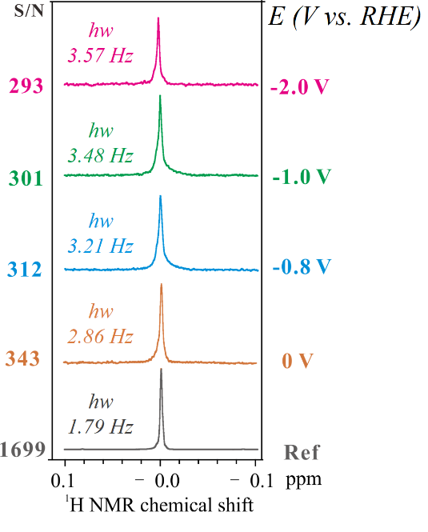
Figure S2. Operando ¹H NMR spectra of the TMSP-D4 (3-(Trimethylsilyl)propionic-2,2,3,3-d4 acid sodium salt) sample at different voltages at 298 K with 2 s recycle delay and 16 scans, where S/N ratio represents the signal-to-noise ratio (SNR) and hw represents the full width at half maximum (FWHM) of the ¹H NMR signal. Working condition: 450 µL D₂O + 50 µL H₂¹⁷O (¹⁷O content is 37.5%) + 5 mg KHCO₃ under 1.5 mL/min CO₂ bubbing.

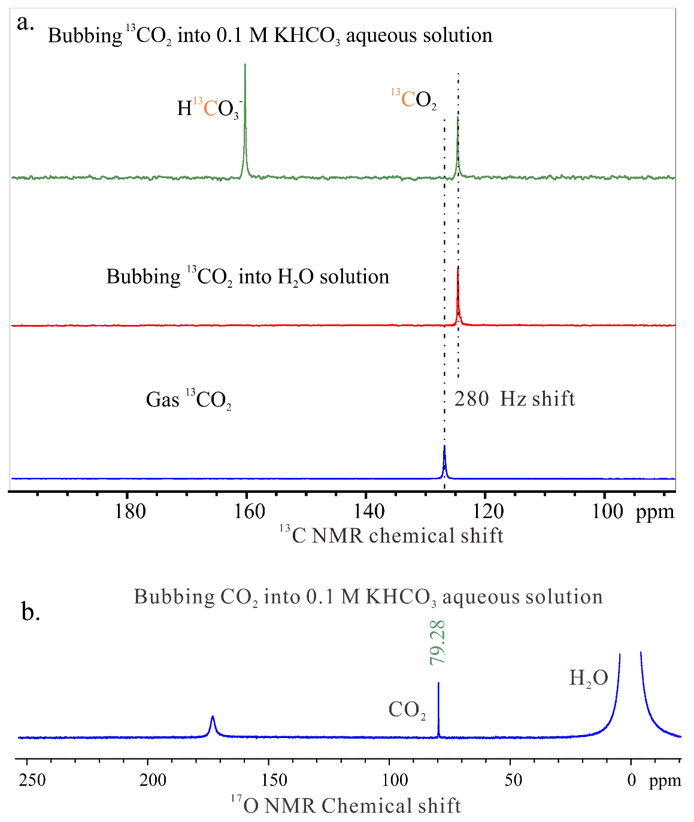
Figure S3. Operando NMR set-up was used to study the effect of hydrogen-bond network on the electronic structure of CO₂ gas. (a) Gas ¹³CO₂: 2 bar ¹³CO₂ gas of is sealed in a closed NMR tube for testing; Bubbing ¹³CO₂ into H₂O solution: 500 µL D₂O under 1.5 mL/min CO₂ bubbing; Bubbing ¹³CO₂ into 0.1 M KHCO₃ aqueous solution: 500 µL D₂O + 5 mg KHCO₃ under 1.5 mL/min ¹³CO₂ bubbing. (b) ¹⁷O NMR spectrum and test condition is 450 µL D₂O + 50 µL H₂¹⁷O (¹⁷O content is 37.5%) + 5 mg KHCO₃ under 1.5 mL/min CO₂ bubbing.

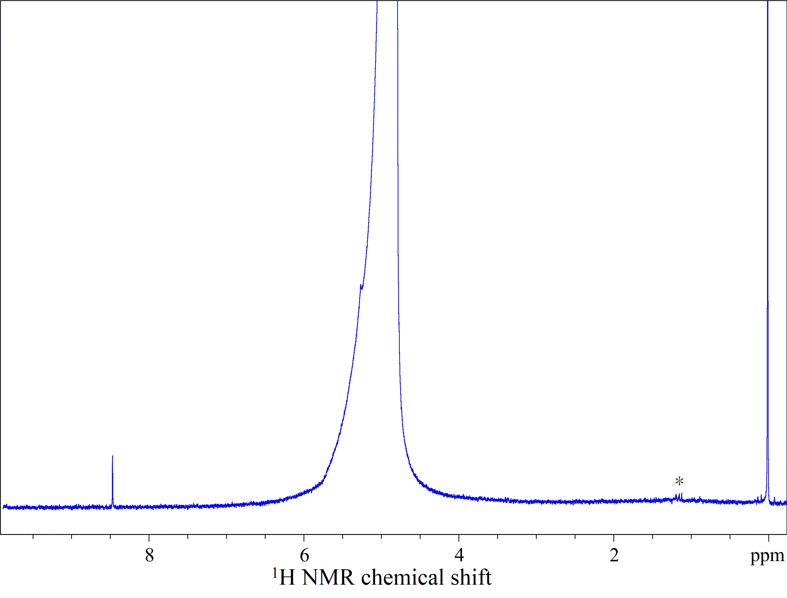
Figure S4. Full-band ¹H-NMR spectrum obtained from the catholyte of CO₂ reduction on Nano Cu precatalyst at - 1.2 V (vs. RHE; non-iR corrected) in H cell. TMSP-D4 is used as an internal standard for quantification of liquid products. It is mentionable that the liquid products were collected after the reaction run for 12 h. The asterisk (*) represents impurities introduced by KHCO₃ electrolyte.

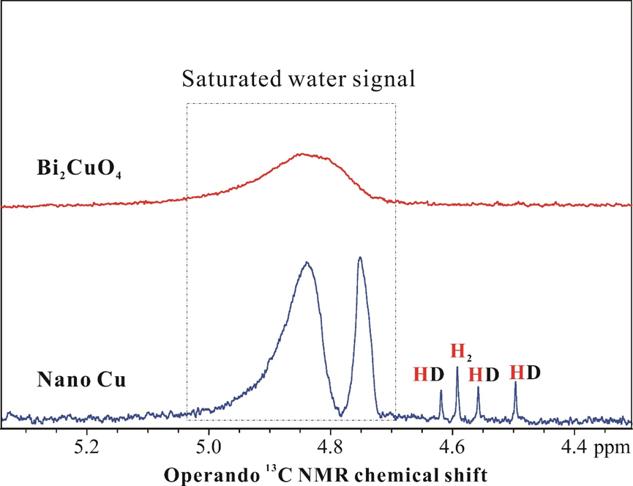
Figure S5. Operando ¹H NMR spectra obtained from electrocatalytic Nano Cu and Bi₂CuO₄ systems at - 1.2 V (vs. RHE). Working condition: 450 µL D₂O + 50 µL H₂¹⁷O (¹⁷O content is 37.5%) + 5 mg KHCO₃ under 1.5 mL/min CO₂ bubbing.

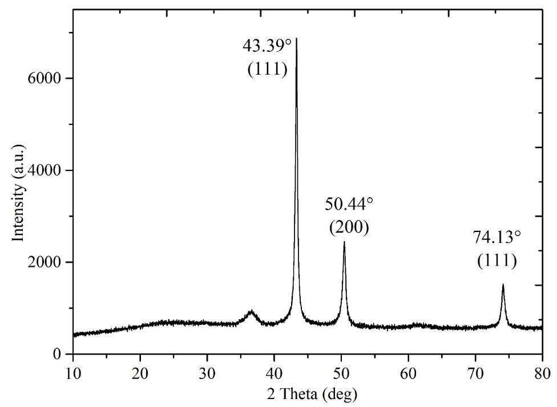
Figure S6. XRD patterns of Nano Cu precatalyst.

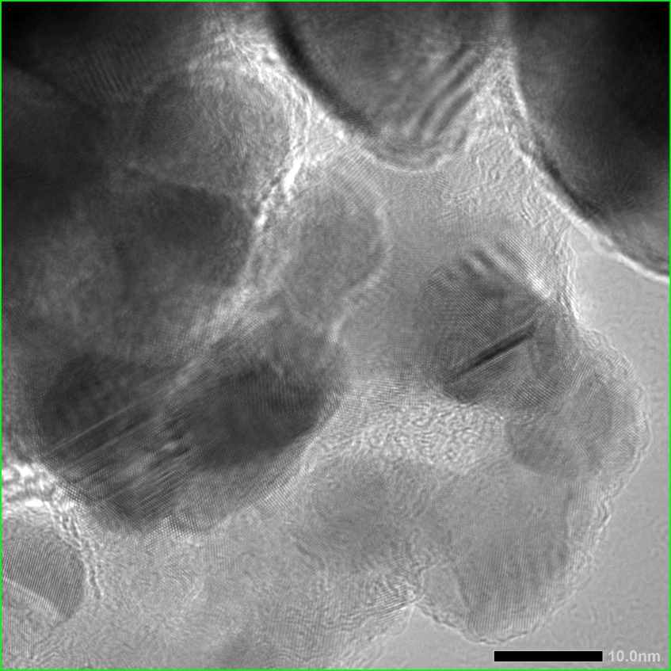
Figure S7. TEM patterns of Nano Cu precatalyst.

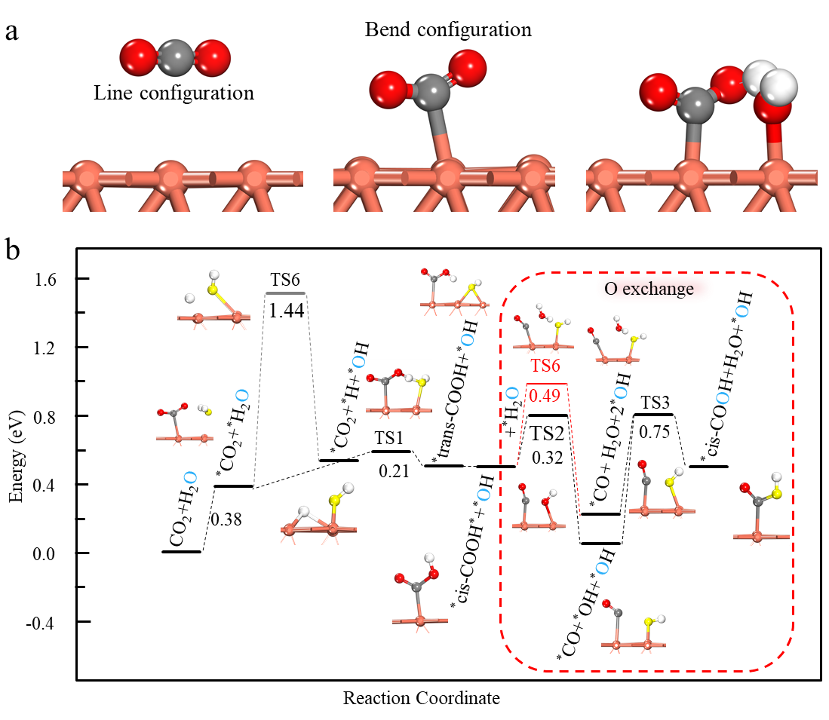
Figure S8. (a) The adsorption structures of CO₂, H₂O and co-adsorption between CO₂ and H₂O. (b) The energy profile of CO₂ reaction with H₂O on Cu (111) surface. The insert structures show the initial, transition and finial states of every reaction steps. The yellow atom shows the oxygen in H₂O.

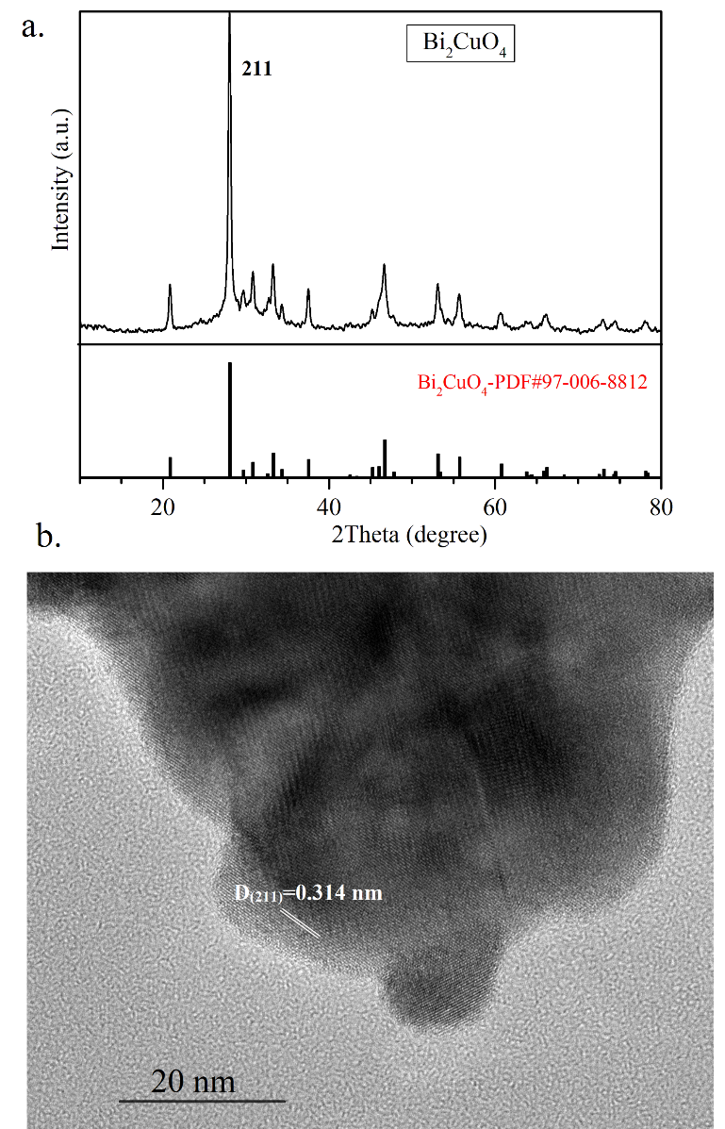
Figure S9. (a) XRD pattern of Bi₂CuO₄ precatalyst indexed to Bi₂CuO₄ (JCPDS standard card #97-008-8812). (b) HRTEM image of Bi₂CuO₄ precatalyst.

Figure S10. XPS spectra of (a) Cu 2p (Cu²⁺) and (b) Bi 4f (Bi³⁺) regions of Bi₂CuO₄ precatalyst.

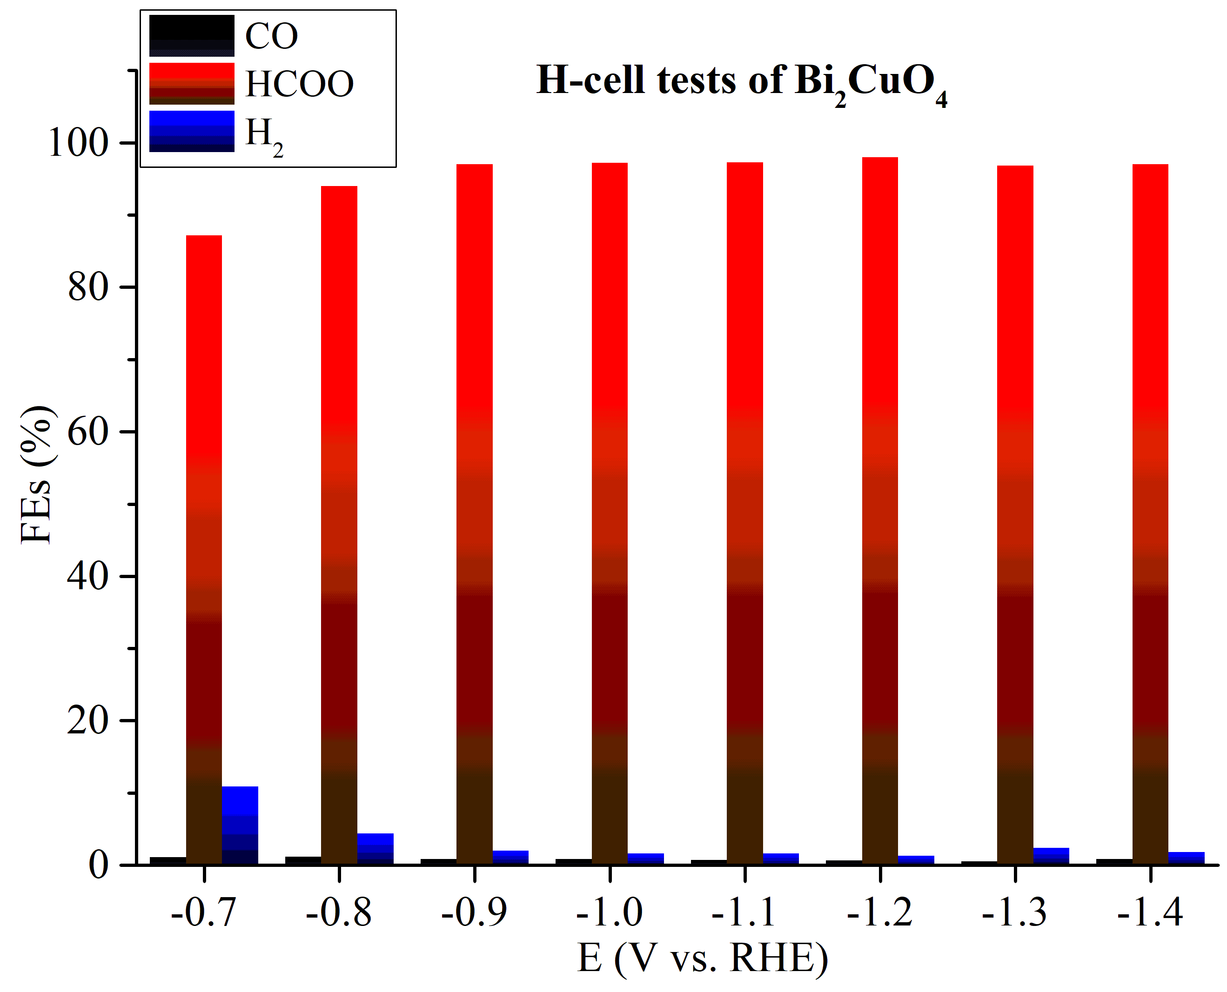Figure S11. Potential-dependent FEs of main products using a H cell in 0.1 M KHCO₃ for Bi₂CuO₄ precatalyst.

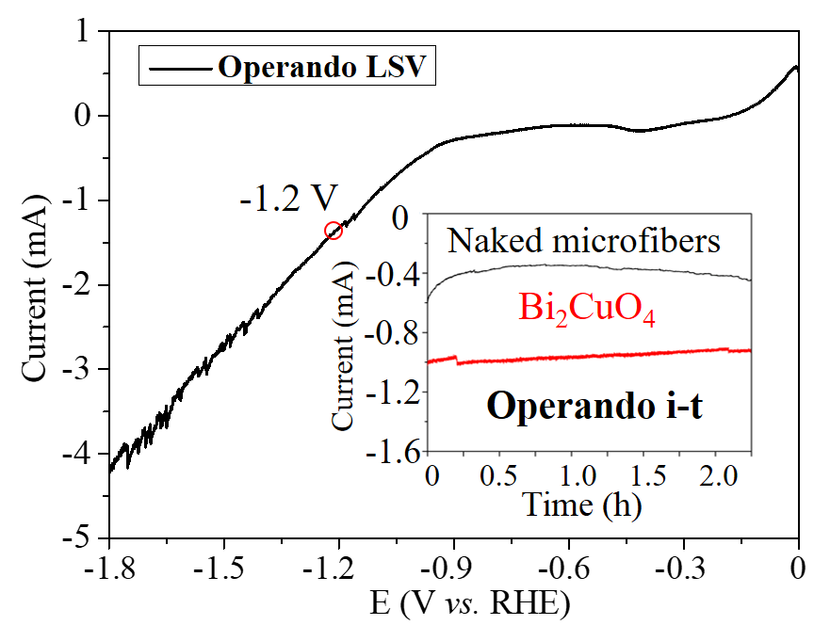
Figure S12. Operando LSV (linear sweep voltammetry) profile of Bi₂CuO₄ precatalyst with a scan rate of 10 mV s⁻¹. Working condition: 450 µL D₂O + 50 µL H₂¹⁷O (¹⁷O content is 37.5%) + 5 mg KHCO₃ under 1.5 mL/min CO₂ bubbing. Insert: Comparison of operando i-t curves with and without catalyst (denoted as Bi₂CuO₄ and Naked microfibers), which the applied potential was set to -1.2 V (vs. RHE) and other conditions were same as that of operando LSV experiment.

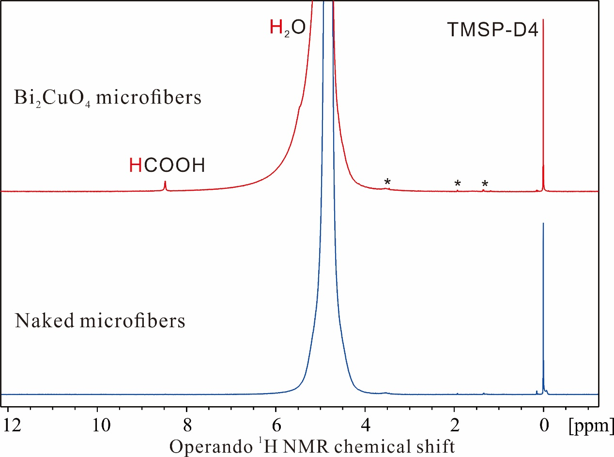
Figure S13. Comparison of operando ¹H NMR spectra with and without catalyst (denoted as Bi₂CuO₄ and Naked microfibers), which the potential is set to - 1.2 V (vs. RHE) and other conditions are same as that of operando i-t experiment.

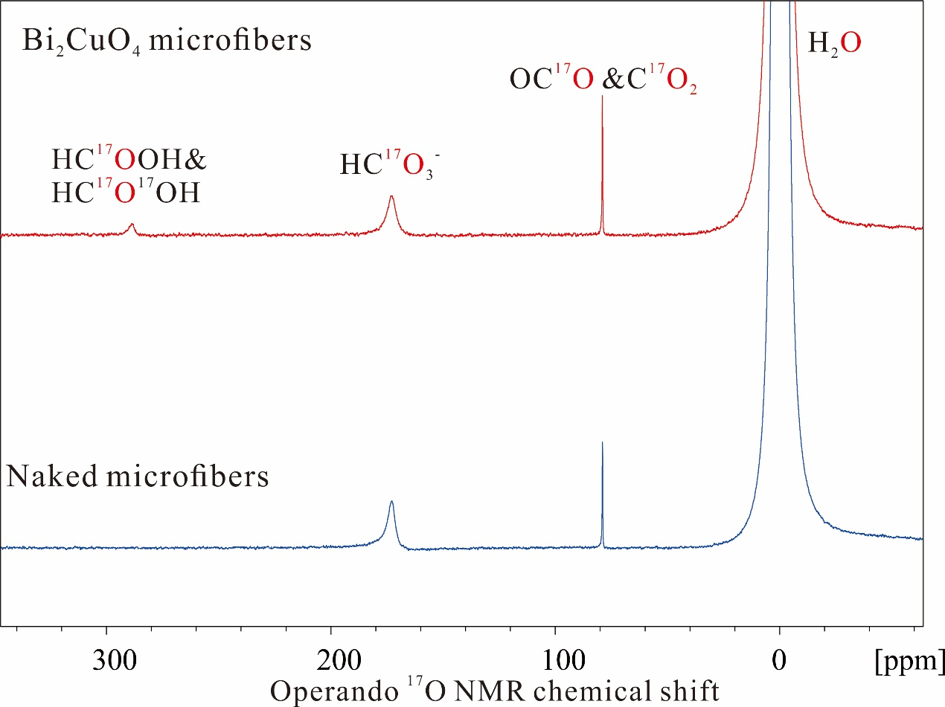
Figure S14. Comparison of operando ¹⁷O NMR spectra with and without catalyst (denoted as Bi₂CuO₄ and Naked microfibers), which the potential is set to - 1.2 V (vs. RHE) and work conditions are 450 µL D₂O + 50 µL H₂¹⁷O (¹⁷O content is 37.5%) + 5 mg KHCO₃ under 1.5 mL/min CO₂ bubbing.

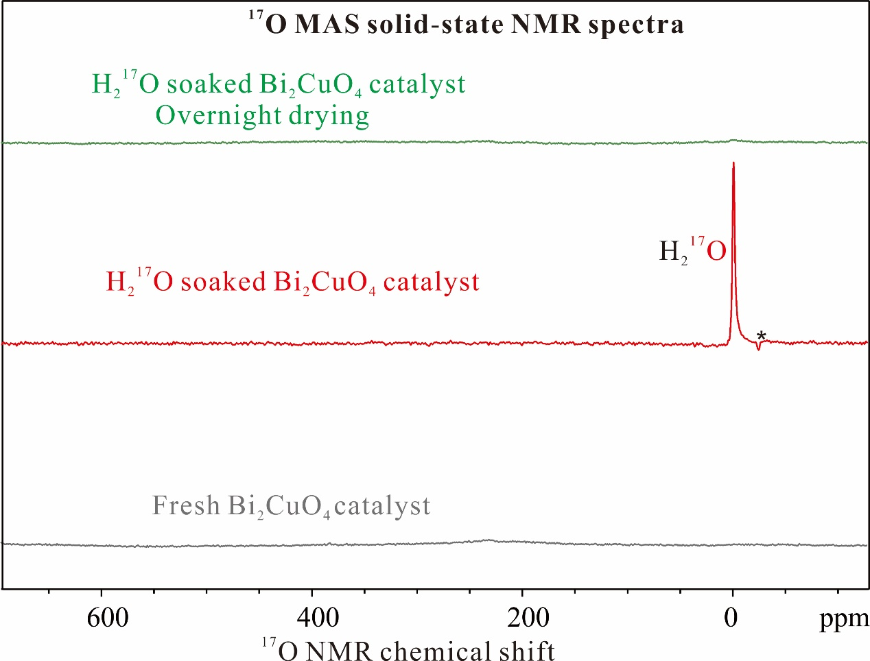
Figure S15. Ex-situ solid-state NMR experiments to investigate the possibility of the oxygen exchange between active sites and water molecule on Bi₂CuO₄ surface.

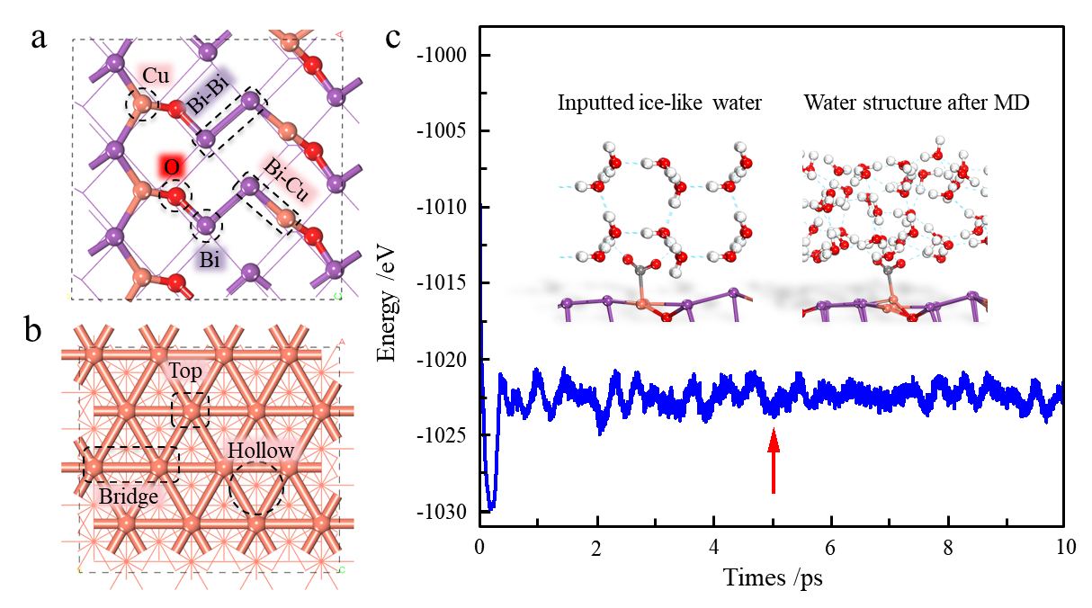
Figure S16. (a) The top structure of Bi-O-Cu surface with the possible active sites marked by Cu, Bi, [Bi-Bi] and [Bi-Cu]. (b) The top structure of Cu (111) surface with possible active sites marked as top bridge and hollow. (c) Energy profile of MD simulation for water/ Bi-O-Cu model. The side views of the input ice-like water structure and the water structure obtained after the MD simulation. The red arrow indicates the time that energy starts to oscillate around a constant. Purple, Bi; Red, O; Orange, Cu; White, H. These color notations are used throughout the DFT sections.

The other possible active sites are also investigated and the results show CO₂ even in the linear configuration cannot adsorb on active sites with the Bi sites involved with smaller adsorption energies (Table S1), implying that the active site on the Bi-O-Cu surface is still Cu atom and the Bi atom on the surface may has a synergistic effect with Cu atom.
.

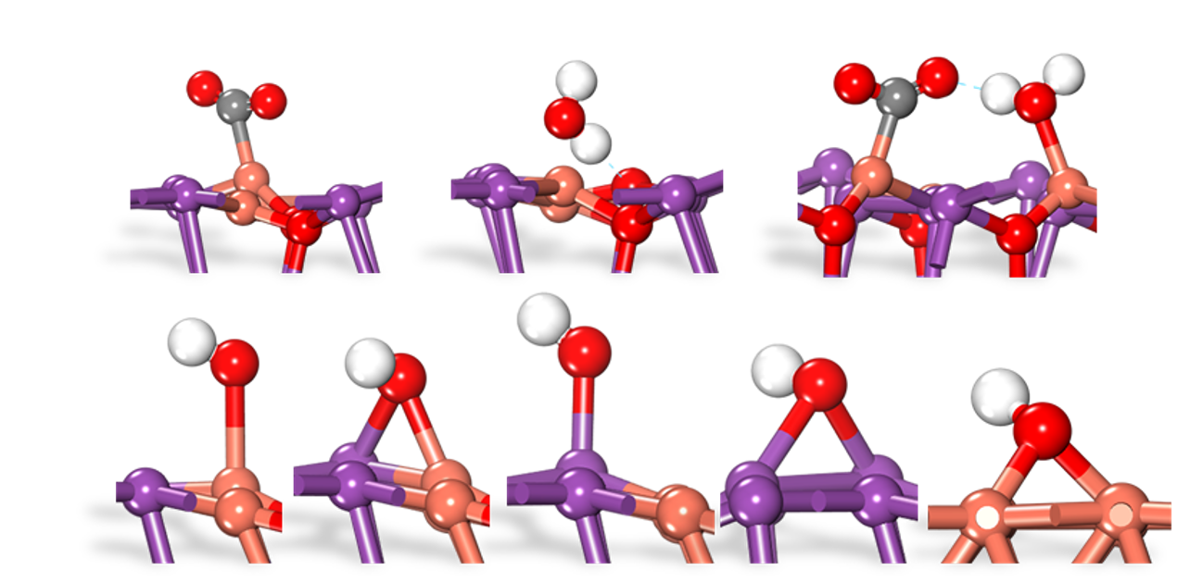
Figure S17. Calculated configurations of the OH adsorbs on the Cu, Bi sites and the bridges [Bi-Bi] (formed by the two Bi atoms) and [Bi-Cu] (formed by one Bi and one Cu atoms).

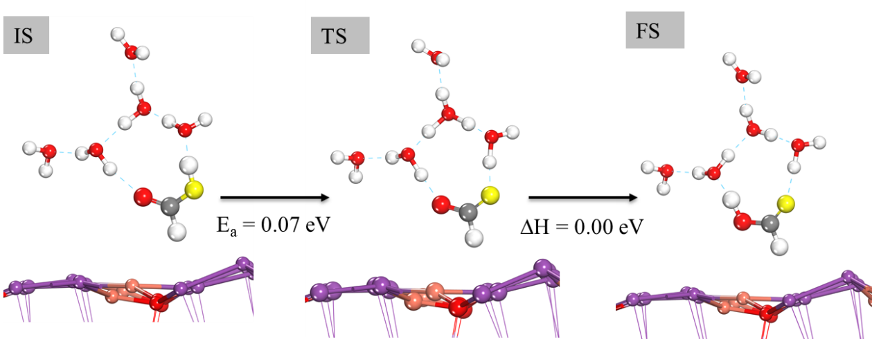
Figure S18. Geometry structures of IS, TS and FS for the proton transfer by the hydrogen bond network.

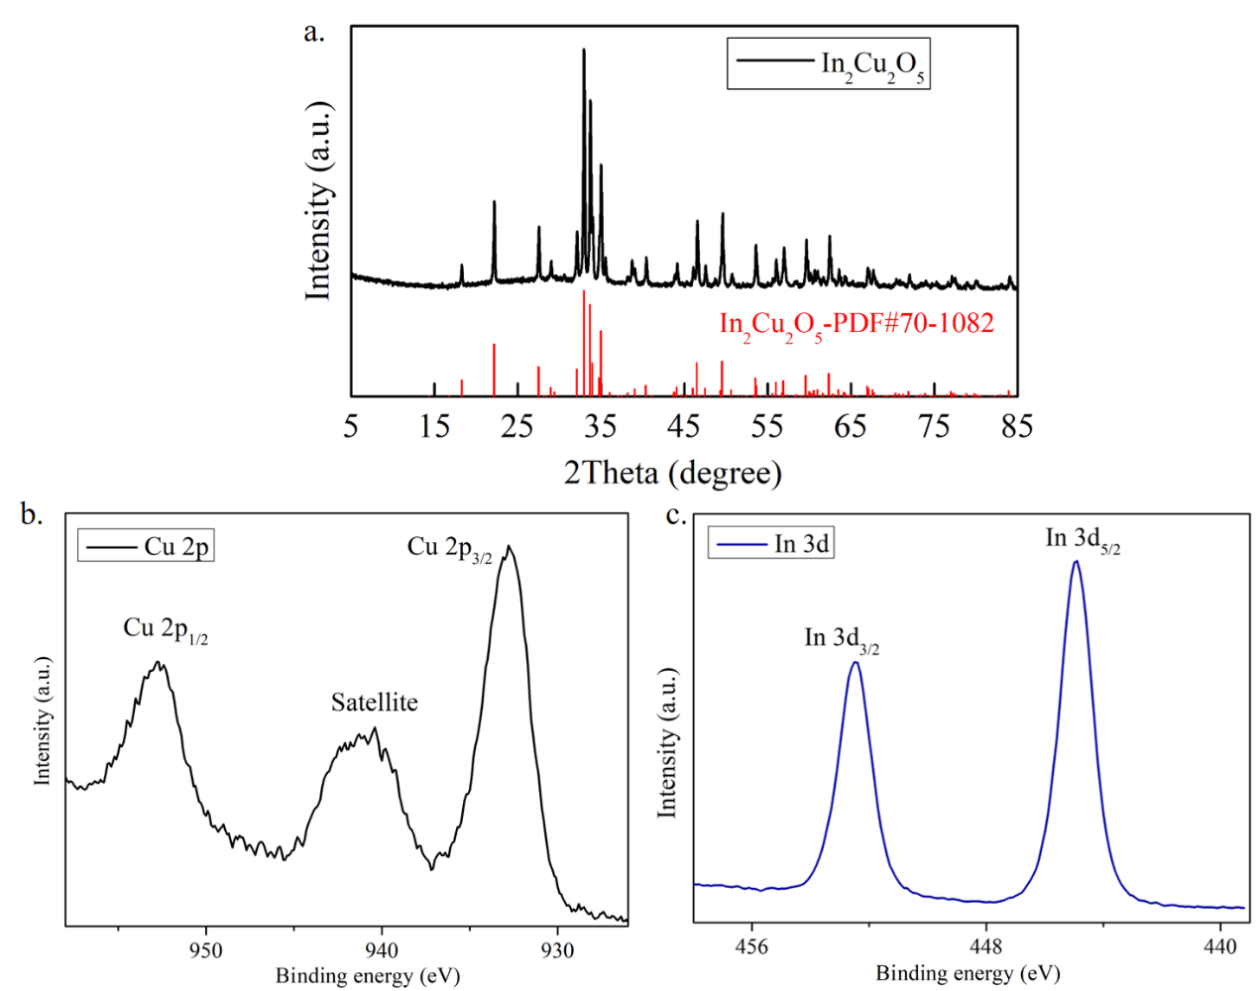
Figure S19. (a) The XRD structural refinement of In₂Cu₂O₅ precatalyst (ICSD standard card #70-1082). The high resolution XPS spectra of Cu 2p (b) and In 3d (c).

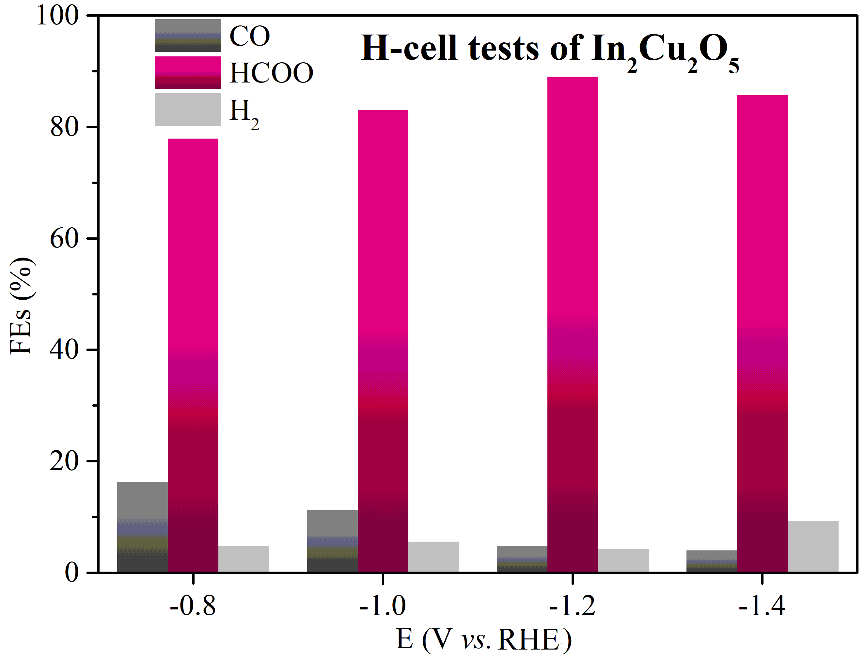
Figure S20. Potential-dependent FEs of main products using a H cell in 0.1 M KHCO₃ for In₂Cu₂O₅ precatalyst.

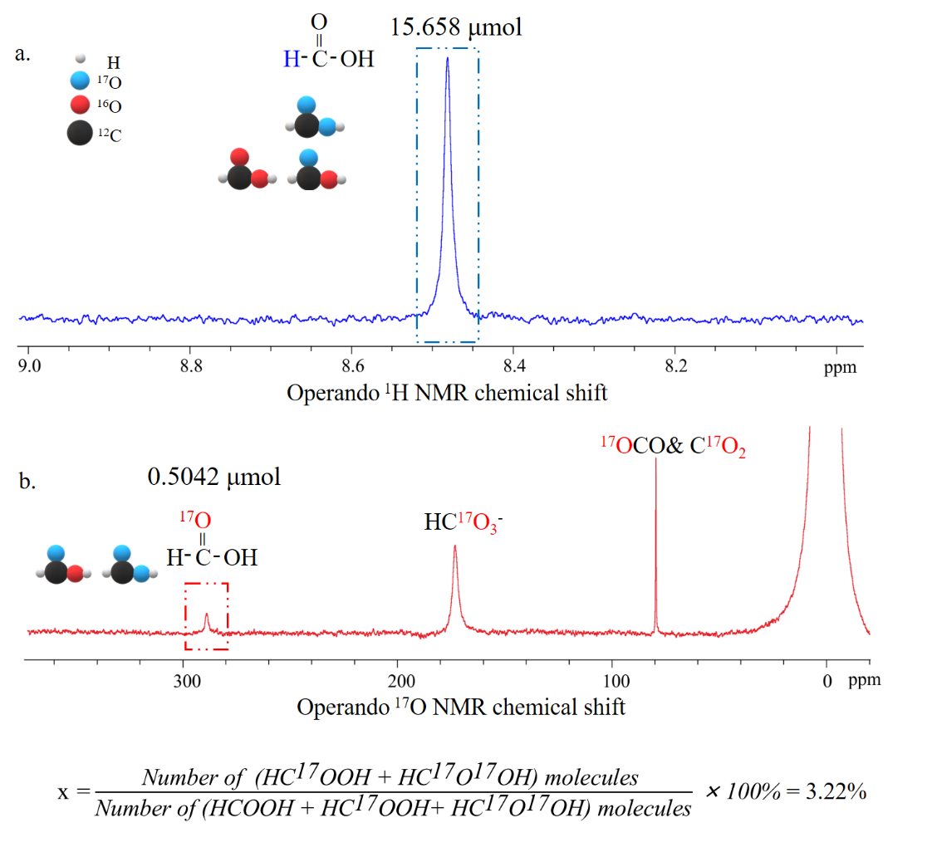
Figure S21. Operando NMR analysis of electrocatalytic In₂Cu₂O₅ precatalyst. (a) Quantitative operando ¹H NMR spectrum of electrocatalytic products obtained for In₂Cu₂O₅ systems at 298 K with a 2 s recycle delay and 16 scans. (b) Quantitative operando ¹⁷O NMR spectrum obtained for electrocatalytic In₂Cu₂O₅ systems at 298 K with a 200 ms recycle delay and 2048 scans. Working condition: 450 µL D₂O + 50 µL H₂¹⁷O (¹⁷O content is 37.5%) + 5 mg KHCO₃ under 1.5 mL/min CO₂ bubbing and -1.2 V potential.

References
1. Perdew JP, et al. Restoring the density-gradient expansion for exchange in solids and surfaces. Phys. Rev. Lett. 100, 136406 (2008).
2. Kresse, Hafner. Ab initio molecular-dynamics simulation of the liquid-metal-amorphous-semiconductor transition in germanium. Phys. Rev. B 49, 14251-14269 (1994).
3. Kresse G, Furthmuller J. Efficiency of ab-initio total energy calculations for metals and semiconductors using a plane-wave basis set. Comp. Mater. Sci. 6, 15-50 (1996).
4. Payne MC, Teter MP, Allan DC, Arias TA, Joannopoulos JD. Iterative minimization techniques for ab initio total-energy calculations: molecular dynamics and conjugate gradients. Rev. Mod. Phys. 64, 1045-1097 (1992).
5. Kresse G, Joubert D. From ultrasoft pseudopotentials to the projector augmented-wave method. Phys. Rev. B 59, 1758-1775 (1999).
6. Alavi A, Hu PJ, Deutsch T, Silvestrelli PL, Hutter J. CO oxidation on Pt(111): An ab initio density functional theory study. Phys. Rev. Lett. 80, 3650-3653 (1998).
7. Liu ZP, Hu P. General rules for predicting where a catalytic reaction should occur on metal surfaces: A density functional theory study of C-H and C-O bond breaking/making on flat, stepped, and kinked metal surfaces. J. Am. Chem. Soc. 125, 1958-1967 (2003).
8. Wang H-F, Kavanagh R, Guo Y-L, Guo Y, Lu G-Z, Hu P. Structural Origin: Water Deactivates Metal Oxides to CO Oxidation and Promotes Low-Temperature CO Oxidation with Metals. Angew. Chem. Int. Ed. 51, 6657-6661 (2012).
9. Wang H-F, Wang D, Liu X, Guo Y-L, Lu G-Z, Hu P. Unexpected C-C Bond Cleavage Mechanism in Ethylene Combustion at Low Temperature: Origin and Implications. ACS Catal. 6, 5393-5398 (2016).
10. Dai Y-H. A perfect example for the BFGS method. Math Program 138, 501-530 (2013).
11. Wang D, Wang H, Hu P. Identifying the distinct features of geometric structures for hole trapping to generate radicals on rutile TiO₂(110) in photooxidation using density functional theory calculations with hybrid functional. Phys. Chem. Chem. Phys. 17, 1549-1555 (2015).
12. Zhang J, Peng C, Wang H, Hu P. Identifying the Role of Photogenerated Holes in Photocatalytic Methanol Dissociation on Rutile TiO₂(110). ACS Catal. 7, 2374-2380 (2017).
13. Wang D, Sheng T, Chen J, Wang H-F, Hu P. Identifying the key obstacle in photocatalytic oxygen evolution on rutile TiO₂. Nat. Catal. 1, 291-299 (2018).
14. Jin J, Sun N, Hu W, Yuan H, Wang H, Hu P. Insight into Room-Temperature Catalytic Oxidation of Nitric oxide by Cr₂O₃: A DFT Study. ACS Catal. 8, 5415-5424 (2018).

