Supplementary Table 1 ﻿List of primers used for candidate gene expression analysis in mungbean (Vigna radiata) accessions exposed to drought and low phosphorus stress

S. No. | Gene name | Gene ID |  | Nucleotide Sequence | Product size (bp)
1 | VrNCED | Vradi05g18970 | Forward | 5’- TGTTTCTGCTTCCACCTCTG-3’ | 128
 |  |  | Reverse | 5’- AGCACACTCTTCAAACTCTCG-3’
2 | VrDREB | Vradi05g13560 | Forward | 5’-CATCGTGTCTCTTCCCTTGG-3’ | 81
 |  |  | Reverse | 5’-GAAAACTCTCCCTCAATCCCC-3’
3 | VrDHN3 | Vradi01g04470 | Forward | 5’- GCTTTTACGACCCTTGACCAG-3’ | 150
 |  |  | Reverse | 5’- TCATCAGTTTCCCTTACGACG-3’
4 | VrIFR | Vradi07g02160 | Forward | 5’- TGCTATCTCTGGTGTTCACTTC-3’ | 150
 |  |  | Reverse | 5’- CCTGGTTCTAATGCATCTCCC-3’
5 | VrMDH | Vradi08g00610 | Forward | 5’-ACCCAGTTCGTGTTCTTGTC -3’ | 150
 |  |  | Reverse | 5’-CCCCGTTCAATGATTCTGCT-3’
6 | VrPAP1 | Vradi08g20940 | Forward | 5’-GTTTGCTGGAGGTCTTATAGGG-3’ | 141
 |  |  | Reverse | 5’-GAGGGCTGAGAACCATTACG-3’
7 | VrPHO1 | Vradi07g06380 | Forward | 5’- TGTCGCTGTGATTCCATACTG-3’ | 143
 |  |  | Reverse | 5’- CAAGAGTATCCGCTGTTCTGAG-3’
8 | VrPEPCase | Vradi0236s00040 | Forward | 5’- GACCGCTTCCTTGACATTCT -3’ | 150
 |  |  | Reverse | 5’- ACCAGTTAGCATGTTCCCAAG -3’
9 | VrP5CS | Vradi09g07820 | Forward | 5’- TTAACTCACCTCAACTCGCTC-3’ | 146
 |  |  | Reverse | 5’- CTACCCAGTGCTAATCTTCCATC-3’
10 | VrRAB18 | Vradi05g15040 | Forward | 5’- AAGCTTCACCGATCTGACAG-3’ | 140
 |  |  | Reverse | 5’- ACAACCTCCACTTTCTCAACTG-3’
11 | VrSPX1 | Vradi03g09880 | Forward | 5’- AGAGATGGTCTTGCTCGAAAAC-3’ | 148
 |  |  | Reverse | 5’- AAGGTCAGTGGTGAAGAAAGG-3’
12 | VrSQD2 | Vradi08g04250 | Forward | 5’- AAATGGGAGATGAGGTGATGG-3’ | 136
 |  |  | Reverse | 5’- GGACTAAGTGCCAAGGAGAG-3’
13 | VrActin-3 | Vradi03g00210 | Forward | 5’- ACCTTCAACACTCCTGCTATG-3’ | 125
 |  |  | Reverse | 5’- TCGTAAATAGGAACCGTGTGAC-3’
14 | VrEF-1∝ | Vradi01g08330 | Forward | 5’- GGTTTTGAAGCCGGTATTTCC-3’ | 146
 |  |  | Reverse | 5’- ATTTCATCGTACCTAGCCTTGG-3’
15 | VrUbi | Vradi0129s00240 | Forward | 5’- ACGCTCTGATTCCTGATAACTTC-3’ | 141
 |  |  | Reverse | 5’-TGTTGAATGAGATACTTCCAGTCC-3’

Supplementary Table 2 Significance of F values derived from analysis of variance for plant growth, nodule characteristics and yield traits of mungbean accessions (G) grown under different soil P (sufficient - 25.6 mg P kg⁻¹ soil, low - 7.8 mg P kg⁻¹ soil) and moisture (W) regimes (irrigated and drought). ***P<0.001, **P<0.01, *P<0.05, NS, not significant.

Traits | Significance of sources of variability
Traits | P | W | G | P × W | P × G | W × G | P × W × G
Leaf area | 199*** | 571*** | 52*** | 24.9*** | 11.2*** | 29.8*** | 14.8***
Leaf dry weight | 147*** | 646*** | 56.7*** | 33.9*** | 3.48* | 28.1*** | 21.1***
Stem dry weight | 81*** | 641*** | 34*** | 22.6*** | 4.57** | 2.39NS | 10.5***
Root dry weight | 8.89** | 16.2*** | 69.3*** | 134*** | 9.11*** | 43.1*** | 7.27***
Total biomass | 140*** | 663*** | 121.0*** | 20.4*** | 4.59** | 57.3*** | 15.7***
Specific leaf weight | 14.3*** | 6.96* | 11.5*** | 2.68NS | 6.14** | 2.83* | 5.72**
Root-shoot ratio | 0.46NS | 164*** | 26.4*** | 101*** | 5.1** | 18.5*** | 11.8***
Number of pods plant⁻¹ | 51.8*** | 38.6*** | 119.7*** | 1.7 NS | 1.70NS | 1.8 NS | 9.50***
Number of seed pod-¹ | 4.7* | 49*** | 71.4*** | 0.7 NS | 13.3** | 16.1*** | 2.90*
100 seed weight (g) | 34.4*** | 0.5 NS | 308*** | 5.3* | 29.9* | 21.1*** | 12.5***
Seed yield (g plant⁻¹⁾ | 71.8*** | 219.0*** | 125*** | 7.5** | 3.50* | 15.1*** | 1.10NS
Nodule FW | 169.0*** | 187.0*** | 20.1*** | 20.8*** | 1.79NS | 14.5*** | 2.78NS
Nodule number | 65.9*** | 355.0*** | 46.3*** | 1.71NS | 0.70NS | 19.2*** | 3.28*
Leghaemoglobin content | 407.0*** | 2211.0*** | 129.0*** | 4.07 NS | 47.8*** | 4.58** | 9.93***
ARA activity | 135.0*** | 558.0*** | 4.09* | 70.2*** | 1.44NS | 1.07NS | 0.55NS

Supplementary Table 3 The significance of F values derived from analysis of variance for relative water content, membrane stability and other antioxidant scavenging system in mungbean accessions (G) grown under different soil P (sufficient - 25.6 mg P kg⁻¹ soil, low - 7.8 mg P kg⁻¹ soil) and moisture (W) regimes (irrigated and drought). ***P<0.001, **P<0.01, *P<0.05, NS, not significant.

Traits | Significance of sources of variability
Traits | P | W | G | P × W | P × G | W × G | P × W × G
Relative water content | 38.0*** | 157.0*** | 8.70*** | 5.20* | 4.90** | 1.00NS | 4.70**
Membrane stability index | 179.0*** | 328.0*** | 40.0*** | 4.00NS | 10.0*** | 13.0*** | 26.0***
H₂O₂ | 33.9*** | 72*** | 4.37** | 1.54 NS | 0.88NS | 2.36* | 2.7*
MDA content | 202*** | 434*** | 77.5*** | 27.6*** | 8.6*** | 59.1*** | 13.3***
Ascorbate | 1.95NS | 626*** | 359*** | 0.36NS | 1.56NS | 48.4*** | 6.67***
Proline | 590*** | 2658*** | 226*** | 986*** | 226*** | 196*** | 196***
Reduced glutathione | 81*** | 151*** | 36.2*** | 36.2*** | 4.53** | 16.7*** | 12.1***
Total soluble sugars | 1.25NS | 430*** | 294*** | 10.7*** | 81*** | 47.3*** | 27***
SOD activity | 80.4*** | 167*** | 45.6*** | 3.47* | 9.09*** | 24.4*** | 4.67***
CAT activity | 1.57NS | 51.6*** | 15.7*** | 5.45** | 5.51** | 9.56*** | 11.3***
GR activity | 11.3** | 104*** | 81.4*** | 6.27** | 31.7*** | 8.05*** | 19.3***
APX activity | 116*** | 22*** | 27.3*** | 4.33* | 16.2*** | 26.1*** | 4.55***
POD activity | 68.4*** | 3.44* | 20.4*** | 33.2*** | 20.8*** | 13.4*** | 20.4***

Supplementary Table 4 The significance of F values derived from analysis of variance for concentration of phosphorus in various tissues and P uptake in mungbean accessions (G) grown under different soil P (sufficient - 25.6 mg P kg⁻¹ soil, low - 7.8 mg P kg⁻¹ soil) and moisture (W) regimes (irrigated and drought). ***P<0.001, **P<0.01, *P<0.05, NS, not significant.

Traits | Significance of sources of variability
Traits | P | W | G | P × W | P × G | W × G | P × W × G
Leaf P concentration (%) | 0.283NS | 20.404*** | 4.214* | 1.983NS | 10.437*** | 0.928NS | 0.409NS
Stem P concentration (%) | 3.421NS | 43.47*** | 34.727*** | 27.14*** | 100.127*** | 8.423*** | 20.28***
Root P concentration (%) | 21.389*** | 93.898*** | 10.419*** | 5.692* | 12.784*** | 5.807** | 1.824NS
Nodule P concentration (%) | 6.219* | 17.946*** | 10.632*** | 2.481NS | 0.972NS | 8.357*** | 4.044*
Grain P concentration (%) | 7.723** | 12.905** | 73.218*** | 19.41*** | 13.008*** | 5.753** | 5.865**
Leaf P content (mg P plant⁻¹) | 271.79*** | 1408.93*** | 127.23*** | 78.76*** | 10.48*** | 45.94*** | 32.7***
Stem P content (mg P plant⁻¹) | 440.2*** | 4594.26*** | 65.06*** | 69.46*** | 173.61*** | 12.39*** | 149.7***
Root P content (mg P plant⁻¹) | 49.28*** | 465.69*** | 231.94*** | 515.84*** | 12.82*** | 186.56*** | 26.64***
Nodule P content (mg P plant⁻¹) | 910.715*** | 9.038** | 129.229*** | 100.554*** | 6.453** | 346.571*** | 337.103***
Grain P content (mg P plant⁻¹) | 861.66*** | 3330.07*** | 1105.51*** | 61.48*** | 49.69*** | 259.35*** | 19.12***

Supplementary Table 5 Effect of drought stress and low soil P on phosphorus content (mg P plant⁻¹) in different tissues of tolerant (IC333090, IC507340) and sensitive (IC488526, EC397142) mungbean accessions. P – phosphorus, W – water regimes, G – accessions

Treatments | Accessions | Leaves | Stem | Root | Nodule | Grain
Control | IC333090 | 2.863 | 1.477 | 1.873 | 0.352 | 11.257
 | IC507340 | 2.470 | 1.972 | 1.291 | 0.519 | 12.502
 | IC488526 | 2.638 | 1.524 | 2.294 | 0.208 | 10.864
 | EC397142 | 2.259 | 1.981 | 1.737 | 0.189 | 7.610
Drought | IC333090 | 1.640 | 0.779 | 2.581 | 0.373 | 8.050
 | IC507340 | 1.607 | 0.846 | 1.867 | 0.119 | 8.128
 | IC488526 | 1.603 | 0.800 | 1.551 | 0.536 | 2.818
 | EC397142 | 0.594 | 0.454 | 1.283 | 0.363 | 5.248
Low P | IC333090 | 2.095 | 1.576 | 2.273 | 0.196 | 8.890
 | IC507340 | 1.576 | 1.115 | 1.981 | 0.265 | 10.608
 | IC488526 | 2.308 | 1.781 | 2.266 | 0.322 | 7.080
 | EC397142 | 1.635 | 0.912 | 1.894 | 0.131 | 5.448
Combined stress | IC333090 | 1.476 | 0.676 | 1.794 | 0.238 | 5.513
Combined stress | IC507340 | 1.457 | 0.492 | 1.292 | 0.156 | 8.660
Combined stress | IC488526 | 0.864 | 0.641 | 1.045 | 0.184 | 0.743
 | EC397142 | 0.861 | 0.394 | 0.841 | 0.108 | 3.424
Critical Difference (P ≤ 0.05) | P | 0.05 | 0.028 | 0.034 | 0.009 | 0.143
Critical Difference (P ≤ 0.05) | W | 0.05 | 0.028 | 0.034 | 0.009 | 0.143
Critical Difference (P ≤ 0.05) | G | 0.07 | 0.039 | 0.048 | 0.013 | 0.202
Critical Difference (P ≤ 0.05) | P × W | 0.07 | 0.039 | 0.048 | 0.013 | 0.202
Critical Difference (P ≤ 0.05) | P × G | 0.099 | 0.056 | 0.068 | 0.018 | 0.286
Critical Difference (P ≤ 0.05) | W × G | 0.099 | 0.056 | 0.068 | 0.018 | 0.286
Critical Difference (P ≤ 0.05) | P × W × G | 0.141 | 0.079 | 0.096 | 0.025 | 0.405

Supplementary Table 6 Significance of F values derived from analysis of variance for gene expression in contrasting mungbean accessions (G) grown under three moisture regimes (W) (irrigated, withholding irrigation and re-watering), and two P levels (sufficient - 25.6 mg P kg⁻¹ soil, low - 7.8 mg P kg⁻¹ soil). ***P <0.001, **P <0.01, *P <0.05, NS – not significant

Gene | Significance of sources of variability
Gene | P | W | G | P×W | P×G | W×G | P×W×G
Leaf
VrSQD1 | 1.27NS | 3.52* | 95.0*** | 14.8*** | 1.35NS | 4.24* | 14.3***
VrSPX1 | 0.44NS | 23.8*** | 70.4*** | 2.19NS | 21.4*** | 6.72** | 0.28NS
VrPEPCase | 0.15NS | 6.93** | 94.4*** | 6.51** | 0.95NS | 9.30** | 5.68**
VrPHO1 | 1.04NS | 8.48** | 9.76** | 0.43NS | 20.0*** | 4.06* | 3.22NS
VrPAP1 | 4.39* | 0.71NS | 101*** | 7.07** | 0.13 NS | 2.64NS | 16.3***
VrMDH | 55.9*** | 992*** | 1673*** | 67.3*** | 46.1*** | 948*** | 60.1***
VrIFR | 3.90NS | 62.2*** | 94.5*** | 6.44** | 1.16NS | 48.3*** | 3.85*
VrDHN3 | 32.6*** | 46.8*** | 78.8*** | 32.2*** | 25*** | 48.1*** | 32.5***
VrDREB | 3.41NS | 8.19** | 16.7*** | 0.38NS | 0.69NS | 13.8*** | 2.11NS
VrNCED | 6.78* | 46.0*** | 94.3*** | 10.4*** | 1.81NS | 37.5*** | 6.87**
VrRAB18 | 14.2*** | 18.5*** | 88.0*** | 14.4*** | 13.6** | 14.0*** | 12.9***
VrP5CS | 0.37NS | 69.9*** | 89.1*** | 2.07NS | 0.91NS | 25.8*** | 2.97NS
Petiole
VrSQD1 | 44.9*** | 44.3*** | 94.9*** | 12.2*** | 3.23NS | 36.2*** | 27.3***
VrSPX1 | 18.5*** | 4.85* | 3.66NS | 4.84* | 3.74NS | 17.5*** | 2.11NS
VrPEPCase | 83.5*** | 10.5*** | 74.1*** | 21.9*** | 2.18NS | 37.1*** | 8.35**
VrPHO1 | 6.27* | 4.73* | 49.4*** | 4.91* | 15.5*** | 10.1*** | 3.15NS.
VrPAP1 | 1.64NS | 28.7*** | 60.6*** | 2.06NS | 1.79NS | 28.9*** | 2.22NS
VrMDH | 0.01NS | 81.8*** | 121*** | 0.38NS | 0.11NS | 86*** | 0.83NS
VrIFR | 4.04NS | 0.23NS | 0.27NS | 6.13** | 4.98* | 5.79** | 5.9**
VrDHN3 | 19.9*** | 16.2*** | 227*** | 20.4*** | 32.8*** | 11.4*** | 26.4***
VrDREB | 0.07NS | 43.2*** | 9.23** | 18.3*** | 7.87** | 1.94NS | 1.87NS
VrNCED | 2.4NS | 36.2*** | 130*** | 24.7*** | 48*** | 12.4*** | 63.3***
VrRAB18 | 1.03NS | 3.8* | 135*** | 11.1*** | 4.59* | 19.3*** | 5.12*
VrP5CS | 1.25NS | 1.74NS | 14.4*** | 1.64NS | 2.14NS | 2.54NS | 1.36NS

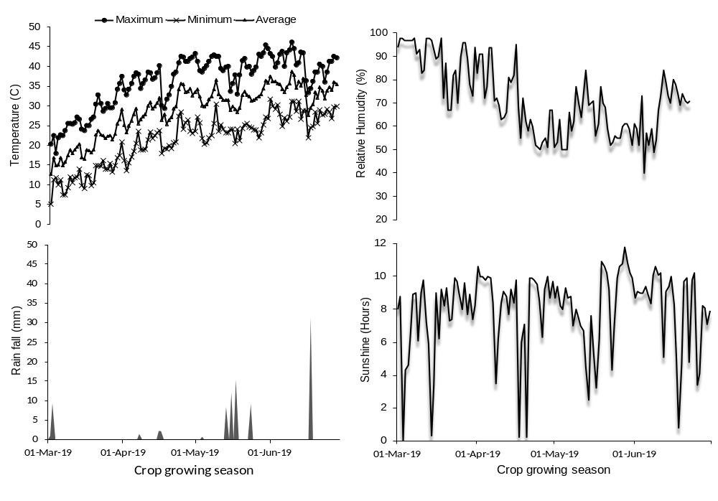
Supplementary Fig. 1 Weather data (maximum and minimum temperature, rainfall, relative humidity and sunshine hours) collected during the experimental period

Supplementary Fig. 2 Variation in root size in four contrasting mungbean accessions grown under control, low P, drought and combined (low P & drought) stress. Tolerant accessions – IC333090, IC507340; sensitive accessions – IC488526, EC397142

