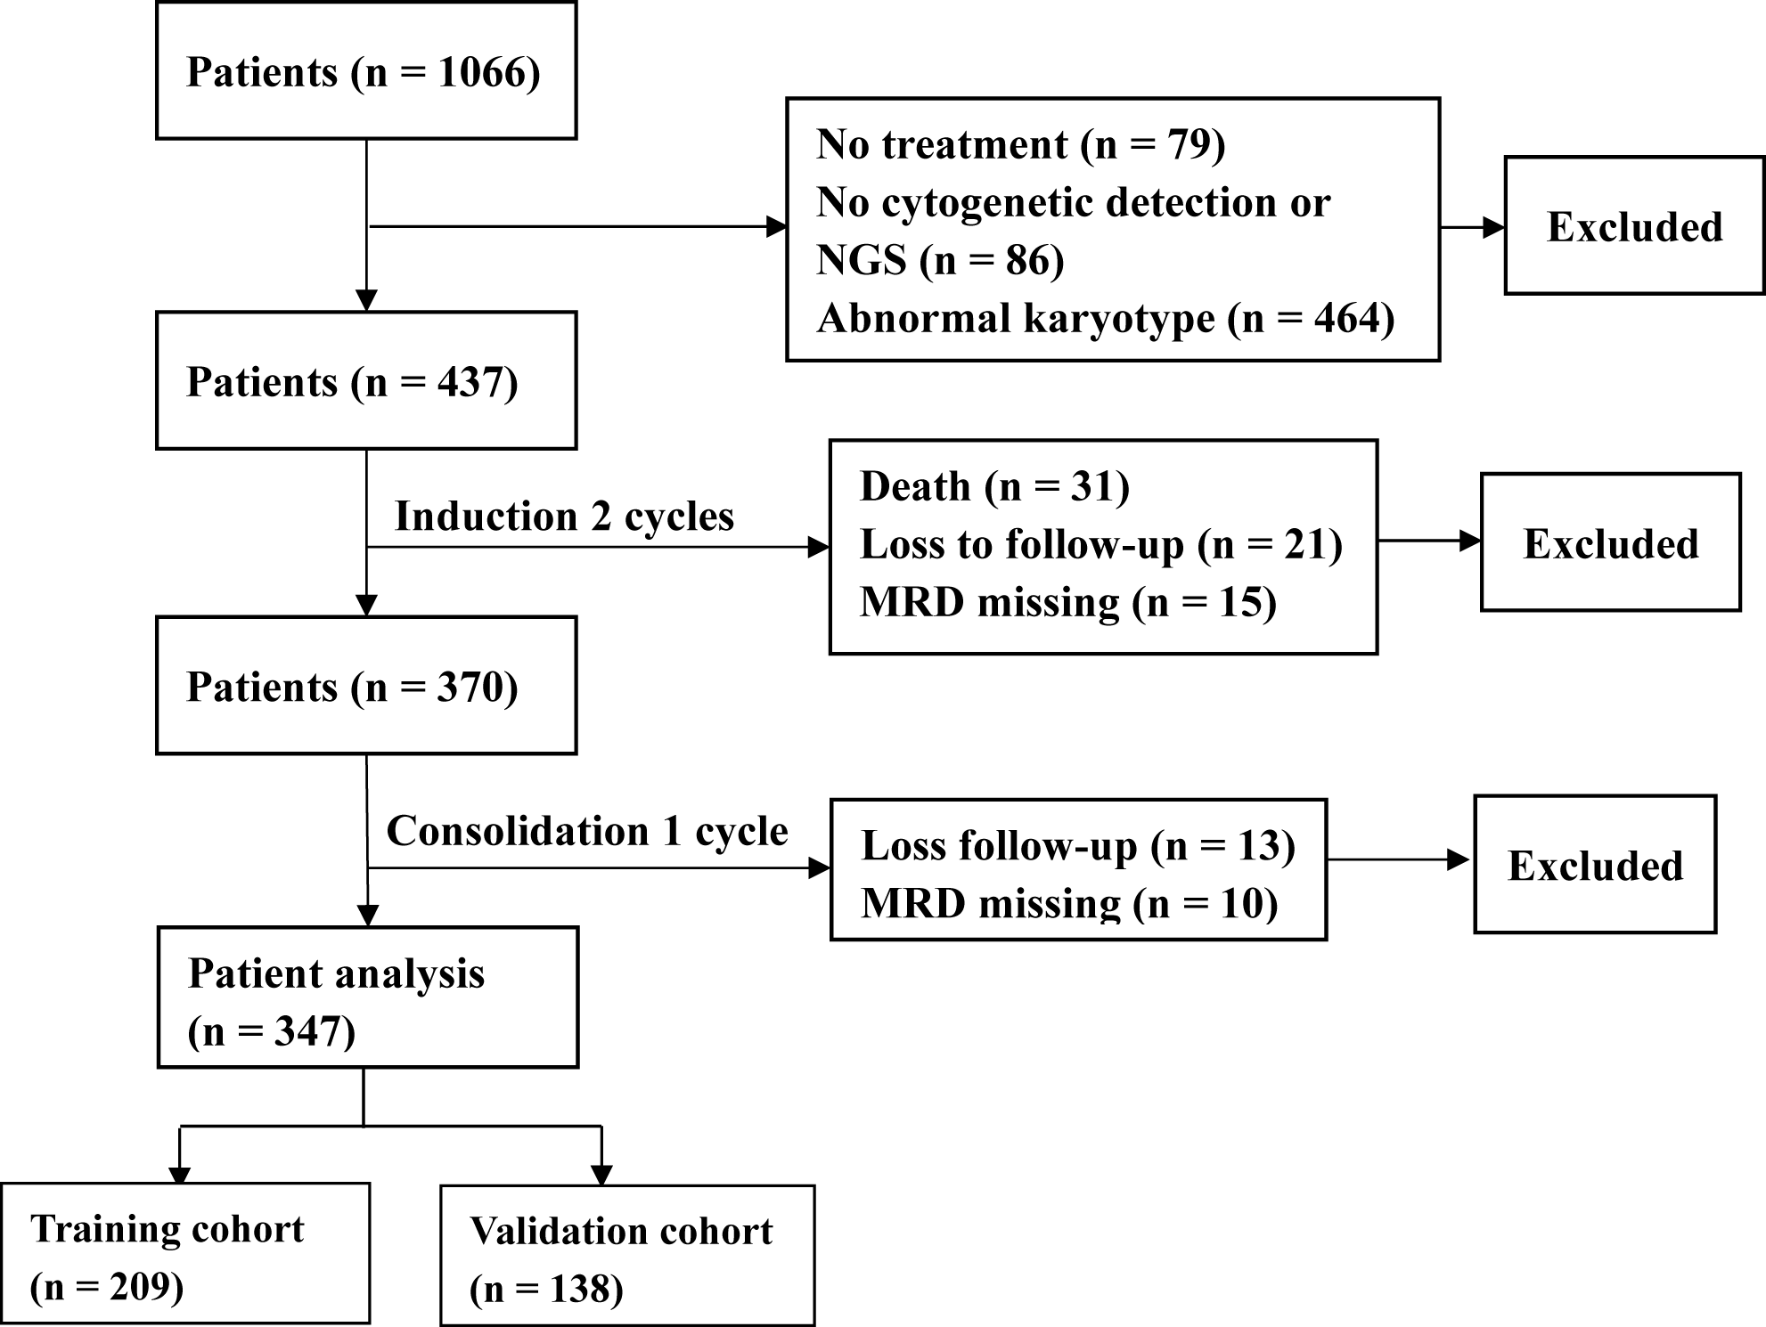

Additional File Figure 1. Diagnosis and selection procedure of the patients enrolled in this study. MRD, measurable residual disease; NGS, next-generation sequencing.

(a)
(b)
Additional File Figure 2. (a) Relapse and (b) difference in GMS constitution patients in the FLT3-ITD-high, -low, and wild type groups according to the mutation allelic ratio in all patients. GMS, genomic mutation signature.

(a)
(b)
Additional File Figure 3. Morphology and MRD (at the time of relapse) of two patients with NK-AML with relapse. (a) Patient 1, Relapse: 9 months; Death: 10 months; Mutated genes: FLT3-ITD; GMS (score): 1.025; GMSN (score): 1.424. (b) Patient 2, Relapse: 6 months; Death: 6 months; Mutated genes: CEBPA, TP53; GMS (score): 0.792; GMSN (score): 1.973. GMS, genomic mutation signature; GMSN, genomic mutation signature nomogram; MRD, measurable residual disease. NK-AML, normal karyotype acute myeloid leukemia.

Additional File Table 1. Univariate and multivariate analysis of DFS and OS in the training cohort
Variable | Univariate |  |  | Multivariate
Variable | HR (95% CI) | P |  | HR (95% CI) | P
DFS
Age (> 40 vs. ≤ 40) | 2.03 (1.25-3.27) | 0.002* |  | 1.76 (1.04-2.99) | 0.035*
Gender (male vs. female) | 0.95 (0.59-1.53) | 0.843 |  | NA | NA
Risk category (favorable vs. unfavorable/intermediate) | 0.39 (0.18- 0.86) | 0.102 |  | NA | NA
WBC (≥100 vs. < 100) ×10⁹/L | 2.53 (0.85-7.54) | 0.009* |  | 2.32 (1.05-5.09) | 0.036*
sAML (yes vs. no) | 2.43 (1.08-5.43) | 0.001* |  | 2.94 (1.56-5.53) | < 0.001*
Cycle1st (non-CR vs. CR) | 1.61 (0.87-2.97) | 0.075 |  | NA | NA
Cycle2nd (non-CR vs. CR) | 1.27 (0.53-3.01) | 0.540 |  | NA | NA
Cycle3rd (non-CR vs. CR) | 4.15 (1.38-12.48) | < 0.001* |  | 1.70 (1.04-2.76) | 0.031*
MRD1st (positivity vs. negativity) | 1.44 (0.82-2.52) | 0.238 |  | NA | NA
MRD2nd (positivity vs. negativity) | 1.23 (0.76-1.97) | 0.387 |  | NA | NA
MRD3rd (positivity vs. negativity) | 1.85 (1.15-2.98) | 0.009* |  | 1.46 (0.87-2.43) | 0.143
Treatment (allo-HSCT/auto-HSCT vs. chemotherapy) | 0.33 (0.19-0.58) | < 0.001* |  | 0.75 (0.55-1.02) | 0.066
GMS (high vs. low) | 3.14 (1.77-5.57) | < 0.001* |  | 3.09 (1.85-5.17) | < 0.001*
OS
Age (> 40 vs. ≤ 40) | 2.29 (1.34-3.92) | 0.001* |  | 2.17 (1.18-4.01) | 0.012*
Gender (male vs. female) | 1.23 (0.72-2.09) | 0.429 |  | NA | NA
Risk category (favorable vs. unfavorable/intermediate) | 0.52 (0.21- 1.24) | 0.254 |  | NA | NA
WBC (≥100 vs. < 100) ×10⁹/L | 2.43 (0.70-8.39) | 0.031* |  | 2.03 (0.81-5.05) | 0.126
sAML (yes vs. no) | 2.82 (1.16-6.84) | < 0.001* |  | 3.72 (1.88-7.31) | < 0.001*
Cycle1st (non-CR vs. CR) | 1.32 (0.67-2.59) | 0.370 |  | NA | NA
Cycle2nd (non-CR vs. CR) | 1.03 (0.40-2.62) | 0.945 |  | NA | NA
Cycle3rd (non-CR vs. CR) | 4.04 (1.23-13.27) | < 0.001* |  | 1.64 (0.96-2.80) | 0.069
MRD1st (positivity vs. negativity) | 1.17 (0.62-2.20) | 0.628 |  | NA | NA
MRD2nd (positivity vs. negativity) | 0.83 (0.48-1.41) | 0.499 |  | NA | NA
MRD3rd (positivity vs. negativity) | 1.97 (1.15-3.35) | 0.012* |  | 1.52 (0.85-2.71) | 0.149
Treatment (allo-HSCT/auto-HSCT vs. chemotherapy) | 0.47 (0.27- 0.80) | 0.006* |  | 0.91 (0.65-1.27) | 0.593
GMS (high vs. low) | 3.33 (1.76-6.27) | < 0.001* |  | 3.40 (1.90-6.06) | < 0.001*
Abbreviations: allo-HSCT, allogeneic hematopoietic stem cell transplantation; auto-HSCT, autologous hematopoietic stem cell transplantation; CI, confidence interval; CR, complete remission; Cycle1st~3rd, response after the 1st~3rd chemotherapy cycle, respectively; DFS, disease-free survival; OS, overall survival; GMS, genomic mutation signature; HR, hazard ratio; MRD, measurable residual disease; MRD1st~3rd, measurable residual disease after the 1st~3rd chemotherapy cycle, respectively; NA, not available; non-CR, partial remission + no remission; sAML, secondary acute myeloid leukemia; WBC, white blood cell. *P < 0.05.

Additional File Table 2. Nomogram model calculation formula.
Variable | Coefficients | P
Risk category (favorable vs. intermediate vs. unfavorable) | -0.05976 | 0.768
sAML (yes vs. no) | 0.64267 | 0.020*
Cycle3rd (NR vs. PR vs. CR) | 0.82208 | < 0.001*
MRD3rd (positivity vs. negativity) | 0.99823 | < 0.001*
Treatment (allo-HSCT vs. auto-HSCT vs. chemotherapy) | -0.59617 | < 0.001*
GMS (high vs. low) | 1.50954 | < 0.001*
Abbreviations: allo-HSCT, allogeneic hematopoietic stem cell transplantation; auto-HSCT, autologous hematopoietic stem cell transplantation; CR, complete remission; Cycle3rd, response after the 3rd chemotherapy cycle; GMS, genomic mutation signature; MRD3rd, measurable residual disease after the 3rd chemotherapy cycle; NR, no remission; PR, partial remission; sAML, secondary acute myeloid leukemia. *P < 0.05.

