Supplementary Figure S1. Flow diagram of the study.
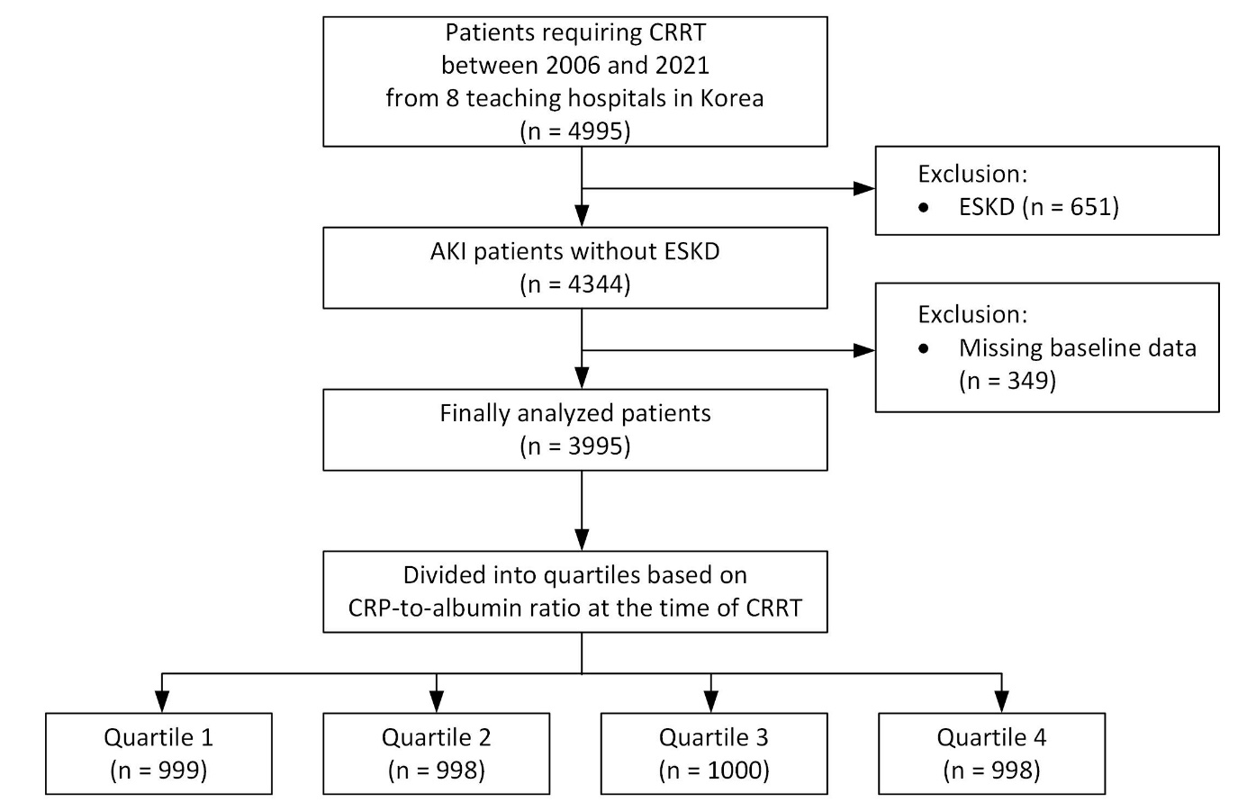
Abbreviations: CRRT, continuous renal replacement therapy; ESKD, end-stage kidney disease; AKI, acute kidney injury; CRP, C-reactive protein.
Supplementary Table S1. Cox regression analyses for 7- and 30-day mortality in the CAR quartile groups
 | Model 1 |  | Model 2 |  | Model 3 |  | Model 4
 | HR (95% CI) | P | aHR (95% CI) | P | aHR (95% CI) | P | aHR (95% CI) | P
7-day mortality
Quartile 1 | Reference |  | Reference |  | Reference |  | Reference
Quartile 2 | 0.98 (0.84–1.13) | 0.731 | 0.97 (0.84–1.12) | 0.690 | 0.96 (0.83–1.11) | 0.555 | 1.00 (0.85–1.18) | 0.983
Quartile 3 | 1.11 (0.96–1.28) | 0.148 | 1.10 (0.96–1.27) | 0.180 | 1.10 (0.96–1.27) | 0.168 | 1.07 (0.91–1.25) | 0.404
Quartile 4 | 1.41 (1.23–1.61) | <0.001 | 1.39 (1.22–1.59) | <0.001 | 1.36 (1.19–1.56) | <0.001 | 1.24 (1.07–1.44) | 0.005
30-day mortality
Quartile 1 | Reference |  | Reference |  | Reference |  | Reference
Quartile 2 | 1.07 (0.95–1.21) | 0.271 | 1.07 (0.95–1.20) | 0.300 | 1.06 (0.94–1.20) | 0.345 | 1.10 (0.96–1.25) | 0.182
Quartile 3 | 1.20 (1.07–1.35) | 0.003 | 1.19 (1.06–1.34) | 0.004 | 1.20 (1.07–1.35) | 0.002 | 1.16 (1.02–1.32) | 0.027
Quartile 4 | 1.46 (1.30–1.64) | <0.001 | 1.45 (1.29–1.62) | <0.001 | 1.43 (1.27–1.61) | <0.001 | 1.33 (1.17–1.51) | <0.001
Model 1: unadjusted.
Model 2: adjusted for age, and sex.
Model 3: adjusted for age, sex, hypertension, and CCI.
Model 4: adjusted for age, sex, hypertension, CCI, APACHE II score, and mechanical ventilator use.
Abbreviations: CAR, C-reactive protein-to-albumin ratio; HR, hazard ratio; aHR, adjusted hazard ratio; CI, confidence interval; CCI, Charlson Comorbidity Index; APACHE II, Acute Physiology and Chronic Health Evaluation II.

