Spiking Neural Networks for Predictive and Explainable Modelling of Multimodal Streaming Data with a Case Study on Financial Time-series and Online News

<< Supplementary Material >>

Nikola K. Kasabov* ^{1,2,3} , Iman AbouHassan* ^{3,4}, Vinayak Jagtap ⁵, Parag Kulkarni ⁶

- KEDRI, SECMS, Auckland University of Technology, New Zealand.
- Ulster University, the UK.
- Technical University of Sofia, Bulgaria.
- Central Bank of Lebanon, Lebanon.
- College of Engineering, Pune, India.
- Tokyo International University, Japan.

* Contact persons: Nikola Kasabov (nkasabov@aut.ac.nz), Iman AbouHassan (iabouhassan@tu-sofia.bg)

News | News Link | Class | TNI
- Production outages in Asia lend slight support to prices | http://feeds.reuters.com /~r/reuters/ INbusinessNews /~3/NREDmlBQ6wc/global-lng-idINKBN19L14Q | Indirect | 0.032
- UK consumers suffer the longest decline in spending power since the 1970 s | http://feeds.reuters.com/~r/reuters/ INbusinessNews /~3/Xsx0vFoiNeg/britain-economy-idINKBN19L144 | Indirect | -0.09558
- Market Now: Gammon Infra, GVK Power Infra surge over 10% | http://economictimes.indiatimes.com/ markets/ stocks/news/market-now-gammon-infra-gvk-power-infra-surge-over-10/articleshow/59384964.cms | Direct | -0.13671
- Global markets: Brightening economy sets euro up for strongest quarter since debt crisis | http://feeds.reuters.com /~r/reuters/ INbusinessNews/~3/jAAVKhzW9jo/global-markets-idINKBN19L13U | Indirect | -0.04412
Supplementary Table S1: Selected News Topics, Links, and TNI calculation.

Supplementary Fig. S1: Turning News Index (TNI).

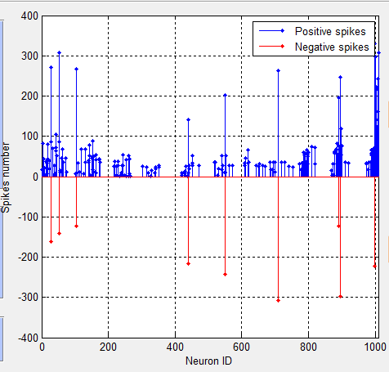
Supplementary Fig. S2: Positive and negative spike amounts emitted by each neuron.

 | WIT | MSFT | LEN | IBM | ADMP | GOOG | RIL | TCS | TNI
Mean | 4.92 | 62.61 | 47.94 | 140.30 | 3.94 | 868.06 | 608.81 | 1,106.42 | -0.17
Standard Error | 0.02 | 0.25 | 0.27 | 0.74 | 0.06 | 5.41 | 5.92 | 4.14 | 0.01
Median | 4.89 | 61.67 | 49.16 | 141.34 | 3.85 | 835.67 | 632.02 | 1,108.06 | -0.18
Standard Deviation | 0.21 | 2.86 | 3.03 | 8.45 | 0.63 | 61.47 | 67.22 | 47.03 | 0.10
Sample Variance | 0.04 | 8.17 | 9.19 | 71.38 | 0.40 | 3,778.66 | 4,518.00 | 2,211.37 | 0.01
Kurtosis | 0.26 | -1.04 | -0.89 | -1.54 | -0.51 | -1.31 | -1.15 | -0.53 | 1.06
Skewness | 0.37 | 0.42 | -0.76 | -0.06 | 0.47 | 0.56 | -0.61 | 0.14 | 0.60
Minimum | 4.47 | 58.41 | 41.41 | 127.80 | 3.00 | 786.14 | 491.87 | 996.04 | -0.39
Maximum | 5.42 | 68.80 | 52.12 | 153.14 | 5.75 | 983.68 | 696.49 | 1,238.68 | 0.19
Supplementary Table S2: Descriptive Statistics

Supplementary Fig. S3: Evolution of selected stock prices (Jan-Jun 2017, in USD).

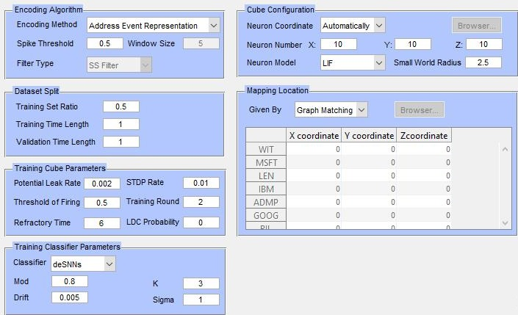
Supplementary Fig. S4: NeuCube Parameter Setting Panel

Supplementary Fig. S5 (a) shows the interactions of time-series variables when a NeuCube SNN predictive model is created to predict WIT stock without using online news. In the absence of news indicator, the analyzed feature [WIT] is heavily influencing/influenced by [TSC] and [LEN], but less so by [MSFT] and [RIL]. It does, however, show a high correlation with other indices. The impact of the time-series variables on the whole model is visualized in Supplementary Fig. S5 (b). The proportion of neurons in the NeuCube that are part of an input neuron cluster ranges from 3% for the [GOOG] index to 21% for the [RIL] index. The examined feature [WIT] accounts for 8% of the total. This type of analysis allows to compare directly the temporal association between the input variables in a SNN model that is using news versus a SNN model that does not use news.

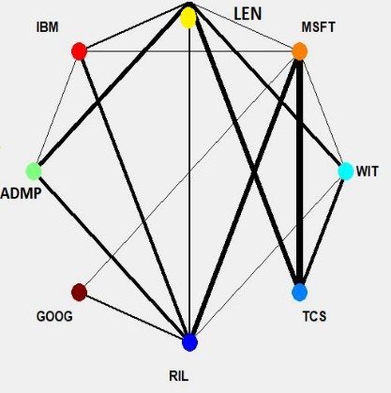  (a) | 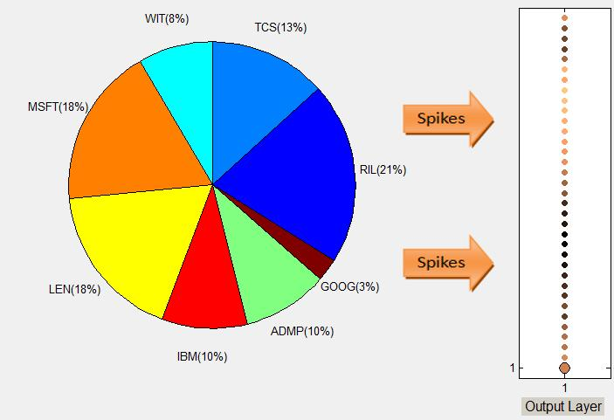  (b)
Supplementary Fig. S5 (a) The variable interaction network of a SNN predictive model to predict WIT stock without using online news; (b) The proportion of spiking neurons connected (influenced) by the corresponding input time-series variables.

Model/Method | News indicator | Training/Test mode | RMSE
NeuCube/deSNN | No | 50/50 | 0.08
NeuCube/deSNN | Yes | 50/50 | 0.06
NeuCube/deSNN | Yes | 3-K fold | 0.05
NeuCom/EFuNN | Yes | 50/50 | 0.43
NeuCom/EFuNN | Yes | 80/20 | 0.24
NeuCom/DENFIS | Yes | 50/50 | 0.53
NeuCom/DENFIS | Yes | 80/20 | 0.17
Supplementary Table S3: Comparative results of Wipro Limited [WIT] stock prediction price when using the proposed NeuCube SNN method [23] versus the use of traditional vector-based evolving connectionist systems EFuNN and DENFIS from the NeuCom environment [19,24].

Wipro Limited [WIT] | Open | High | Low | Close | Adj.Close | TNI
Mean | 4.98 | 5.02 | 4.94 | 4.98 | 4.92 | -0.17
Standard Error | 0.02 | 0.02 | 0.02 | 0.02 | 0.02 | 0.01
Median | 4.95 | 4.99 | 4.89 | 4.95 | 4.89 | -0.18
Standard Deviation | 0.21 | 0.21 | 0.20 | 0.21 | 0.21 | 0.10
Sample Variance | 0.04 | 0.04 | 0.04 | 0.04 | 0.04 | 0.01
Kurtosis | 0.50 | 0.35 | 0.32 | 0.32 | 0.26 | 0.96
Skewness | 0.48 | 0.38 | 0.40 | 0.37 | 0.37 | 0.59
Minimum | 4.53 | 4.58 | 4.50 | 4.53 | 4.47 | -0.39
Maximum | 5.55 | 5.55 | 5.45 | 5.48 | 5.42 | 0.19
Supplementary Table S4: Descriptive Statistics of the WIT stock

Supplementary Fig. S6: Behavior of WIT stock features.

