Author biography
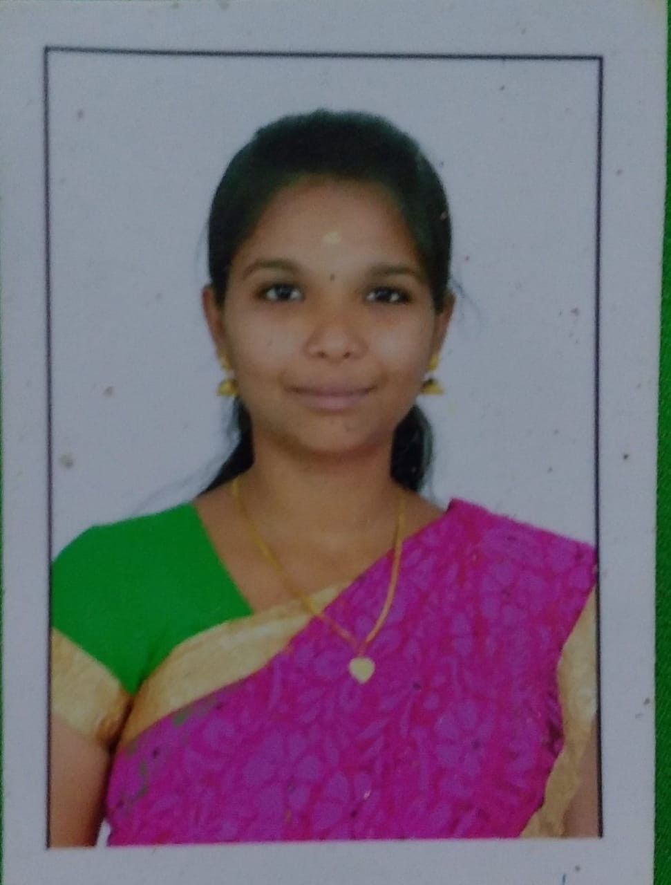
Kavitha A Kavitha A, She completed her Under graduate in Information Technology and her Post graduate in Computer science engineering under Anna University Chennai; now she is doing her research in the area of Image processing. She is having wide area of experience around 9 years in teaching. Her areas of Interest includes Image processing, Digital Signal processing and Java Programming. She delivered lecture in her research area as well as she is a JAVA trainer in ILP (Initial Learning Program)for TCS placed students.
Worked in NAAC and NBA committee and also in IMC Ramkrishna Bajaj National Quality Award in Institute level.

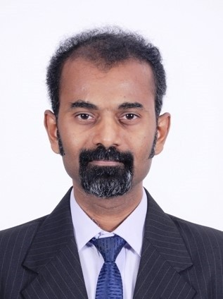
Daniel Madan Raja S Dr. S. Daniel Madan Raja is currently working as an Associate Professor in the Department of Information Technology at Ban- nari Amman Institue of Technology, Sathyamangalam, India. He received his B.E in ECE and M.E. in CSE from Madras University and Ph.D. in Information and Communication Engineering from Anna University, Chen- nai. His areas of interest include Pattern Recognition, Scene classification,
Image processing, Artificial intelligence, and Networks. He has published 40 papers in National and International journals and Conferences. He has also presented his research papers in International forums in China and Singapore.

