Spatial Modeling of Groundwater Level in Bangladesh Using
Physio-Climatic Variables: Machine Learning and Statistical Approaches
A S M Maksud Kamal^{1*}, Abul Kashem Faruki Fahim¹ and Shamsuddin Shahid²
¹Department of Disaster Science and Climate Resilience, University of Dhaka, Dhaka-1000, Bangladesh (email: maksudkamal@du.ac.bd; fahim-4-2015117896@dsm.du.ac.bd)
²Department of Water & Environmental Engineering, School of Civil Engineering, Faculty of Engineering, Universiti Teknologi Malaysia, Johor Bahru 81310, Malaysia (email: sshahid@utm.my)
*Corresponding author. Email: maksudkamal@du.ac.bd

Figure S1. Flow of ANN model

Figure S2. Scatter plot showing the relationship between GWS (m) and GWL (m).

GWL
GWL
Figure S3. Observed and predicted GWL using the ANN model for all the grids
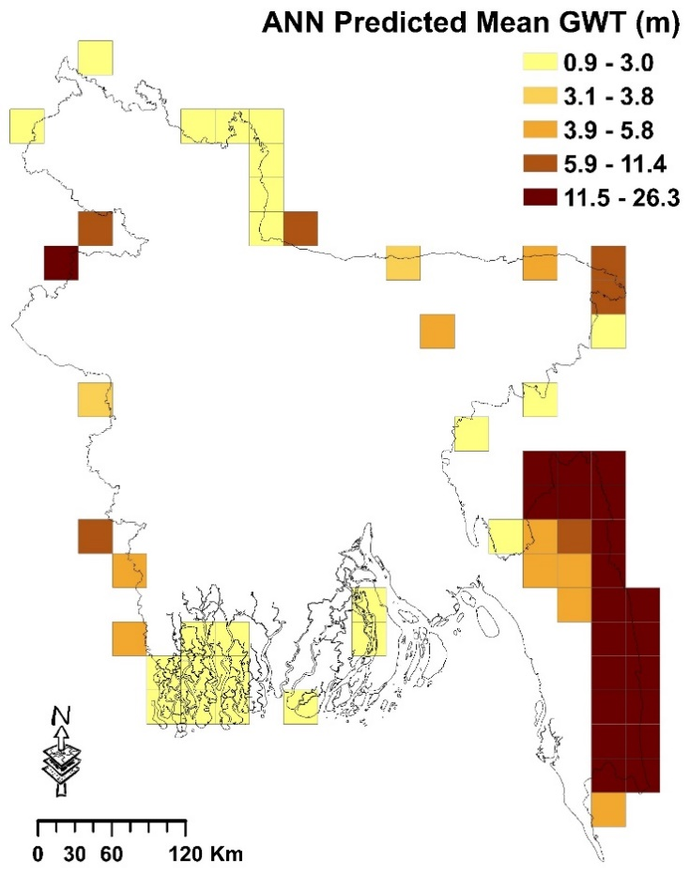
.
GWL
Figure S4. ANN model-predicted mean in the areas where no BWDB GWL observation wells are available.

