Table 5. Mutagenicity transformation rules for the substitution of structural alerts
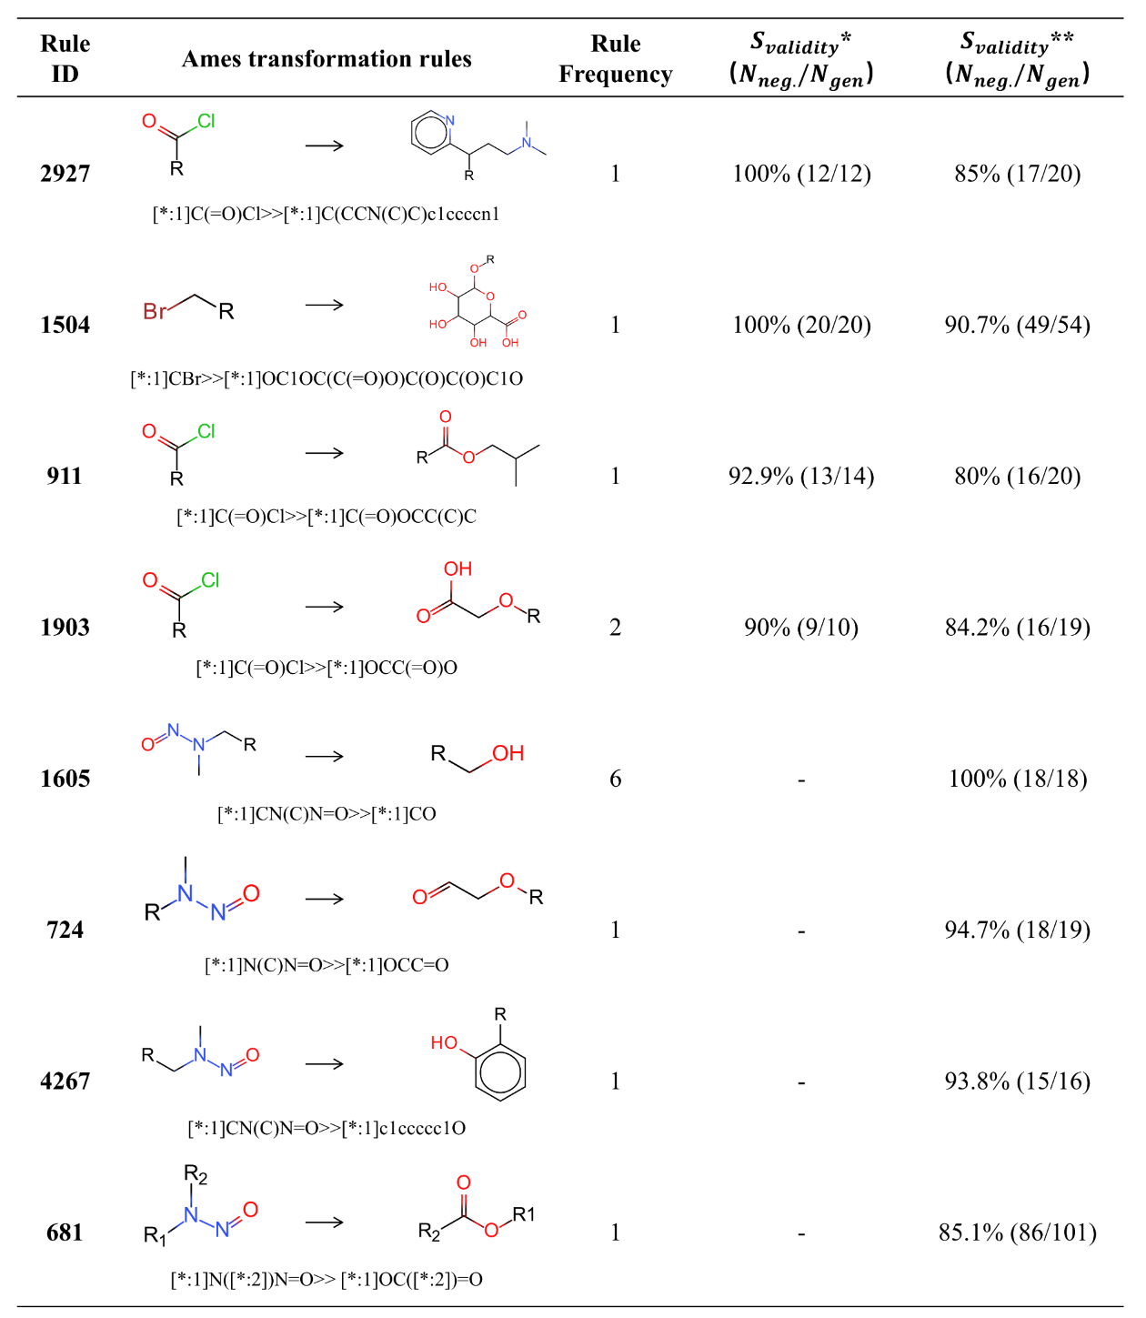S_{validity}* was calculated through the transformation of Ames positives from the DGM/NIHS data set. S_{validity}** was calculated through the transformation of Ames positives from the Hansen/ISSSTY data set.

