Table 1: Characteristics of the patients studied for model training and test using ERG spectral components from three different recording devices.
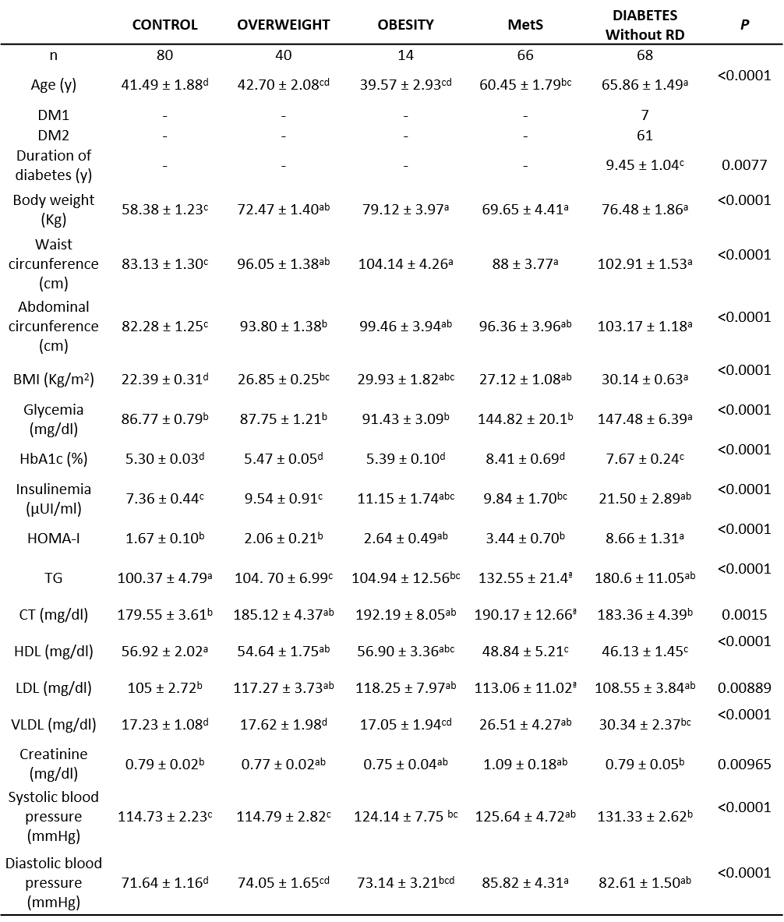
Values, mean ± s.d. P values were determined by the Welch ANOVA test. Values that do not share a letter (a, b, or c) are statistically different. Years, y.

Table 2: Characteristics of the patients studied for external model validation.
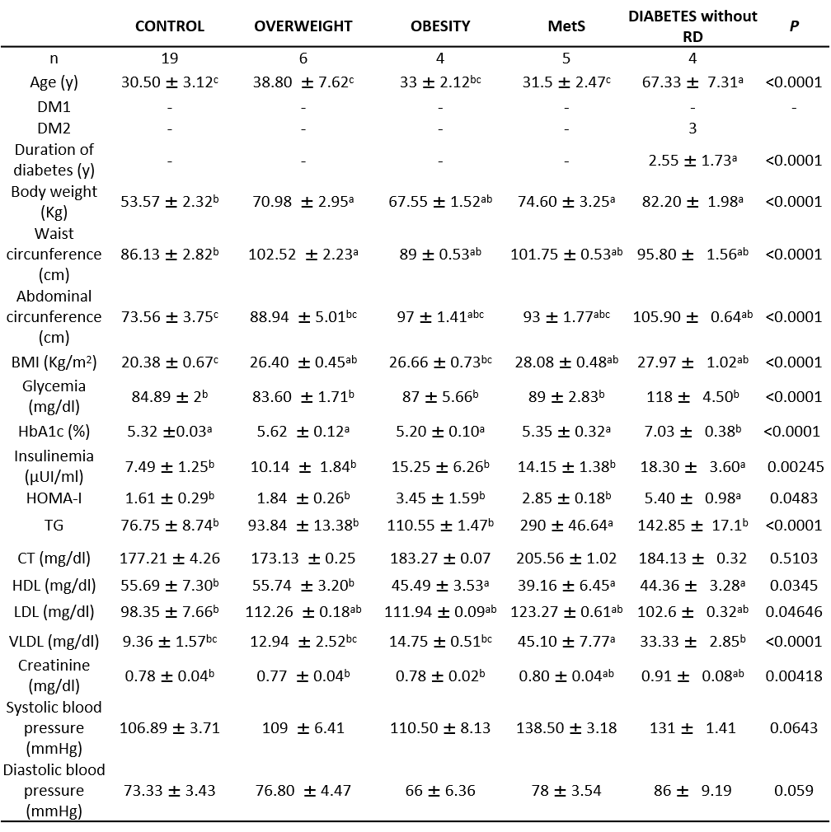
Values, mean ± s.d. P values were determined by the Welch ANOVA test. Values that do not share a letter (a, b, or c) are statistically different. Years, y.

Table 3: Characteristics of the patients studied for external model validation using ERG spectral components from one recording device.

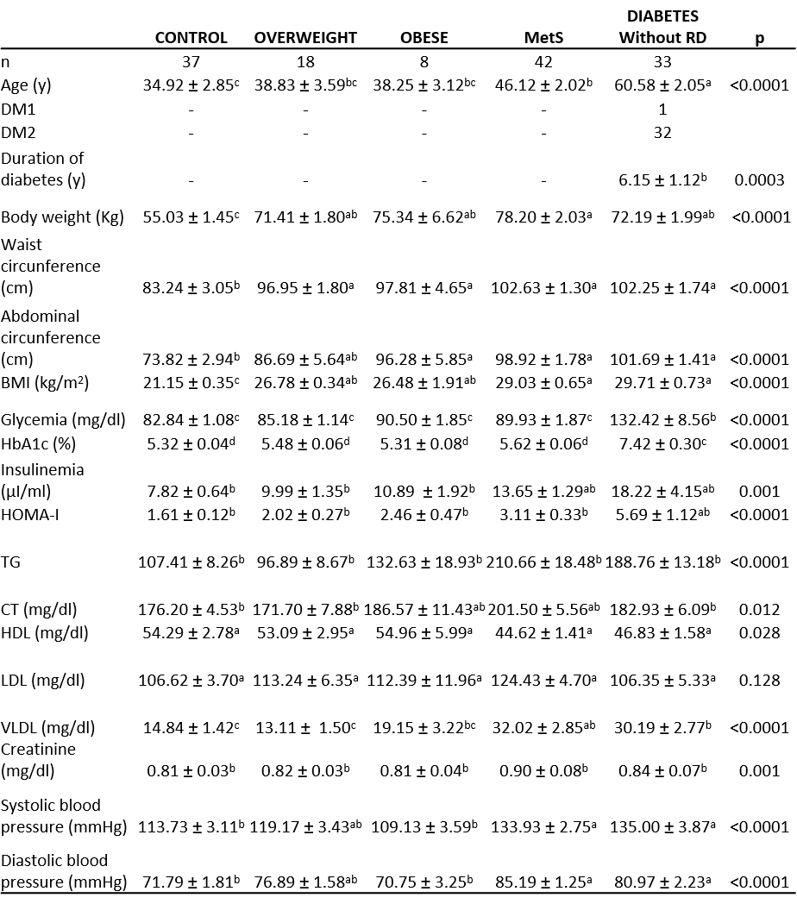
Values, mean ± s.d. P values were determined by the Welch ANOVA test. Values that do not share a letter (a, b, or c) are statistically different. Years, y.

