Supplementary Information for:
Genetic relationships among laboratory lines of the egg parasitoid Trissolcus japonicus (Ashmead) from native and adventive populations

Table S1 Details of 19 Trissolcus japonicus laboratory lines.
ID code | Line type | Country | Province | Locality | Latitude | Longitude | Collection date | Pentatomid host | Plant host | Collector
SWI-1 | iso-line | Switzerland | Basel-Stadt | Basel | 47.552704 | 7.601758 | 2019-06-18 | Halyomorpha halys | Catalpa bignoides | T. Haye
SWI-2 | iso-line | Switzerland | Zurich | Zurich | 47.355866 | 8.550646 | 2019-06-28 | H. halys | C. bignoides | T. Haye
SWI-3 | iso-line | Switzerland | Ticino | Manno | 46.031216 | 8.922518 | 2019-06-01 | H. halys | Acer palmatum | T. Haye
BEI-1 | iso-line | China | Beijing | Lengquan Village | 40.018094 | 116.219792 | 2019-07-22 | H. halys | Morus sp. | T. Haye
BEI-2 | iso-line | China | Beijing | Baiwang Mountain | 40.032932 | 116.257793 | 2019-07-24 | H. halys | Robinia pseudoacacia | T. Haye
BEI-3 | iso-line | China | Beijing | Beijing Bot. Gardens | 39.999196 | 116.202318 | 2019-07-25 | H. halys | R. pseudoacacia | T. Haye
HEB-1 | iso-line | China | Hebei | Langfang | 39.509678 | 116.597256 | 2019-07-23 | H. halys | R. pseudoacacia | T. Haye
HEB-2 | iso-line | China | Hebei | Langfang | 39.509678 | 116.597256 | 2019-07-23 | H. halys | R. pseudoacacia | T. Haye
HEB-3 | iso-line | China | Hebei | Langfang | 39.509678 | 116.597256 | 2019-07-23 | H. halys | R. pseudoacacia | T. Haye
HEIL-1 | iso-line | China | Heilongjiang | Harbin | 45.724229 | 126.641464 | 2019-07-03 | H. halys | unknown | J. Zhang
CHIL | iso-line | Canada | British Columbia | Chilliwack | 49.1582 | -122.0041 | 2018-08-26 | H. halys | Acer sp. | P. Abram
WAL | iso-line | USA | Washington | Walla Walla | 46.0673 | -118.3195 | 2017-08-13 | H. halys | unknown | J. Milnes
VAN | iso-line | USA | Washington | Vancouver | 45.6106 | -122.6026 | 2016-06-18 | H. halys | unknown | J. Milnes
LON (BEI-USDA) | mixed | China | Beijing | Beijing Bot. Gardens | 39.994264 | 116.216662 | 2009-08-27 | H. halys | unknown | K. Hoelmer
AGA | iso-line | Canada | British Columbia | Agassiz (Exp. Farm) | 49.2446 | -121.7601 | 2021-08-19 | H. halys | Fabaceae/  Helianthus sp. | J. Thiessen
LAN | iso-line | Canada | British Columbia | Langley | 49.1756 | -122.6236 | 2021-07-27 | H. halys | Juglans sp. | T. Hueppelsheuser
KEL | iso-line | Canada | British Columbia | Kelowna (Leon Ave) | 49.885 | -119.4847 | 2021-07-29 | H. halys | Acer sp. | S. Acheampong
ON1/2 | mixed | Canada | Ontario | London | 42.998389 | -81.227444 | 2019-08-21 | H. halys | Ailanthus altissima | T. Gariepy
ON strainB2021 | mixed | Canada | Ontario | London | 42.997806 | -81.313472 | 2020-06-28 | Banasa dimidiata | unknown | C. MacDonald

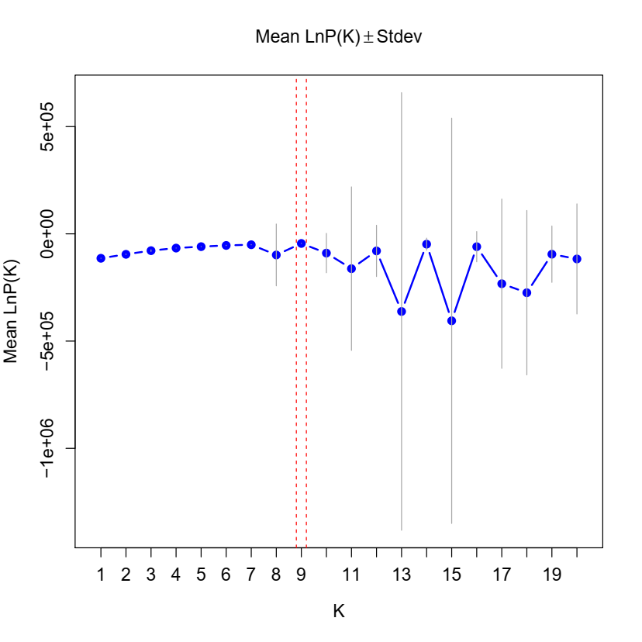
Fig. S1 LnP(K) support for K=1–20 in the ‘full structure dataset’ comprising 70 Trissolcus japonicus pools from 18 laboratory lines.

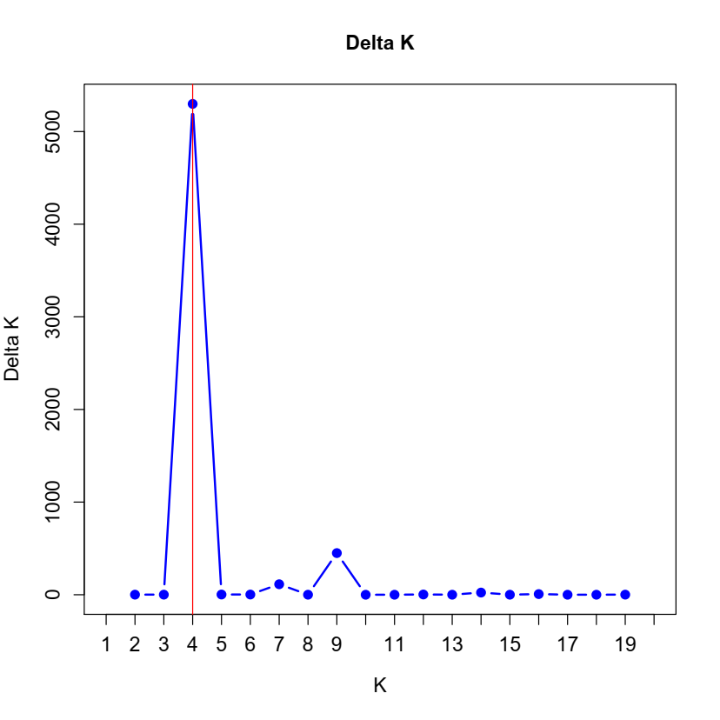
Fig. S2 ΔK support for K=2–19 in the ‘full structure dataset’ comprising 70 Trissolcus japonicus pools from 18 laboratory lines.

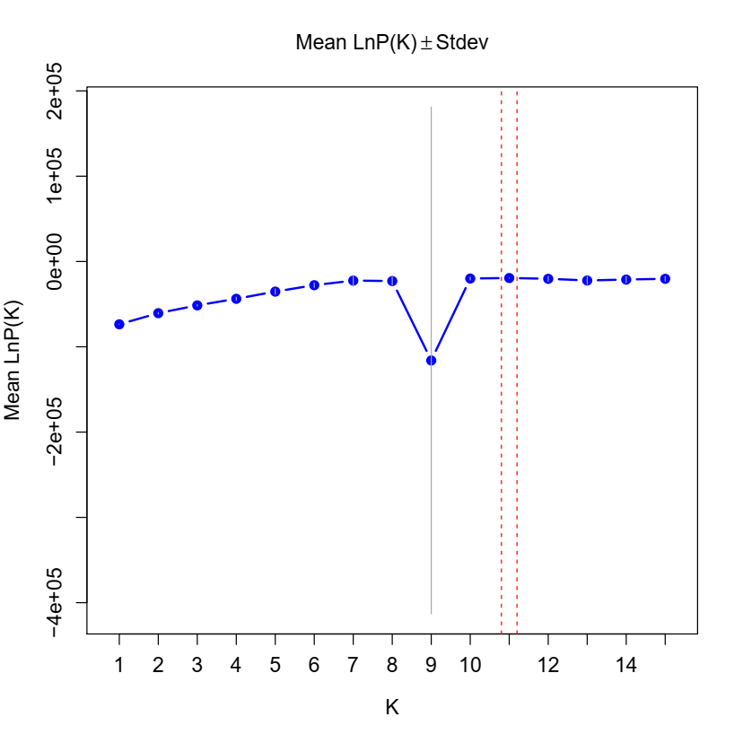
Fig. S3 LnP(K) support for K=1–15 in the ‘geographic structure dataset’ comprising 28 Trissolcus japonicus pools from 7 laboratory lines.

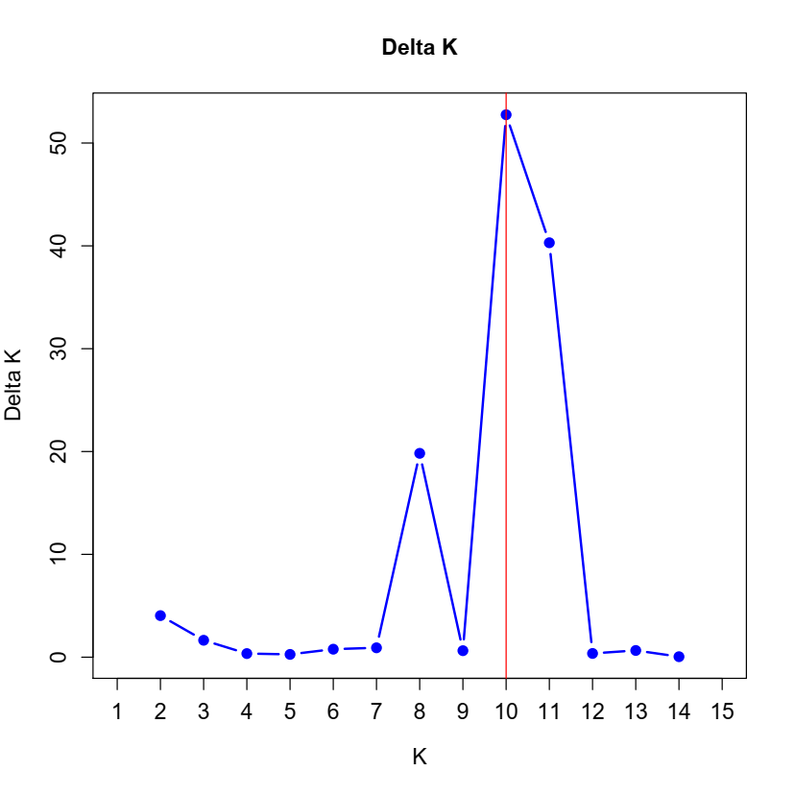
Fig. S4 ΔK support for K=2–14 in the ‘geographic structure dataset’ comprising 28 Trissolcus japonicus pools from 7 laboratory lines.

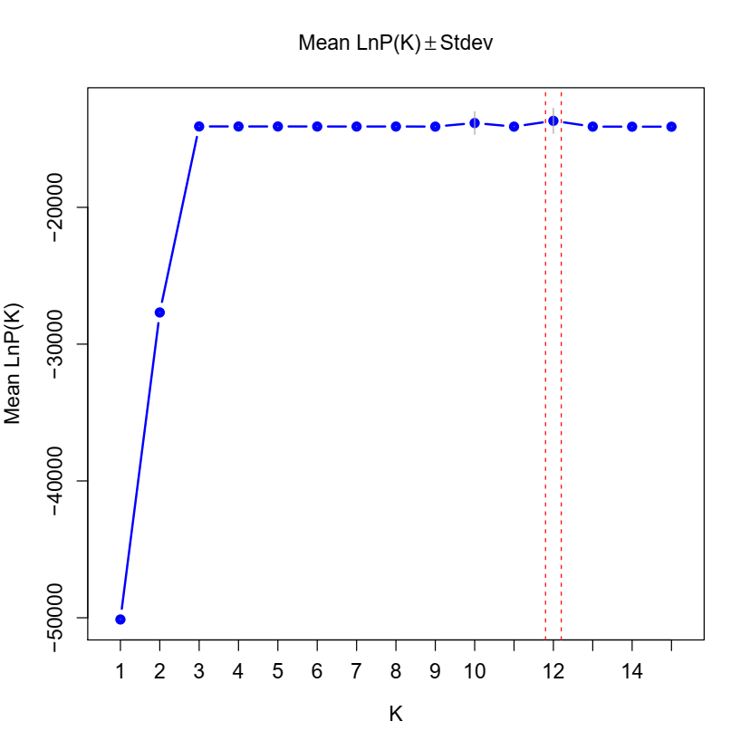

Fig. S5 LnP(K) support for K=1–15 in the ‘Pacific Northwest structure dataset’ comprising 23 Trissolcus japonicus pools from 6 laboratory lines.

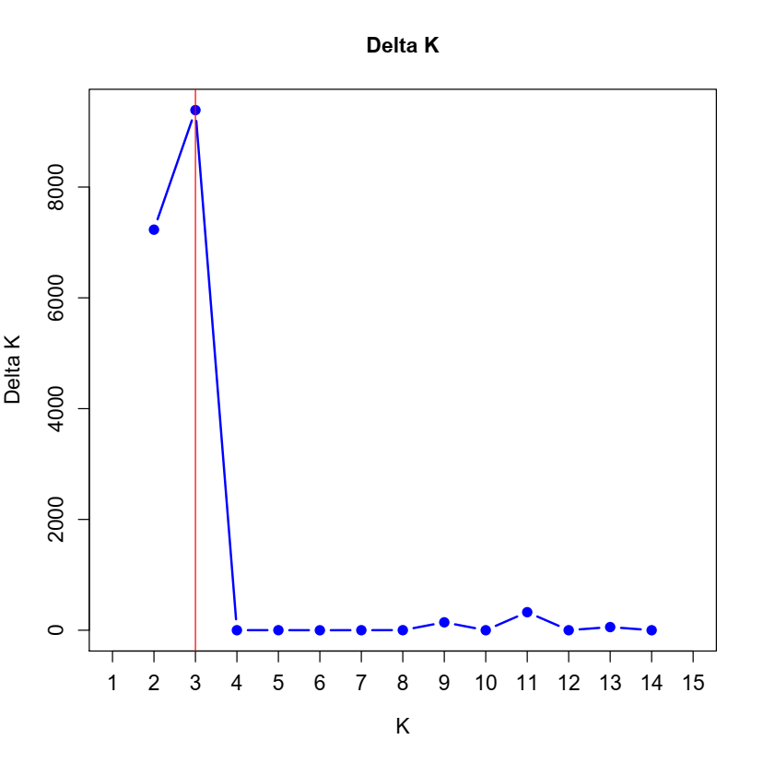
Fig. S6 ΔK support for K=2–14 in the ‘Pacific Northwest structure dataset’ comprising 23 Trissolcus japonicus pools from 6 laboratory lines.

