Competing oxygen evolution reaction mechanisms revealed by high-speed compressive Raman imaging

^{1,2}Raj Pandya✉, ^{3,4}Florian Dorchies#, ^{5,6}Davide Romanin#, ¹Sylvain Gigan, ⁵Alex W. Chin, ¹Hilton B. de Aguiar✉ and ^{3,4,7}Alexis Grimaud✉

¹Laboratoire Kastler Brossel, ENS-Université PSL, CNRS, Sorbonne Université, Collège de France, 24 rue Lhomond, 75005 Paris, France
²Department of Physics, Cavendish Laboratory, University of Cambridge, JJ Thomson Avenue, Cambridge CB3 0HE, United Kingdom
³Chimie du Solide et de l’Energie, UMR 8260, Collège de France, Paris, France
⁴Réseau sur le stockage Electrochimique de l’Energie (RS2E), Amiens, France
⁵Sorbonne Université, CNRS, Institut des Nanosciences de Paris, UMR7588, F-75252, Paris, France
⁶Université Paris-Saclay, CNRS, Centre de Nanosciences et de Nanotechnologies, 91120, Palaiseau, France
⁷Department of Chemistry, Boston College, Merkert Chemistry Center, 2609 Beacon St., Chestnut Hill, MA, 02467 USA

✉Correspondence to: rp558@cam.ac.uk, h.aguiar@lkb.ens.fr, grimauda@bc.edu
#These authors contributed equally

Supporting Information

Supplementary Note 1: Compressive Raman methodology 3
Supplementary Note 2: Substrate effect and degradation 8
Supplementary Note 3: Raman spectra over multiple cycles 10
10
Supplementary Note 4: Density Functional Theory Calculations 12
Supplementary Note 5: Operando Raman imaging using LiOH electrolyte and α-Li₂IrO₃ particles and KOH electrolyte and IrO₂. 15
Supplementary Note 6: Operando Raman imaging with KOH electrolyte of α-Li₂IrO₃ at 550 cm⁻¹ 24
Supplementary Note 7: Repeat measurements and additional cycling images 26
Supplementary Note 8: Estimation of cation (de)intercalation velocities 27
Supplementary Note 9: Calculation of turn-over-frequency 31
Supplementary Note 10: Additional details on experimental setup 33
Supplementary Note 11: Cost comparison between single pixel Raman spectrometers, EMCCD based Raman spectrometers and bright-field microscopes 35
References 36

Supplementary Note 1: Compressive Raman methodology

The methodology of compressive Raman microspectroscopy has been detailed fully previously^{1–4}. Here, we demonstrate the validity of our implementation and provide details of spectral filters used, in particular demonstrating no leakage between species channels. We consider the spectrum of our system as consisting of 4 species with different spectra (despite the fact that only 3 chemical species are present): S₁ = 550 cm⁻¹ mode of Li₂IrO₃; S₂ = 640 cm⁻¹ mode of Li₂IrO₃; S₃ = Nafion and S₄ = Background. We can write the library spectra as a matrix, S. The filters for each of the species S₁ to S₃ will cover each of the Raman bands of the given species, whilst S₄ covers the remainder of the spectrum. We denote the matrix of spectral filters F as depicted in Supplementary Figure 1. We define a matrix G = $S^{T} F$. Within the compressive Raman imaging framework it is key to ensure that these filters, which correspond to patterns on the digital micromirror device (DMD), allow efficient estimation of each of the species. The species proportion $\hat{z}$ is estimated as [G^{T}G]⁻¹G^{T}n, where the T denotes the transpose and n represents the measurements. In the main manuscript, we plot images based on n. Given that G is close to diagonal, there is little to no species leakage between the measurements n. This is better seen in Supplementary Figure 2 where we demonstrate this to be the case, validating our approach. Therefore, the figures in the main manuscript are measurements of the species themselves.
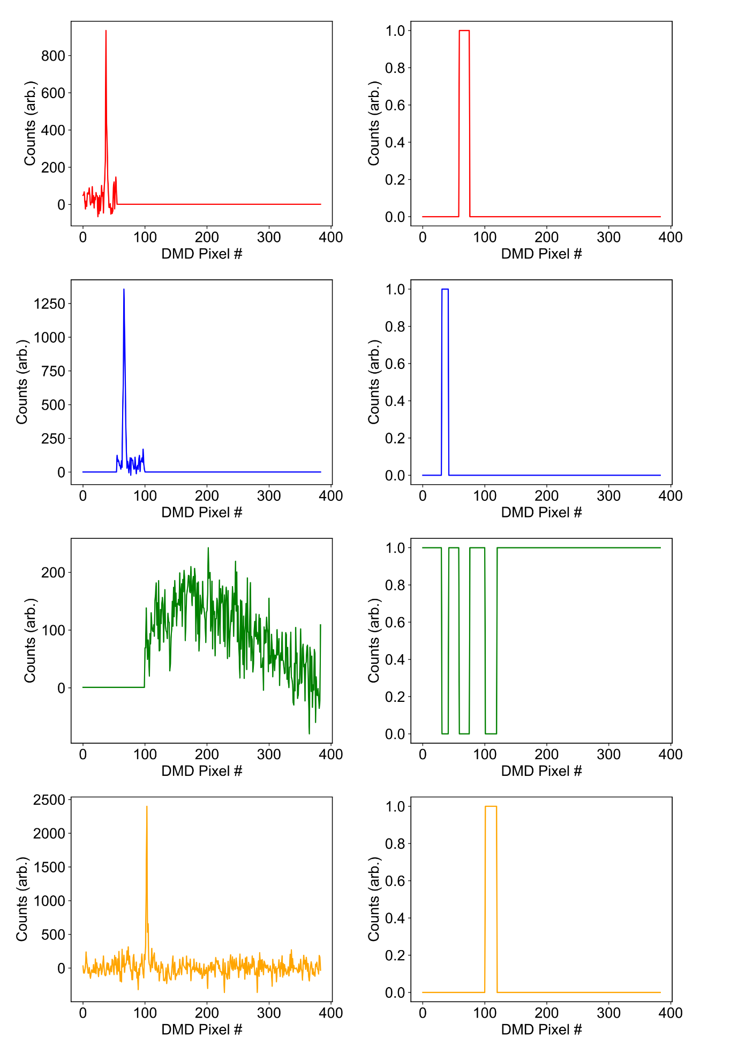

Supplementary Figure 1: Spectra of four species present in spectra of system with associated filters. We note that we consider the two peaks of α-Li₂IrO₃ and background as three separate species as they each have a different response. We hence also segment the spectra for each component around its band, padding the remainder of the spectrum with zeros.

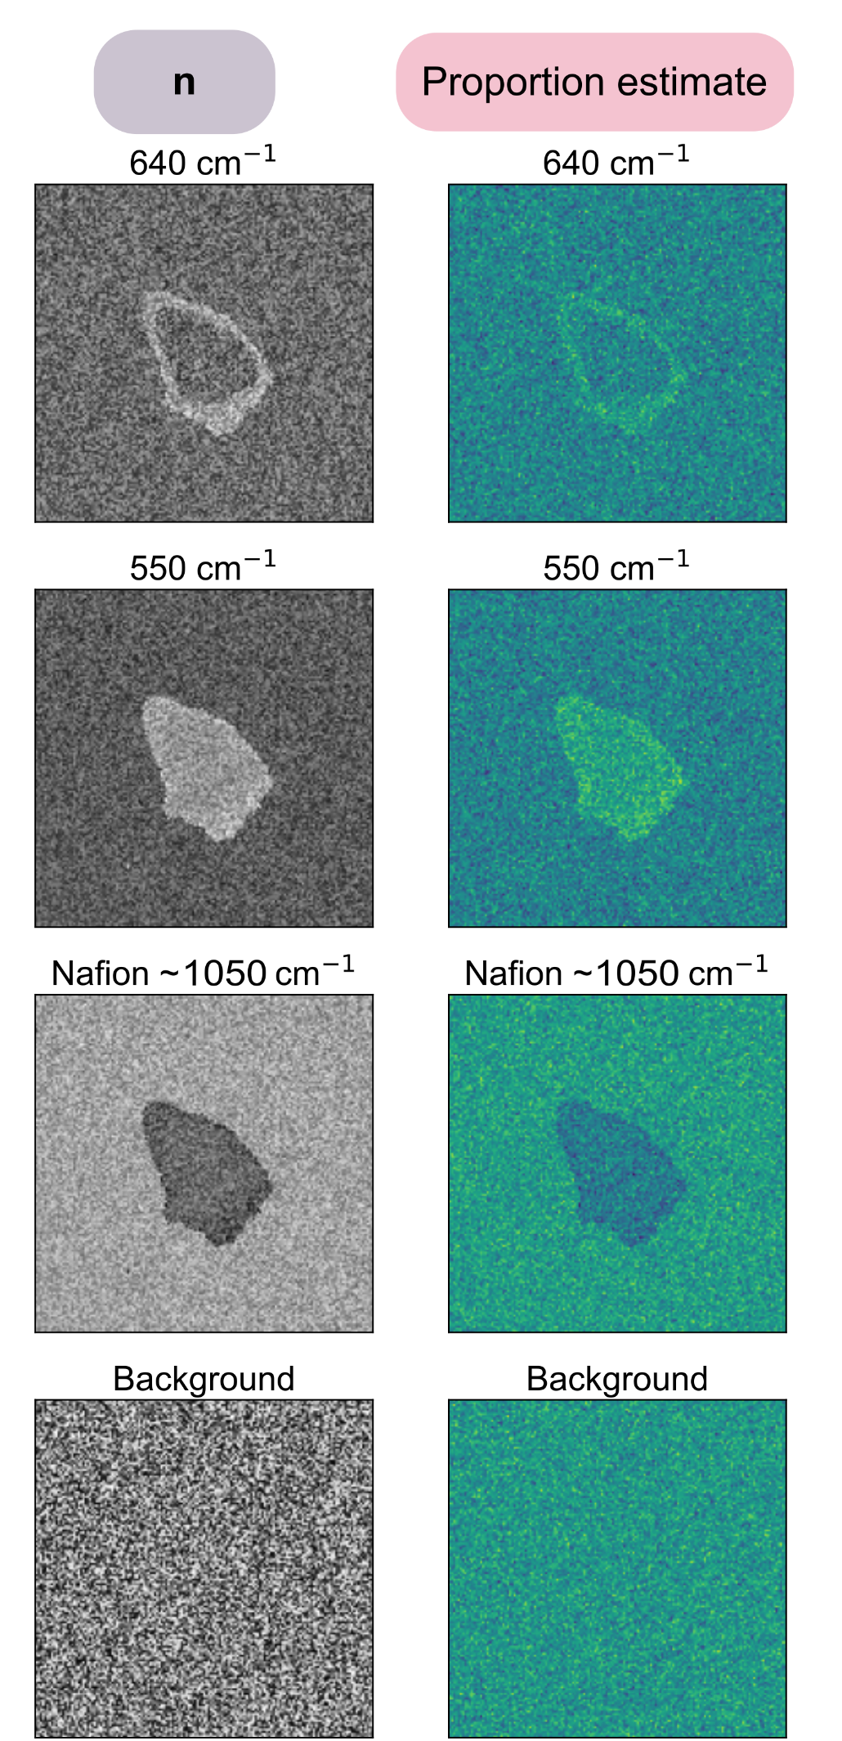

Supplementary Figure 2: Images of system at given timepoints during cycling (left) and associated images obtained from proportion estimation (right). Images appear identical based on visual inspection indicating no leakage between channels.

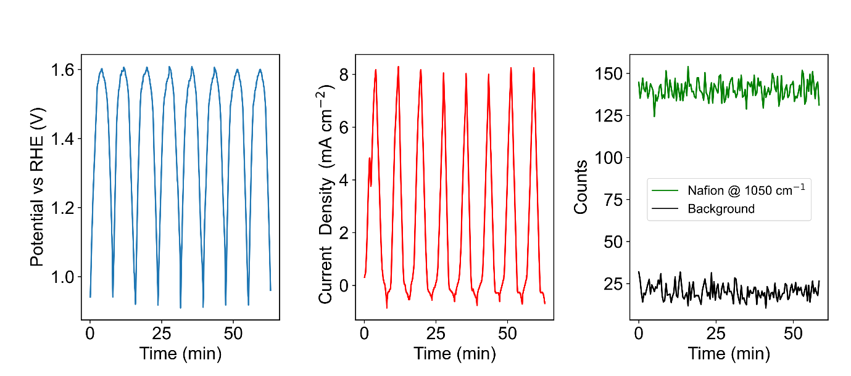

Supplementary Figure 3: Intensity of Nafion spectral band centred around ~1050 cm⁻¹ and background. The intensity of both remains constant throughout cycling of the catalyst.

Supplementary Note 2: Substrate effect and degradation

ITO is known to degrade in high (low) pHs at negative (positive) potentials⁵. Under the high pH, positive potential and sub-1 hr exposure times used, we find a change of only 5 to 10% in the substrate transmission over the 60 to 80 mins over which experiments are performed. Nonetheless to ensure that such effects do not influence our results, measurements requiring cycling over 40 mins e.g. multiple slow cycles, were also performed on coverslides (0.13 – 0.15 mm thickness) coated in Ti (10 nm).
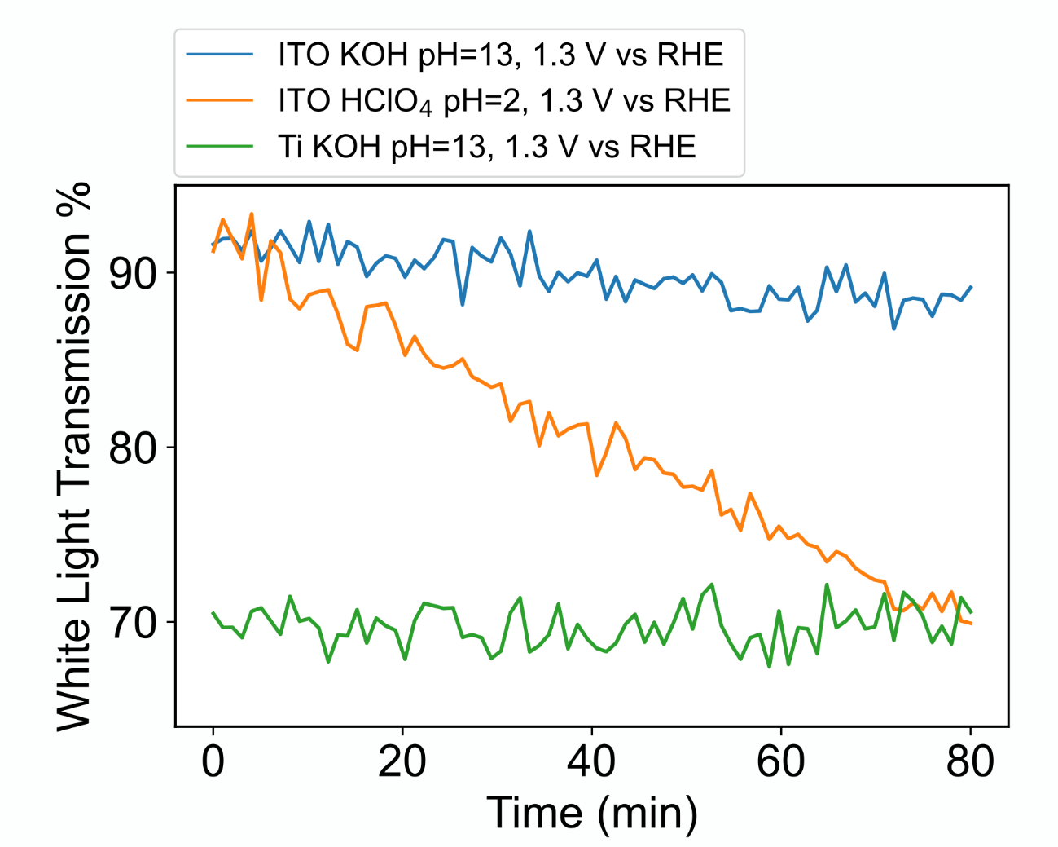

Supplementary Figure 5: Transmission of ITO or Ti coated glass slide under different conditions demonstrating stability under basic conditions at positive potentials but not acidic ones. Potential is ramped to 1.3 V vs RHE before measuring transmission through well of given aqueous electrolyte (2 mm diameter).

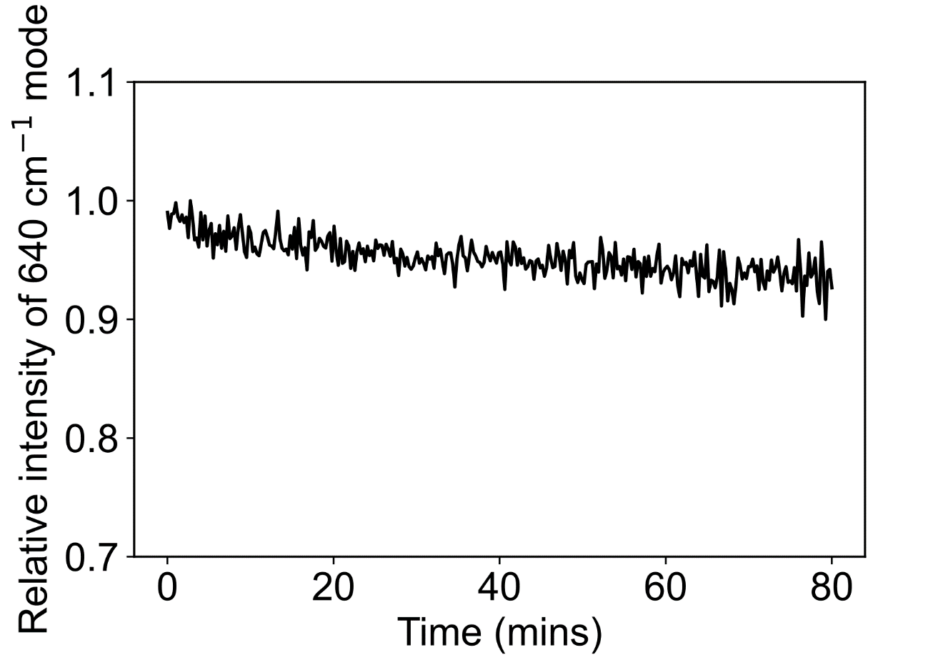

Supplementary Figure 6: Raman mode intensity of ~640 cm⁻¹ mode of α-Li₂IrO₃over 80 mins. Spectra are measured every 25 seconds from a single particle which is continuously illuminated with the 532 nm ~100 mW power before objective. The intensity of the signal decays around ~5% over this period far below that observed in cycling experiments.

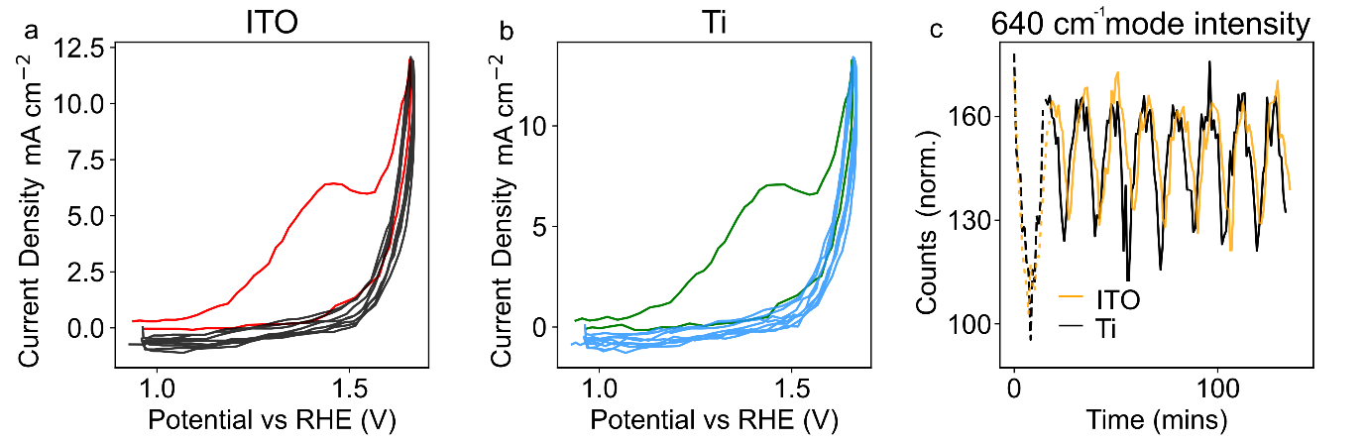

Supplementary Figure 7: a-b. Cyclic voltamogramms of α-Li₂IrO₃ deposited on ITO or Ti coated coverslides. A near identical electrochemical response is observed between the two. c. Intensity of 640 cm⁻¹ Raman mode when cycling α-Li₂IrO₃ on Ti and ITO coverslides. The counts are normalised arbitrarily but on both sample slides a similar response is observed.

Supplementary Note 3: Raman spectra over multiple cycles

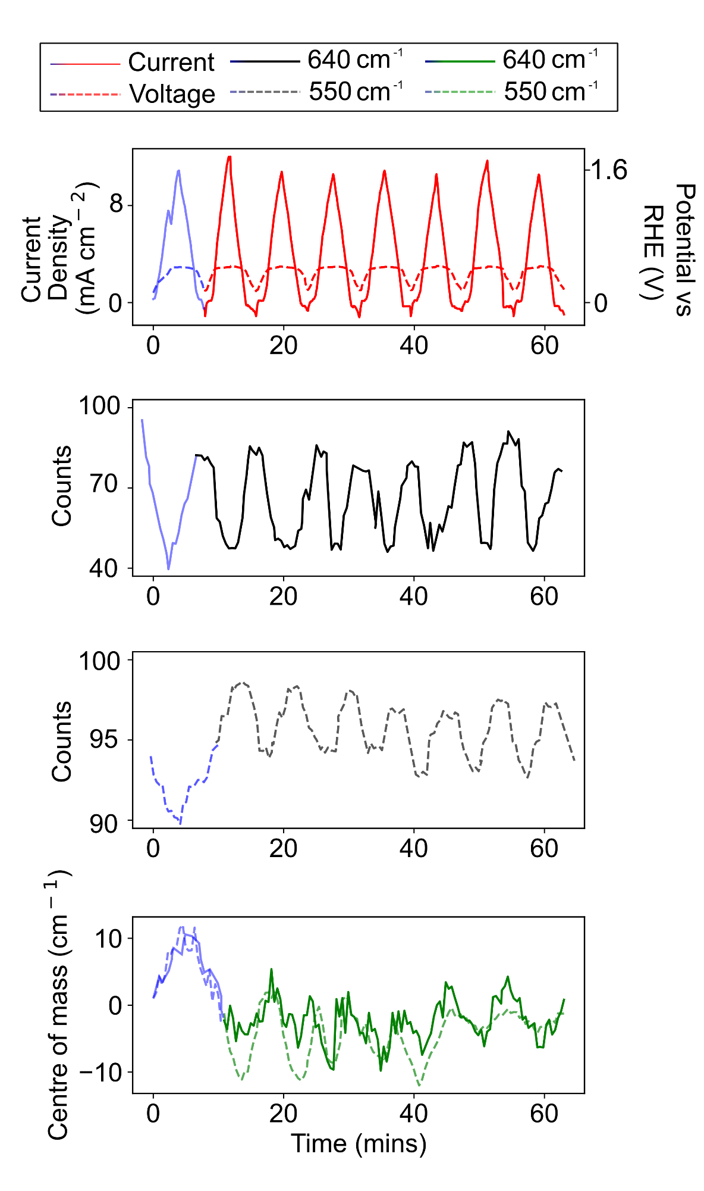

Supplementary Figure 8: Current-voltage profile and associated intensity of modes and centre-of-mass over 8 cycles of α-Li₂IrO₃. First cycle (activation) is highlighted in blue.

The broad spectral window of collection we use (300 – 2200 cm⁻¹) for single shot Raman measurements results in the sacrifice of spectral resolution to ~12 cm⁻¹. Hence, rather than report absolute peak positions we report the peak centre-of-mass. The weighted estimate $x_{CoM}= \frac{\sum{x_{i}I_{i}}}{\sum{I_{i}}}$ where x_{i} and I_{i} are the position and intensities of the i^{th} data point, hence provide a more accurate value for the peak position in our case.

Supplementary Note 4: Density Functional Theory Calculations

Density functional theory (DFT) are performed with localized Gaussian basis functions and the PBE0 hybrid functional as implemented in the CRYSTAL17 code^{6,7}. The choice of the PBE0 functional for modelling exchange and correlation is done in order to reproduce Raman active measured frequencies. For Iridium (Ir) ⁸, Hydrogen (H), Lithium (Li) and Potassium (K) ⁹ we employed a triple-ζ split-valence plus polarization basis set, while we used a double-ζ split-valence basis set for oxygen (O) atoms⁸. Real space integration tolerances of 7-7-7-15-30 for α-Li_{0.5}IrO₃, 8-8-8-16-32 for α-Li₂IrO₃ and 10-10-10-20-40 for the K⁺ intercalated system were used. Calculations were made for the K⁺ intercalated phase with a stoichiometry of α-Li₁K_{0.25}IrO₃.0.5H₂O, close to the one that was experimentally found of α-Li₁K_{0.3}IrO₃.0.7H₂O in our previous work¹⁰. Calculations for the delithiated phase were performed with the α-Li_{0.5}IrO₃ stoichiometry, which is the end product obtained after full delithiation of the phase when oxidized in a Lithium-ion battery (the fully delithiated α-Li₀IrO₃ phase cannot be experimentally obtained). This way, changes in the Raman vibrations upon delithiation can be discussed by comparing the fully lithiated phase with the phase with the highest delithiation state. Experimentally, α-Li_{0.5}IrO₃ was not observed upon OER as the partially delithiated phase α-Li₁IrO₃ is found to react prior to the full delithiation. Nevertheless, the exact amount of lithium remaining in the phase is hard to experimentally assess and the final composition is, very likely, very close to α-Li_{0.5}IrO₃ when holding the potential at high potential for a prolonged period of time.

We set the energy tolerance for the self-consistent cycle to 10⁻¹⁰ Ha. The Brillouin zone has been sampled with a grid of 8$×$8$×$8 k-points for α-Li_{0.5}IrO₃ and the potassium intercalated system and 10$×$10$×$10 k-points for α-Li₂IrO₃, with a Fermi-Dirac smearing of 0.0008 Ha in all cases. We have only considered a paramagnetic groundstate since experimental measurements are performed at a sufficiently high temperature that a magnetic order cannot be stabilized. We fixed the lattice parameters to the experimental values and relaxed the internal coordinates.

Since Ir can lead to spin-orbit interaction (SOC), we checked its relevance on the Raman active frequencies in α-Li_{0.5}IrO₃ and α-Li₂IrO₃ at the PBE level via plane-waves and Quantum ESPRESSO^{11,12}. This also allowed us to check the quality of the Gaussian basis sets we have chosen. For this scope we have employed a ultrasoft pseudopotential^{13,14} for Li and Ir and a projector augmented-wave (PAW) pseudopotential^{13,14} for O, with 75 Ry and 600 Ry cut-off for the energy and density respectively. The energy convergence for the self-consistent cycle is set to 10⁻¹⁰ Ry. The irreducible Brillouin zone has been sampled with 150 k-points and a Methfessel-Paxton smearing of 0.008 Ry (0.004 Ry when considering spin-orbit coupling) in the case of α-Li_{0.5}IrO₃. On the other hand, the irreducible Brillouin zone has been sampled with 282 k-points and a Methfessel-Paxton smearing of 0.0008 Ry (with and without SOC) in the case of α-Li₂IrO₃.

QE – no SOC [cm⁻¹] | QE – SOC [cm⁻¹] | CRY – no SOC [cm⁻¹]
170.0 | 157.0 | 160.8
180.6 | 188.7 | 176.7
183.4 | 192.2 | 179.8
285.2 | 283.1 | 277.1
343.1 | 341.7 | 330.5
533.3 | 524.1 | 536.1
541.8 | 526.5 | 549.5
544.9 | 558.1 | 552.4
566.9 | 559.5 | 565.9
584.5 | 588.8 | 573.4
Supplementary Table 1: Comparison of the Raman active frequencies at the PBE level with and without spin-orbit coupling (SOC) as obtained via Quantum ESPRESSO (QE) and via CRYSTAL17 (CRY) for α-Li_{0.5}IrO₃.

QE – no SOC [cm⁻¹] | QE – SOC [cm⁻¹] | CRY – no SOC [cm⁻¹]
-130.9 | 105.2 | -110.3
82.6 | 149.3 | 67.0
154.6 | 203.1 | 154.8
252.8 | 249.7 | 280.3
274.1 | 270.8 | 294.2
280.9 | 273.1 | 316.0
308.4 | 342.7 | 370.0
321.4 | 347.4 | 382.9
374.6 | 376.6 | 387.8
431.3 | 444.1 | 462.2
449.2 | 485.1 | 475.5
456.8 | 496.6 | 476.9
515.6 | 510.0 | 531.0
519.5 | 520.5 | 533.3
589.6 | 598.4 | 586.7
Supplementary Table 2: Comparison of the Raman active frequencies at the PBE level with and without spin-orbit coupling (SOC) as obtained via Quantum ESPRESSO (QE) and via CRYSTAL17 (CRY) for α-Li₂IrO₃.

In supplementary Table 1 and Table 2 we report the comparisons of Raman frequencies for α-Li_{0.5}IrO₂ and α-Li₂IrO₃, respectively: we can see that spin-orbit coupling has little to no effect on the Raman active frequencies, with the highest effect happening in the low-frequency part of the spectrum. We would also like to stress that the choice of the PBE0 functional removes the vibrational instability appearing at the PBE level without the spin-orbit interaction, as it happens when taking into account SOC.

Supplementary Note 5: Operando Raman imaging using LiOH electrolyte and α-Li₂IrO₃ particles and KOH electrolyte and IrO₂.

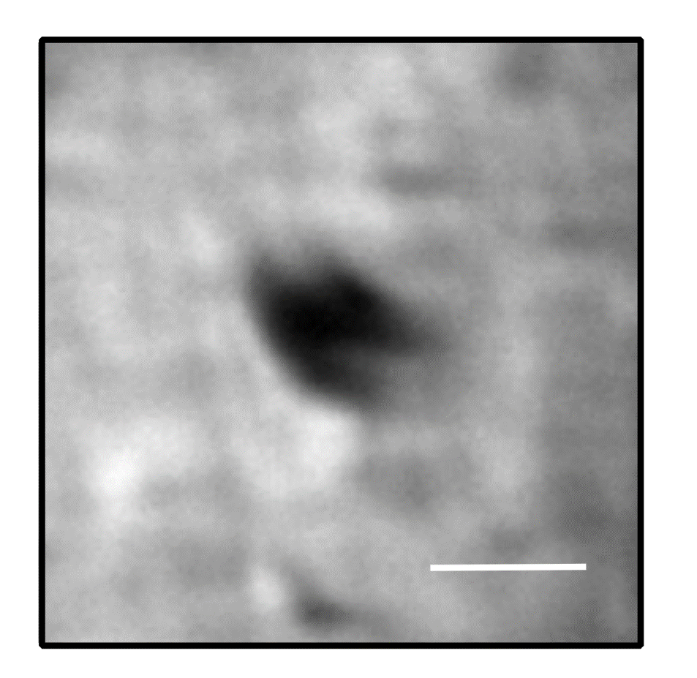

Supplementary Figure 9: Bright-field optical image of α-Li₂IrO₃ particle. Scale bar is 5 μm.

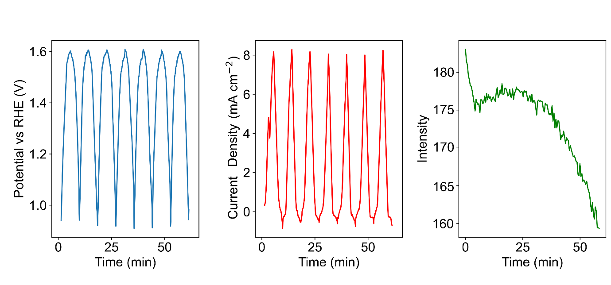

Supplementary Figure 10: Variation in intensity of 640 cm⁻¹ mode of α-Li₂IrO₃ when cycling in LiOH. There is a drop in the mode intensity associated with the delithiation in the first anodic cycle, followed by negligible (~10%) decrease in mode intensity in the subsequent scans.

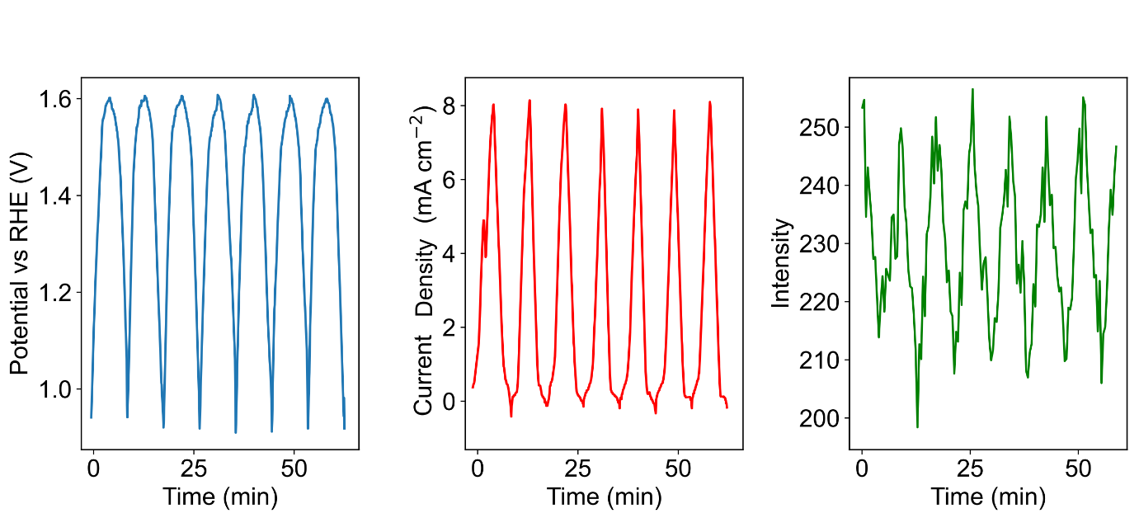

Supplementary Figure 11: Variation in intensity of 550 cm⁻¹ mode of α-Li₂IrO₃ when cycling in LiOH, a small 10% modulation in intensity is observed.

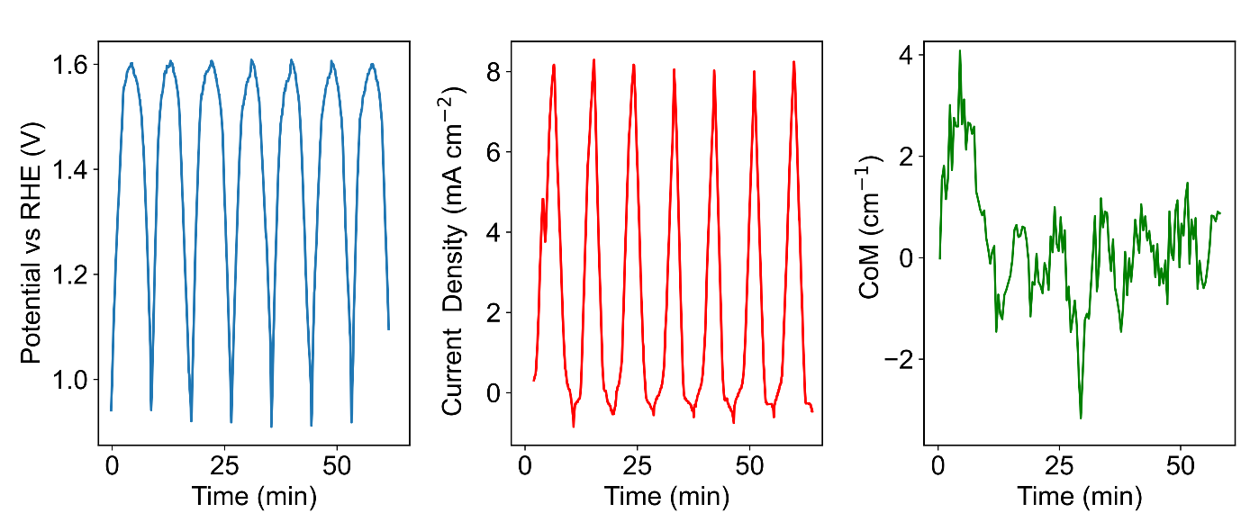

Supplementary Figure 12: Variation in CoM of 640 cm⁻¹ mode of α-Li₂IrO₃ when cycling in LiOH.

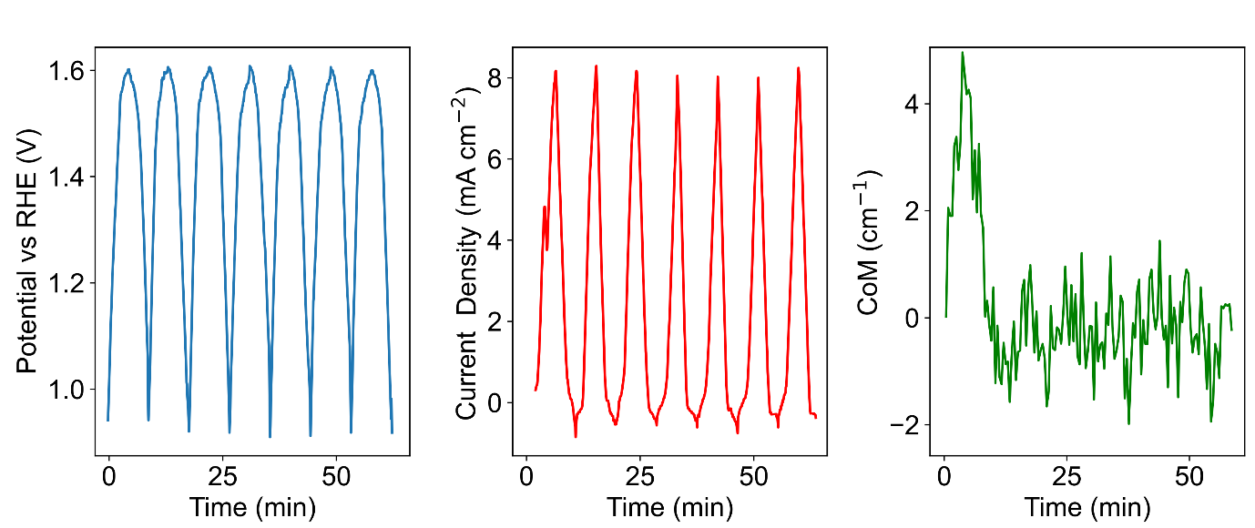

Supplementary Figure 13: Variation in CoM of 550 cm⁻¹ mode of α-Li₂IrO₃ when cycling in LiOH.

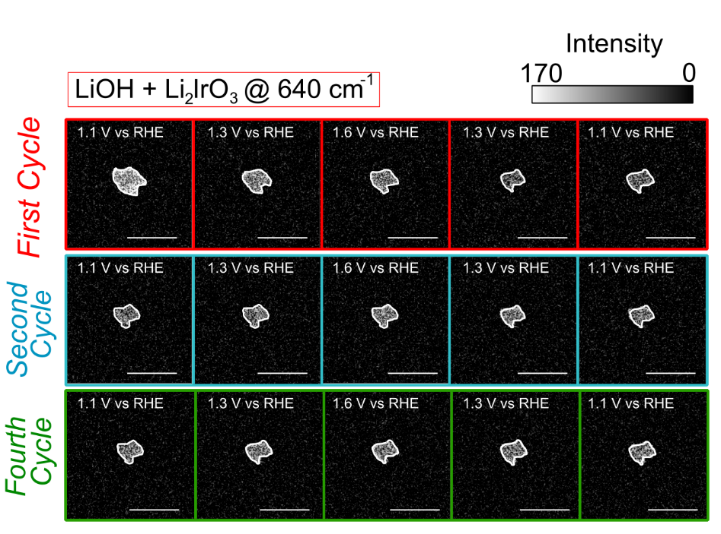

Supplementary Figure 14: Spatial distribution of intensity of 640 cm⁻¹ mode, during cycling of α-Li₂IrO₃ in LiOH. Scale bar is 5 μm. During the first anodic scan a shrinking core type pattern can be observed consistent with delithiation. The intensity of the 640 cm⁻¹ does not change in the cathodic scans and subsequent cycles in stark contrast to the core-shell behaviour observed in KOH.

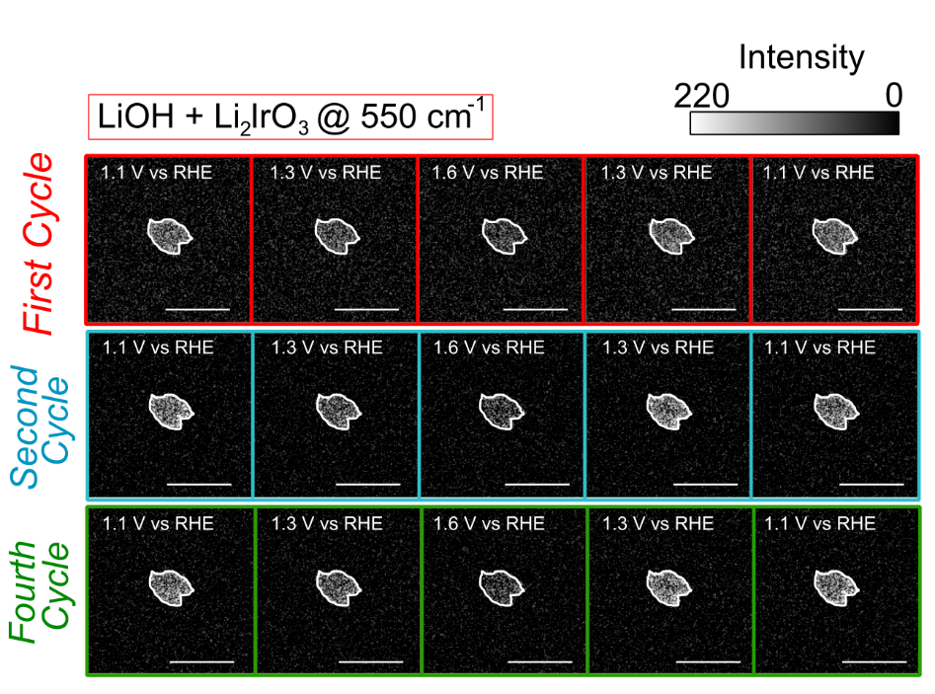
Supplementary Figure 15: Spatial distribution of intensity of 550 cm⁻¹ mode, during cycling of α-Li₂IrO₃ in LiOH. Scale bar is 5 μm. The mode intensity uniformly decreases (increases) across the particle during the anodic (cathodic) scan.

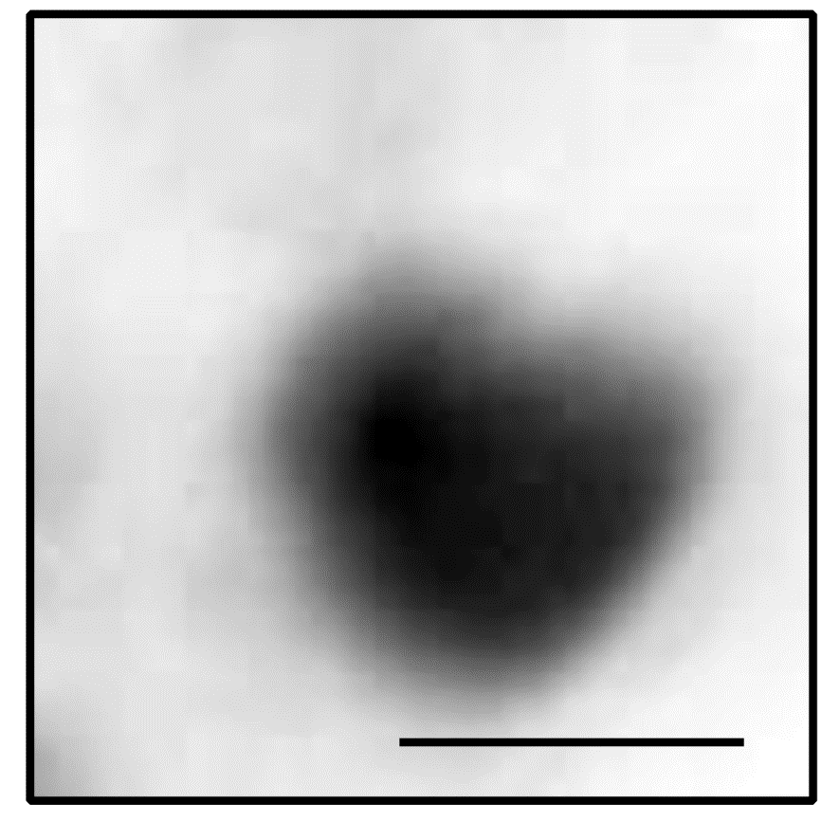

Supplementary Figure 16: Bright-field reflection image of IrO₂ particle. Scale bar is 4 μm.
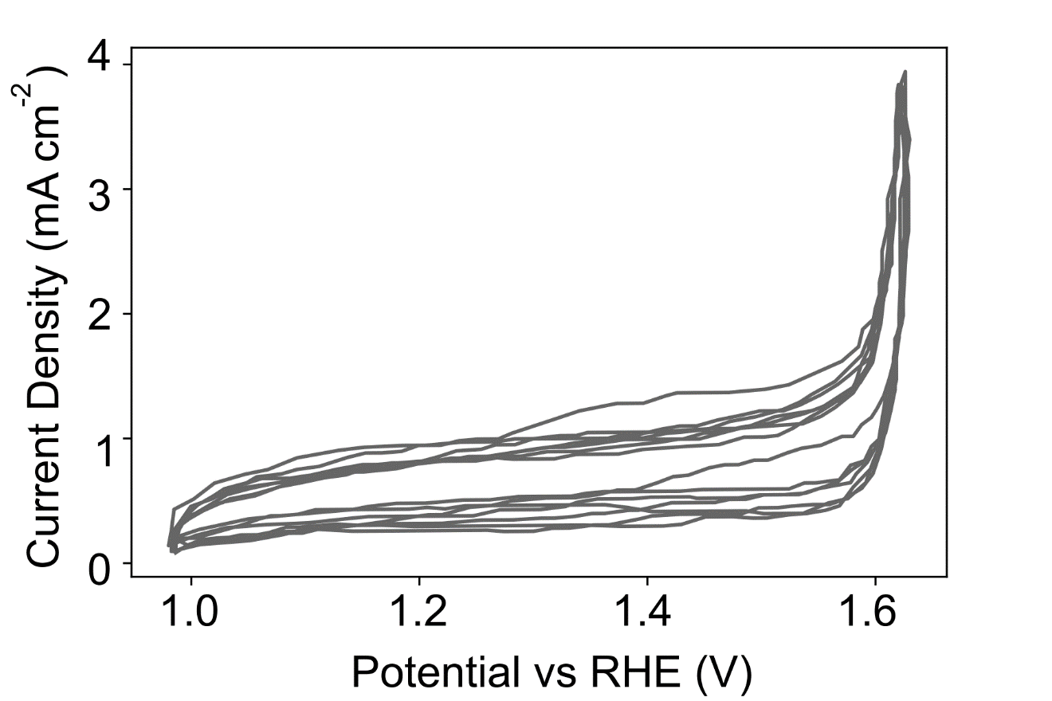
Supplementary Figure 17: Cyclic voltammogram of IrO₂ cycled in KOH over 8 cycles.

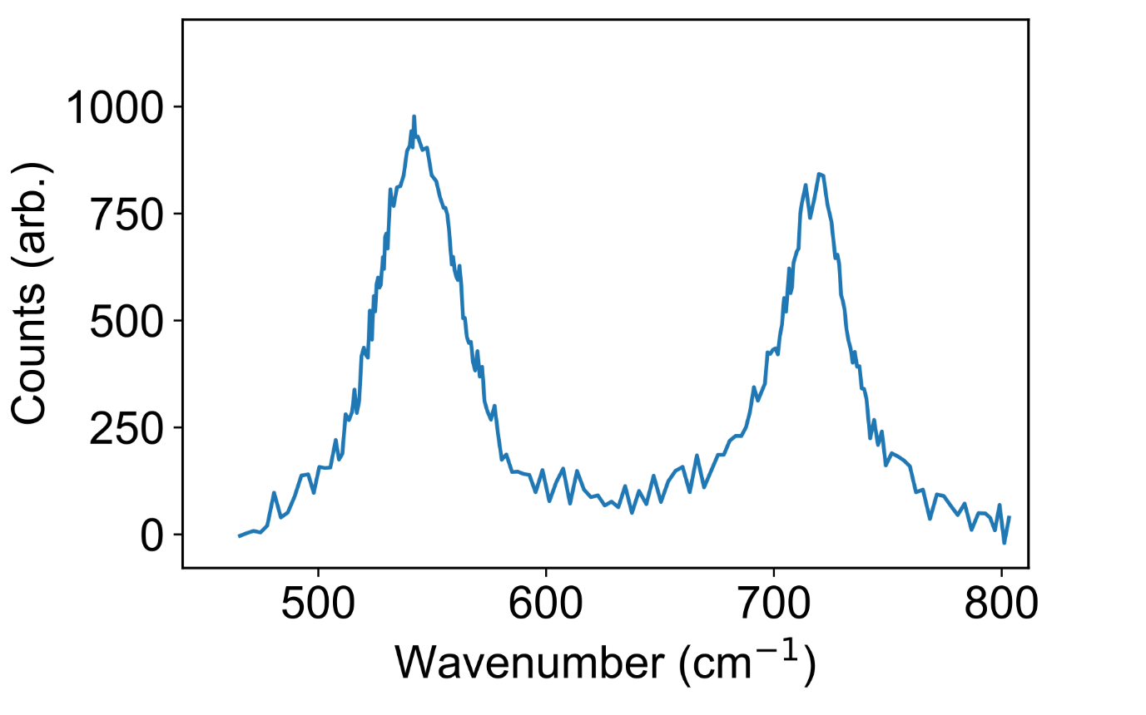
Supplementary Figure 18: Raman spectrum of IrO₂. The spectrum is in good agreement with previous studies^{15–17}.

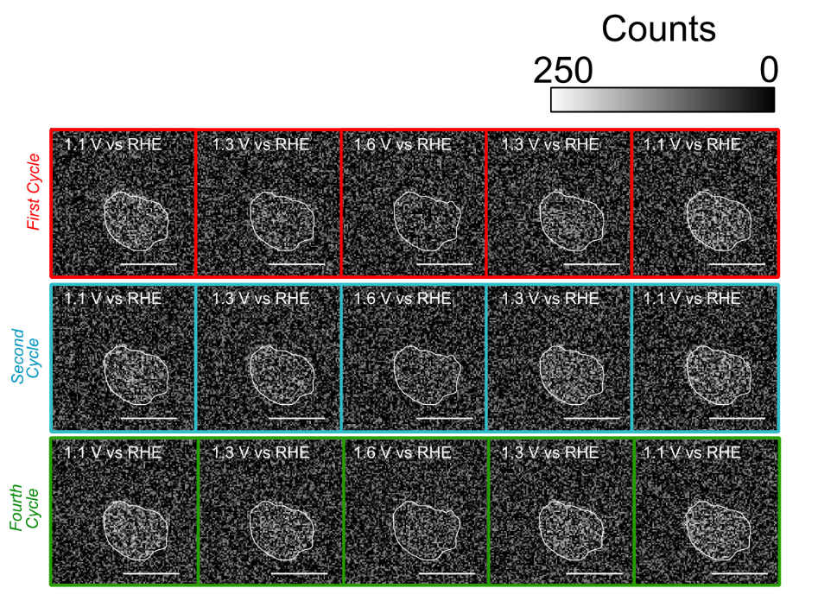

Supplementary Figure 19: Spatial intensity distribution integrating over ~500 cm⁻¹ mode for IrO₂ at given potentials and cycle number.

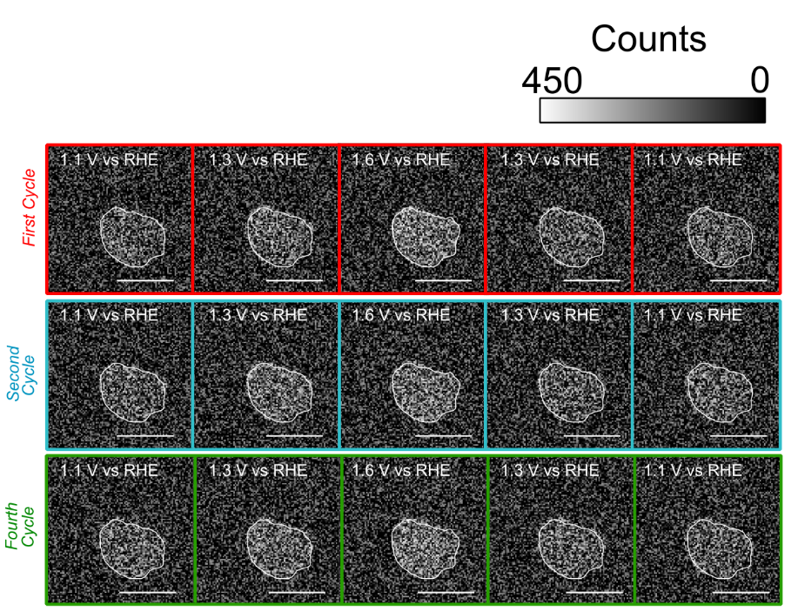

Supplementary Figure 20: Spatial intensity distribution integrating over 700 cm⁻¹ mode for IrO₂ at given potentials and cycle number.

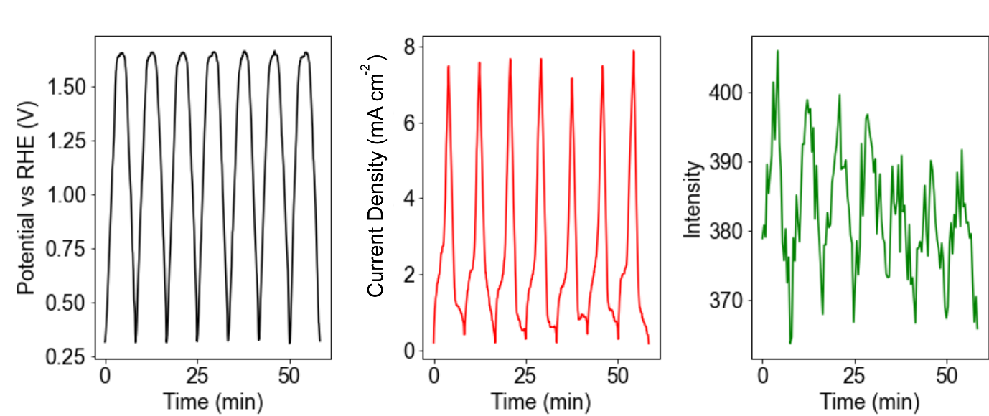
Supplementary Figure 21: Intensity of 500 cm⁻¹ mode for IrO₂ across multiple cycles.

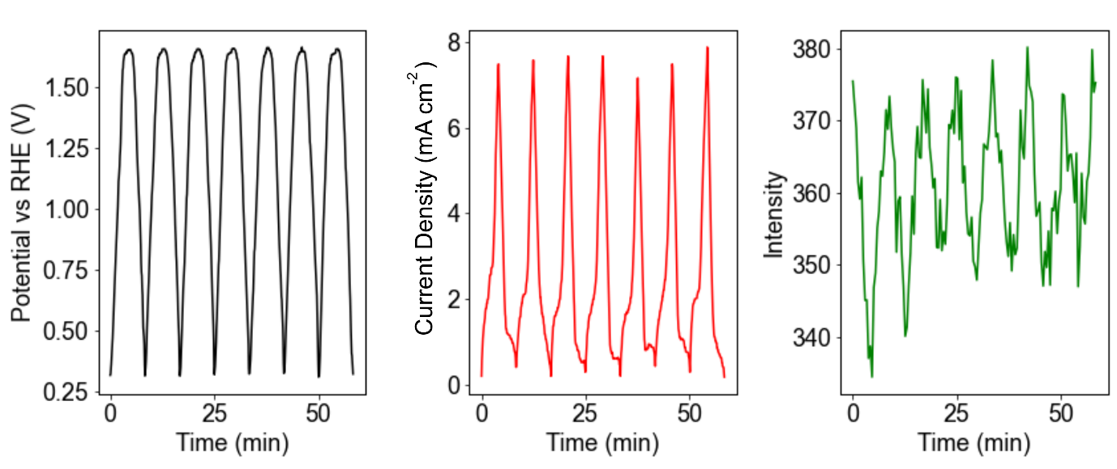
Supplementary Figure 22: Intensity of 700 cm⁻¹ mode for IrO₂ across multiple cycles.

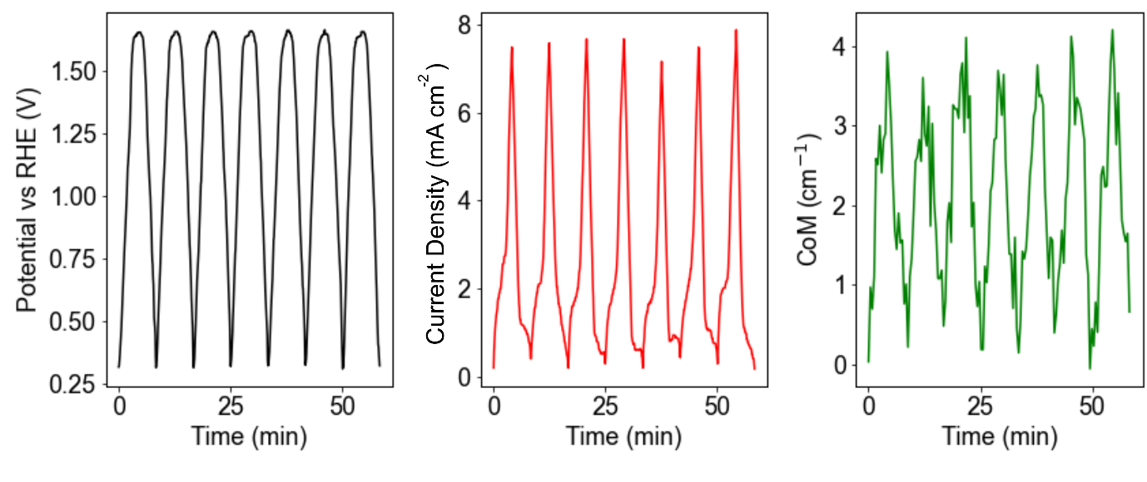
Supplementary Figure 23: CoM of 500 cm⁻¹ mode for IrO₂ across multiple cycles.

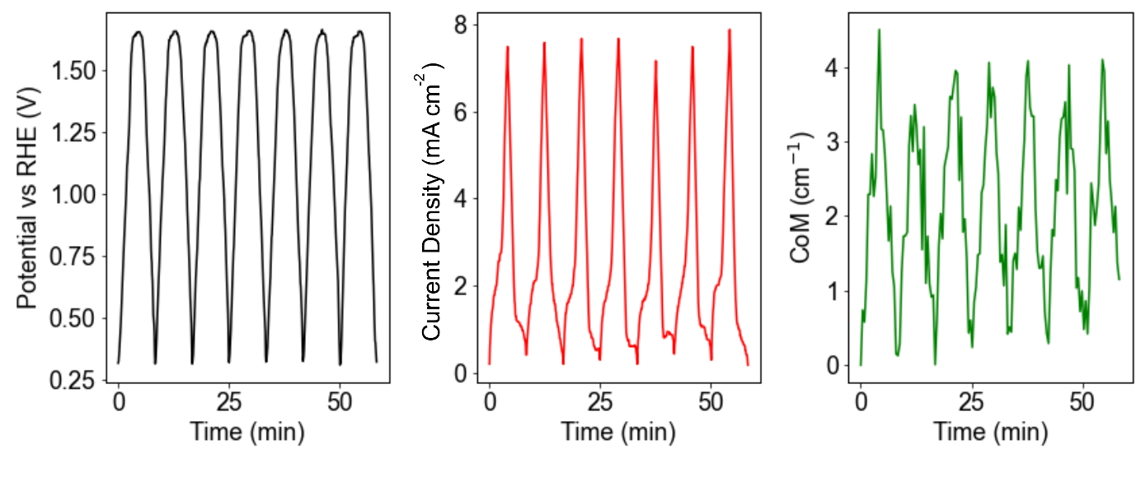

Supplementary Figure 24: CoM of 700 cm⁻¹ mode for IrO₂ across multiple cycles.

Supplementary Note 6: Operando Raman imaging with KOH electrolyte of α-Li₂IrO₃ at 550 cm⁻¹
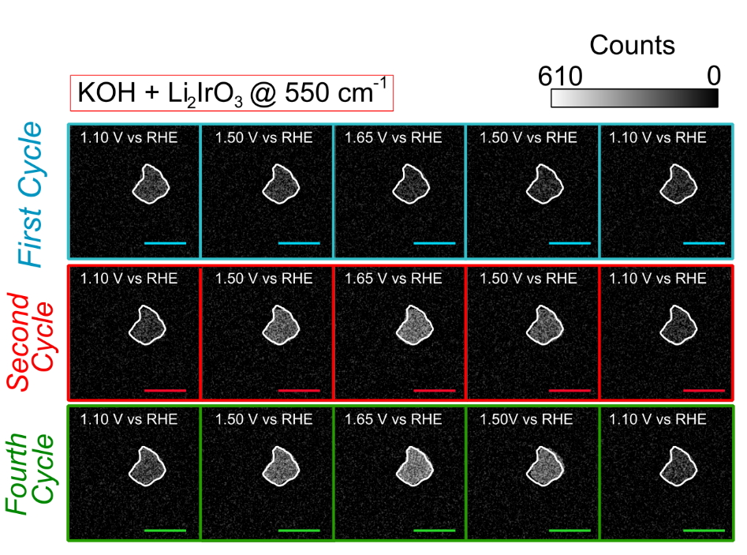

Supplementary Figure 25: Spatial distribution of intensity of 550 cm⁻¹ mode during cycling of α-Li₂IrO₃ particle shown in main text in KOH. Scale bar is 5 μm. In the first cycle a dimming of the mode intensity, uniformly across the particle, is seen on the anodic scan followed by a brightening on the cathodic scan. For subsequent scans (> 2), the anodic scan results in brightening of the particle and then dimming on the cathodic scan. Further, cycles are shown in Supplementary Videos 1-2; in the videos we note the mode intensity counts are arbitrary.

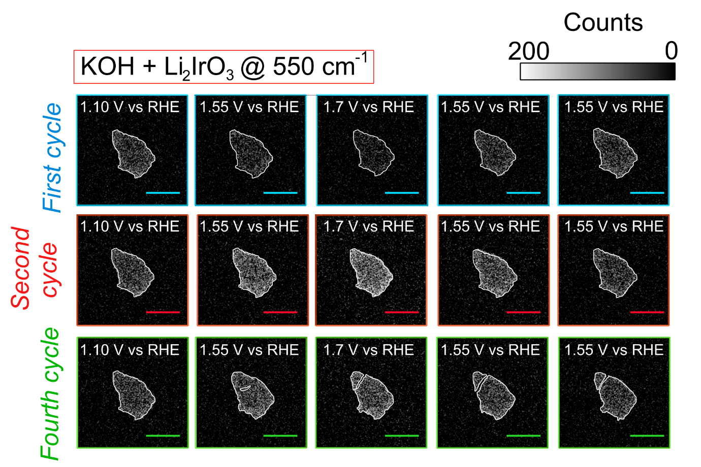
Supplementary Figure 26: Spatial distribution of intensity of 550 cm⁻¹ mode during cycling of a second α-Li₂IrO₃ particle in KOH. Scale bar is 5 μm. In the first cycle a dimming of the mode intensity, uniformly across the particle, is seen on the anodic scan followed by a brightening on the cathodic scan. For subsequent scans (> 2), the anodic scan results in brightening of the particle and then dimming on the cathodic scan. Further, cycles are shown in Supplementary Videos 3-4; in the videos we note the mode intensity counts are arbitrary

Supplementary Note 7: Repeat measurements and additional cycling images
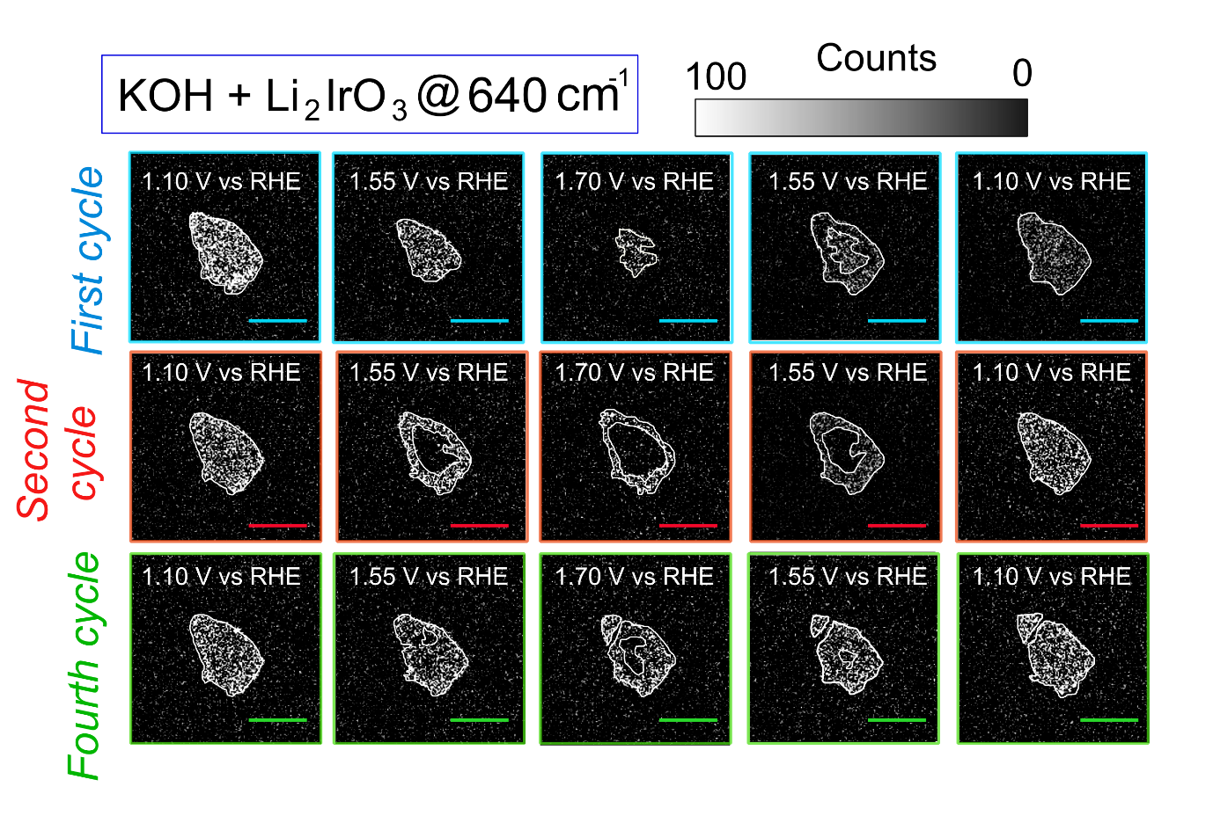

Supplementary Figure 27: Spatial distribution of intensity of 640 cm⁻¹ mode during cycling of a different α-Li₂IrO₃ particle to that considered in main text in KOH. Scale bar is 5 μm. Although a similar pattern of behaviour to that observed in the main text is observed, for this particle full delithiation does not occur during the first cycle and in the fourth cycle there is cracking/fatiguing of the particle which partially obscures the reaction fronts.

Supplementary Note 8: Estimation of cation (de)intercalation velocities

A velocity is strictly only relevant for experiments at a constant potential as discussed in the main text. However, by normalising the change in displacement of the intensity front, corresponding to a given phase front, by the voltage change in that period we can estimate a pseudo ‘velocity’ as illustrated in Supplementary Figures 28 – 30. We note for the > 2 anodic scans in KOH there is a competing effect of K⁺ entering the structure from the electrolyte. We hence estimate the deintercalation ‘velocity’ by examining the propagation of intensity fronts only up to 1 to 2 μm from the centre of particles where the intensity change is expected to be dominated by cation deintercalation. The ‘velocity’ obtained ~4.5 ± 1.5 nm s⁻¹ V⁻¹ is close to that obtained for cation reintercalation during the first cycle ~3.8 ± 1 nm s⁻¹ V⁻¹. Error bars are derived from at least 7 repeat experiments for a given cycle across different particles. We note that a kinetic model where we treat the potassium deintercalation as charge transfer limited and the potassium intercalating from the electrolyte as diffusion limited although tempting requires a large number of assumptions and complex parameterisations e.g. the current does not necessarily reflect only K⁺ deintercalation, mass transfer limited current is not necessarily constant with potential, etc. As a result, we use the above simplified method to estimate for our potential conditions the ‘velocity’ of cation deintercalation. Indeed, the ‘velocity’ as extracted by CV are at the quasi equilibrium. This is directly demonstrated by seeing that the un-normalised values obtained from the CV (~2 nm s⁻¹) are the same as those extracted for K⁺ diffusion into the structure after the potential holding measurements. Hence, overall we are imaging competing rates and while the cation ‘velocity’ is independent of potential, the OER rate is dependent on potential leading to the observed changes in mechanism. We also re-emphasise that our un-normalised velocity for the delithiation, ≈ 6 ± 2 nm s⁻¹, agrees well, albeit on the lower end, with Li⁺ deintercalation velocities previously reported for layered oxides such as lithium cobalt oxide, which are between 1 to 50 nm s⁻¹ (estimated from their measured diffusion^{18,19}).

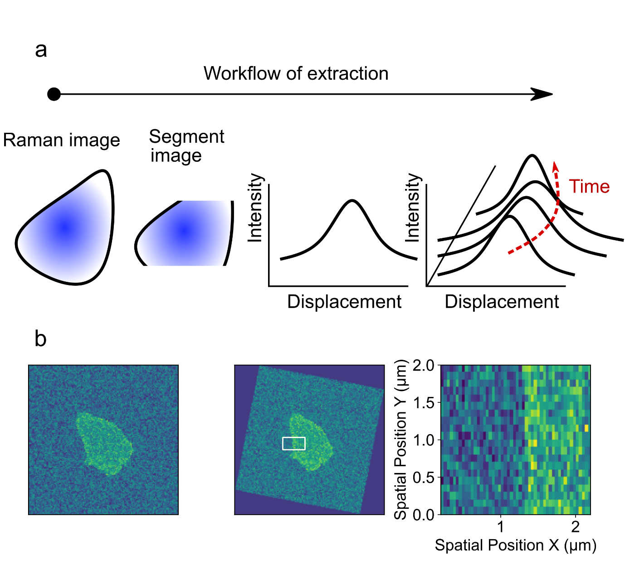

Supplementary Figure 28: a. The spatial Raman image at a given time point is averaged along a direction (x or y) to give a 1D line intensity. The process is then repeated over time to show the spatial evolution of intensity fronts. From examining iso-intensity points (red arrow) as a function of time and displacement as well as the voltage change the velocity can be determined. b. The figure illustrates the aforementioned re-orientation of the image and segmentation (white box) such that the spatial propagation of the front can be tracked.

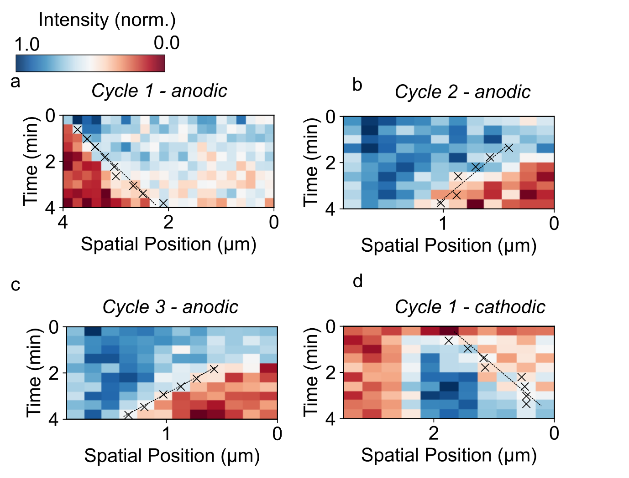
Supplementary Figure 29: a-d Performing the analysis detailed in Supplementary Figure 28 produces the following intensity plots for the first anodic scan of α-Li₂IrO₃ in KOH, second anodic scan of α-Li₂IrO₃ in KOH (b), third anodic scan of α-Li₂IrO₃ in KOH (c) and the first cathodic scan of α-Li₂IrO₃ in KOH (d). The crosses show points of iso-intensity (0.5). From the change in spatial position of these points (d) vs time (t), the ‘velocity’ can be determined (as the gradient) after normalising by the potential change for the same time period.

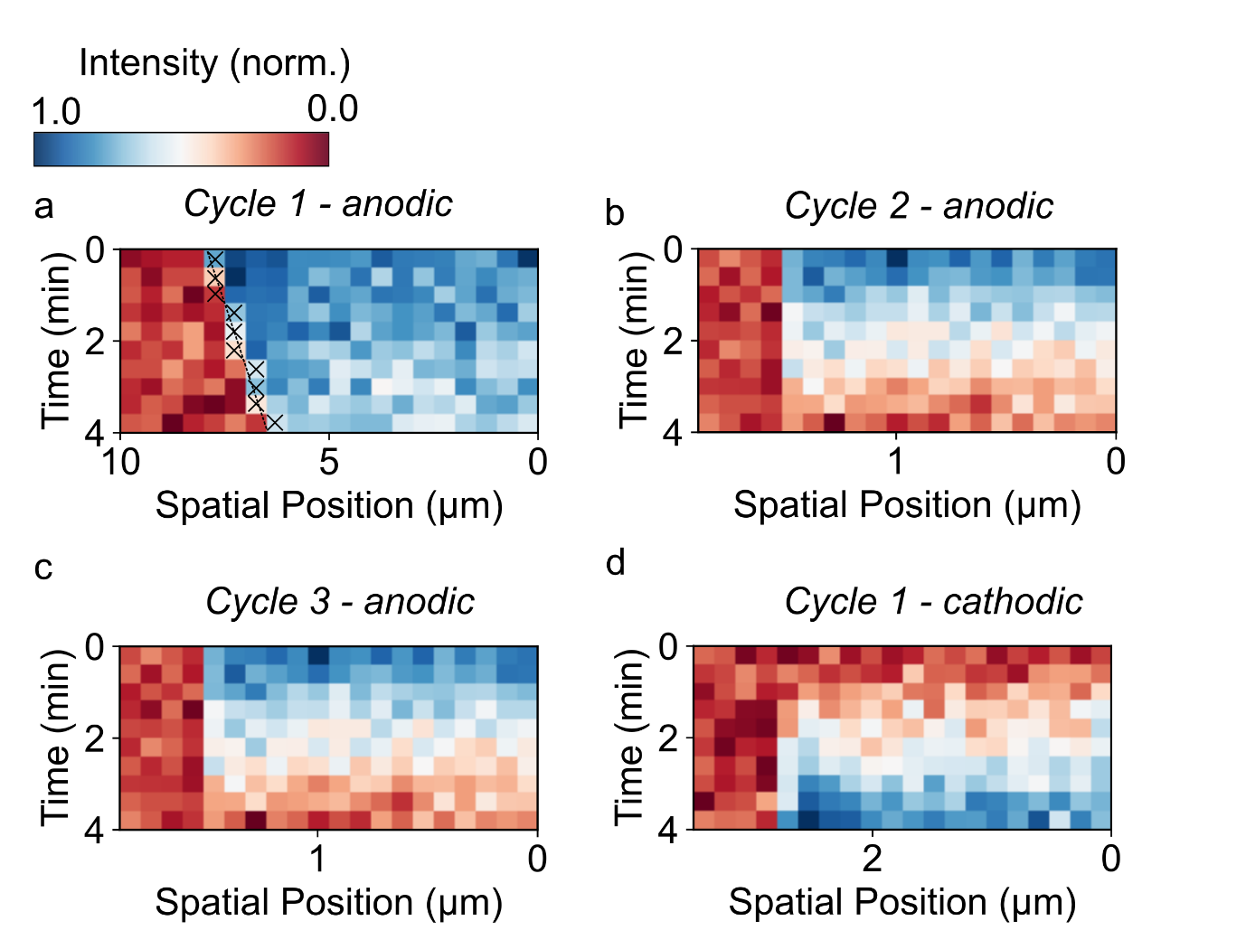

Supplementary Figure 30: a-d Performing the analysis detailed in Supplementary Figure 28 produces the following intensity plots for the first anodic scan of α-Li₂IrO₃ in LiOH, second anodic scan of α-Li₂IrO₃ in LiOH (b), third anodic scan of α-Li₂IrO₃ in LiOH (c) and the first cathodic scan of α-Li₂IrO₃ in LiOH (d). In this electrolyte after the lithium deintercalation in the first anodic scan (a) no phase fronts can be clearly discerned.

Supplementary Note 9: Calculation of turn-over-frequency

For the (001) facets, the ones predominantly exposed for platelets-like particles:

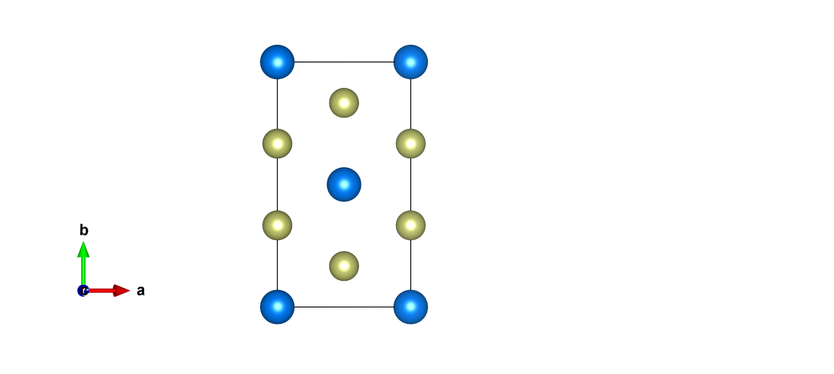
Ir
Li
8.93 Å
5.16 Å
Supplementary Figure 31: α-Li₂IrO₃ (001) facet showing the number of lithium and iridium atoms per ab plane (oxygen atoms removed for clarity) and the unit cell edges a and b lengths as obtained from X-ray powder diffraction (XRD)¹⁰.

The turnover frequency (TOF) calculations are carried out for the Li₂IrO₃ phase whose structure was obtained from refinement of XRD¹⁰. Note that upon delithiation, only a minor change in a and b parameters was reported¹⁰. The calculation of the TOF is therefore relatively insensitive to delithiation.
There are 4 × (1/4) + 2 × (1/2) = 2 Ir atoms per area of 8.93 × 5.16 = 46.10 Å² which gives 0.043 Ir.Å⁻².
For the following reaction: $4{ OH}^{-}→ O_{2}+2 H_{2}O+4 e^{-}$,
the quantity of O₂ (in mol) produced per second and per cm² of oxide is equal to ${\dot{n}}_{O2}= \frac{J}{4F}$ with J the current density (A.cm⁻²).
Hence the TOF, which is the number of O₂ molecules produced per second and per active site is equal to:
$TOF= \frac{{\dot{n}}_{O2}*N_{a}}{[Ir]}=\frac{J*N_{a}}{4F*[Ir]}$ with [Ir]=0.043 Ir.Å⁻² and N_{a} the Avogadro constant.
- For J = 10 mA.cm⁻²:
$$TOF=\frac{\frac{10mA}{cm^{2}}×6,022×{10}^{23}{mol}^{-1}}{4×96500 C.{mol}^{-1}×0.043 Ir.Å^{-2}}=\frac{\left(10*{10}^{-3}\right)×6.022*{10}^{23}}{{10}^{16}×4×96500×0.043}≈36$$

For 2.5 mA.cm⁻² and for 1.0 mA.cm⁻², TOF values of 9 and 4 molecules of O₂ per Ir active site and per second are found, respectively.

Supplementary Note 10: Additional details on experimental setup

Supplementary Figure 32 shows some examples of our experimental setup. An Ag wire (0.5 mm diameter; Sigma) was attached to the conductive coverslide using epoxy glue and conductive copper tape to allow connection to the working electrode. The reference (Ag/AgCl porous frit electrode; redox.me) and counter (Pt wire; 0.5 mm thickness; Sigma) were well separated and the reference was held just above the surface of the coverslides with micrometre screw gauges used to achieving exact positioning. Silicone rectangular or circular shaped wells (Mcmaster Carr) with a predefined area were bonded to the sample such that the active area with electrolyte could be determined. Wells were filled with the given electrolyte (200 μL to ~1500 μL depending on the experiment) to ensure all electrodes were wet. Potentials were then applied as detailed in the main text. For experiments requiring long-term (> 30 mins) focus stability on a single particle either a line based²⁰ or phase imaging based²¹ autofocus at 405 nm was used to maintain axial position.

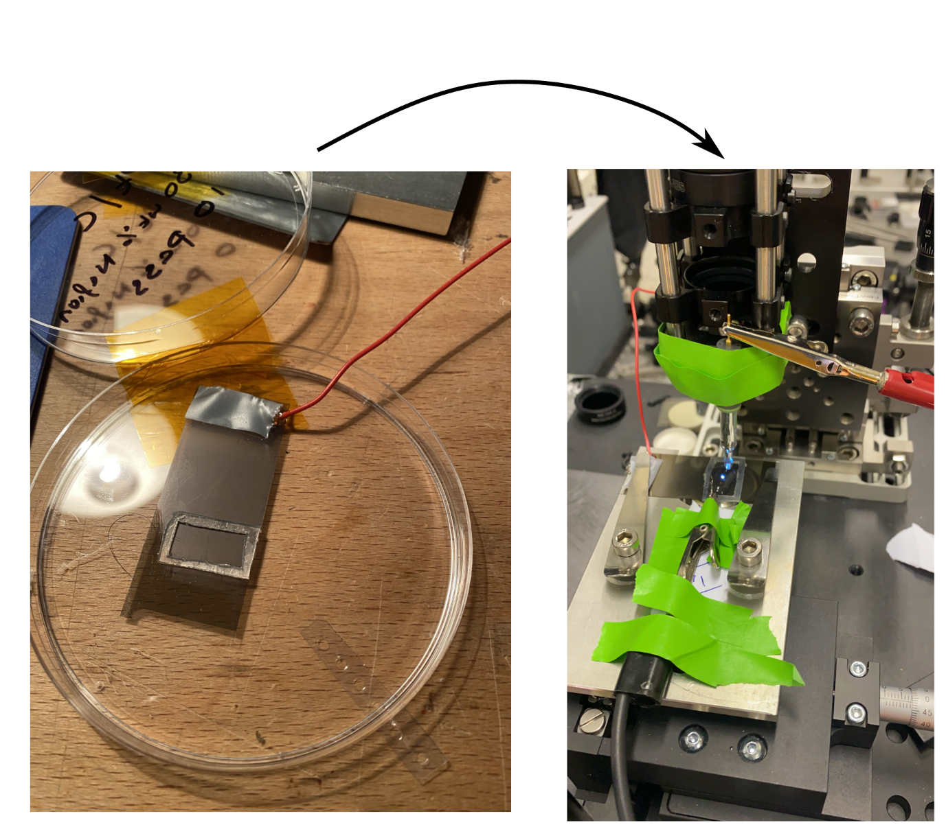

Supplementary Figure 32: Example of conductive coverslide (in this case with electrodeposited Nafion only), with wire bonded to allow electrical connection to working electrode (left). The coverslide is then mounted onto the microscope with the Pt counter (connected to black crocodile clip) and reference (connected to red crocodile clip) dipped into the well with electrolyte. Imaging can then be performed with epi-illumination.

Supplementary Note 11: Cost comparison between single pixel Raman spectrometers, EMCCD based Raman spectrometers and bright-field microscopes

The advantages/disadvantages of single pixel spectrometers in terms of sensitivity and cost specifically for Raman imaging have already been highlighted in previous studies²². Here, we compare Raman and bright-field (BF) optical microscopes. The latter has gained popularity for non-chemically specific characterisation of electrochemical materials²³. Both Raman and bright-field microscopes can be broken down into: (i) an excitation source, (ii) a microscope body and (iii) a detection system. Both BF and Raman require near identical (scanning) microscope bodies with appropriate stages, high-resolution objectives, etc and hence on this front have comparable costs. The excitation source in Raman is a laser whereas in BF an LED, lamp or laser can be used depending on the exact experiment^{24–27}. LED/lamp options typically represent approximately half the cost of those using a laser ($100 to $10,000 versus $5000 to $20,000 based on the equipment used from the referenced studies above). We note however, that a number of the BF studies do also use lasers²⁸. Hence, we can also consider on excitation the two methods to be cost comparable. In BF a camera retailing between $500 and $30,000 is used for detection depending on the sensitivity needed²⁹. In conventional Raman measurements an EMCCD and spectrograph is required costing between $30,000 and $50,000. However, our single pixel spectrometers replaces the EMCCD camera by a DMD ($500), an additional grating ($500) together with avalanche photodiode ($2000)³⁰. This makes the compressive spectrometer an order-of magnitude cheaper than conventional spectrometers and at a comparable and competitive price point with the detectors used in BF microscopy. However, with the added benefits of quantitative chemically sensitive information across both solid and liquid phases, which can be readily interpreted and linked to physical parameters, in contrast to that from BF experiments. Hence, although the above analysis is simple we believe it highlights that Raman imaging particularly with our single-pixel computational framework can be a competitive low-cost option for label-free characterisation of electrochemical systems.

References

1. Sturm, B. et al. High-Sensitivity High-Speed Compressive Spectrometer for Raman Imaging. ACS Photonics 6, 25 (2019).
2. Soldevila, F., Dong, J., Tajahuerce, E., Gigan, S. & De Aguiar, H. B. Fast compressive Raman bio-imaging via matrix completion. Optica 6, 341–346 (2019).
3. Mankani, B. R. et al. Binary Complementary Filters for Compressive Raman Spectroscopy. Appl. Spectrosc. Vol. 72, Issue 1, pp. 69-78 72, 69–78 (2018).
4. Lin, H. & B. de Aguiar, H. Compressive Raman microspectroscopy . in Stimulated Raman Scattering Microscopy (2022).
5. Senthilkumar, M., Mathiyarasu, J., Joseph, J., Phani, K. L. N. & Yegnaraman, V. Electrochemical instability of indium tin oxide (ITO) glass in acidic pH range during cathodic polarization. Mater. Chem. Phys. 108, 403–407 (2008).
6. Dovesi, R. et al. CRYSTAL17 User’s Manual. (2018).
7. Dovesi, R. et al. Quantum-mechanical condensed matter simulations with CRYSTAL. Wiley Interdiscip. Rev. Comput. Mol. Sci. 8, e1360 (2018).
8. Ping, Y., Galli, G. & Goddard, W. A. Electronic structure of IrO2: The role of the metal d orbitals. J. Phys. Chem. C 119, 11570–11577 (2015).
9. Laun, J. & Bredow, T. BSSE-corrected consistent Gaussian basis sets of triple-zeta valence with polarization quality of the fifth period for solid-state calculations. J. Comput. Chem. 43, 839–846 (2022).
10. Yang, C. et al. Cation insertion to break the activity/stability relationship for highly active oxygen evolution reaction catalyst. Nat. Commun. 2020 111 11, 1–10 (2020).
11. Giannozzi, P. et al. QUANTUM ESPRESSO: a modular and open-source software project for quantum simulations of materials. J. Phys. Condens. Matter 21, 395502 (2009).
12. Giannozzi, P. et al. Advanced capabilities for materials modelling with Quantum ESPRESSO. J. Phys. Condens. Matter 29, 465901 (2017).
13. Lejaeghere, K. et al. Reproducibility in density functional theory calculations of solids. Science 351, (2016).
14. Prandini, G., Marrazzo, A., Castelli, I. E., Mounet, N. & Marzari, N. Precision and efficiency in solid-state pseudopotential calculations. npj Comput. Mater. 2018 41 4, 1–13 (2018).
15. Pavlovic, Z., Ranjan, C., Gao, Q., Van Gastel, M. & Schlögl, R. Probing the structure of a water-Oxidizing anodic iridium oxide catalyst using raman spectroscopy. ACS Catal. 6, 8098–8105 (2016).
16. Huang, Y. S. et al. Raman spectrum of IrO2. Solid State Commun. 70, 517–522 (1989).
17. Gao, J. et al. Breaking Long-Range Order in Iridium Oxide by Alkali Ion for Efficient Water Oxidation. J. Am. Chem. Soc. 141, 3014-–3023 (2019).
18. Geng, Z., Chien, Y. C., Lacey, M. J., Thiringer, T. & Brandell, D. Validity of solid-state Li+ diffusion coefficient estimation by electrochemical approaches for lithium-ion batteries. Electrochim. Acta 404, 139727 (2022).
19. Xie, J. et al. Orientation dependence of Li-ion diffusion kinetics in LiCoO2 thin films prepared by RF magnetron sputtering. Solid State Ionics 179, 362–370 (2008).
20. Bian, Z. et al. Autofocusing technologies for whole slide imaging and automated microscopy. J. Biophotonics 13, e202000227 (2020).
21. Silvestri, L. et al. Universal autofocus for quantitative volumetric microscopy of whole mouse brains. Nat. Methods 2021 188 18, 953–958 (2021).
22. Scotté, C. et al. Assessment of Compressive Raman versus Hyperspectral Raman for Microcalcification Chemical Imaging. Anal. Chem. 90, 7197–7203 (2018).
23. Meyer, L., Saqib, N. & Porter, J. Review—Operando Optical Spectroscopy Studies of Batteries. J. Electrochem. Soc. 168, 090561 (2021).
24. Merryweather, A. J., Schnedermann, C., Jacquet, Q., Grey, C. P. & Rao, A. Operando optical tracking of single-particle ion dynamics in batteries. Nature 594, 522–528 (2021).
25. Sanchez, A. J., Kazyak, E., Chen, Y., Lasso, J. & Dasgupta, N. P. Lithium stripping: anisotropic evolution and faceting of pits revealed by operando 3-D microscopy. J. Mater. Chem. A 9, 21013–21023 (2021).
26. Godeffroy, L. et al. Bridging the Gap between Single Nanoparticle Imaging and Global Electrochemical Response by Correlative Microscopy Assisted By Machine Vision. Small Methods 2200659, 1–12 (2022).
27. Ye, X., Saqib, M., Mao, J., Li, G. & Hao, R. Spatiotemporally super-resolved dendrites nucleation and early-stage growth dynamics in Zinc-ion batteries. Cell Reports Phys. Sci. 2, 100420 (2021).
28. Merryweather, A. J. et al. Operando monitoring of single-particle kinetic state-of-charge heterogeneities and cracking in high-rate Li-ion anodes. Nat. Mater. 2022 2111 21, 1306–1313 (2022).
29. Salido, J., Bueno, G., Ruiz-Santaquiteria, J. & Cristobal, G. A review on low-cost microscopes for Open Science. Microsc. Res. Tech. 85, 3270–3283 (2022).
30. Musiienko, A., Žídek, K. & Denk, O. Differential single-pixel camera enabling low-cost microscopy in near-infrared spectral region. Opt. Express, Vol. 27, Issue 4, pp. 4562-4571 27, 4562–4571 (2019).

