Supplementary Figure 1. Surface charges on Al₂O₃ NPs and the overlap of the electrical double layers (EDL) between two adjacent Al₂O₃ NPs¹

Supplementary Figure 2. XRD pattern of Al₂O₃ NPs

Supplementary Figure 3. SEM of Al₂O₃ film: (a) and (b) surface. (c) and (d) cross-section. (e) EDS of the point marked in (b).

Supplementary Figure 4. Comparison of the average OCV generated in the equilibrium state from five different sensors

Supplementary Figure 5. Comparison of the average V_{sharp,max}/V_{broad,max} calculated from five different sensors. V_{sharp} and V_{broad} were measured after the moisture inside each sensor was allowed to reach equilibrium.
Supplementary Figure 6. Full FFT results of the V_{broad} over a time scale of 0-0.15 s. (a) H₂O. (b) D₂O

Supplementary Figure 7. Time dependence of V_{sharp} for several devices on application of 8 μL volume droplets of H₂O and D₂O droplets to the detector

Supplementary Figure 8. Output of dV_{sharp}/dt. (a) H₂O. (b) D₂O.
Supplementary Figure 9. Relationship between the thickness of the Al₂O₃ layer and the mass of Al₂O₃ nanoparticles before compression
Supplementary Figure 10. Characteristics of OCV pulses generated from application of 8 μL volume droplets of H₂O and D₂O measured by detectors fabricated with different thicknesses of the Al₂O₃ layer: (a) and (e) 0.4 mm. (b) and (f) 0.6 mm. (c) and (g) 1.3 mm. (d) and (k) 1.8 mm.
Supplementary Figure 11. Characteristics of OCV pulses generated from application of 8 μL volume droplets of H₂O and D₂O measured from detectors fabricated with Ag top electrode and different bottom electrodes: (a) and (b) Cu. (c) and (d) ITO-coated PET. (e) and (f) Pt.

Supplementary Figure 12. Characteristics of OCV pulses generated from application of 8 μL volume droplets of H₂O and D₂O measured from detectors fabricated with Cu top electrode and carbon paper bottom electrode

Supplementary Figure 13. Temporal evolution of the voltage pulses generated from application of 8 μL droplets of (a) H₂O and (b) D₂O on the sensor operating at 50 °C. The time interval between applied water droplets was 2.5 min. (c) H₂O and (d) D₂O on the sensor operating at 75 °C. The time interval between applied water droplets was 1.5 min. The droplet temperature was 25 °C.

Supplementary Figure 14. Characteristics of the OCV pulses generated from application of 8 μL volume droplets of (a) H₂O and (b) D₂O onto an Ag-Al₂O₃ nanowire-carbon paper device

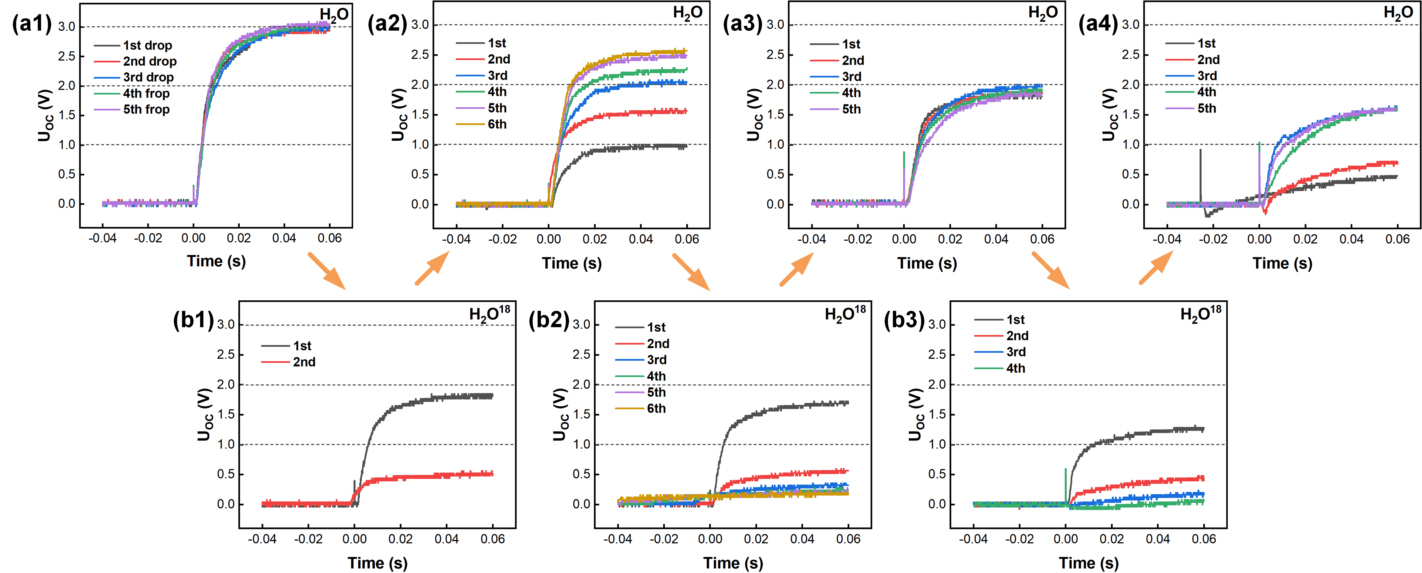
Supplementary Figure 15. Time sequence of the leading edge of the V_{broad} response on exposure to a series of 8 μL droplets of H₂O and H₂¹⁸O applied to one same detector as shown in Figure 1a. The arrows indicate the sequence of droplet application.

Supplementary Figure 16. Characteristics of voltage output when H₂O and D₂O droplets kept at higher temperatures (initially at 25 °C) are applied to sensor (1.3 mm thickness). (a-c) H₂O. (d-f) D₂O. Some variability in Vsharp is observed which can be attributed to the different surface tension of the liquid at 50 °C and 75 °C which affects the spread of the droplets on the Al₂O₃ surface.

Supplementary Figure 17. Raman spectra of bare Al₂O₃ nanoparticles, H₂O-treated nanoparticles and D₂O-treated nanoparticles
Supplementary Figure 18. FTIR spectra of Al₂O₃ nanoparticles before and after exposure to liquid H₂O and liquid D₂O
Supplementary Figure 19. V_{sharp} generated on application of H₂O and D₂O droplets to a series of metal (top) – metal (bottom) electrode pairs
Supplementary Figure 20. V_{sharp} generated when apply H₂O and D₂O droplets to a only one electrode system
References
1. Israelachvili, J. N. Electrostatic Forces between surface in Liquids. Intermolecular Surf. Forces 291–340 (Elsevier, 2011).

