SUPPLEMENTARY MATERIAL
Unravelling the fabric of the human mind: the brain-cognition space

Valentina Pacella^{ab}*, Victor Nozais^{ab}, Lia Talozzi^{c}, Stephanie J Forkel^{bdef}, Michel Thiebaut de Schotten^{ab}*
ª Groupe d'Imagerie Neurofonctionnelle, Institut des Maladies Neurodégénératives-UMR 5293, CNRS, CEA, University of Bordeaux, Bordeaux, 33076, France.
^{b} Brain Connectivity and Behaviour Laboratory, Sorbonne Universities, Paris, 75006, France.
^{c} Department of Neurology and Neurological Sciences, Stanford University School of Medicine, Stanford, California, 94305, USA
^{d} Donders Centre for Cognition, Radboud University, Thomas van Aquinostraat 4, 6525 GD Nijmegen, the Netherlands
^{e} Centre for Neuroimaging Sciences, Department of Neuroimaging, Institute of Psychiatry, Psychology and Neuroscience, King's College London, London, SE5 8AF, United Kingdom.
^{f} Departments of Neurosurgery, Technical University of Munich School of Medicine, Munich, 81675, Germany.

Index
Supplementary Table 1 Features of the new task-related activation maps. 2
Supplementary Figure 1 Projection of new function onto the Brain Cognition Space. 6
Relationship between cognitive domains branches 6
Brain structures of the rationality map 7
Replication of the BCS space architecture 8
References 9

Supplementary Table 1 Features of the new task-related activation maps.

Map | Type of map | Reference | Task | Contrast | Results
Abstract Words | T-map | Pauligk et al., 2019¹ | A delayed lexical decision task required indicating if a visually presented stimulus was a word or a pseudoword by left and right button presses. | Abstract VS. concrete words | Inferior frontal, superior and middle temporal cortices
Emotional Words | T-map | Pauligk et al., 2019¹ | Same as above. | Emotional VS. neutral words | Superior and medial frontal, cingulate cortices, middle temporal gyrus and amygdala, precuneus
Concrete Words | T-map | Pauligk et al., 2019¹ | Same as above | Concrete VS. abstract words | Superior and middle frontal gyri, medial temporal and calcarine cortices
Acute Fear | T-map | Hudson et al., 2020² | Participants watched feature-length horror movies. | Joint analysis of jump-scare events | Cingulate, Temporal, Insular cortices, Amygdala and Thalamus
Congruent Movement | T-map | Limanowski and Friston, 2020³ | Participants control a virtual hand and are asked to match the movement with their own or the virtual hands. | Congruent VS. incongruent movement | Superior, middle temporal and postcentral gyri, somatosensory cortex
Visuo-proprioception | T-map | Limanowski and Friston, 2020³ | Same as above | Visuo-proprioception of Congruent VS. Incongruent movement | Bilateral temporal and left secondary somatosensory cortices
Danger Expectance | T-map | Suarez-Jimenez et al., 2018⁴ | Activity differences during stationary periods of the threat learning task after picking flowers predicting either danger or safety. | Danger VS. safe | caudate, dACC, insula and midbrain
Friends Ownership | T-map | Lockwood et al., 2018⁵ | Associative learning task foster learning about fractal images that belonged to participants, their best friend, or a stranger. Ownership associative strength (OAS) between picture and label at the time of the picture (the strength of ownership) and the size of the ownership prediction error (OPE) at the time of the outcome. | Friends_OAS | Ventromedial prefrontal and cingulate cortices, middle temporal gyrus and medial temporal cortex.
Friends Prediction | T-map | Lockwood et al., 2018⁵ | Same as above. | Friends_OPE | Caudate, putamen, globus pallidum, left inferior temporal gyrus.
Ingroup Prediction Errors | T-map | Zhou et al., 2021⁶ | Participants expected to receive painful shocks but were saved from pain by different ingroup or outgroup members in 75% of all trials. Initial ingroup bias in impression ratings was significantly reduced over the course of learning (prediction errors). | Ingroup vs. outgroup prediction errors | Inferior parietal lobule and anterior insula.
Latent Group | T-map | Lau et al., 2020⁷ | Participants are asked to report their position on a political issue. They then learned the positions of three other hypothetical participants (A, B and C) on the same issue (trial-by-trial dyadic similarity learning). After repeating this procedure for eight different issues, the volunteers had to decide whether they would align with A or with B on a 'mystery' political issue (latent structure learning is influenced by C views). | Latent structure learning | Right Anterior Insula and Inferior Frontal Gyrus
Social Dyadic  Similarity | T-map | Lau et al., 2020⁷ | Same as above. | Trial-by-trial dyadic similarity index | Pregenual Anterior Cingulate
Learning through verification | T-map | Berens et al., 2018⁸ | Participants have to associate unfamiliar objects with obscure pseudowords. Learning through verification model predicts that the representations rapidly change from being equally similar to all others before they have been learnt to being dissimilar after learning. | Whole-brain searchlight representational similarity analysis on learning through verification model | Left hippocampus
Memory Integration | T-map | van Kesteren et al., 2020⁹ | Participants learn combination of pseudoword and scene (AB association) and object (AC association) so that B and C were linked via A in a congruent (known) or incongruent (unknown) manner. | AB encoding | Middle and inferior temporal gyri and cuneus
Congruency | T-map | van Kesteren et al., 2020⁹ | Same as above | Correct associations | Medial prefrontal cortex, hippocampal and parietal cortices
Speech | T-map | Steiner et al., 2021¹⁰ | Participants discriminate nonverbal (non-speech) and speech-based voice and non-voice (natural, artificial) sounds | Speech VS. non-voice | Left anterior, middle and posterior superior temporal gyrus, posterior superior temporal sulcus
Voice | T-map | Steiner et al., 2021¹⁰ | Same as above | Voice VS. non-voice | Left middle and posterior superior temporal and right middle superior temporal sulcus
Touch | T-map | Suvilehto et al., 2021¹¹ | Touch is delivered by confederates on the upper thigh of the participants | Touch stimulation VS. Baseline | Insular, primary and secondary somatosensory cortex

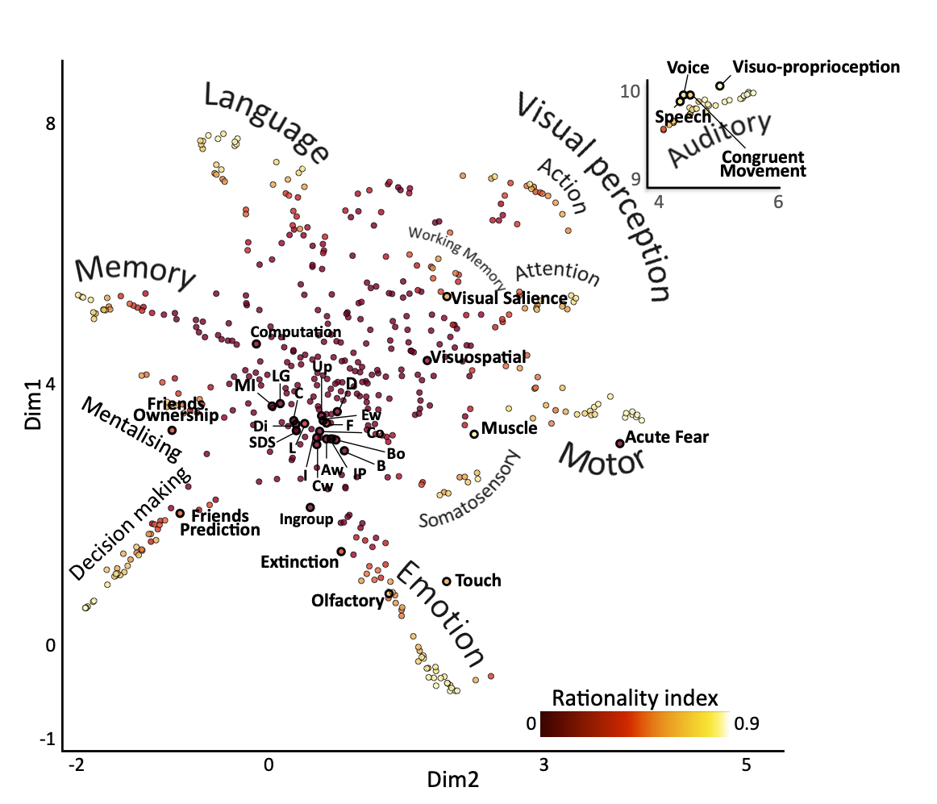Supplementary Figure 1 Projection of new function onto the Brain Cognition Space.
The dots highlighted in bold show the position in the BCS of new maps collected from the >2017 version of Neurosynth and Neurovault. The dots of maps closely located are linked to the correspondent function via lines. The colour indicates the rationality index. MI = Memory Integration. LG = Latent group membership. C = Congruency. Up = Updating. D = Danger expectance. WA = Emotional Words. F = Focus. Co = Confidence. Bo = Bodily. B = Balance. IP = Ingroup Prediction. WA = Abstract Words. WC = Concrete Words. I = Interoception. L = Learning. Ss= Social similarity. Di = Divided.

Relationship between cognitive domains branches
Cognitive domains clustered within each branch of the neuron-shaped architecture of the BCS, and the position of each branch reflects the relationship between the domains. For instance, the close position of the vision and attention branches with regards to other reflect the anatomical overlap between activations related to vision paradigms, from simple stimuli observation to eye-tracking paradigms, overlap anatomically with attentional networks¹². Vision and action activations are also closely located in the BCS and their interaction is known to manifest as embodiment mechanisms (e.g. rubber hand illusion¹³). Motor cognition and somatosensory mechanisms are jointly recruited during a movement to ensure the online control and the successful outcome of the performance¹⁴. Further, the clusterisation of the domains within the BCS shows that the emotion and somatosensory domains are adjacents, reflecting bodily signal generation and processing of emotional responses^{15–17}. Emotions and somatic responses guide decision-making¹⁸ and this is confirmed by the proximity of Emotion and Decision-making within the BCS. The joint contribution of learning and memory allows humans to orient in social experiences¹⁹, thus their close clusterisation in the space. Contextualisation of memories passes by assigning meaning and words to them²⁰, and language has been ascribed as part of the working memory as the phonological loop component²¹. Accordingly, memory, language, and working memory have interrelated aspects and follow one another in the BCS. The auditory cognition clusters far away from the other domains. The striking difference in the anatomical pattern of auditory-modality fMRI task opens further queries on the possible influence of stimuli modality in activation studies. In fact, the pronounced difference in the auditory cluster could be led by the number of studies conducted in the visual modality that investigated the other cognitive domains.

Brain structures of the rationality map
The structures associated with the high rationality index correlate with the gradients that mostly explains the overall brain activity in particular regions in the spectrum of auditory and motor processing²². The superior temporal cortex is known for its contribution to auditory cognition²³ and processing of the object's spatial features²⁴, while medial temporal cortices such as the rhinal cortex, hippocampus, and amygdala play a role in memory^{25–28} and stimuli representation (e.g. objects, faces, and scenes,²⁹. The premotor cortex contributes to action planning³⁰ and speech³¹, while the FEF and PEF are involved in visual target detection^{32,33}. An extensive range of functions for the implementation of voluntary action, such as timing, sensory predictions, sequence implementation, and inhibition of concurrent movements, involve the SMA and pre-SMA areas^{34–36}. Finally, the involvement of Broca's area as a hub of the language network in the brain has been extensively confirmed by the literature since its first description by Broca in 1861^{31,37,38}. Prediction, learning and reward mechanisms emerge from the activity of subcortical structures such as the basal ganglia and its connections^{39,40} as well as the medial temporal lobe structures⁴¹.

Replication of the BCS space architecture
To test the reliability of the BCS in terms of meta-analytic maps clusterisation in cognitive domains and positioning onto the space, the Euclidean distances between the BCS maps were compared with the Euclidean distances of a two-dimensional space built on the updated (2021) version of the 2017 meta-analytic maps.
Specifically, 506 maps were downloaded from Neurosynth repository, matched for terms with the 2017 dataset. No thresholding was applied to the 2021 meta-analytic maps because the more recent version of Neurosynth automatically applies thresholding (z ≥ 3.4) to correct for multiple comparisons. The maps underwent parcellation using the Glasser and colleagues^{42–44} and AAL3 atlases delineated by our group.
The Uniform Manifold Approximation and Projection (UMAP,⁴⁵) algorithm was applied to reduce the dimensionality of the parceled, 2021 meta-analytic dataset in a two-dimensional space, and UMAP default parameter values were used. Specifically, the space was built in two dimensions to foster the interpretability and successive manipulation of the data organisation; the algorithm used the information of 15 local neighbours to learn the manifold structure of the data points; 0.1 minimum distance was allowed by the algorithm to pack the data; the Euclidean metric was used for the data embedding.
The Euclidean distances between each and the other maps within the obtained 2021, two-dimensional space were then computed in Python (https://github.com/vale-pak/BCS.git). The obtained Euclidean distances were then compared with the Euclidean distances computed between each and other maps of the BCS (by the year 2017) via Pearson’s correlations. A positive correlation was found (r = 0.8). The results confirm that the clusterisation and positioning of the maps in 2017 can be replicated in later versions of the dataset.

References
1. Pauligk, S., Kotz, S. A. & Kanske, P. Differential Impact of Emotion on Semantic Processing of Abstract and Concrete Words: ERP and fMRI Evidence. Sci. Reports 9, 1–13 (2019).
2. Hudson, M. et al. Dissociable neural systems for unconditioned acute and sustained fear. Neuroimage 216, (2020).
3. Limanowski, J. & Friston, K. Attentional Modulation of Vision Versus Proprioception during Action. Cereb. Cortex 30, (2020).
4. Suarez-Jimenez, B. et al. Linked networks for learning and expressing location-specific threat. Proc. Natl. Acad. Sci. U. S. A. 115, 1032–1040 (2018).
5. Lockwood, P. L. et al. Neural mechanisms for learning self and other ownership. Nat. Commun. 9, 1–11 (2018).
6. Zhou, Y. et al. Learning from ingroup experiences changes intergroup impressions. Preprint at https://www.biorxiv.org/content/10.1101/2021.11.02.466926v1 (2021).
7. Lau, T., Gershman, S. J. & Cikara, M. Social structure learning in human anterior insula. Elife 9, (2020).
8. Berens, S. C., Horst, J. S. & Bird, C. M. Cross-Situational Learning Is Supported by Propose-but-Verify Hypothesis Testing. Curr. Biol. 28, (2018).
9. van Kesteren, M. T. R., Rignanese, P., Gianferrara, P. G., Krabbendam, L. & Meeter, M. Congruency and reactivation aid memory integration through reinstatement of prior knowledge. Sci. Reports 10, 1–13 (2020).
10. Steiner, F., Bobin, M. & Frühholz, S. Auditory cortical micro-networks show differential connectivity during voice and speech processing in humans. Commun. Biol. 4, 801 (2021).
11. Suvilehto, J. T., Renvall, V. & Nummenmaa, L. Relationship-specific Encoding of Social Touch in Somatosensory and Insular Cortices. Neuroscience 464, (2021).
12. Corbetta, M. et al. A Common Network of Functional Areas for Attention and Eye Movements. Neuron 21, 761–773 (1998).
13. Ehrsson, H. H., Spence, C. & Passingham, R. E. That’s my hand! Activity in premotor cortex reflects feeling of ownership of a limb. Science 305, 875-877 (2004).
14. Friston, K. The free-energy principle: a unified brain theory? Nat. Rev. Neurosci. 11, 127–138 (2010).
15. Damasio, A. R. The somatic marker hypothesis and the possible functions of the prefrontal cortex. Philos. Trans. R. Soc. London. Ser. B Biol. Sci. 351, 1413–1420 (1996).
16. Bufalari, I., Aprile, T., Avenanti, A., Di Russo, F. & Aglioti, S. M. Empathy for pain and touch in the human somatosensory cortex. Cereb. Cortex 17, 2553–2561 (2007).
17. McGlone, F., Wessberg, J. & Olausson, H. Discriminative and affective touch: sensing and feeling. Neuron 82, 737–755 (2014).
18. Bechara, A., Damasio, H. & Damasio, A. R. Emotion, Decision Making and the Orbitofrontal Cortex. Cereb. Cortex 10, 295–307 (2000).
19. Leblanc, H. & Ramirez, S. Linking Social Cognition to Learning and Memory. J. Neurosci. 40, 8782 (2020).
20. Tulving, E., Kapur, S., Craik, F. I., Moscovitch, M. & Houle, S. Hemispheric encoding/retrieval asymmetry in episodic memory: positron emission tomography findings. Proc. Natl. Acad. Sci. U. S. A. 91, 2016–20 (1994).
21. Baddeley, A. D. & Hitch, G. Working Memory. Psychol. Learn. Motiv. - Adv. Res. Theory 8, 47–89 (1974).
22. Margulies, D. S. et al. Situating the default-mode network along a principal gradient of macroscale cortical organization. Proc. Natl. Acad. Sci. U. S. A. 113, 12574–12579 (2016).
23. Jackson, R. L., Bajada, C. J., Rice, G. E., Cloutman, L. L. & Lambon Ralph, M. A. An emergent functional parcellation of the temporal cortex. Neuroimage 170, 385–399 (2018).
24. Karnath, H. O. New insights into the functions of the superior temporal cortex. Nat. Rev. Neurosci. 2, 568–576 (2001).
25. McGaugh, J. L. Memory--a Century of Consolidation. Science . 287, 248–251 (2000).
26. Dudai, Y., Karni, A. & Born, J. The Consolidation and Transformation of Memory. Neuron 88, 20–32 (2015).
27. Binder, J. R. & Desai, R. H. The neurobiology of semantic memory. Trends Cogn. Sci. 15, 527–536 (2011).
28. Squire, L. R., Stark, C. E. L. & Clark, R. E. The medial temporal lobe. Annu. Rev. Neurosci. 27, 279–306 (2004).
29. Robin, J., Rai, Y., Valli, M. & Olsen, R. K. Category specificity in the medial temporal lobe: A systematic review. Hippocampus 29, 313–339 (2019).
30. Romo, R., Hernández, A. & Zainos, A. Neuronal Correlates of a Perceptual Decision in Ventral Premotor Cortex. Neuron 41, 165–173 (2004).
31. Broca, P. Remarques sur le siège de la faculté du langage articulé; suivies d’une observation d’aphémie (perte de la parole). Bull Soc Anthropol. 36, 330–357 (1861).
32. Muggleton, N. G., Kalla, R., Juan, C. H. & Walsh, V. Dissociating the contributions of human frontal eye fields and posterior parietal cortex to visual search. J. Neurophysiol. 105, 2891–2896 (2011).
33. Brotchie, P. R. et al. Head Position Modulates Activity in the Human Parietal Eye Fields. Neuroimage 18, 178–184 (2003).
34. Nachev, P., Wydell, H., O’neill, K., Husain, M. & Kennard, C. The role of the pre-supplementary motor area in the control of action. Neuroimage 36, 155-63 (2007).
35. Lima, C. F., Krishnan, S. & Scott, S. K. Roles of Supplementary Motor Areas in Auditory Processing and Auditory Imagery. Trends Neurosci. 39, 527–542 (2016).
36. Mita, A., Mushiake, H., Shima, K., Matsuzaka, Y. & Tanji, J. Interval time coding by neurons in the presupplementary and supplementary motor areas. Nat. Neurosci. 12, 502–507 (2009).
37. Caramazza, A. & Zurif, E. B. Dissociation of algorithmic and heuristic processes in language comprehension: Evidence from aphasia. Brain Lang. 3, 572–582 (1976).
38. Sahin, N. T., Pinker, S., Cash, S. S., Schomer, D. & Halgren, E. Sequential processing of lexical, grammatical, and phonological information within broca’s area. Science. 326, 445–449 (2009).
39. Schultz, W., Dayan, P. & Montague, P. R. A neural substrate of prediction and reward. Science 275, 1593–1599 (1997).
40. Bayer, H. M. & Glimcher, P. W. Midbrain dopamine neurons encode a quantitative reward prediction error signal. Neuron 47, 129–141 (2005).
41. Henin, S. et al. Learning hierarchical sequence representations across human cortex and hippocampus. Sci. Adv. 7, 4530 (2021).
42. Glasser, M. F. et al. A multi-modal parcellation of human cerebral cortex. Nature 536, 171-178 (2016).
43. Rolls, E. T., Huang, C. C., Lin, C. P., Feng, J. & Joliot, M. Automated anatomical labelling atlas 3. Neuroimage 206, 116-189 (2020).
44. Huang, C. C., Rolls, E. T., Feng, J. & Lin, C. P. An extended Human Connectome Project multimodal parcellation atlas of the human cortex and subcortical areas. Brain Struct. Funct. 227, 763-778 (2022).
45. McInnes, L., Healy, J., Saul, N. & Großberger, L. UMAP: Uniform Manifold Approximation and Projection. Preprint at https://arxiv.org/abs/1802.03426 (2018).

