Forested Patch
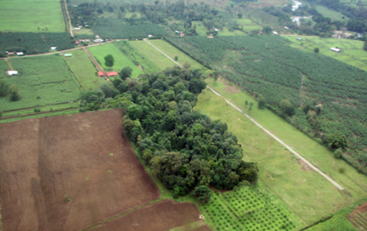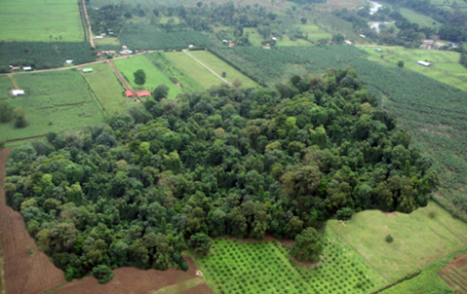

Forested Corridor
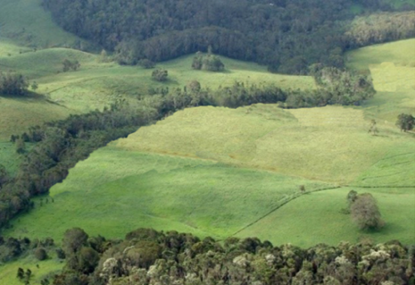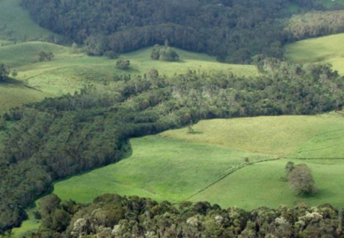

Isolated Trees
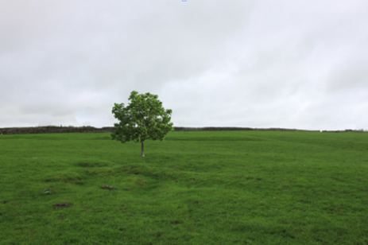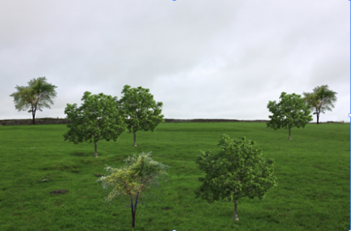

Living Fences
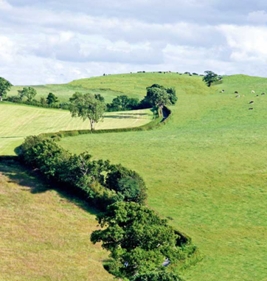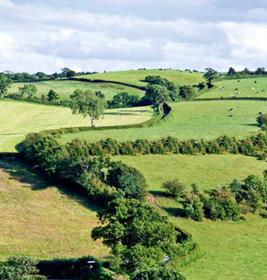

Riparian Corridor
(In compliance with minimum legal requirements)
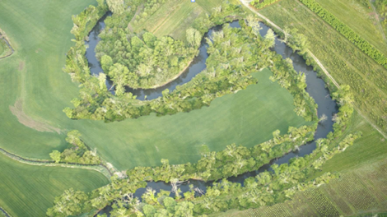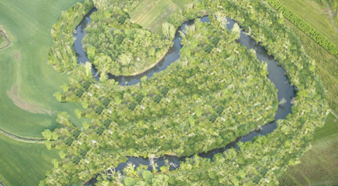

Appendix A. All manipulated images included in the survey to elicit stakeholder interest in having various tree configurations on their property. Tree configurations included: Forested Patch, Forested Corridor, Isolated Trees, Living Fences, and Riparian Corridor. The left column depicts the small example of the tree configuration, while the right column depicts the large example. Survey participants rated each picture individually on a Likert-type scale for how interested they would be to have the tree configuration on their property, from (1) not at all interested to (5) very interested.

