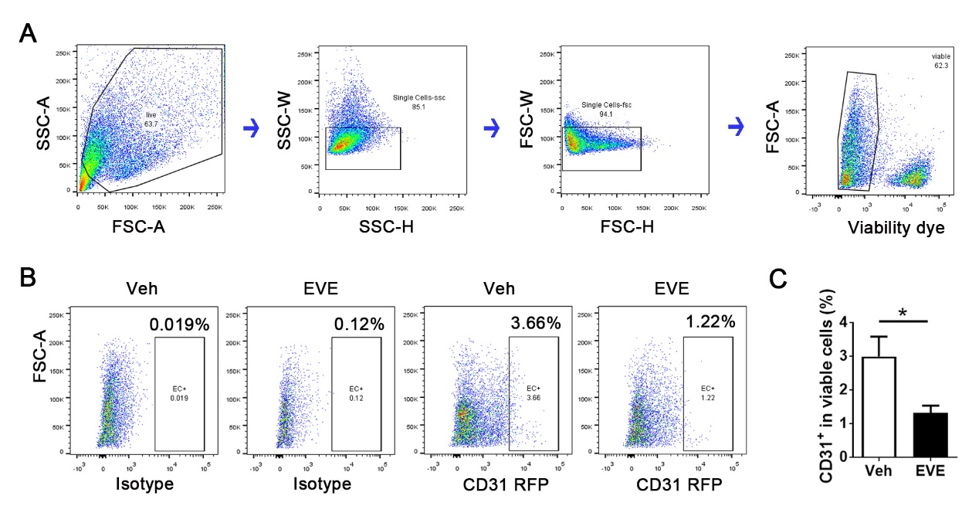

Supplemental Figure 1. EVE reduces tumor vessels. Mice were treated with vehicle or EVE for 15 days. Flow cytometry of single cell suspension from tumor was used to for further assessment. (A) The gating strategy included: forward versus side scatter gate; a singlets gate; and viable cell gate. (B) CD31+ cells in viable cells. (C) Quantified percentage of CD31+ cells in all viable cells (n=7; *P < 0.05 by t test).

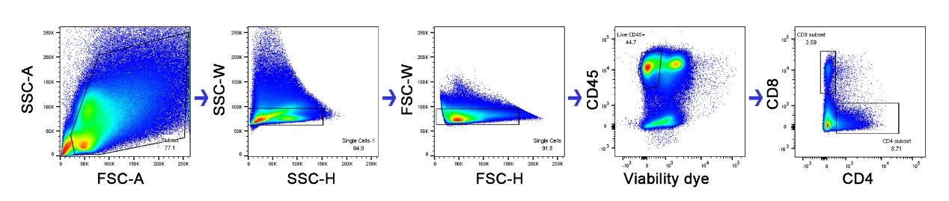
Supplemental Figure 2. Protocol of flow cytometry of single cell suspension from tumor. Doublets were excluded and only viable CD45+ cells were used for further analysis.

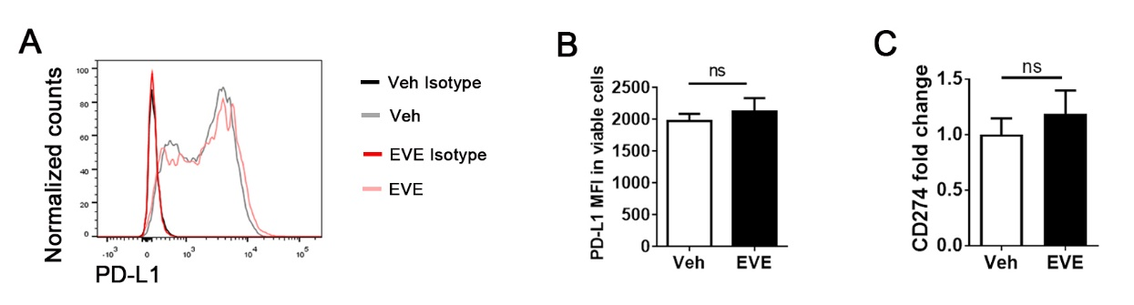
Supplemental Figure 3. Impact of EVE on the expression of programmed death-ligand 1 (PD-L1) in 4T1 TNBC. Mice were treated with vehicle or EVE for 15 days. Flow cytometry of single cell suspension from tumor was used to further assess PD-L1 expression. (A) Representative histogram of PD-L1 expression in all viable cells. (B) PD-L1 MFI (mean fluorescence intensity) of all viable cells (n=5; ns: no significant by t test). (C) Quantitative RT-PCR analysis of PD-L1 (CD274) in tumors from mice treated with Veh or EVE at day 15. Hypoxanthine phosphoribosyltransferase (HPRT) was used to normalize the variability in template loading (n=6; ns: no significant by t test).

