Additional File 1

Figures

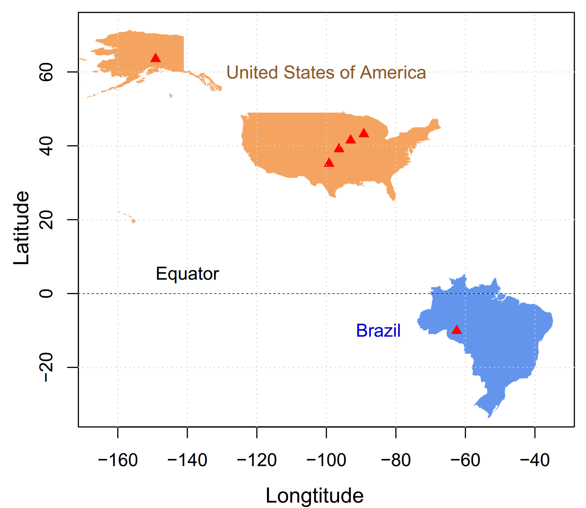
Fig. S1 Geographical distribution of sampling sites.

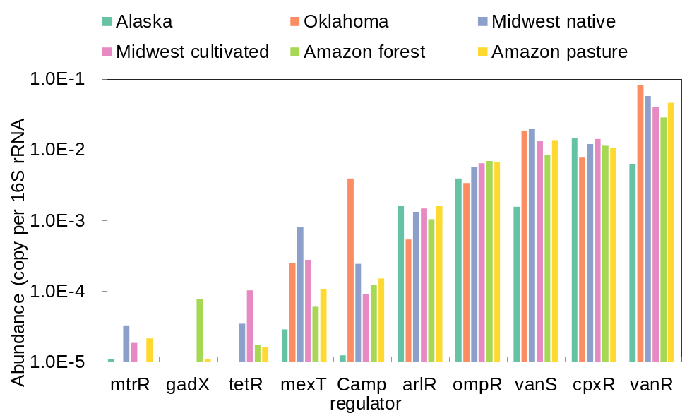
Fig. S2 Antibiotic resistance regulatory genes in soils.

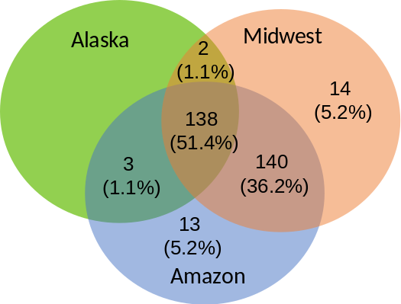
Fig. S3 Venn diagram showing shared ARGs among Alaska, Midwest USA, and Amazon soils.

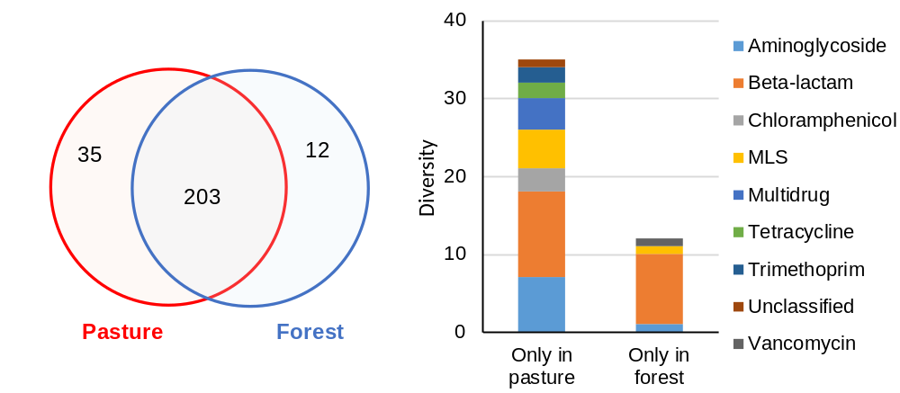
Fig. S4 (A) The shared and exclusive ARGs between Amazon rainforest soils and pasture soils. (B) The composition of the exclusive ARGs.

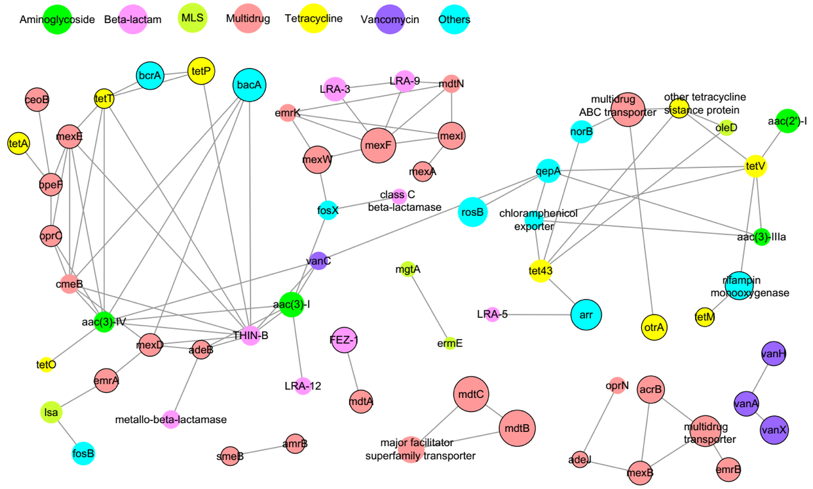

Fig. S5 Network analysis assessing the ARG cluster across soils from tundra, temperate prairie and tropical ecosystems. The lines represent significant (p < 0.05) and strong (R² > 0.8) positive Spearman correlations. The node size is weighted according to the average abundance of each ARG. Circles enclosed with black boundary represent background ARGs. MLS: Macrolides-lincosamides-streptogramines.

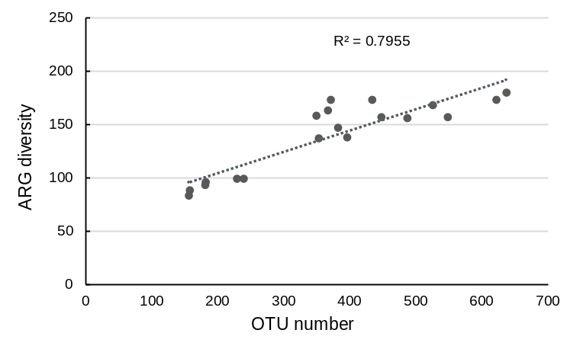
Fig. S6 Pearson correlation between ARG diversity and bacterial diversity.

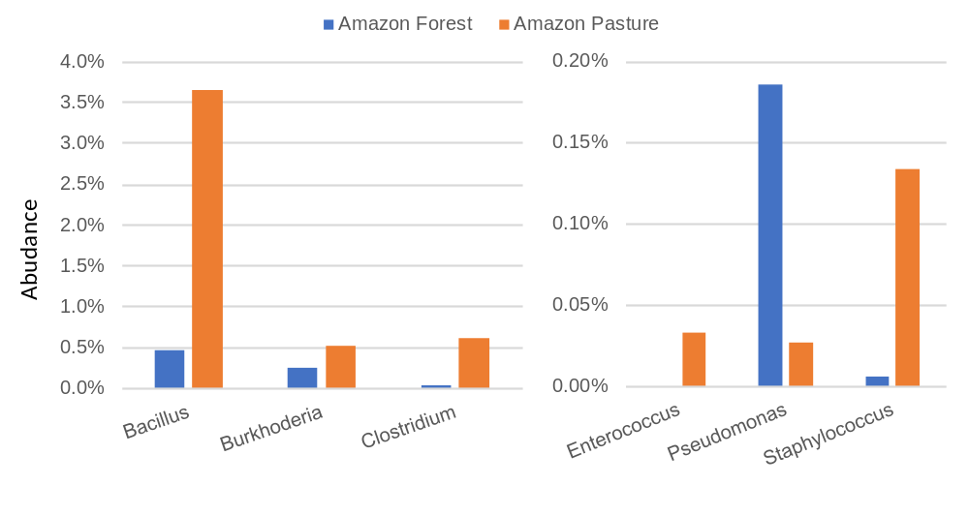
Fig. S7 Abundance of six bacterial genera in Amazon rainforest and pasture soils.

