Supplementary Figures

Histone methyltransferase EHMT2 degradation by propionate derived from Bacteroides thetaiotaomicron induced colon cancer apoptosis via epigenetic regulation of TNFAIP1
Tae Young Ryu^{1*}, Kwangho Kim^{1*}, Tae-Su Han^{1*}, Mi-Ok Lee^{1,2}, Jinkwon Lee^{1,2}, Jinhyeon Choi¹, Eun-Jeong Jeong¹, Da Mi An¹, Cho-Rok Jung^{1, 2}, Jaeeun Jung¹, Kunhyang Park¹, Doo-Sang Park^{1,2}, Dae-Soo Kim ^{1, 2}, Mi-Young Son^{1,2}, Hyun-Soo Cho^{1, 2}
¹Korea Research Institute of Bioscience and Biotechnology, Daejeon, 305-333, Republic of Korea;²Korea University of Science and Technology, Daejeon, 305-333, Republic of Korea

*Authors share co-first authorship

Supplementary figures: 1~4

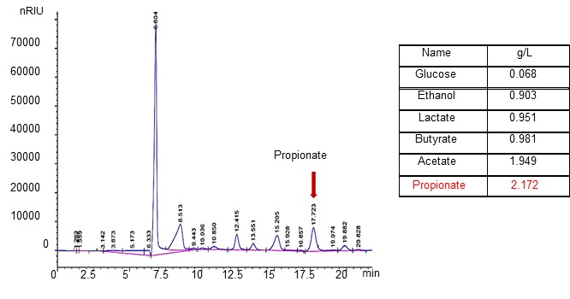

Supplementary Fig. S1 Determination of short chain fatty acid in BT sup
The concentration of propionic acid was determined using a high performance liquid chromatography (HPLC) system (1200 series, Agilent, USA) that had a refractive index detector (RID) and an ion-exchange column (300 ´ 78 mm; Aminex HPX-87H; Bio-Rad, USA). The mobile phase was 2.5 mM H₂SO₄, the flow rate was 0.6 mL/min, the column temperature was 65°C, and the RID was maintained at 45°C
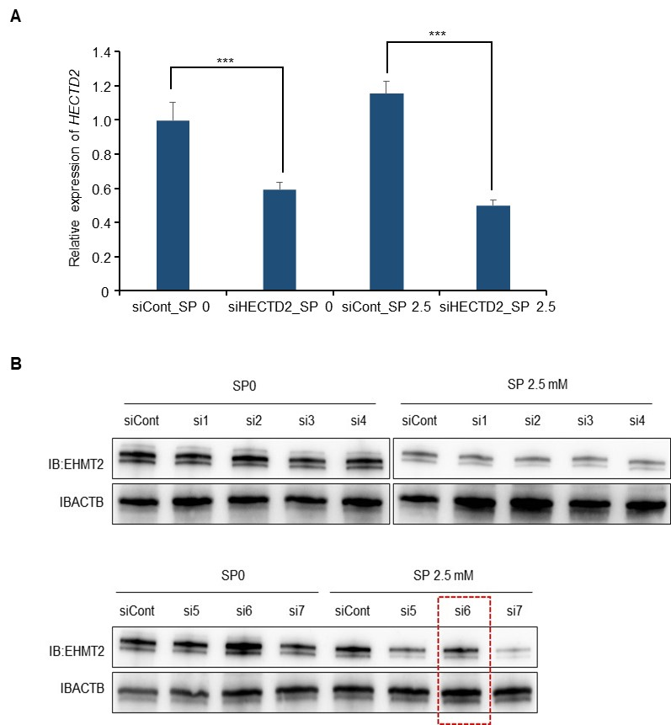

Supplementary Fig. S2 Screening for identification of E3 ligase for EHMT2 degradation
a. qRT-PCR analysis of HECTD2 expression after treatment with siHECTD2 and siControl. p values were calculated using Student’s t-tests (***p < 0.001). b Western blot analysis of EHMT2 after treatment of siNEURL1B, siRNF128, siHERC6, siHERC3, siHECTD3, siHECTD2, and HERC1 and SP for 48h. ACTB was used as the internal control. (siCont: siRNA Control, si1:NEURL1B, si2:RNF128, si3:HERC6, si4:HERC3, si5:HECTD3, si6:HECTD2, si7:HERC1)

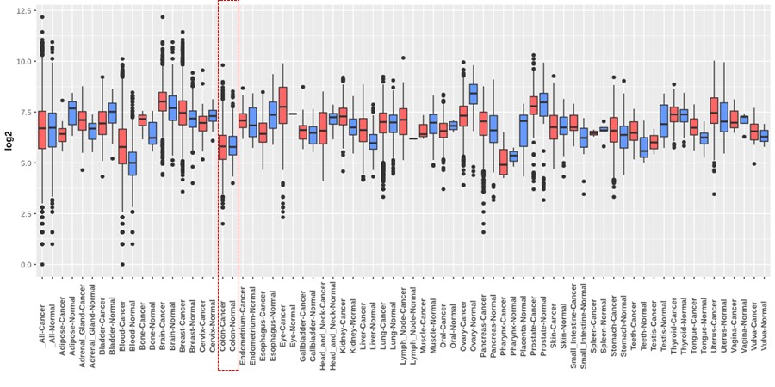

Supplementary Fig. S3 The expression of HECTD2 in several types of cancer.
Tissue-wide expression profile of HECTD2 in several types of cancer and normal tissues using GENT2 analysis (http://gene2.appex.kr/gent2/).

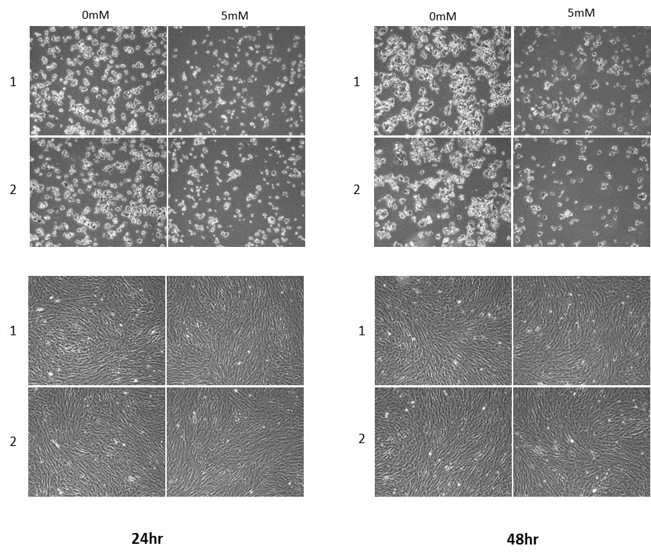

Supplementary Fig. S4 Propionate treatment did not affect cell growth in normal enterocytes.
Cell growth assay with crystal violet staining in HCT116 (upper) and normal enterocyte (lower). After treatment with propionic acid (0 and 5 mM), cells were fixed with 100% methanol and stained with crystal violet.

