Application Exercise for Stroke Medicine TBL
- You are the Physician Associate working in A&E. Your next patient is a 56 year old woman who presents with sudden onset left sided weakness. Which is your initial investigation?
A MRI head
B CT head
C Bedside Blood sugar
D Blood pressure
E ECG

- You are a Physician Associate working in General Practice. Your next patient is a 64 year old woman who presents with right arm weakness that lasted for 30 minutes. This is her 3rd episode in 2 months. You note that she had been referred to the TIA clinic during her last episode and the outcome was ‘unlikely TIA’.

What is the most likely diagnosis?
A TIA
B Migraine
C Recurrent Strokes
D Todd’s Paresis
E Multiple Sclerosis

- A 30-year-old man presents with sudden onset right sided weakness and aphasia. His CT head scan shows a left middle cerebral artery (MCA) infarct. He is admitted to the Stroke Unit. After 24 hours his right sided weakness worsens and his GCS drops from 14 to 8. The Stroke team perform a repeat CT head (shown below). The consultant asks the Physician Associate student to interpret this CT scan. The student states ‘there is no blood as there are no bright areas within the brain tissue but there is increase in the dark area’.
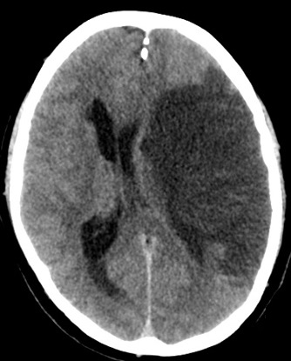
What is the most likely cause for this deterioration?

A New haemorrhagic Stroke
B Haemorrhagic transformation
C New left MCA infarct
D Left MCA syndrome
E Seizure
Describe how you would manage this patient
____________________________________________
____________________________________________
_____________________________________________

- You are a Physician Associate working in the Stroke clinic. Your next patient had a Stroke 4 weeks ago. As part of his work-up, he had an ECG and 24 hour tape that showed no significant abnormalities. You examine his pulse today and it is irregular.

What is the next most appropriate management step?
A ECG
B 24 hour cardiac monitor
C Start Apixaban
D Echo
E Start Clopidogrel

- You are a PA working in a GP practice. Your next patient is John Smith. He has noticed that the left side of his face has become ‘droopy’ since yesterday. He denies any other symptoms. He has a past medical history of type 2 Diabetes and hypertension. When you examine him, you notice the left facial droop. He is able to raise both eyebrows.


What is the most likely diagnosis?
- TIA
- Stroke
- Bell’s Palsy
- Migraine
- Seizure

- Please watch the following video
TBL AE Stroke medicine - YouTube
What is the differential diagnosis?

Outline your management plan for this patient

