Additional Table 1 | Fast-Track Esophagectomy Protocol on Esophageal Cancer Patient.
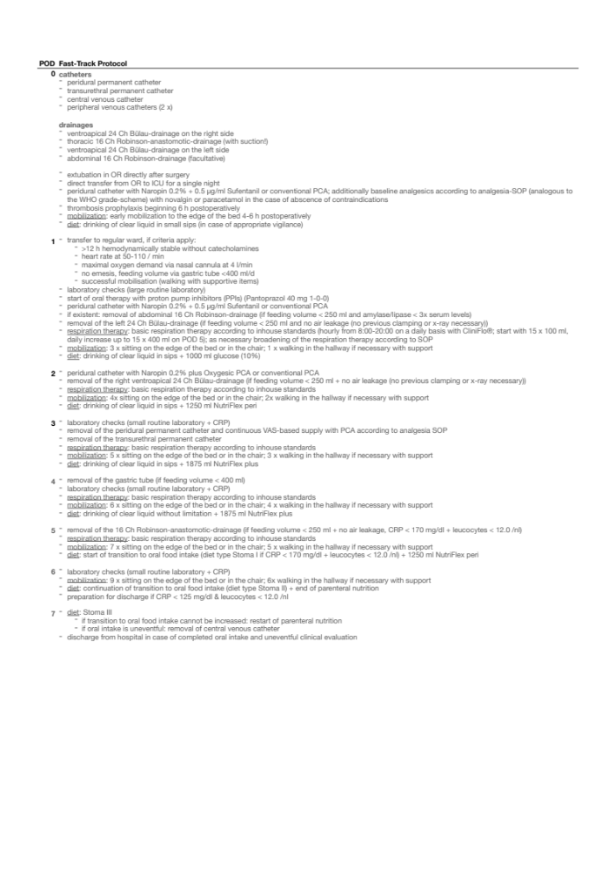
Ch Charrière, ICU intensive care and intermediate care unit, IV intravenous, NGT nasogastric tube, OR operation room, PCA patient controlled analgesia, POD postoperative day, PPI proton pump inhibitor, SOP standard operating procedure, WHO World Health organization.

Additional Table 2 | STOMA diet levels.
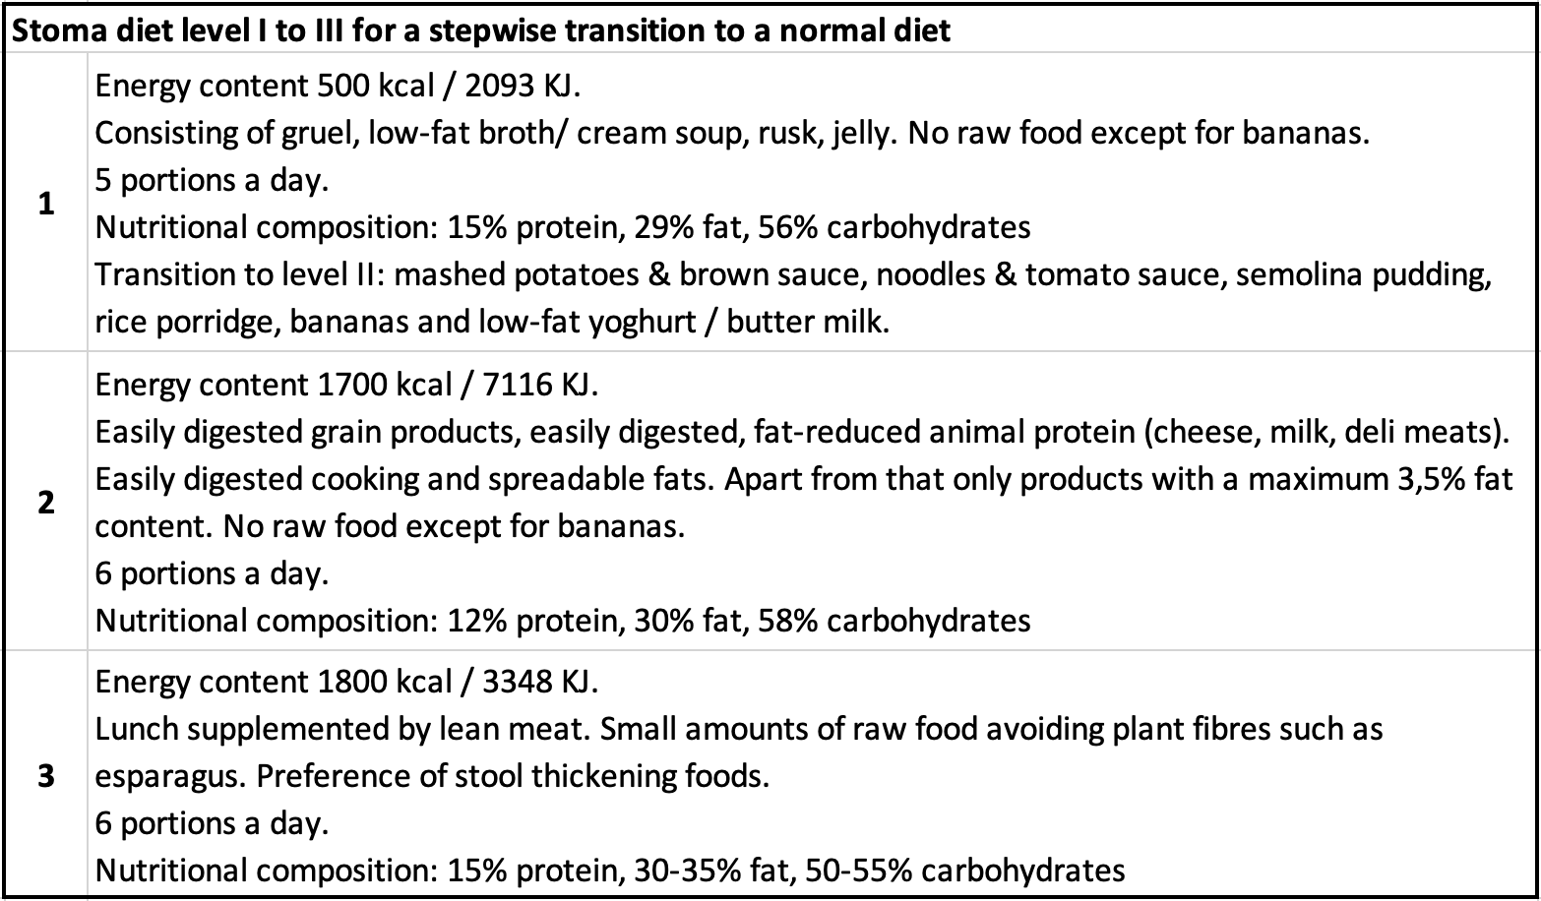
A scheme of a stepwise transition to a normal diet after visceral surgery according to in-house-standards of the University Hospital of Heidelberg.

