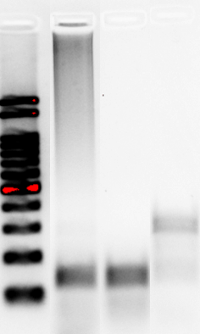
Mycoplasma
Internal control
CMC-Fb03
N
P

Supplement figure 1. PCR results of Mycoplasma detection for CMC-Fb-003 hiPSC.

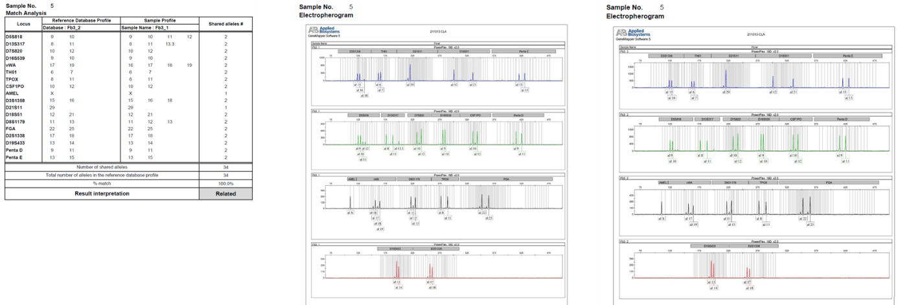
Supplement figure 2. Cell line authentication by short tandem repeat analysis. STR analysis shows 100% match between PBMC and hiPSC line in CMC-Fb-003
STR, short tandem repeat; hiPSC, human induced pluripotent stem cells

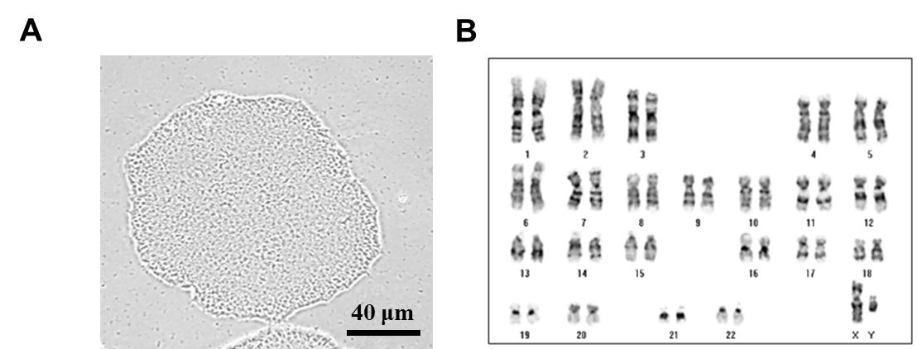

Supplement figure 3. Characterization of CMC-Fb-003 cells. (A) Typical morphology of hiPSC colony of CMC-Fb-003 hiPSC. Scale bar = 40μm. (B) Chromosome karyotyping of CMC-Fb03 hiPSC.
hiPSC, human induced pluripotent stem cells

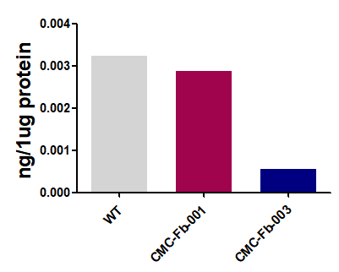

Supplement figure 4. Lyso-Gb-3 level in kidney organoids
Gb-3, globotriaocylceramide

