Supplementary Material

Supplementary Figures
Fig. S1 Study design. EOT, end of treatment; DLT, dose-limiting toxicity; PD, progressive disease; PK, pharmacokinetics. The dose-escalation study consisted of 4 periods: screening (up to 28 days), DLT observation (28 days), extended treatment (3 weeks/cycle), and follow-up. The DLT observation period included a 3-day single-dose period (Cycle 0), a 21-day multiple-dose period (Cycle 1 Day 1 to Day 21), and a 4-day safety observation period (Cycle 1 Day 22 to Day 25). The study drug was given on the first day of the single-dose period (Cycle 0 Day 1) and every day during the multiple-dose period. The first cycle of the extended treatment period was denoted as Cycle 2.
Fig. S2 Patient disposition
Fig. S3 Dose-escalation process.
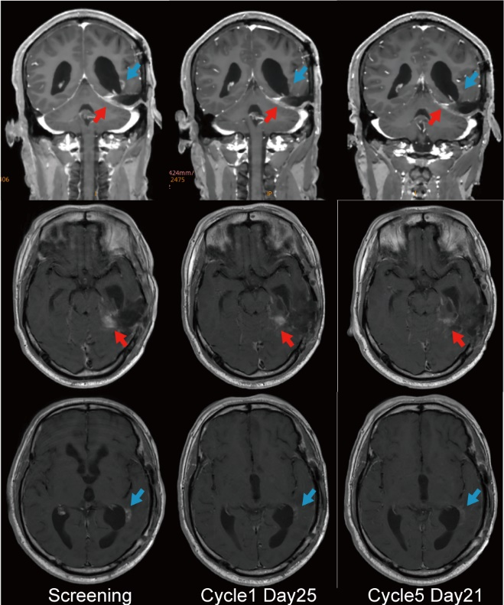
Fig. S4 Representative MRI images of a patient with Objective Response. The baseline MRI shows a target lesion (red arrow) that measured perpendicular diameters of 17.5 mm and 11.2 mm in the left temporal lobe. The tumor decreased in volume by 36.2% at Cycle1 Day25 and by 88.4% at Cycle 5 Day 21, which reflects the RANO criteria of stable disease and partial response. A non-target lesion (blue arrow) in the baseline image and follow-up images that complete disappearance at Cycle 5 Day 21.
Fig. S5 Representative FLAIR MRI images to show the reduction in cerebral edema by SYHA1813.
Fig.S6 Post-treatment changes in plasma PlGF (a), VEGFA (b), sVEGFR2 (c), and CSF1 (d) for individual patients.

Supplementary Tables
Supplementary Table S1. DLT definition
Toxicity | Occurrence of any of the following AE
Hematological toxicity | - Febrile neutropenia (absolute neutrophil count < 1.0×10⁹ /L with a single temperature > 38.3°C or a sustained temperature ≥ 38°C for more than 1 h) ≥ 7 days;  - Grade 4 neutropenia lasting ≥ 7 days (two above allow to use therapeutic colony-stimulating factors);  - Grade 4 thrombocytopenia;  - Grade 3 thrombocytopenia with bleeding.
Non-hematological toxicity | Any other grade ≥ 3 non-hematological AE except for the following:  - ≥ Grade 3 neurological events in patients with brain tumor, possibly caused by the brain lesion, brain surgery or anticipated brain postoperative complication;  - Any grade Seizure in patients with brain tumor;  - ≥ Grade 3 thrombotic events after brain tumor surgery;  - Grade 3 transient abdominal pain (≤ 24 hours), headache and fever, etc., recovered to Grade 2 or baseline level after treatment;  - Grade 3 electrolyte disturbance/appetite/nausea/vomiting/diarrhea/fatigue, relieved to ≤ Grade 2 or baseline level within 3 days after best support care;  - Grade 3 abnormal liver function, recovered to grade 2 or baseline level within 7 days after treatment;  - Grade 3 elevated blood pressure/proteinuria, relieved spontaneously or drug-controlled to ≤ grade 2 within 3 days;  - Allergic reaction;  - Other Grade 3 toxicities, recovered to ≤ grade 2 within 3 days without special treatment or after supportive treatment.
Supplementary Table S2. Treatment-related adverse events (≥ 10% of patients in either treatment group)
MedDRA-Preferred Term, n (%) | 5 mg (n=1) |  | 15 mg (n=8) |  | 30 mg (n=5) |  | All (n=14)
MedDRA-Preferred Term, n (%) | Any grade | Grades 3-4 | Any grade | Grades 3-4 | Any grade | Grades 3-4 | Any grade | Grades 3-4
Laboratory abnormalities
Platelet count decreased | 0 | 0 | 1(12.5) | 0 | 2(40.0) | 2(40.0) | 5(35.7) | 2(14.2)
ALT increased | 0 | 0 | 2(25.0) | 0 | 2 (40.0) | 0 | 4(28.6) | 0
AST increased | 0 | 0 | 1(12.5) | 0 | 2(40.0) | 0 | 3(21.4) | 0
Blood LDH increased | 0 | 0 | 2(25.0) | 0 | 1(20.0) | 0 | 3(21.4) | 0
α-HBDH increased | 0 | 0 | 2(25.0) | 0 | 0 | 0 | 2(14.3) | 0
Neutrophil count decreased | 0 | 0 | 1(12.5) | 0 | 1(20.0) | 0 | 2(14.3) | 0
Lymphocyte count decreased | 0 | 0 | 1(12.5) | 0 | 1(20.0) | 0 | 2(14.3) | 0
White blood cell decreased | 0 | 0 | 1(12.5) | 0 | 1(20.0) | 0 | 2(14.3) | 0
Hypertriglyceridemia | 0 | 0 | 2(25.0) | 0 |  | 0 | 2(14.3) | 0
Cholesterol high | 0 | 0 | 2(25.0) | 0 | 0 | 0 | 2(14.3) | 0
Hyperlipidemia | 0 | 0 | 1(12.5) | 0 | 1(20.0) | 0 | 2(14.3) | 0
Proteinuria | 0 | 0 | 0 | 0 | 2(40.0) | 0 | 2(14.3) | 0
Clinical adverse events
Hypertension | 0 | 0 | 2(25.0) | 1(12.5) | 4(80.0) | 4(80.0) | 6(42.9) | 5(35.7)
Sinus bradycardia | 0 | 0 | 2(25.0) | 0 | 3(60.0) | 0 | 5(35.7) | 0
Mucositis oral | 0 | 0 | 0 | 0 | 1(20.0) | 1(20.0) | 2(14.3) | 1(7.1)
Abbreviations. ALT, alanine aminotransferase; AST, aspartate aminotransferase; LDH, lactate dehydrogenase; α-HBDH, alpha-hydroxybutyrate-dehydrogenase.
Supplementary Table S3. Clinical response to SYHA1813 therapy
 | 5 mg  (n=1) | 15 mg  (n=5) | 30 mg  (n=4) | All  (n=10)
Best overall response, n (%)
Complete response | 0 | 0 | 0 | 0
Partial response | 0 | 1(20) | 1(25) | 2(20)
Stable disease | 1(100) | 4(80) | 2(50) | 7(70)
Progressive disease | 0 | 0 | 1(25) | 1(10)
Overall response rate (CR/PR), n (%) | 0 | 1(20) | 1(25) | 2(20)
Disease control rate (CR/PR/SD), n (%) | 1(100) | 5(100) | 3(75) | 9(90)
Abbreviations: CR, complete response; PR, partial response; SD, stable diseas. Note. Central nervous system tumors were evaluated according to the RANO standard and solid tumors were measured according to RECIST version 1.1 criteria.

