Supporting Information
Synthesis of MoS₂ with Tubular Hierarchical Structures.
MoS₂ with tubular structures (MS-T) were synthesized by hydrothermal method with ammonium molybdate tetrahydrate ((NH₄)₆Mo₇O₂₄∙4H₂O) and thioacetamide (TAA) as raw materials, and tetramethylammonium bromide (TMAB) as additive. In a typical synthesis, (NH₄)₆Mo₇O₂₄∙4H₂O (0.024 mol/L), TAA (0.42 mol/L) and TMAB (0.42 mol/L) were dissolved in deionized water. After stirring for 30 min, the obtained suspension as hydrothermally treated in a 100 mL Teflon-lined autoclave at 200 °C for 6 h. The precipitate was filtered and dried at 50 °C for 12 h in a vacuum oven.
Theoretical Calculation
The densitiy functional theory (DFT) calculations were performed with CASTEP (J. Quantum Chem. 2000, 77, 895) using ultrasoft pseudopotential, plane-wave basis and periodic boundary conditions. The Perdew-Burke-Ernzerh generalized gradient approximation (GGA-PBE) (Phys. Rev. B, 1992, 45, 13244) function for the exchange-correlation term, and a 340 eV cut-off energy for the plane-wave basis set were used in all relaxation process. The self-consistent field (SCF) tolerance was 2.0 × 10⁻⁶ eV. The k-point was set to 3×3×1 for the Brillouin zone integration. MoS₂ and MoP was modeled by a 2×2 supercell slab, which is periodic in the x and y direction, whereas separated by a 15 Å vacuum region in the z direction to avoid the interactions with the adjacent atomic slabs.
The adsorption free energies of H (ΔG_{H*}) is usually considered as an effective descriptor for HER activity and a catalyst with ΔG_{H*} = 0 can be an excellent candidate for HER. The Gibbs free-energy of H* (ΔG_{H*}) was calculated by the equation ΔG_{H*} = ΔE_{H*} + 0.24 eV instead of ΔG_{H*}= ΔE_{H*} + ΔE_{ZPE} – TΔS.

Table S1 Relative molar percentage of measured elements evaluated with EDX elemental mapping
Sample | relative molar percentage of measured elements (%)
Sample | Mo | S | P
MoP/MoS₂-0 | 34.40 | 65.60 | \
MoP/MoS₂-1/3 | 34.47 | 62.11 | 3.42
MoP/MoS₂-1 | 35.03 | 59.88 | 5.09
MoP/MoS₂-5 | 35.63 | 57.47 | 6.90
MoP/MoS₂-40 | 50.91 | \ | 49.19

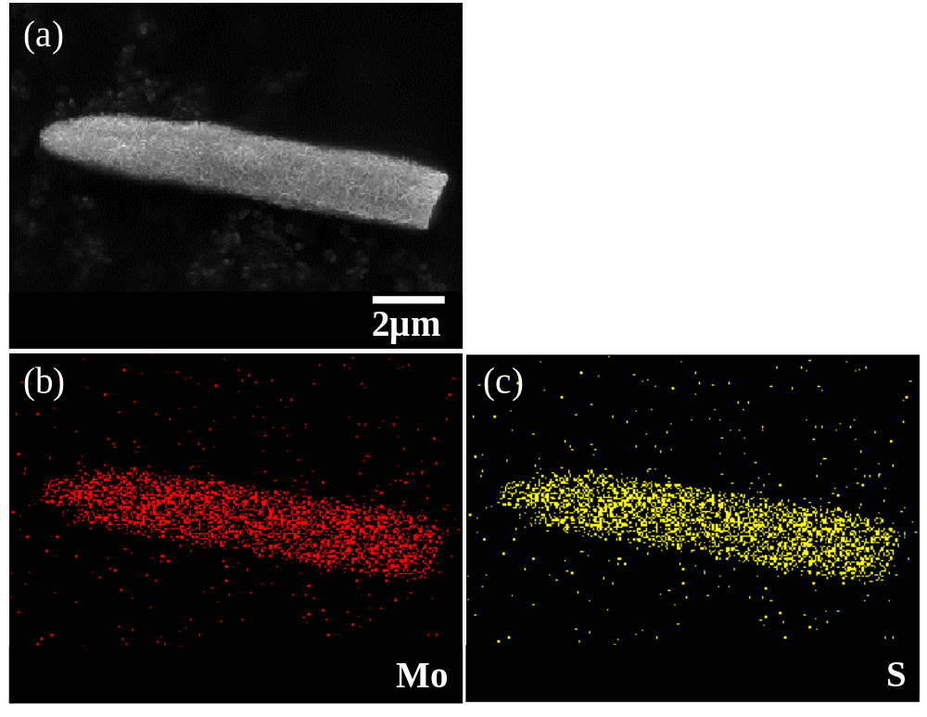
Fig. S1 SEM image (a) and elemental mapping images of Mo and S for MoS₂

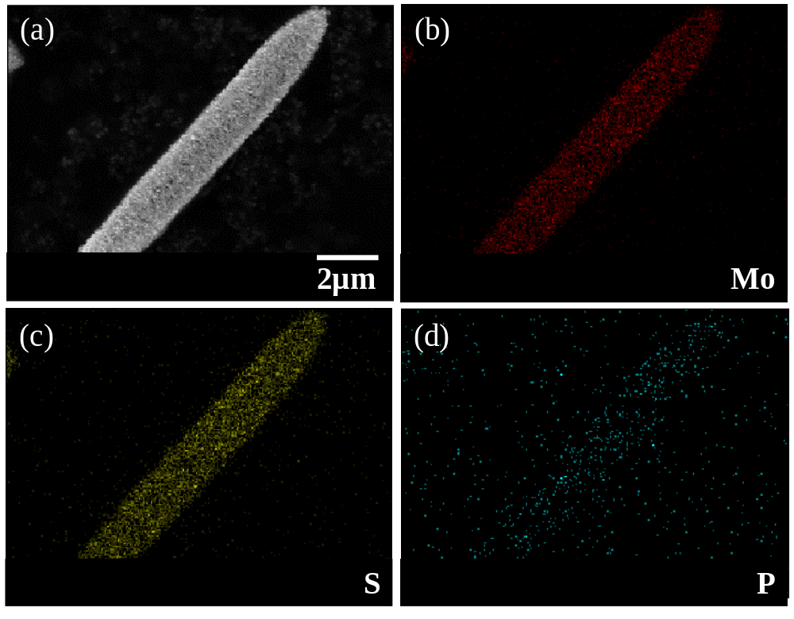
Fig. S2 SEM image (a) and elemental mapping images of Mo (b), S (c) and P (d) for MoP/MoS₂-1/3

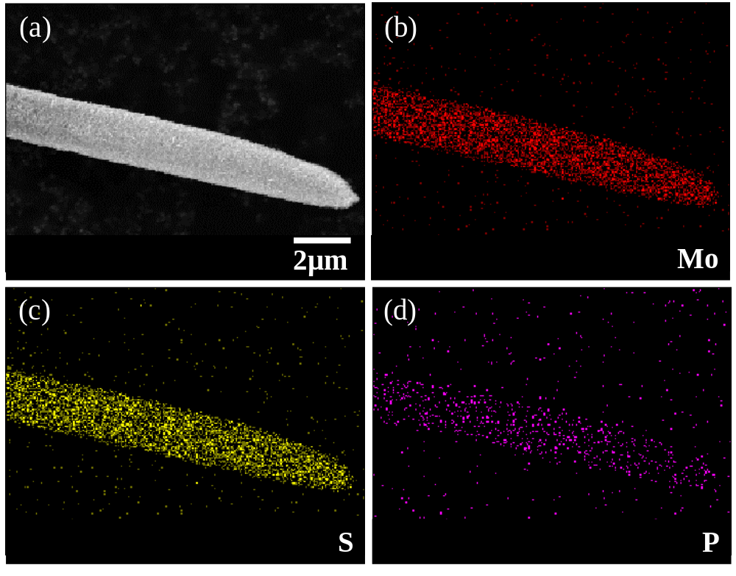
Fig. S3 SEM image (a) and elemental mapping images of Mo (b), S (c) and P (d) for MoP/MoS₂-5

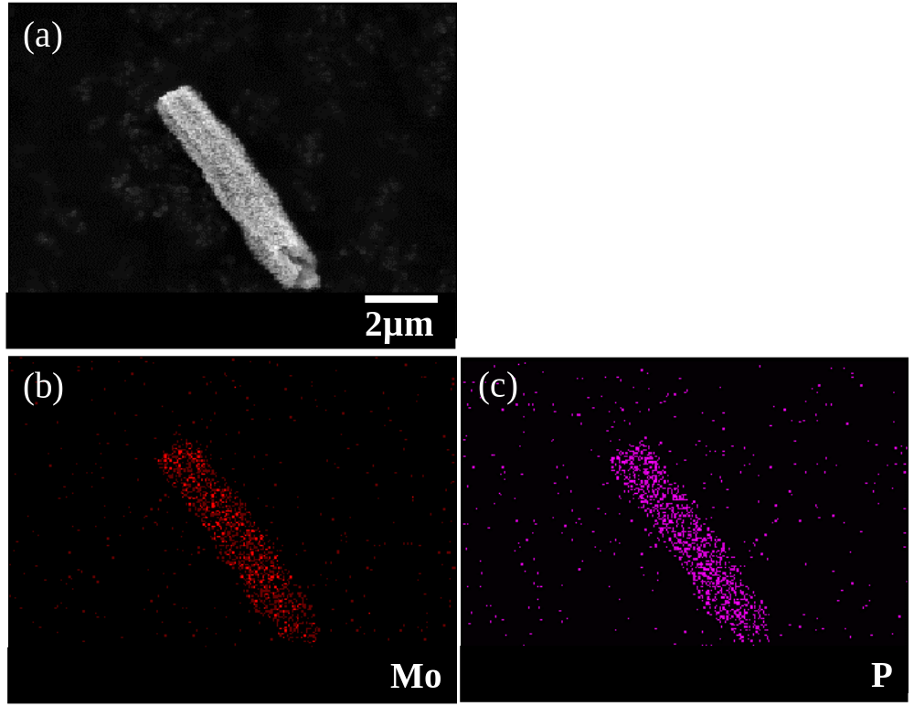
Fig. S4 SEM image (a) and elemental mapping images of Mo (b) and P (c) for MoP/MoS₂-40

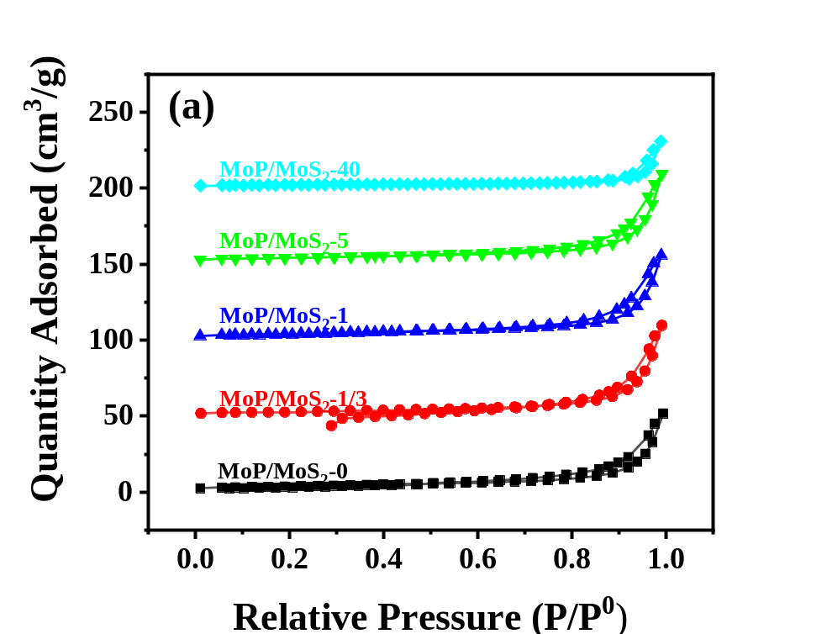
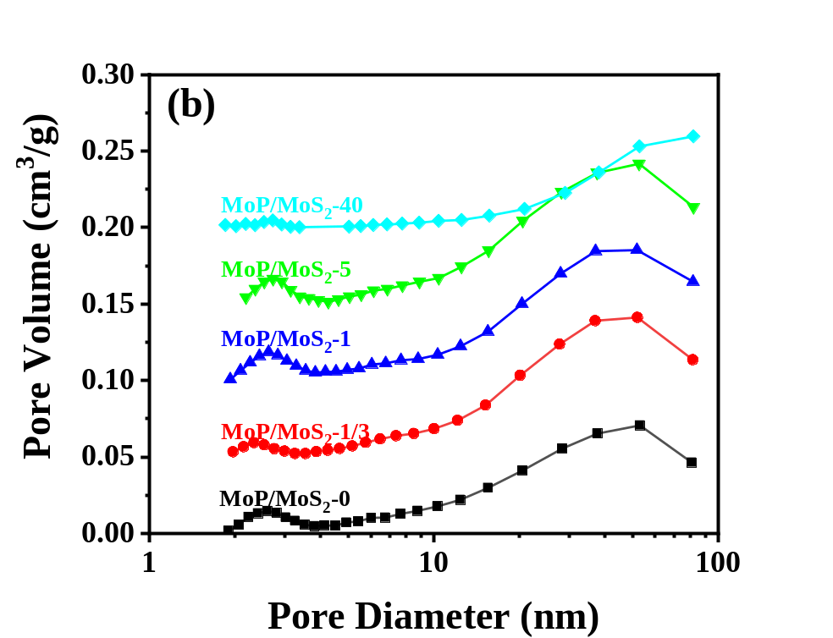
Fig. S5 Nitrogen sorption isotherms (a) and pore size distribution curves (b) of MoP/MoS₂-0, MoP/MoS₂-1/3, MoP/MoS₂-1, MoP/MoS₂-5 and MoP/MoS₂-40

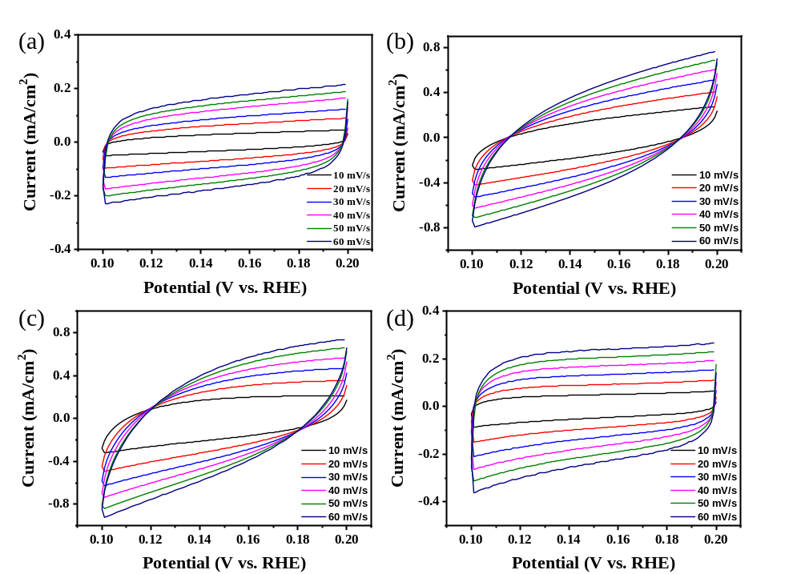
Fig. S6 CV of MoP/MoS₂-0 (a), MoP/MoS₂-1/3 (b), MoP/MoS₂-5 (c) and MoP/MoS₂-40 (d) with rates from 10 to 60 mV/s

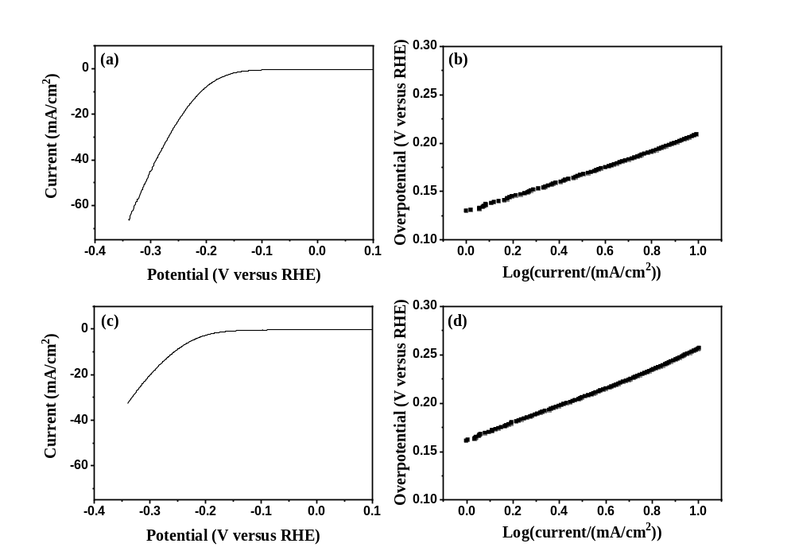
Fig. S7 Polarization curves (a,c) and Tafel plots (b,d) for MoP/MoS₂-1 in 1 M KOH (a,b) and 1 M PBS (c,d)

