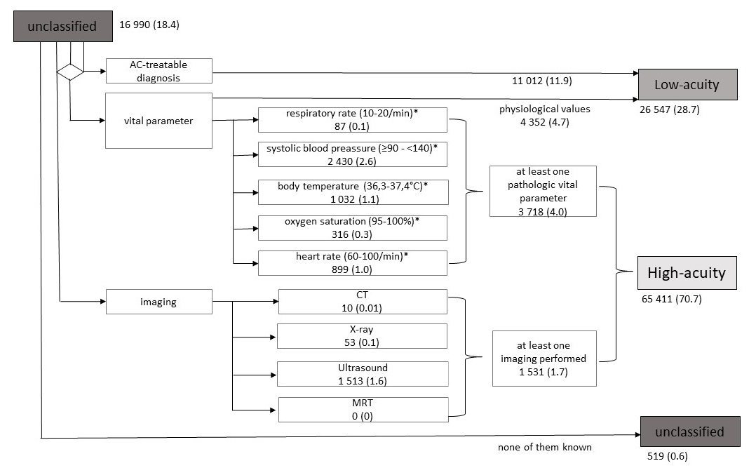
Figure 1S: Sensitivity analysis regarding further classification of previously unclassified ED-presentations. AC – ambulatory care, CT – computer tomography, MRT – magnet resonance tomography.

