RECOVERY PERIOD OF AIR TRANSPORTATION: VECTOR ERROR CORRECTION MODEL

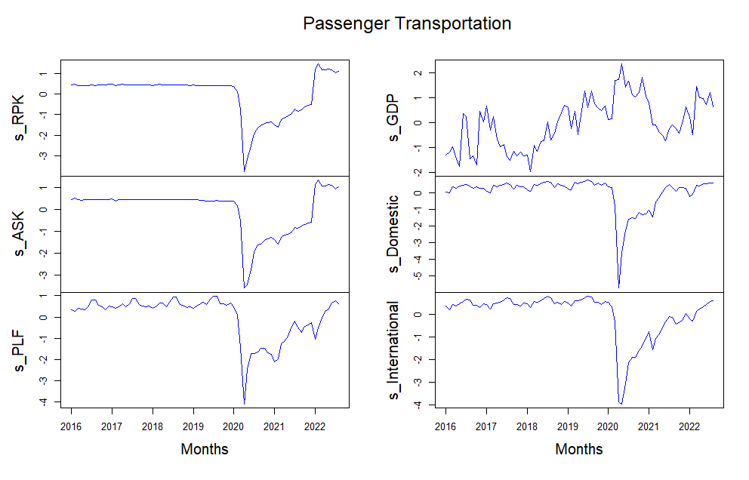

Figure 1. The standardized time series plot of comparing s_RPK, s_GDP, s_Domestic, s_International, s_PLF and s_ASK

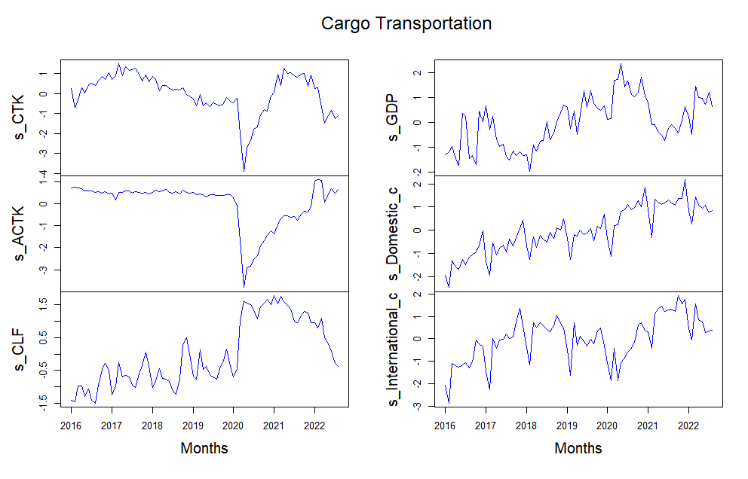
Figure 2. The standardized time series plot of comparing s_CTK, s_ACTK, s_GDP, s_Domestic, s_International, and s_CLF

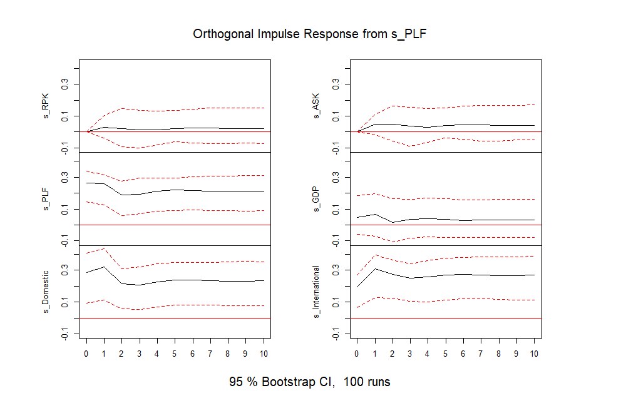
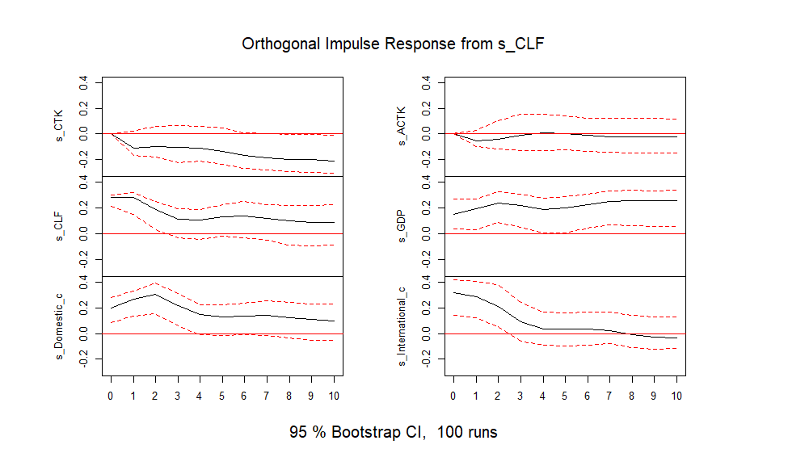
Figure 3. s_PLF and s_CLF impulse response

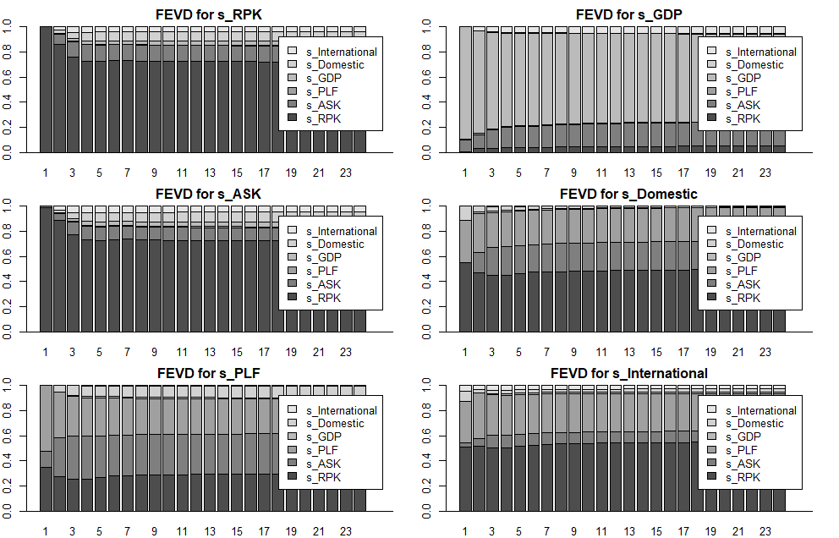

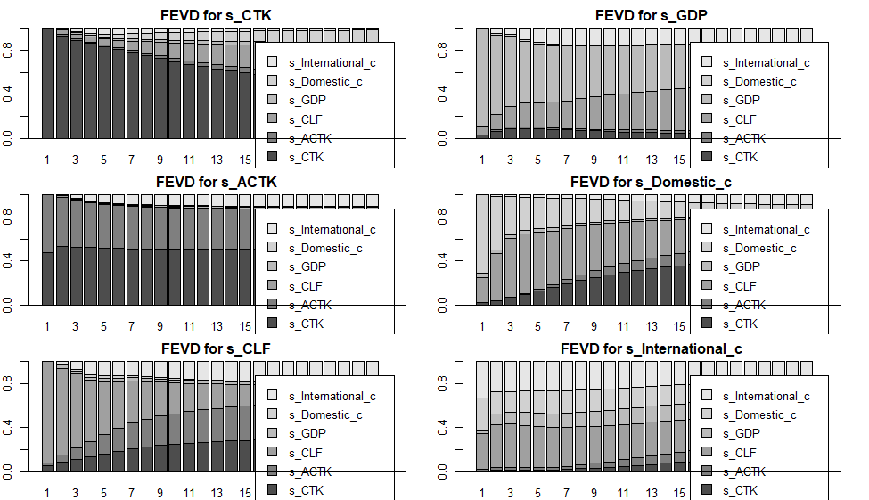

Figure 4. Error variance decomposition of forecasting

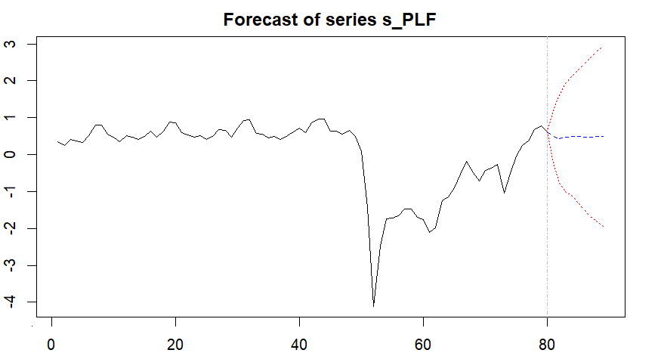
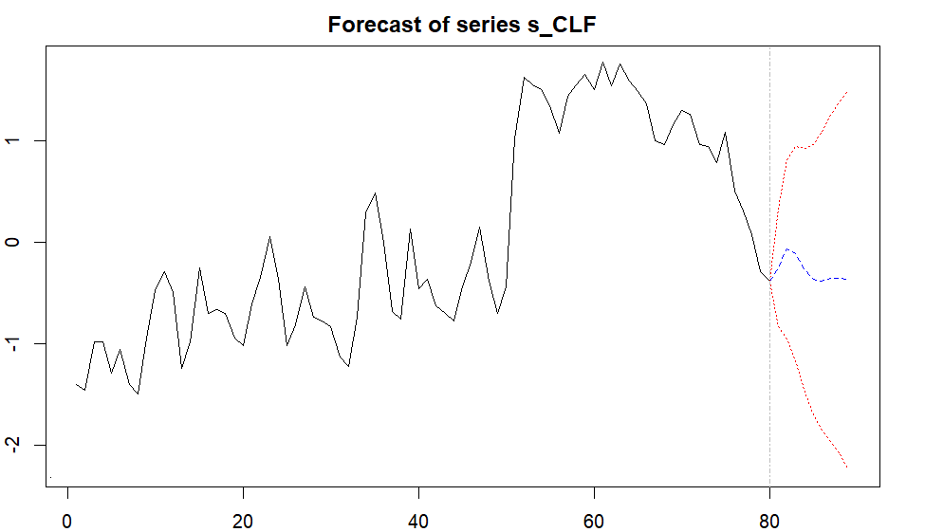

Figure 5. The forecast of s_PLF and s_CLF

