Supplementary Appendix

Figure S1: The Setup and scenario of VR-Rehab system
Figure S2: The chage of TUGT in VR group and AV group
Figure S3: The secondary outcomes of VR group and AV group at each test visit
Table S1: The mean value of QSM in VR and AV group from Baseline(Pre) to Post 14w
Table S2: The Volume value of QSM in VR and AV group from Baseline(Pre) to Post 14w
Table S3: Primary and secondary efficacy outcomes assessed from Baseline（Pre）to Post 6w and 14w in the H&Y<2.5 group and H&Y ≥2.5 group
Table S4: Primary and secondary efficacy outcomes assessed from Baseline（Pre）to Post 6w and 14w in the age < 70 years old and age ≥ 70 years old group
Table S5: Primary and secondary efficacy outcomes assessed from Baseline（Pre）to Post 6w and 14w in the disease duration < 3 years and disease duration ≥ 3 years group
Table S6: Primary and secondary efficacy outcomes assessed from Baseline（Pre）to Post 6w and 14w in the male group and female group
Table S7: The adverse events during Intervention

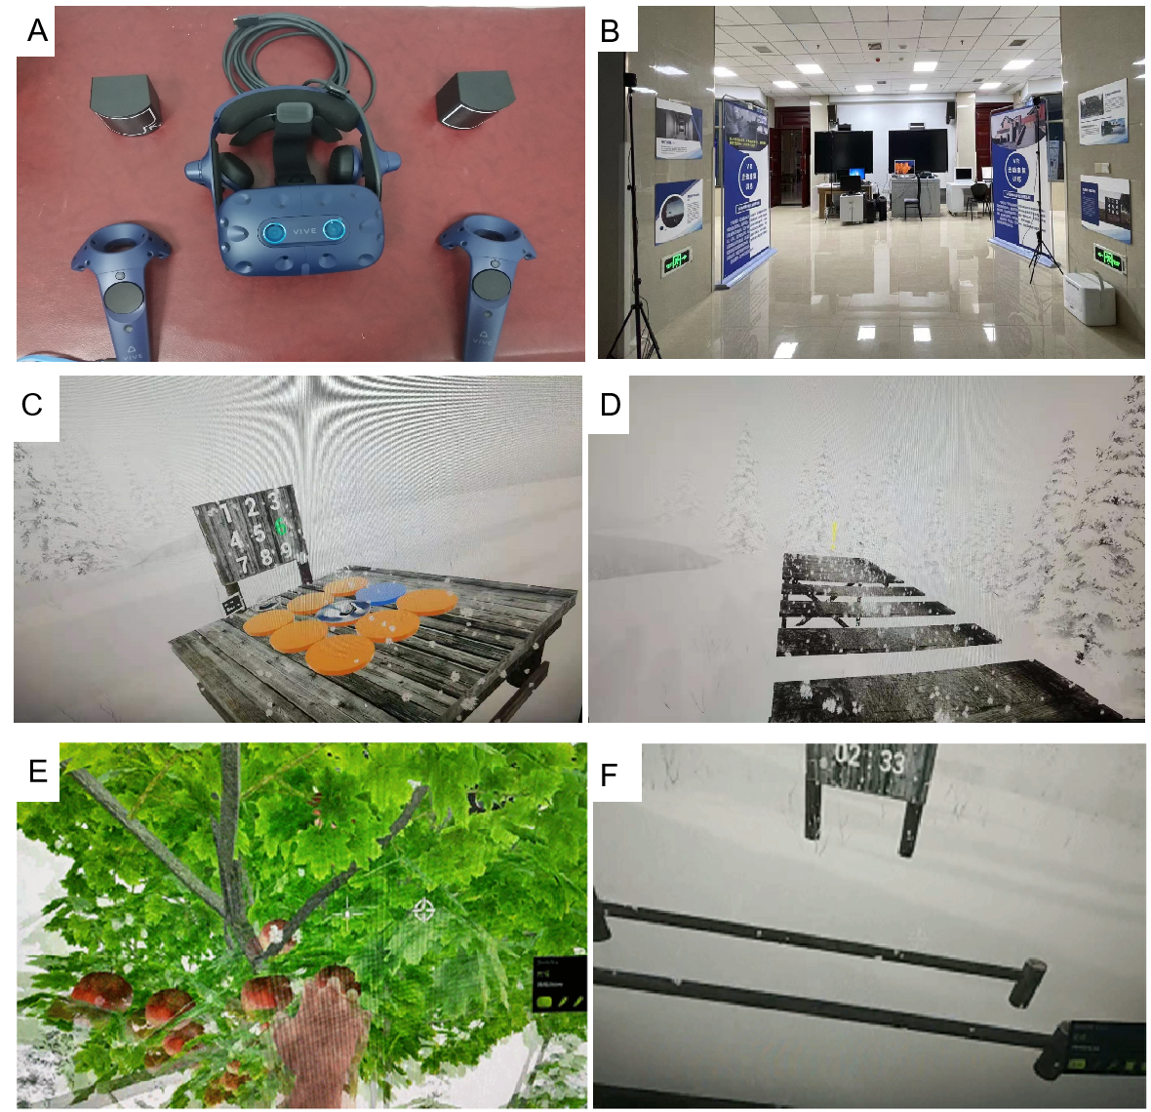

Figure S1:The Setup and scenario of VR-Rehab system: (A)The HTC Vive Pro device comprises of the following elements: A HTC Vive head-mounted display (HMD, HTC Vive Pro) fully immerse the patient in the virtual environment; two base stations equipped with Steam tracking technology to track the patient’s accurate position and motion in virtual environment; two operating handles to track the patient’s movements and transfer the movements onto a virtual limb in the virtual environment. (B) Actual scene diagram of VR-Rehab system.High-configuration computer is used to run the Steam VR software system. The computer generates a virtual environment through the HTC Vive link box and displays it in HMD, and the patient immerse the virtual environment through HMD. Four VR-assisted lower limb gait training scenarios will be available for patients to choose from (nine-grid training(C), single-plank bridge(D), fruit picking(E), training, and crossbar training(F).

Figure S2: The chage of TUGT in VR group and AV group. (A) The change of TUGT in VR group at the Post 6w and 14w visit. (B) The change of TUGT in AV group at the Post 6w and 14w visit. VR：Virtual Reality Group；AV：Audio-visual Group；TUGT：Time Up and Go Test；Pre: Baseline before intervention; Post 6w: 6 weeks postintervention; Post 14w: 14 weeks postintervention; *denotes p < 0.05; **denotes p < 0.01; ***denotes p < 0.001.

Figure S2: The secondary outcomes of VR group and AV group at each test visit. (A) The BBS score at each test visit. (B) The Tinetti score at each test visit. (C) The 6-MWT at each test visit. (D) The UPDRS Ⅲ scores at each test visit. VR：Virtual Reality Group；AV：Audio-visual Group；TUGT：Timed Up and Go Test；BBS：Berg Balance Scale；Tinetti test：Tinetti gait test; 6 MWT：6 Meter Walking Time; Pre: Baseline before intervention; Post 6w: 6 weeks postintervention; Post 14w: 14 weeks postintervention; *denotes P < 0.05; **denotes P < 0.01; ***denotes P < 0.001. *(purple )denotes comparing with Pre test between VR group; *(yellow )denotes comparing with Pre test between AV group.

Table S1: Primary and secondary efficacy outcomes assessed from Baseline（Pre）to Post 6w and 14w in the H&Y<2.5 group and H&Y ≥2.5 group
Outcome | Group Effect | Time Effect | Group × Time Effect
Outcome | F (P Value) | F (P Value) | F (P Value)
Primary Outcome
TUGT | 1.39  (0.259) | 18.477  (<0.001***) | 2.403  (0.035*)
Secondary Outcome
BBS | 6.588  (<0.001***) | 44.513  (0.001**) | 4.528  (0.001**)
Tinetti test | 2.197  (0.105) | 33.723  (<0.001***) | 1.882  (0.096)
6-MWT | 40.719  (<0.001***) | 75.019  (0.007**) | 74.76  (0.05)
UPDRS Ⅲ | 2.806  (<0.001***) | 12.281  (0.052) | 1.44  (0.211)
Analyses were conducted with the use of a Linear mixed models.Values are mean± standard deviation. VR：Virtual Reality Group；AV：Audio-visual Group；TUGT：Time Up and Go Test；BBS：Berg Balance Scale；Tinetti test：Tinetti gait test; 6 MWT：6 Meter Walking Time; *denotes P < 0.05; **denotes P < 0.01; ***denotes P < 0.001.

Table S2: Primary and secondary efficacy outcomes assessed from Baseline（Pre）to Post 6w and 14w in the age < 70 years old and age ≥ 70 years old group
Outcome | Group Effect | Time Effect | Group × Time Effect
Outcome | F (P Value) | F (P Value) | F (P Value)
Primary Outcome
TUGT | 1.499  (0.229) | 28.18  (<0.001***) | 2.193  (0.053)
Secondary Outcome
BBS | 6.052  (<0.001***) | 54.035  (0.002**) | 5.098  (<0.001***)
Tinetti test | 1.124  (0.352) | 49.294  (<0.001***) | 2.688  (0.021*)
6-MWT | 2.793  (0.053) | 33.813(<0.001***) | 1.595  (0.161)
UPDRS Ⅲ | 5.553  (0.003**) | 13.622  (<0.001***) | 0.823  (0.556)
Analyses were conducted with the use of a Linear mixed models.Values are mean± standard deviation. VR：Virtual Reality Group；AV：Audio-visual Group；TUGT：Time Up and Go Test；BBS：Berg Balance Scale；Tinetti test：Tinetti gait test; 6 MWT：6 Meter Walking Time; *denotes P < 0.05; **denotes P < 0.01; ***denotes P < 0.001.

Table S3: Primary and secondary efficacy outcomes assessed from Baseline（Pre）to Post 6w and 14w in the disease duration < 3 years and disease duration ≥ 3 years group
Outcome | Group Effect | Time Effect | Group × Time Effect
Outcome | F (P Value) | F (P Value) | F (P Value)
Primary Outcome
TUGT | 3.198  (0.033*) | 22.555  (<0.001***) | 1.972  (0.08)
Secondary Outcome
BBS | 3.913  (0.016*) | 44.312  (<0.001***) | 1.905  (0.092)
Tinetti test | 5.052  (0.005**) | 40.093  (<0.001***) | 2.333  (0.041*)
6-MWT | 2.793  (0.053) | 29.118  (<0.001***) | 1.595  (0.161)
UPDRS Ⅲ | 5.497  (0.003**) | 15.335  (<0.001***) | 5.497  (0.21)
Analyses were conducted with the use of a Linear mixed models.Values are mean± standard deviation. VR：Virtual Reality Group；AV：Audio-visual Group；TUGT：Time Up and Go Test；BBS：Berg Balance Scale；Tinetti test：Tinetti gait test; 6 MWT：6 Meter Walking Time; *denotes P < 0.05; **denotes P < 0.01; ***denotes P < 0.001.

Table S4: Primary and secondary efficacy outcomes assessed from Baseline（Pre）to Post 6w and 14w in the male group and female group

Outcome | Group Effect | Time Effect | Group × Time Effect
Outcome | F (P Value) | F (P Value) | F (P Value)
Primary Outcome
TUGT | 1.878  (0.149) | 21.621  (<0.001***) | 1.824  (0.106)
Secondary Outcome
BBS | 6.733  (0.001**) | 45.887  (<0.001***) | 4.934  (<0.001***)
Tinetti test | 1.935  (0.141**) | 50.894  (<0.001***) | 3.017  (0.011*)
6-MWT | 3.151  (0.035) | 24.416(<0.001***) | 1.73  (0.126)
UPDRS Ⅲ | 2.412  (0.081) | 15.534  (<0.001***) | 0.775  (0.592)

Analyses were conducted with the use of a Linear mixed models.Values are mean± standard deviation. VR：Virtual Reality Group；AV：Audio-visual Group；TUGT：Time Up and Go Test；BBS：Berg Balance Scale；Tinetti test：Tinetti gait test; 6 MWT：6 Meter Walking Time; *denotes P < 0.05; **denotes P < 0.01; ***denotes P < 0.001.

Table S5: The mean value of QSM in VR and AV group from Baseline(Pre) to Post 14w
Mean(*10-2) | VR |  | AV |  | P（VR） | P（AV）
Mean(*10-2) | Pre | Post 14w | Pre | Post 14w | P（VR） | P（AV）
Caudate_L | 3.75(0.23) | 3.84(0.26) | 3.94(0.18) | 3.98(0.22) | 0.332 | 0.569
Caudate_R | 3.49(0.23) | 3.43(0.22) | 3.73(0.21) | 3.85(0.29) | 0.035 | 0.796
Globus_pallidus_internal_L | 7.75(0.48) | 7.69(0.44) | 7.92(0.51) | 8.23(0.6) | 0.554 | 0.03
Globus_pallidus_internal_R | 7.43(0.44) | 7.14(0.45) | 7.64(0.6) | 8(0.53) | 0.044 | 0.196
Globus_pallidus_external_L | 10.31(0.44) | 9.99(0.55) | 9.17(0.62) | 10.78(0.43) | 0.287 | 0.109
Globus_pallidus_external_R | 9.74(0.59) | 9.7(0.56) | 10.32(0.63) | 10.87(0.64) | 0.758 | 0.013
Putamen_L | 4.51(0.31) | 4.55(0.33) | 4.63(0.28) | 4.82(0.31) | 0.407 | 0.063
Putamen_R | 4.32(0.32) | 4.3(0.3) | 4.72(0.29) | 4.9(0.3) | 0.758 | 0.079
Thalamus_L | -0.13(0.14) | -0.23(0.16) | -0.25(0.13) | -12.79(12.42) | 0.723 | 0.063
Thalamus_R | -0.46(0.16) | -0.6(0.18) | -0.28(0.3) | -0.56(0.21) | 0.407 | 0.063
Pulvinar_L | 2.69(0.23) | 2.63(0.25) | 2.83(0.25) | 2.81(0.28) | 0.619 | 0.959
Pulvinar_R | 4.18(0.41) | 3.31(0.45) | 3.49(0.32) | 3.64(0.42) | 0.025 | 0.679
Subthalamic_nucleus_L | 6.86(0.52) | 6.72(0.47) | 6.95(0.51) | 7.05(0.58) | 0.653 | 0.877
Subthalamic_nucleus_R | 7.79(0.5) | 7.45(0.55) | 7.79(0.54) | 7.94(0.57) | 0.21 | 0.569
Substantia_nigra_L | 8.33(0.55) | 8.51(0.55) | 8.31(0.61) | 8.93(0.73) | 0.309 | 0.01
Substantia_nigra_R | 9.31(0.59) | 8.78(0.58) | 9.59(0.75) | 9.71(0.62) | 0.035 | 0.756
Red_nucleus_L | 9.05(0.58) | 8.78(0.58) | 9.59(0.75) | 9.5(0.65) | 0.149 | 0.605
Red_nucleus_R | 8(0.42) | 7.79(0.42) | 8.02(0.52) | 8.12(0.46) | 0.136 | 0.679
Dentate_L | 5.94(0.31) | 5.97(0.33) | 6.65(0.47) | 6.75(0.47) | 0.619 | 0.501
Dentate_R | 6.15(0.61) | 6.17(0.43) | 6.5(0.51) | 6.45(0.47) | 0.943 | 0.877
Ventricles | 0.55(0.07) | 0.64(0.07) | 0.5(0.1) | 0.5(0.1) | 0.001 | 0.877
CSF | 0.06(0.04) | 0.06(0.04) | 0.02(0.04) | -22.15(22.19) | 0.981 | 0.326
Cortex | 0.14(0.02) | 0.15(0.02) | 0.16(0.03) | 0.13(0.03) | 0.554 | 0.03
White_matter | -0.5(0.06) | -0.5(0.05) | -0.53(0.06) | -0.54(0.05) | 0.795 | 0.179
VR：Virtual Reality Group；AV：Audio-visual Group; Pre: Baseline before intervention; Post 14w: 14 weeks postintervention; *denotes p < 0.05; **denotes p < 0.01.

Table S6: The Volume value of QSM in VR and AV group from Baseline(Pre) to Post 14w

Volume(mm3) | VR |  | AV |  | P（VR） | P（AV）
Volume(mm3) | Pre | Post 14w | Pre | Post 14w | P（VR） | P（AV）
Caudate_L | 4029.01(152.85) | 4059.88(163.29) | 3735.68(145.88) | 3686.34(142.09) | 0.795 | 0.918
Caudate_R | 4262.57(187.75) | 4255.89(191.03) | 3982.93(194.7) | 3973.12(197.79) | 0.868 | 1
Globus_pallidus_internal_L | 511.07(20.05) | 502.2(18.87) | 497.1(22.99) | 494.52(22.49) | 0.287 | 0.877
Globus_pallidus_internal_R | 476.37(17.14) | 464.33(19.06) | 463.26(24.58) | 461(23.48) | 0.179 | 0.877
Globus_pallidus_external_L | 1508.29(36.51) | 1484.53(38.28) | 1537.6(66.08) | 1522.75(78.25) | 0.201 | 0.836
Globus_pallidus_external_R | 1364.56(47.3) | 1325.66(35.05) | 1343.42(67.24) | 1373.64(69.59) | 0.055 | 0.756
Putamen_L | 3852.39(111.56) | 3780.25(103.08) | 3573.72(106.77) | 3502.62(96.66) | 0.098 | 0.605
Putamen_R | 4087.05(113.13) | 4057.94(107.62) | 3694.48(124.88) | 3747.43(120.54) | 0.687 | 0.642
Thalamus_L | 4672.33(115.3) | 4697.18(109.98) | 4417.27(105.54) | 4437.93(110.97) | 0.435 | 0.836
Thalamus_R | 4979.43(108.75) | 5063.06(114.38) | 4569.41(155.23) | 4610.54(164.73) | 0.149 | 0.959
Pulvinar_L | 1031.5(41.31) | 1016.49(45.29) | 992.07(34.75) | 966.88(44.01) | 0.246 | 0.756
Pulvinar_R | 1323.9(75.27) | 1122.42(60.78) | 1071.69(80.42) | 1081.51(96.18) | 0.039 | 0.569
Subthalamic_nucleus_L | 143.01(7.02) | 142.83(7.21) | 153.75(8.95) | 150.85(9.75) | 0.962 | 0.776
Subthalamic_nucleus_R | 144.89(6.99) | 138.87(7.88) | 142(6.35) | 142.39(6.88) | 0.309 | 0.717
Substantia_nigra_L | 541.16(22.44) | 555.92(22.85) | 539.14(28.94) | 542.3(31.67) | 0.076 | 0.776
Substantia_nigra_R | 616.52(29.15) | 575.07(31.13) | 589.38(28.52) | 572.33(27.15) | 0.019 | 0.642
Red_nucleus_L | 591.17(36.16) | 575.07(31.13) | 589.38(28.52) | 535.01(40.57) | 0.068 | 0.438
Red_nucleus_R | 256.11(8.65) | 255.08(10.98) | 246.74(9.4) | 248.87(9.63) | 0.653 | 0.856
Dentate_L | 684.16(46.32) | 704.28(52.63) | 741.45(53.29) | 732.93(52.59) | 0.67 | 0.796
Dentate_R | 736.61(79.5) | 889.77(92.9) | 798.21(85.78) | 860.01(113.92) | 0.193 | 0.877
Ventricles | 41437.95(2910.72) | 41843.94(3046.73) | 41718.42(6385.75) | 41949.47(6378.65) | 0.21 | 0.605
CSF | 322896.28(7591.72) | 322825.05(7459.88) | 290520.19(8945.54) | 294203.04(8895.35) | 0.943 | 0.469
Cortex | 663466.59(12989.15) | 662886.53(12908.72) | 623602.66(14679.94) | 624852.9(14729.34) | 0.523 | 0.836
White_matter | 415358.78(8905.98) | 415422.9(8760.33) | 380047.88(8753.16) | 380611.95(8897.47) | 0.943 | 0.796
VR：Virtual Reality Group；AV：Audio-visual Group; Pre: Baseline before intervention; Post 14w: 14 weeks postintervention; *denotes p < 0.05; **denotes p < 0.01.

Table S7: The adverse events during Intervention

Event | (%) of participants
Event | VR（n=22） | AV（n=22）
Dizziness | 1 | 0
Nausea | 0 | 0
Eye pain | 0 | 0
Disorientation | 0 | 0
Fall | 0 | 0

