Supporting Information

Microwave-assisted High-Throughput Synthesis of Crystalline Porphyrin-based Two-dimensional Polymers for Neuromorphic Vision Sensor

Haoyong Yang^{1,7#}, Qihao Sun^{2#}, Zhongquan Liao⁵, Mike Hambsch⁶, Zhecheng Guo^{2,4}, Daheng Wu¹, Birgit Jost⁵, Yuejun Zhang⁴, Stefan C. B. Mannsfeld⁶, Xinliang Feng^{3*}, Xiaojian Zhu^{2*}, Tao Zhang^{1*}
¹Key Laboratory of Marine Materials and Related Technologies, Zhejiang Key Laboratory of Marine Materials and Protective Technologies, Ningbo Institute of Materials Technology and Engineering, Chinese Academy of Sciences, Ningbo 315201, China;
²CAS Key Laboratory of Magnetic Materials and Devices, Zhejiang Province Key Laboratory of Magnetic Materials and Application Technology, Ningbo Institute of Materials Technology and Engineering, Chinese Academy of Sciences, Ningbo 315201, P. R. China.;
³Faculty of Chemistry and Food Chemistry and Center for Advancing Electronics Dresden (cfaed), Technische Universität Dresden, 01062 Dresden, Germany;
⁴Faculty of Electrical Engineering and Computer Science, Ningbo University, Ningbo, China;
⁵Fraunhofer Institute for Ceramic Technologies and Systems (IKTS), Maria-Reiche-Strasse 2, 01109, Dresden, Germany;
⁶Center for Advancing Electronics Dresden (cfaed) and Faculty of Electrical and Computer Engineering Technische Universität Dresden 01062 Dresden, Germany;
⁷School of Chemical Sciences, University of Chinese Academy of Sciences, Beijing 100049, China;
#These authors contributed equally: Haoyong Yang, Qihao Sun
*Corresponding: xinliang.feng@tu-dresden.de; zhuxj@nimte.ac.cn; tzhang@nimte.ac.cn;

Table of Content

Section A Supplementary Figures 3
Section B Supplementary Table 21
Section C Supplementary Notes 22
Section D References 27

Supplementary Figures

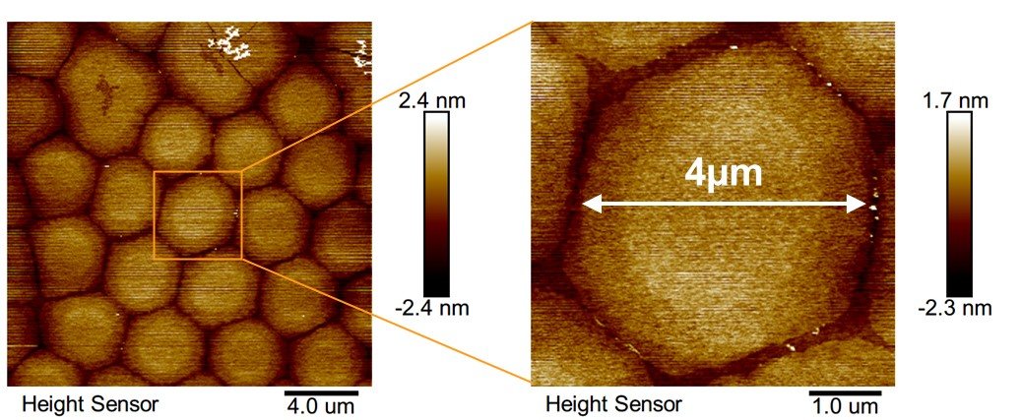

Supplementary Figure 1 | Atomic Force Microscopy image of p2DP after 3 min polymerization transferred onto SiO₂/Si substrate.

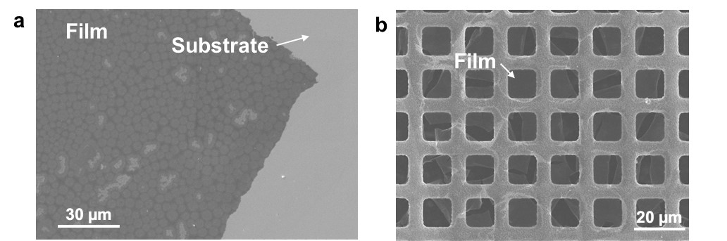
Supplementary Figure 2 | SEM image of the as-prepared p2DP film on Cu/Si substrate (a) and copper grid (b).

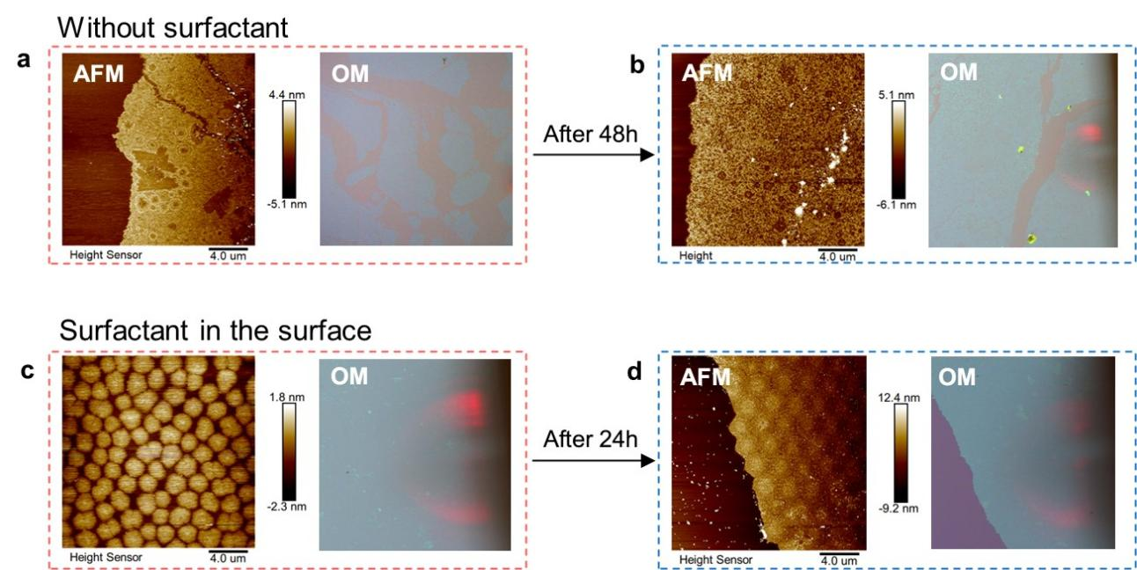
Supplementary Figure 3 | The synthesis of p2DP film assisted with or without surfactant. The morphology of the films after a) 3min and b) 48h reactions without surfactant. The morphology of the film after c) 3min and d) 24h reactions assisted with surfactant.

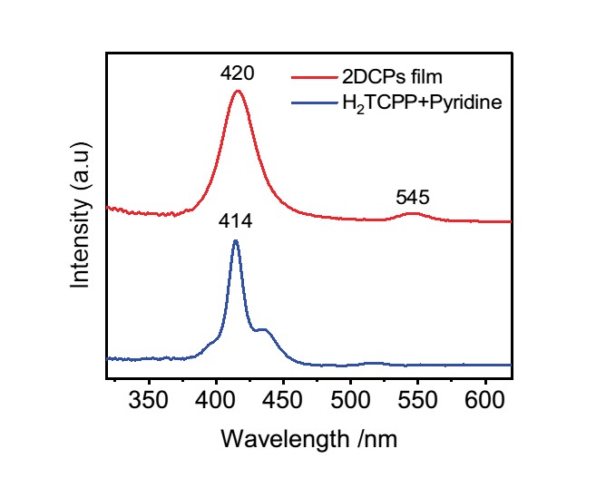
Supplementary Figure 4 | UV-vis absorption spectra of p2DP film and monomer.

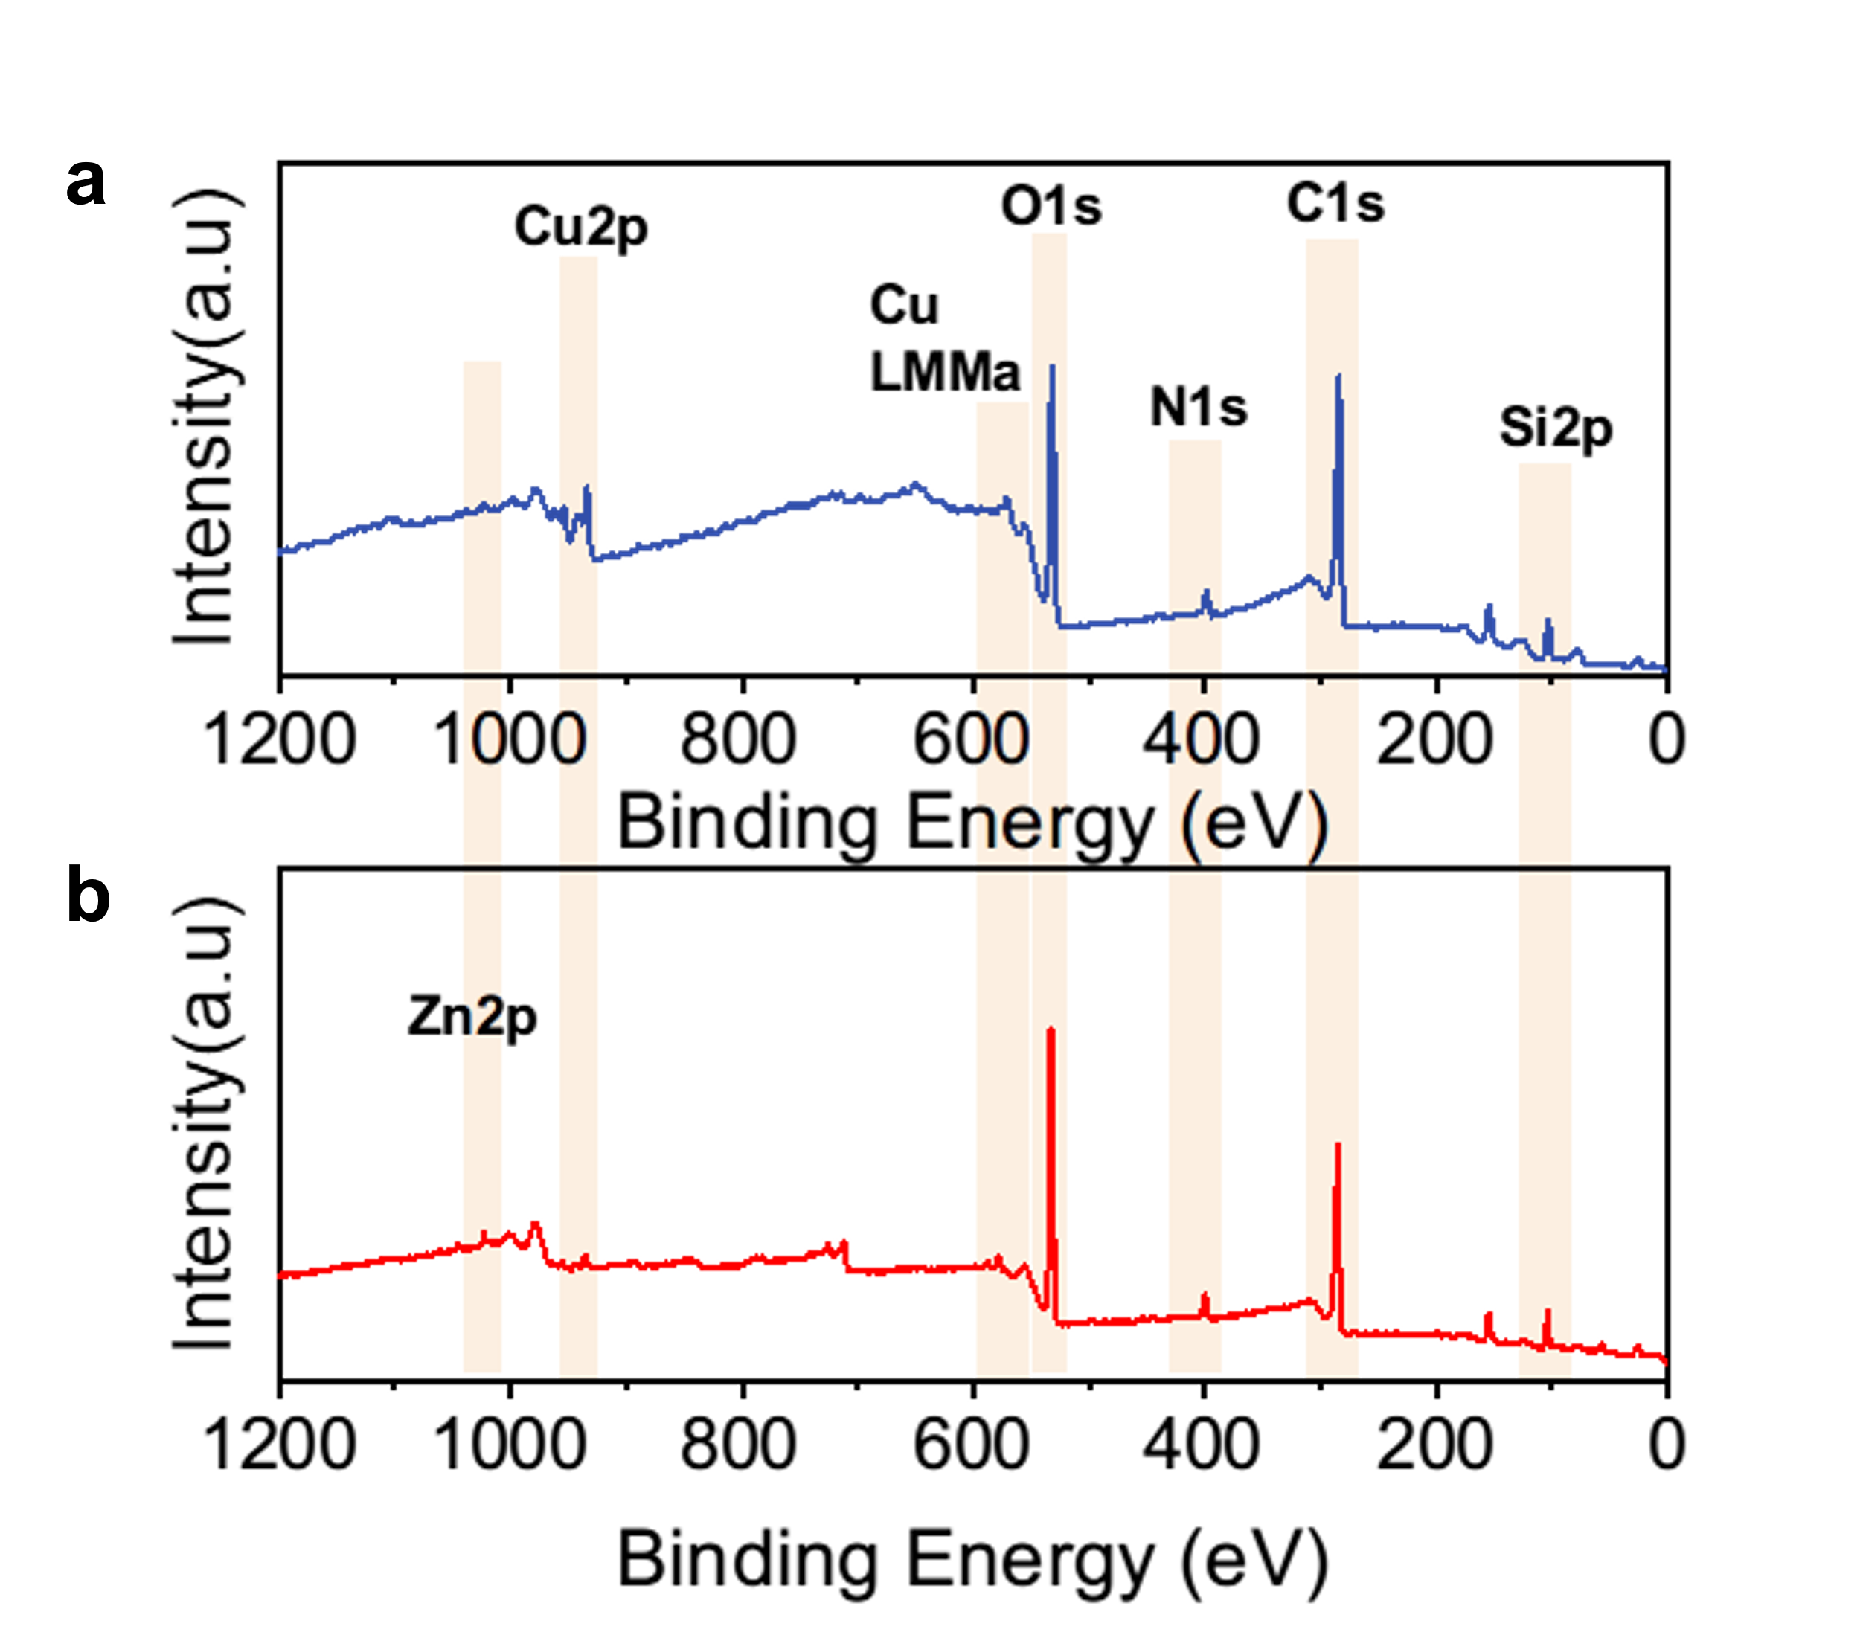
Supplementary Figure 5 | XPS survey scan spectra. a) p2DP film. b) p2DP/ZnO_{NP} heterostructure device.

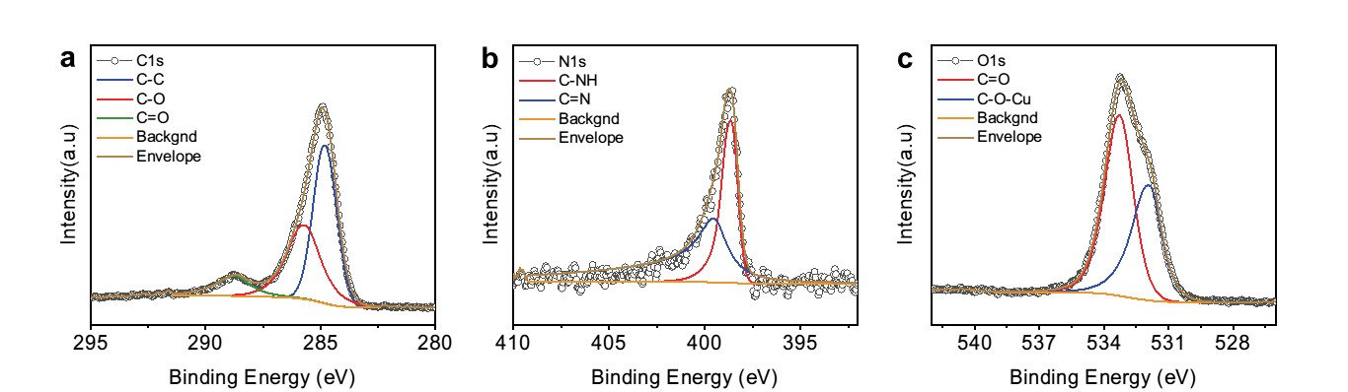
Supplementary Figure 6 | XPS spectra of p2DP film. High-resolution spectrum in the (a) C 1s region, (b) N 1s region and (c) O 1s region, respectively.

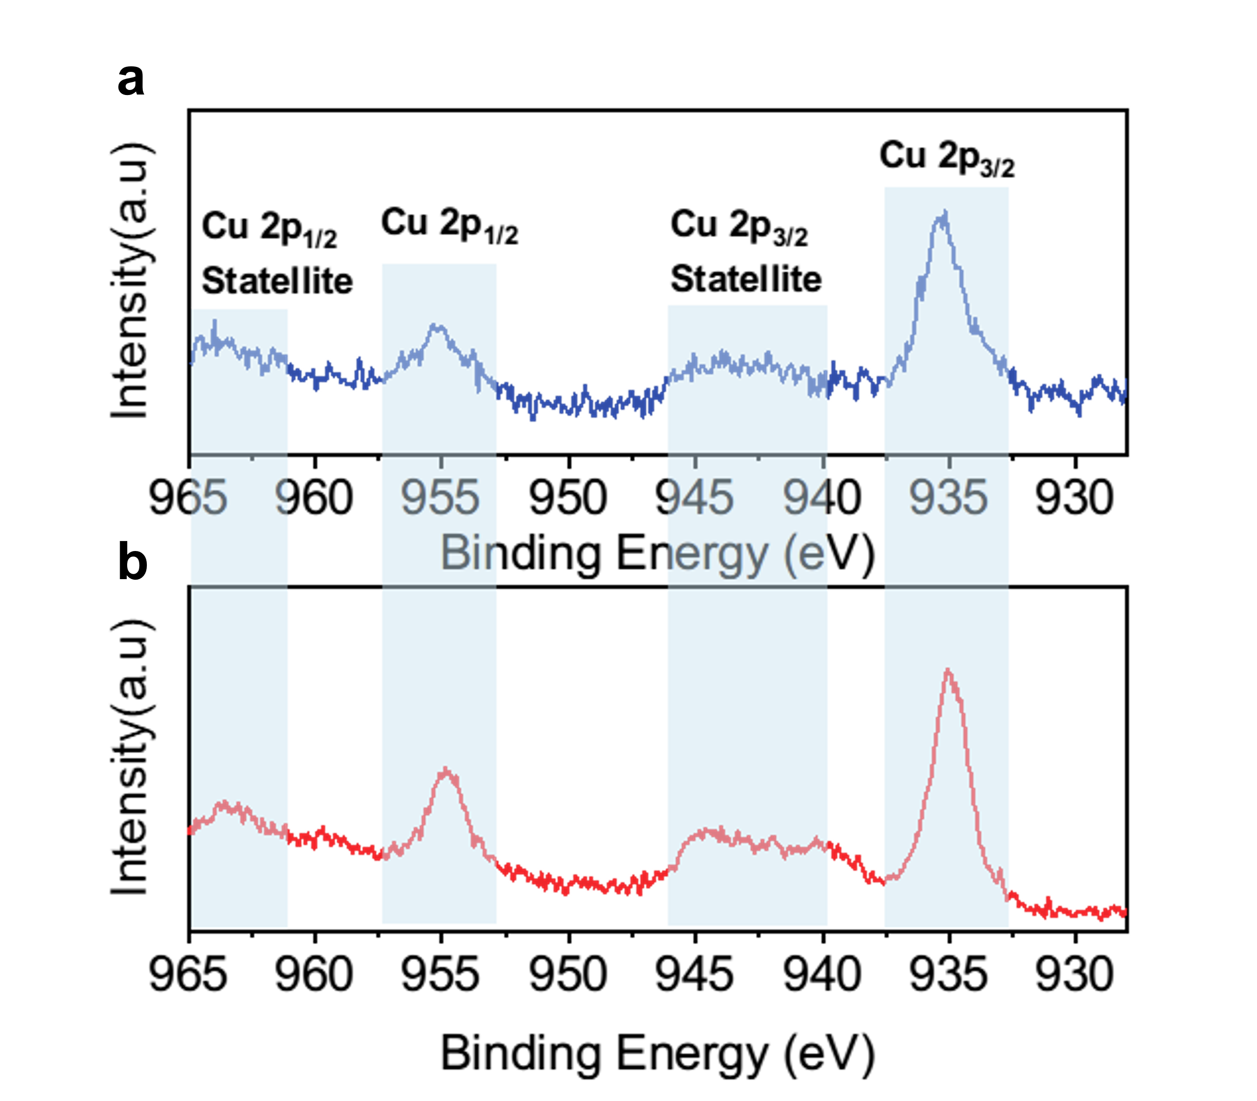
Supplementary Figure 7 | Cu2p XPS spectra. a) p2DP film. b) p2DP/ZnO heterostructure device.

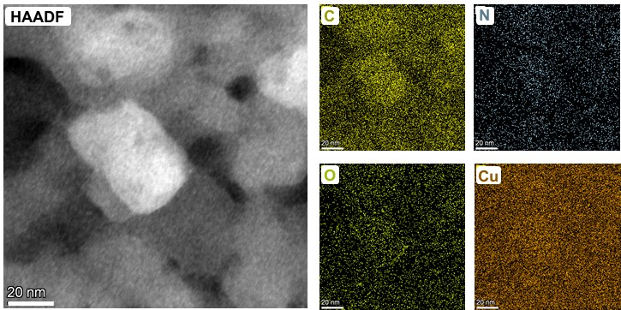
Supplementary Figure 8 | STEM image and elemental mapping of C (yellow), N (blue), O (green), Cu (orogen).

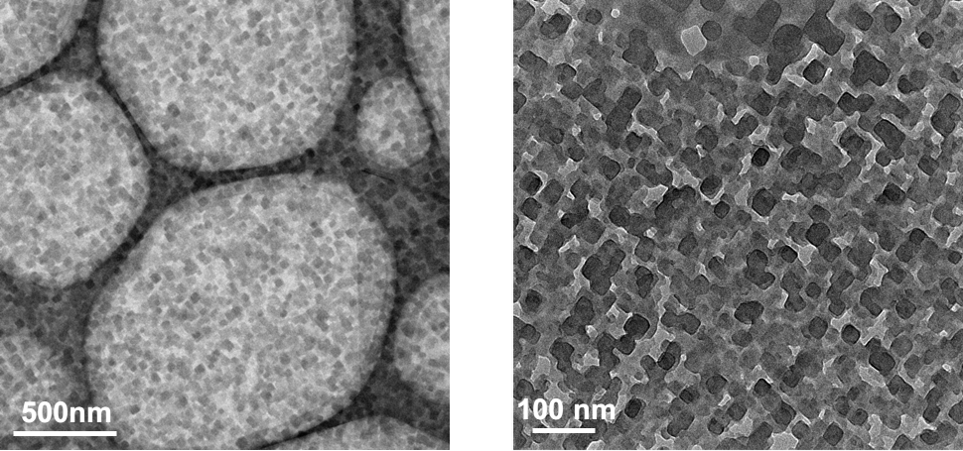
Supplementary Figure 9 | Overview TEM image of p2DP film.

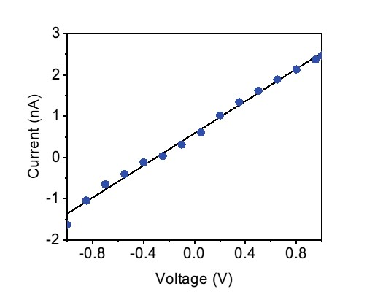
Supplementary Figure 10 | Electrical conductivity characterization of the p2DP film. I–V characteristic curve of the p2DP film from two-probe. The average conductivity of p2DP was 6.6×10⁻⁴ S cm⁻² (38 μm channel width, 2 μm channel length, and 40 nm thick film)

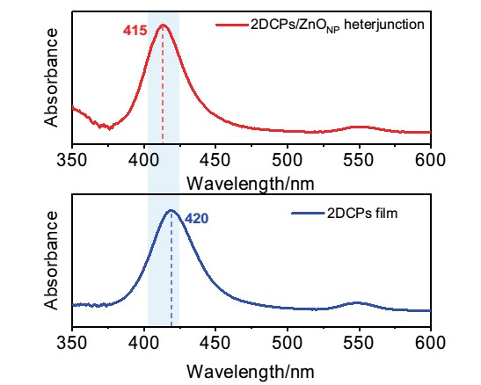
Supplementary Figure 11 | UV-vis absorption spectra. The absorption spectra of the p2DP film and the p2DP/ZnO_{NP} heterostructure on a quartz substrate.

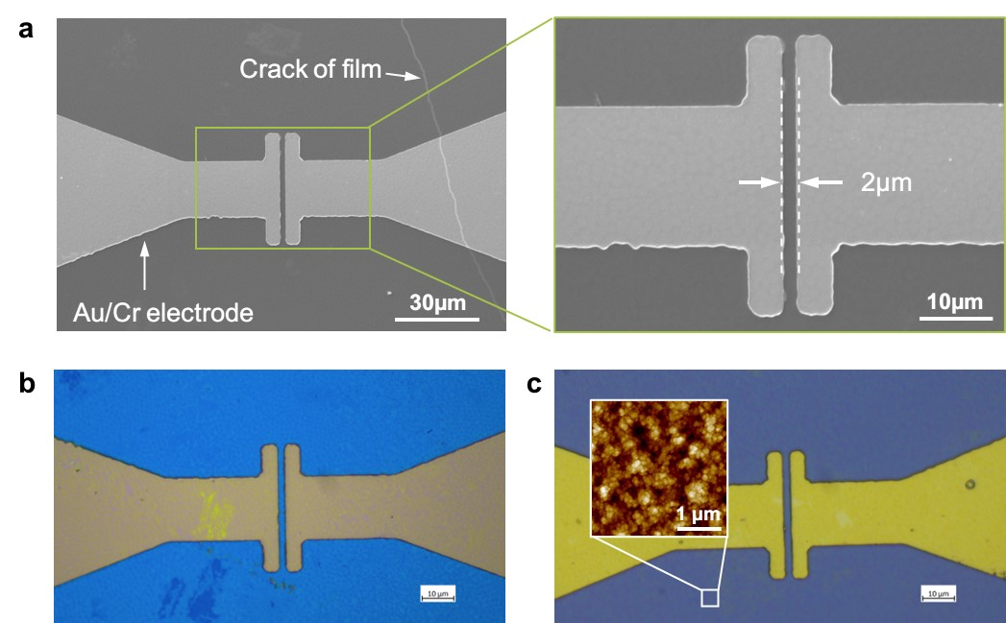
Supplementary Figure 12 | Characterization of p2DP/ZnO heterostructure device. a) SEM image of pure p2DP film on the device after transferred. b) Optical image of p2DP film device. c) Optical image of p2DP/ZnO heterostructure device (inset: AFM image of surface)

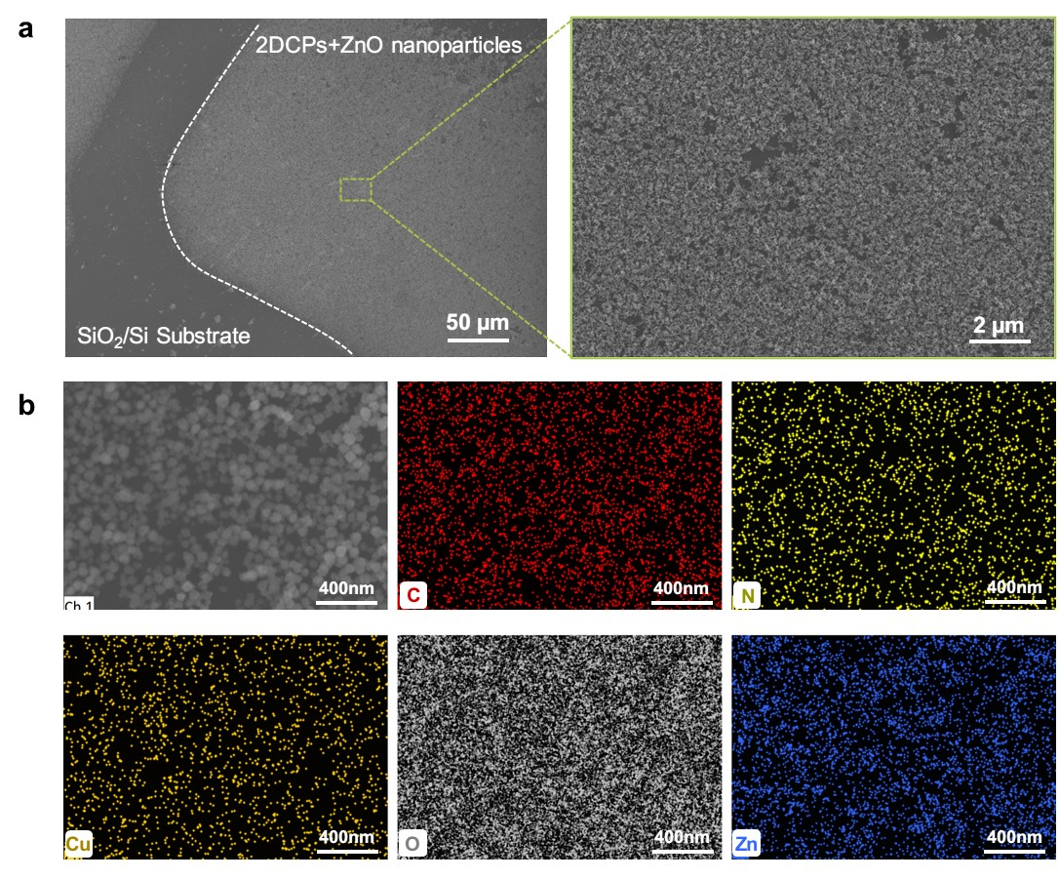
Supplementary Figure 13 | Characterization of p2DP/ZnO heterostructure device. a) SEM image of p2DP/ZnO heterostructure. b) Elemental mapping of C (red), N (yellow), Cu (orogen), O (gray), Zn (blue).

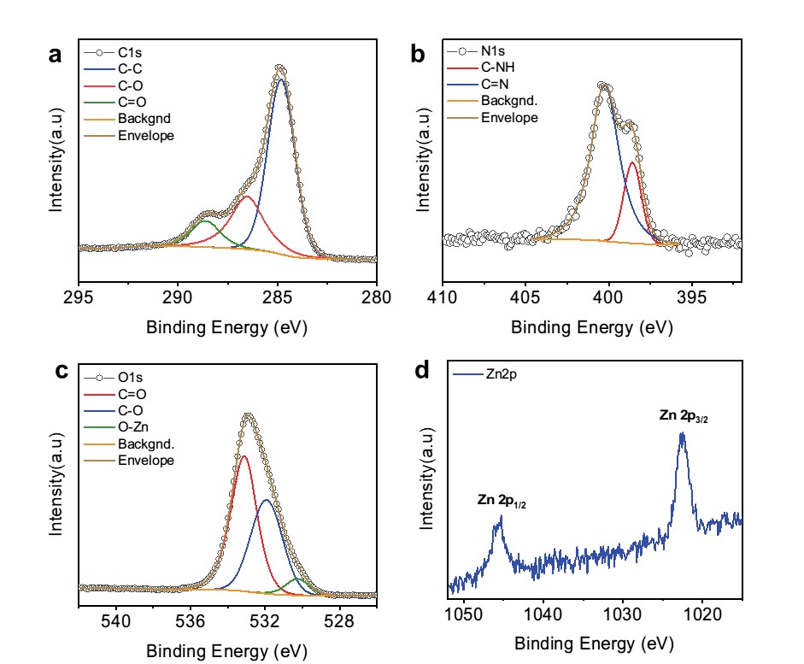
Supplementary Figure 14 | XPS spectra of p2DP/ZnO_{NP} heterostructure device. High-resolution spectrum in the (a) C 1s region, (b) N 1s region, (c) O 1s region and d) Zn 2p region, respectively.

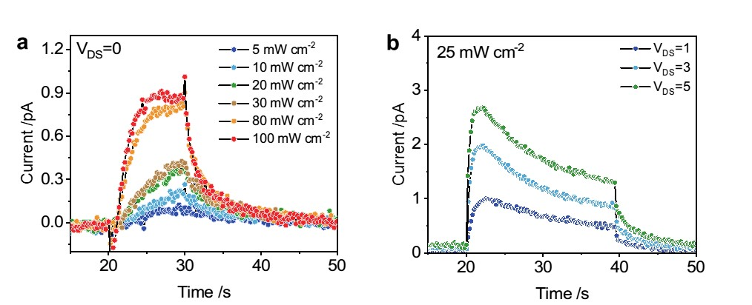
Supplementary Figure 15 | The photoresponse curves of the device. a) The photoresponse curves of device under different stimuli intensity (V_{DS}=0V). b) The photoresponse curves of p2DP/ZnO_{NP} heterostructure film under different read voltage (V_{DS}) (Light intensity: 25mW cm⁻²)

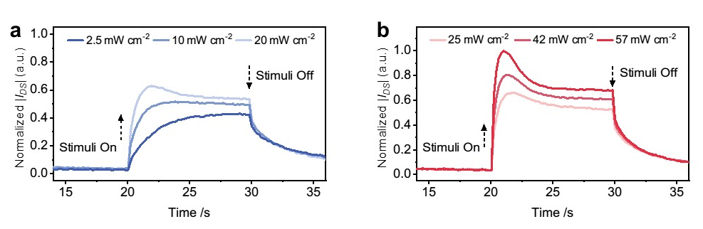
Supplementary Figure 16 | The photoresponse curves of the device. a) The photoresponse curves to dim light stimuli (ranging from 2.5 to 20 mW cm⁻² ). b) The photoresponse curves to bright light stimuli (ranging from 25 to 57 mW cm⁻² )

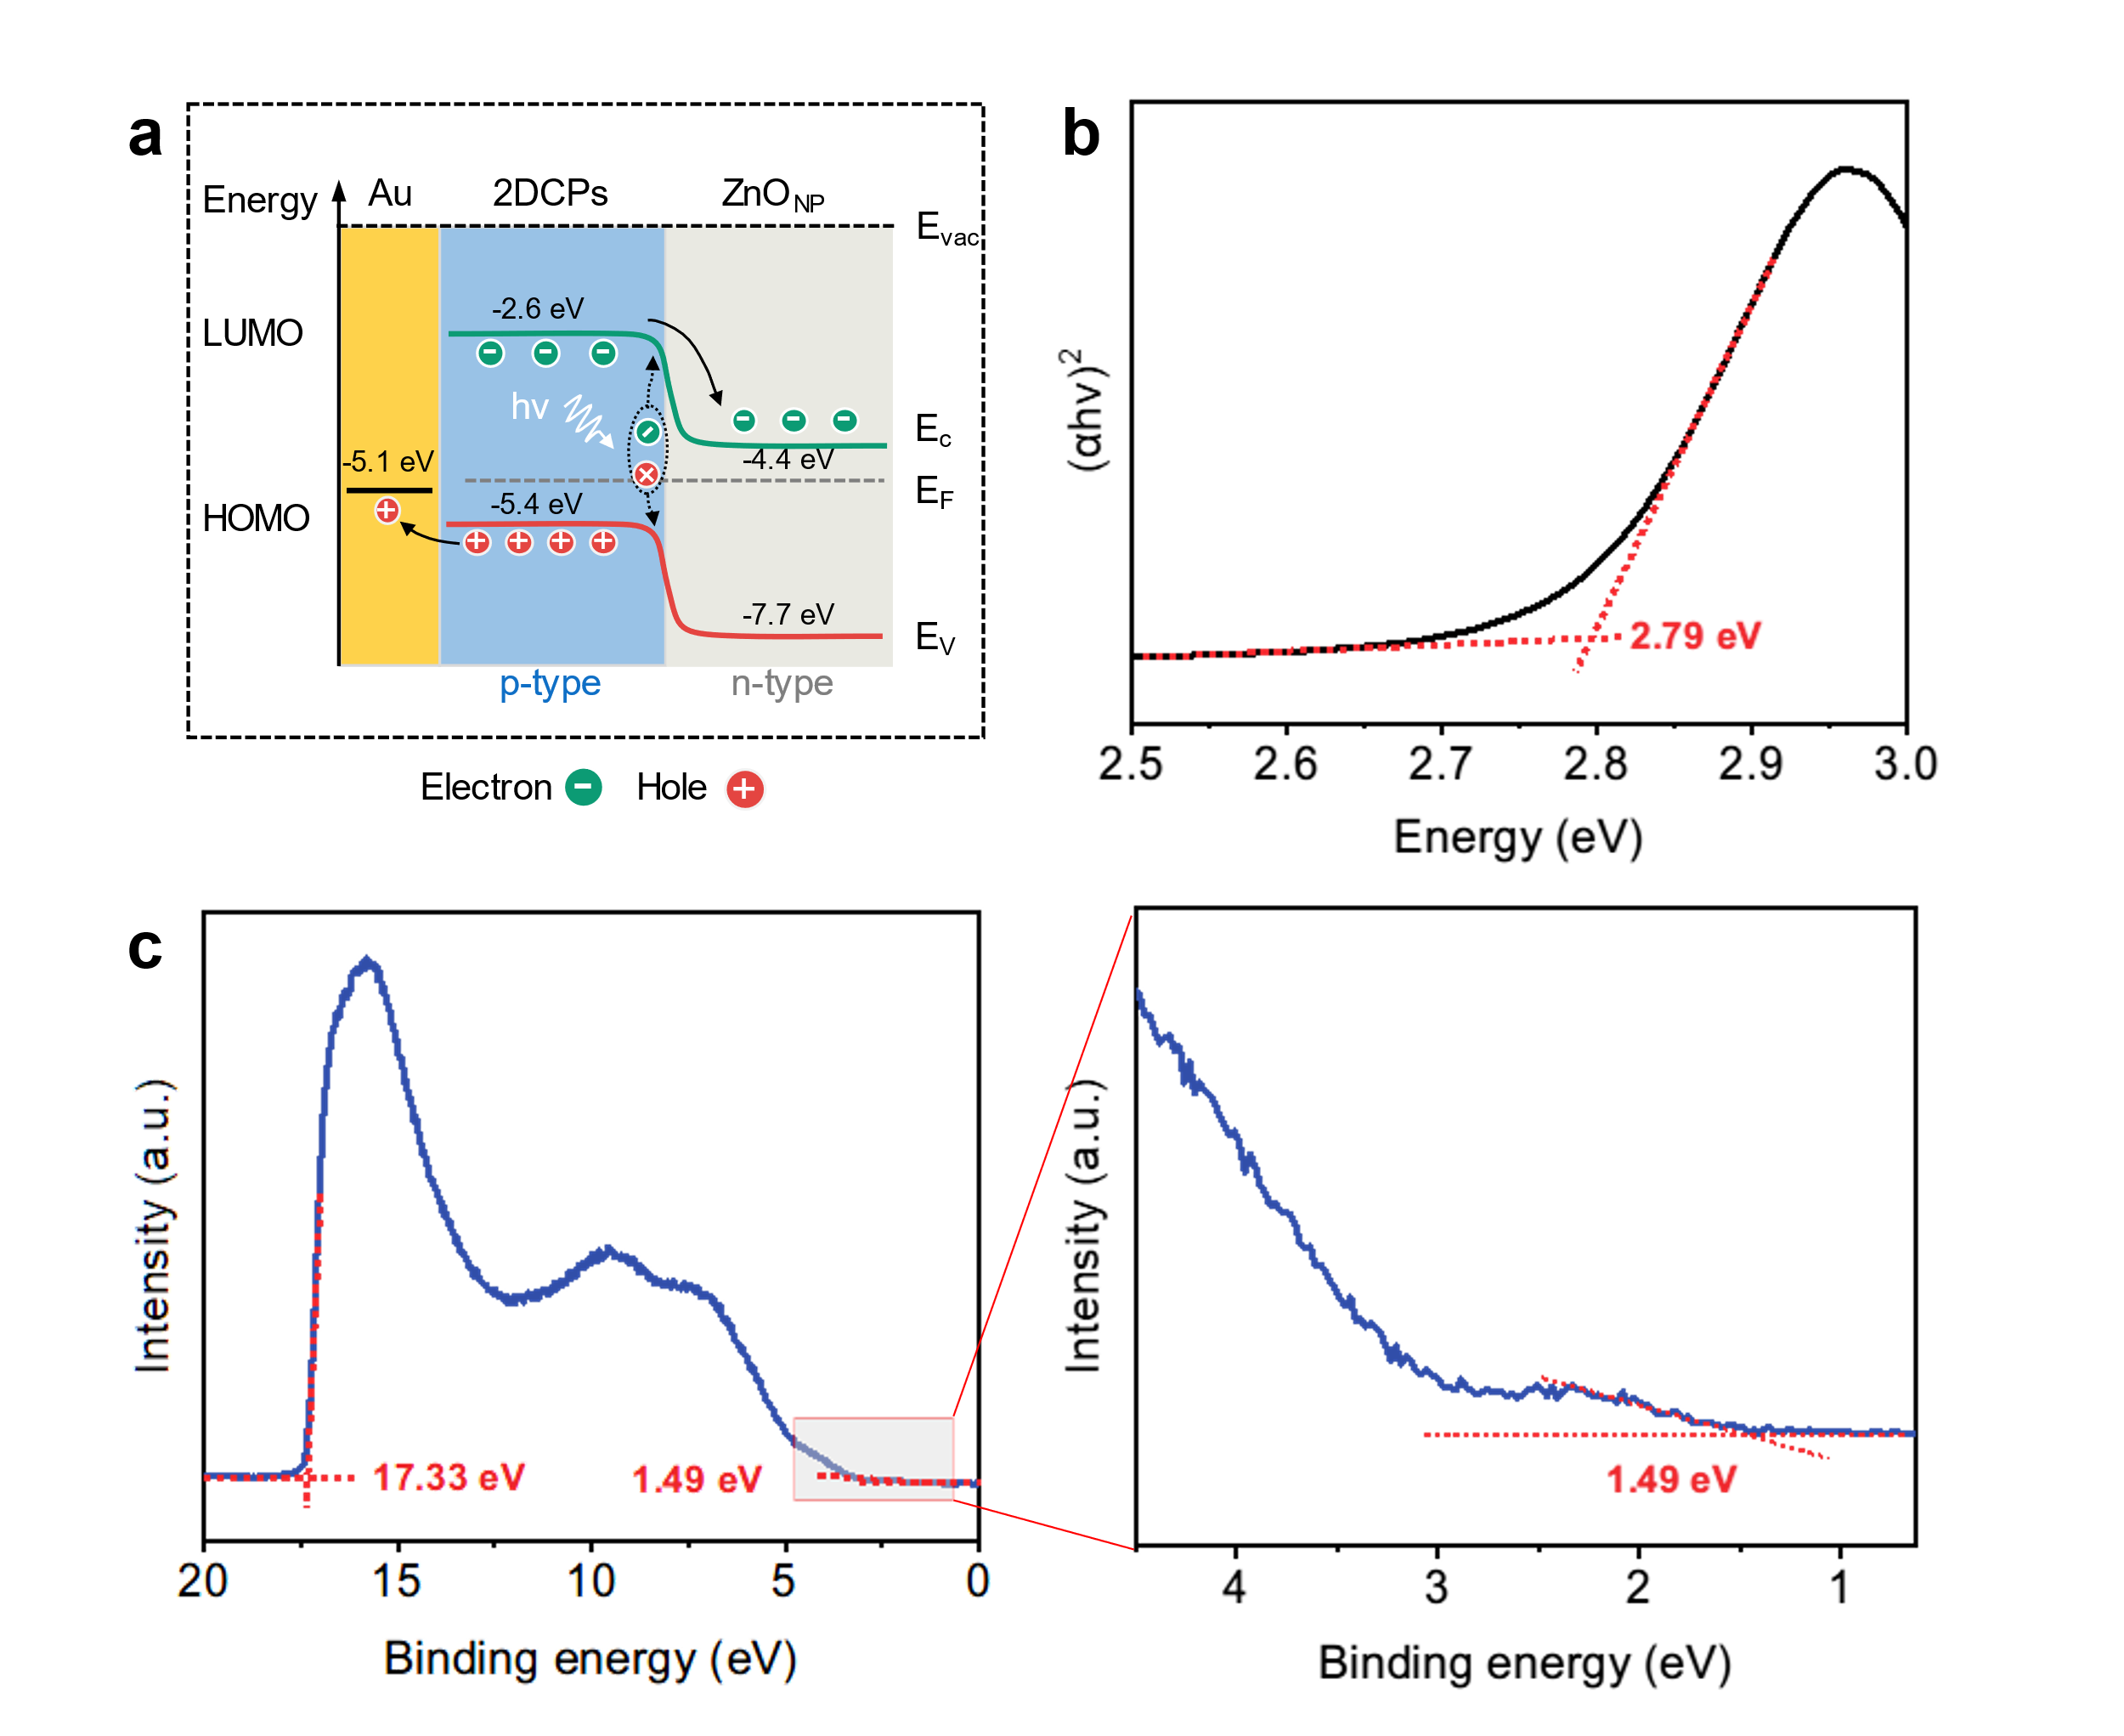
Supplementary Figure 17 | Energy band diagrams of the p2DP/ZnONP heterostructure device. a) Band gap of p2DP/ZnO_{NP} heterostructure. b) Optical band-gap spectrum of the p2DP film based on UV-vis absorption spectrum. c) UPS spectrum of the p2DP film. The edges of the UPS spectrum are given by the intersections of two dashed red lines of the tangents and the baseline.

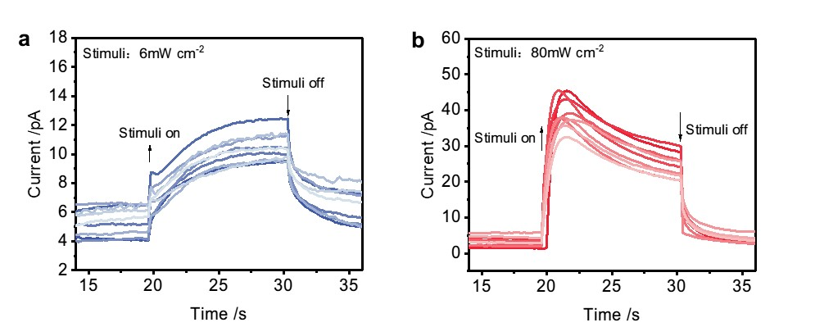
Supplementary Figure 18 | The photoresponse curves of the sensor array. a) Photoresponse curves of the array under light intensity of 6 mW cm⁻². b) Photoresponse curves of the array under light intensity of 80 mW cm⁻².

Supplementary Table
Table 1. Grazing-incidence wide-angle X-ray scattering. GIWAXS peak positions and corresponding lattice spacing.

In-plane
Peak | Q_{xy}(Å⁻¹) |  |  | d_{hkl}(Å) |  | hkl
1 | 0.373 |  |  | 16.845 |  | 100
2 | 0.528 |  |  | 11.900 |  | 110
3 | 0.747 |  |  | 8.411 |  | 200
4 | 0.835 |  |  | 7.525 |  | 210
5 | 1.059 |  |  | 5.933 |  | 220
6 | 1.123 |  |  | 5.595 |  | 300
7 | 1.351 |  |  | 4.651 |  | 320
8 | 1.491 |  |  | 4.214 |  | 400
9 | 1.588 |  |  | 3.957 |  | 330
10 | 1.880 |  |  | 3.342 |  | 430
11 | 2.112 |  |  | 2.975 |  | 440
Out-of-plane
Peak |  | Q_{z}(Å⁻¹) | d_{hkl}(Å) |  | hkl
1 | 1.309 |  |  | 4.799 |  | 002

Supplementary Notes
Supplementary note 1: Habituation behavior of the vision sensor
In addition to the light intensity-dependent photoadaptation, another dynamic adaptation is habituation, which is a phenomenon of decreased response to identically repeated stimuli (e.g., interval time, conditioning time)^{1,2}. We investigated the current response of the device triggered by a pair of stimuli with different interval time (IT) and conditioning time (CT)³. Under the interval time (IT) from 0.35s to 9.6s, the device showed decreased current responses to the following stimuli (~30 mW cm⁻²) (Supplementary Fig. 19a). With the extension of the pulse interval, the peak current of the second pulse is gradually decayed exponentially, which is consistent with the single exponential decay model (Supplementary Fig. 19c). For example, with the internal time increase from 0.35s to 9.6s, the peak current of second stimuli decreases from 0.77 to 0.56. Besides the internal time of repeated stimuli, the response of devices is also impacted by the duration of the first stimuli (Conditioning time, CT). By applying the conditioning stimuli of duration from 0.4s to 8.8s, we can obtain the photo responses of the device (Supplementary Fig. 20a). The peak current of the second stimuli is decided by the initial stimuli. Under short conditioning stimuli, the peak current is enhanced, while inhibited under long conditioning stimuli. However, the trend of the second pulse current still decays, which is consistent with the monoexponentially decay model (Supplementary Fig. 20c). Interestingly, the devices showed fast adaptive behavior in short conditioning stimuli and slow adaptive behavior in long conditioning stimuli¹.

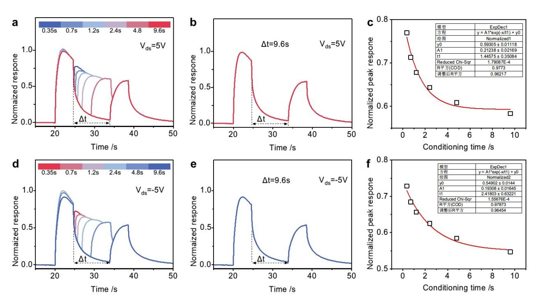
Supplementary Figure 19 | Habituation behavior of the vision sensor. a) Normalized photoresponse curves of the device under two consecutive optical pulses with different time intervals. b) Normalized photoresponse curves of the device with an interval time of 9.6s. c) Single exponential decay model of current response under different interval times. (Light intensity: 30 mW⁻², V_{DS}=5V) d) Normalized photoresponse curves of the device under two consecutive optical pulses with different time intervals. e) Normalized photoresponse curves of the device with an interval time of 9.6s. f) Single exponential decay model of current response under different interval times. (Light intensity: 30 mW⁻², V_{DS}=-5V)

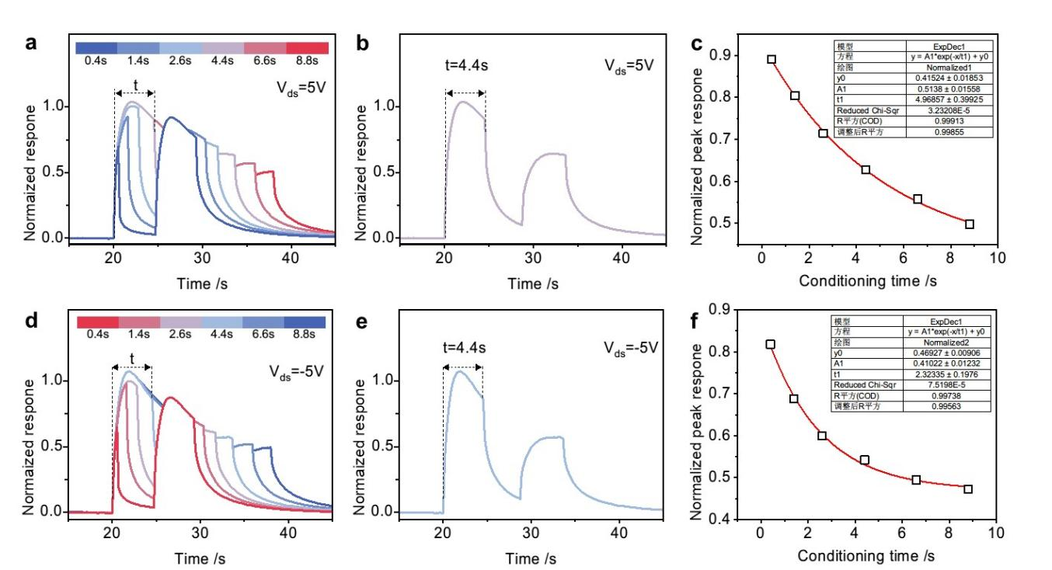
Supplementary Figure 20 | Habituation behavior of the vision sensor. a) Normalized photoresponse curves of the device under two consecutive optical pulses under different conditioning stimuli times. b) Normalized photoresponse curves of the device under conditioning stimuli times of 4.4s. c) Single exponential decay model of current response under different conditioning stimuli times. (Light intensity: 30 mW⁻², V_{DS}=5V) d) Normalized photoresponse curves of the device under two consecutive optical pulses with different time intervals. e) Normalized photoresponse curves of the device under conditioning stimuli times of 4.4s. f) Single exponential decay model of current response under different conditioning stimuli times. (Light intensity: 30 mW⁻², V_{DS}=-5V)

Supplementary note 2: Voltage refresh behavior of sensor
In addition to the effect of the magnitude of the read voltage, the effect of voltage switching on the adaptive behavior in the visual sensor is worth exploring¹. A comparison of single stimuli recorded at 5V and -5V respectively show that there is little difference in peak current (Supplementary Fig. 21a). In contrast to the current response under voltage reverse, the single stimuli response contributed to a lower peak current when the read voltage was not changed (Supplementary Fig. 21c). The subsequent photocurrent response could not reach the height of the previous one due to the carriers generated by the photovoltaic effect in the device staying in the trap state. By switching the voltage, the current response resumes the initial trend, which is verified in the next voltage transition.

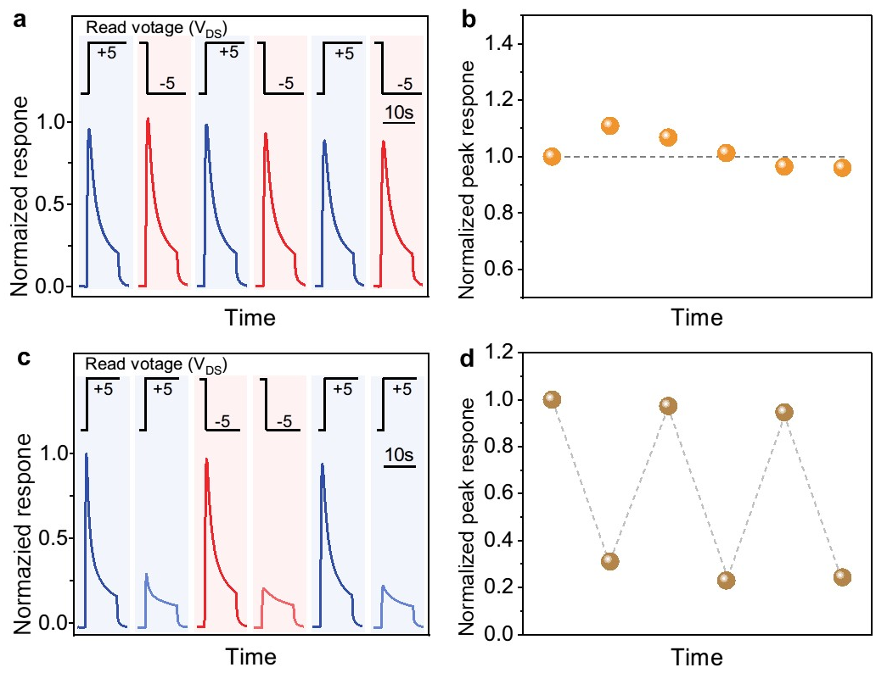
Supplementary Figure 21 | Voltage refresh behavior of sensor. a) Normalized photoresponse curves of the device under opposite V_{DS} (light intensity of 30 mW cm⁻²). b) Normalized peak response of a). c) Normalized photoresponse curves of the device under the same V_{DS} (light intensity of 30 mW cm⁻²). d) Normalized peak response of c).

References
1. Hao, J. & Delmas, P. Multiple Desensitization Mechanisms of Mechanotransducer Channels Shape Firing of Mechanosensory Neurons. Journal of Neuroscience 30, 13384–13395 (2010).
2. Wu, Z. et al. A Habituation Sensory Nervous System with Memristors. Adv. Mater. 32, 2004398 (2020).
3. Xie, D. et al. Photoelectric Visual Adaptation Based on 0D‐CsPbBr ₃ ‐Quantum‐Dots/2D‐MoS ₂ Mixed‐Dimensional Heterojunction Transistor. Adv. Funct. Mater. 31, 2010655 (2021).

