supplementary table 1: The results from interviews based on thematic analysis
Main theme | Subtheme | Concept (initial code)
Needs and expectations | Selecting (predicting) disease | Problem with disease diagnosis
Needs and expectations | Selecting (predicting) disease | Determining the type of disease used in the application
Needs and expectations | Determining the end users of the application  (physicians and patients) | Dedicating a part of the application to patients
Needs and expectations |  | Dedicating the application to the team of physicians
Needs and expectations | Determining the type of application language  (For physician: English  For the patient: Persian) | Using English concepts and assigning English language for physicians in the application
Needs and expectations |  | The type of question is understandable and simple, and assign Persian language for patients in the application
Functional features of the application | Creating resources in the application | Giving access to clinical information, guidelines and authoritative and reference books for physicians
Functional features of the application | Creating resources in the application | Providing information needed by patients
Functional features of the application | Creating reports of activities | Recording the activity time in the application
Functional features of the application | Creating reports of activities | Recording activities in the application
Functional features of the application | Determining patient medical and medication history | Inserting the list of diseases in the application for medical history
Functional features of the application | Determining patient medical and medication history | Inserting the list of medications in groups in the application for medication history
Functional features of the application | Selecting the appropriate treatment | Determining the dose of prescribed drug in the application
Functional features of the application | Selecting the appropriate treatment | Selecting appropriate treatments as the main treatment and supportive treatment
Functional features of the application | Sharing information and  physician-patient communication | Sharing patient information with the physician in the application
Functional features of the application | Sharing information and  physician-patient communication | Frequently Asked Questions for patients and physicians
Functional features of the application | Uploading images and playing audio files for patients | Creating an audio play feature for ease of use by patients
Functional features of the application | Uploading images and playing audio files for patients | Uploading images by patient in the application

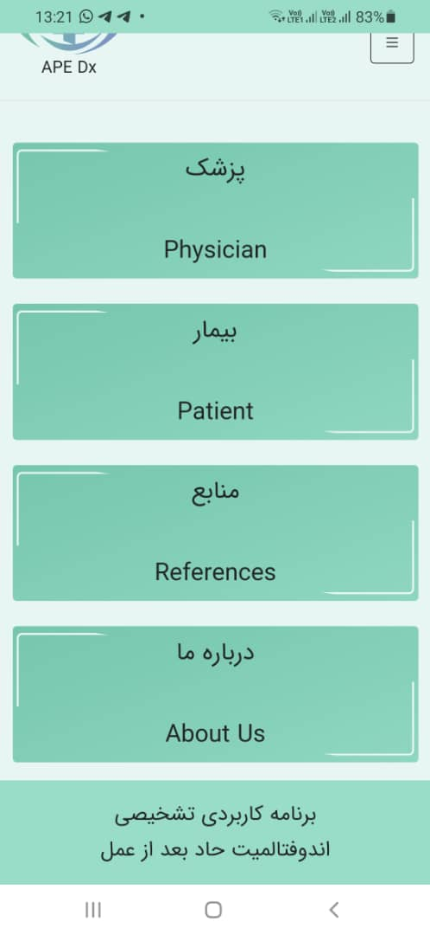
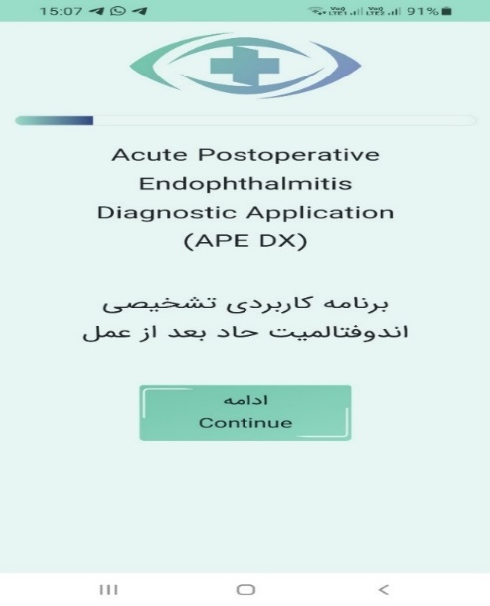

1. Login page. 2. Home page.

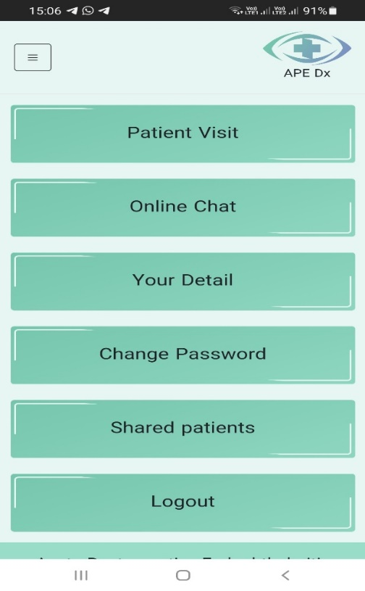
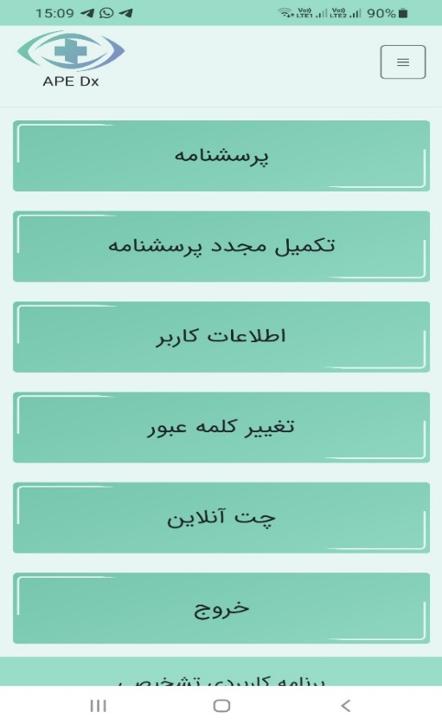 3. Physician user interface. 4. Patient user interface.

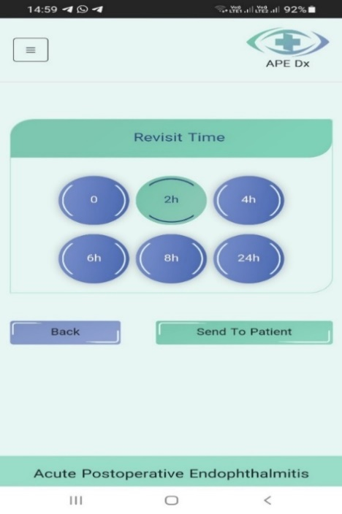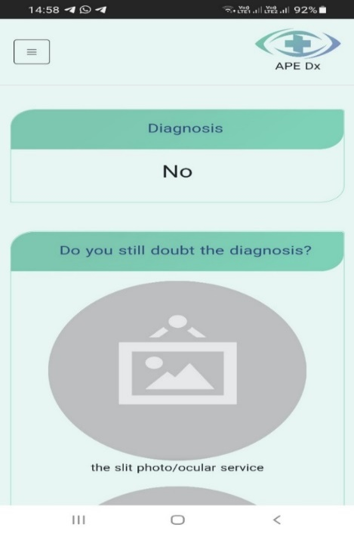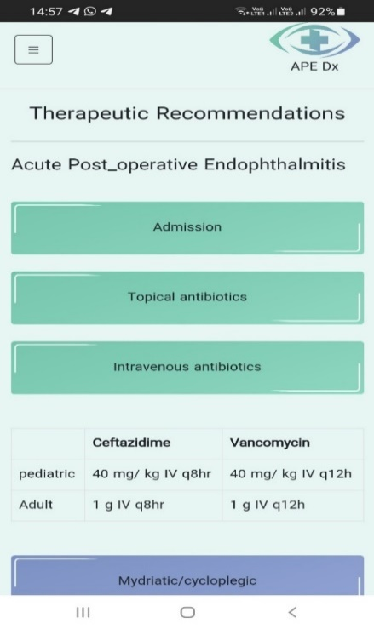
F1
F2
F3
5. Sample screenshots from physician user interface, 1) therapeutic recommendation, 2) diagnosis, 3) revisit time/ fill out the questionnaire.

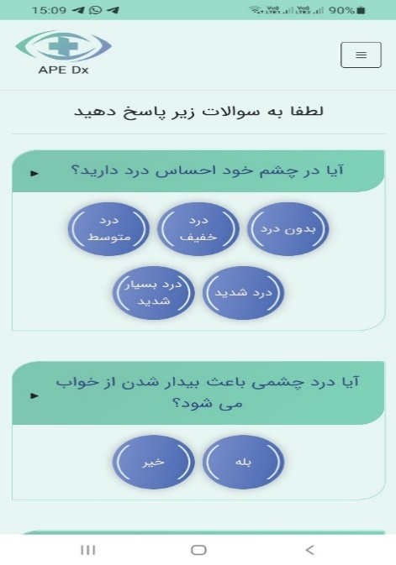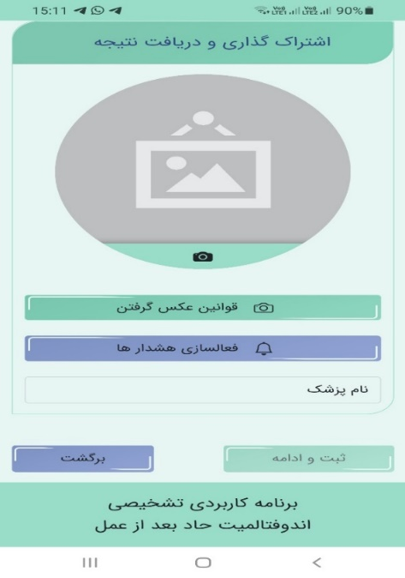
G2
G1
6. Sample screenshots from patient user interface, 1) Patient questionnaire, 2) Information sharing.

