Supporting Information
Evaluation of in Vitro Cytotoxic, Cardiac Safety and Genotoxic Effects of Hydrogenated Cannabidiol (H₄CBD) on Cells
Tesfay T. Tesfatsion†, Giovanni A. Ramirez†, Arianna C. Collins†, Kyle P. Ray†, Westley Cruces†
†Colorado Chromatography labs, 10505 S Progress Way Unit 105, Parker, CO 80134
*Corresponding authors: Westley Cruces
Email: wes@coloradochromatography.com

Table of Contents:
- Abbreviations…………………………………………………………………………….S2
- Scheme S1. H₄CBD Reaction ….…………………………...…...……………………..S3
- ¹H NMR and ¹³C NMR Spectra of the Final Compound….....…………………..……...S4
- HPLC…………………………………………………………………………………….S6
- HRMS of H₄CBD…………………………………………………………………..……...S7
- GCMS of H₄CBD…………………………………………...……………………...………...S8
- Ames Data Tables………………………………………………………………………..S9

Abbreviations

HPLC: High performance liquid chromatography
NMR: Nuclear magnetic resonance
MeCN: Acetonitrile
DCM: Dichloromethane
ATM: Atmosphere
CBD: Cannabidiol
Pd/C: Palladium on carbon
HRMS: High Resolution-Mass Spectrometry
GCMS: Gas Chromatography-Mass Spectrometry
2NF 2-Nitrofluorene
DMSO Dimethylsulfoxide
ICR ICR-191 Acridine
NQNO 4-nitroquinoline-N-oxide
SA Sodium azide
P Precipitate
R Reduced
SR Slightly Reduced

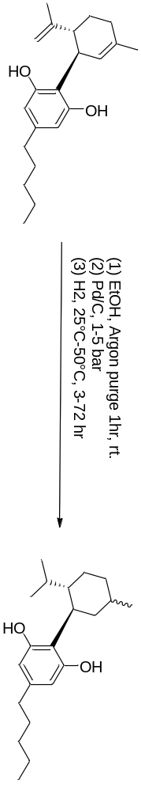
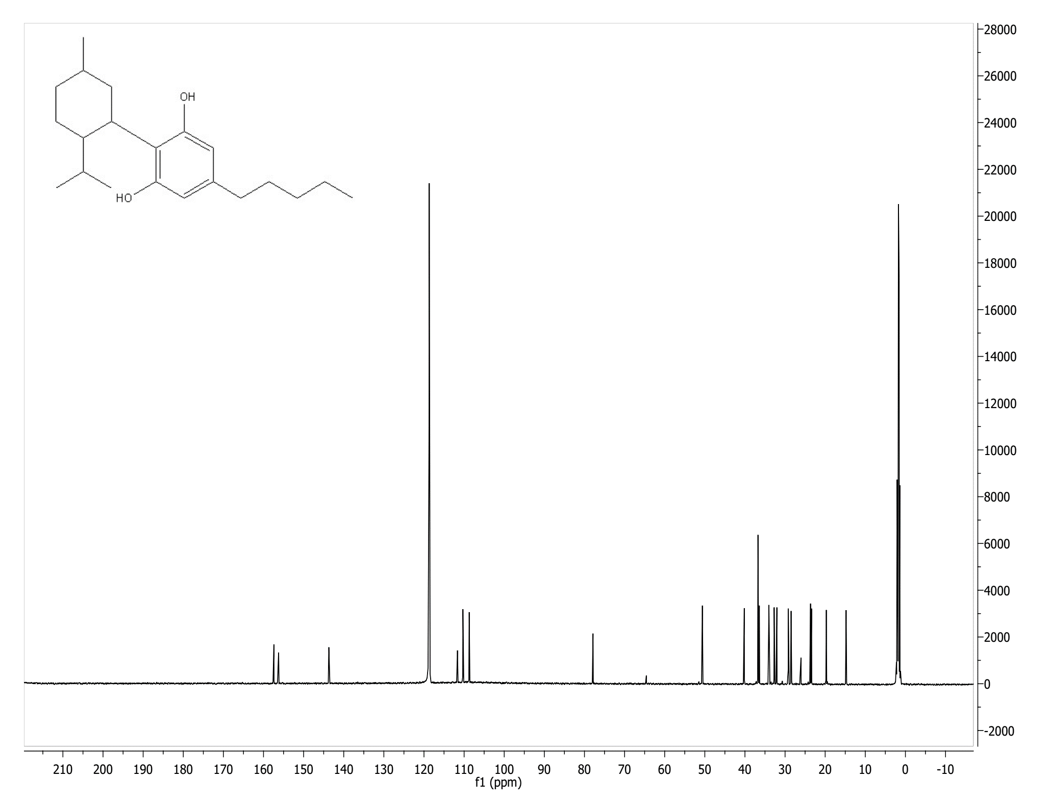
¹³C NMR
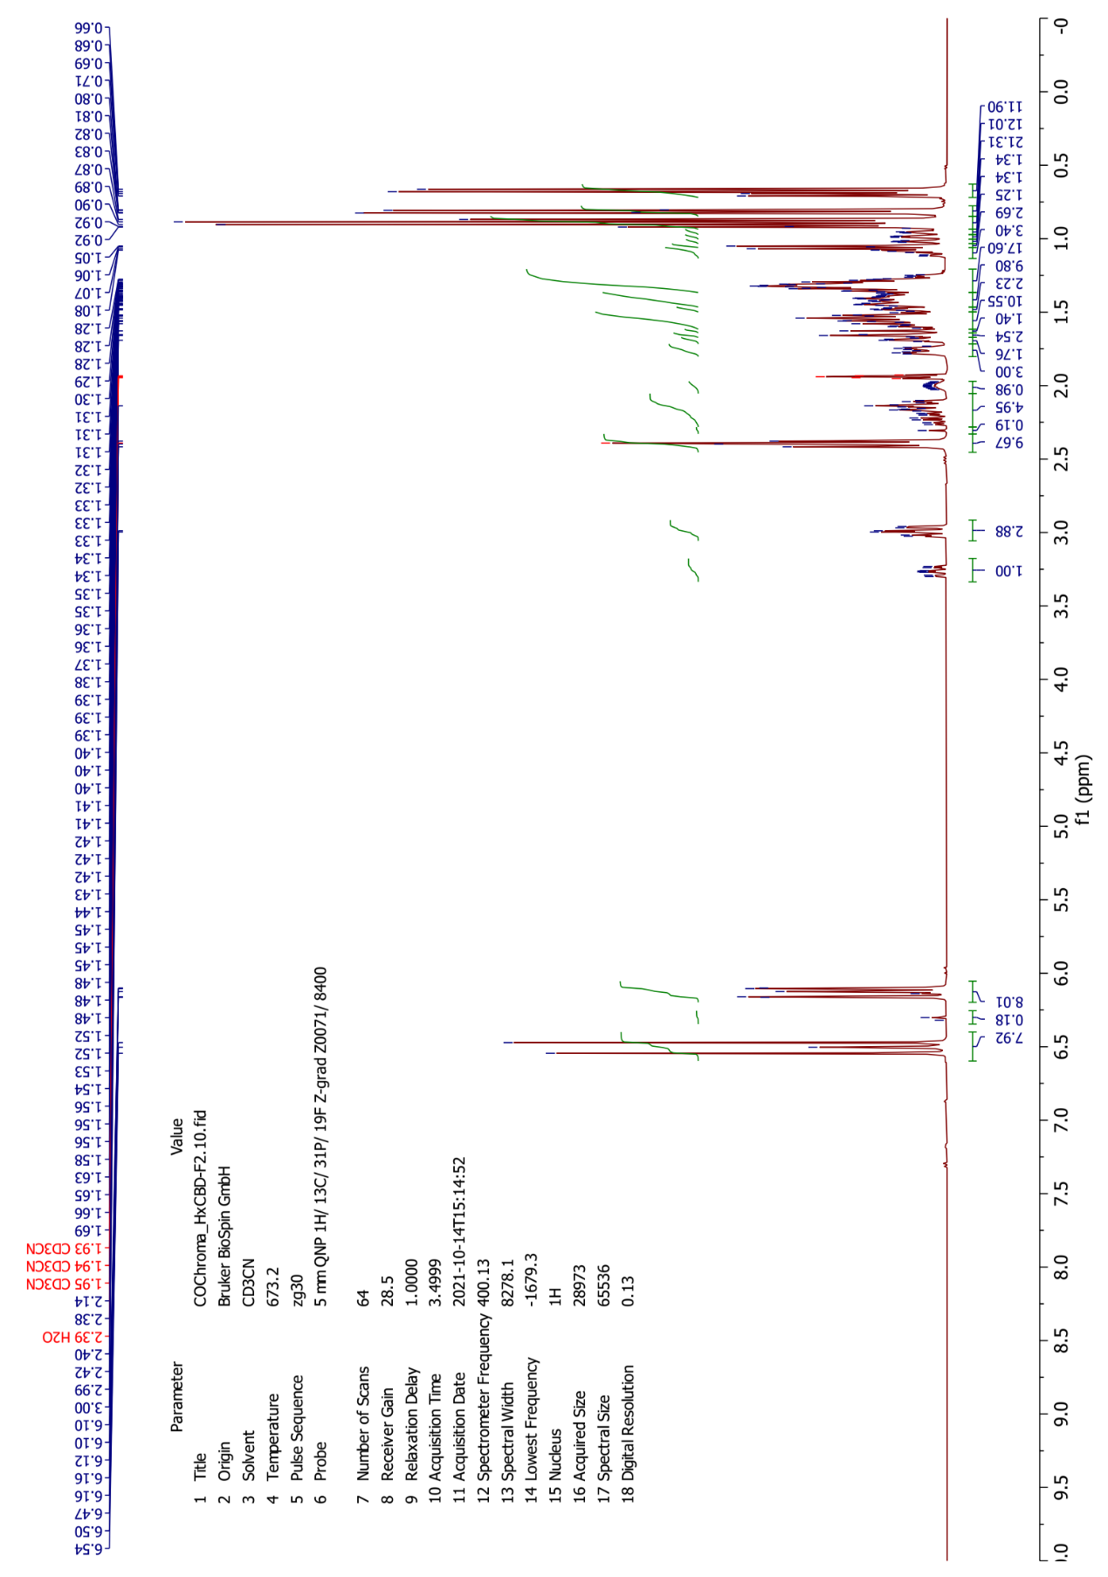
¹H NMR
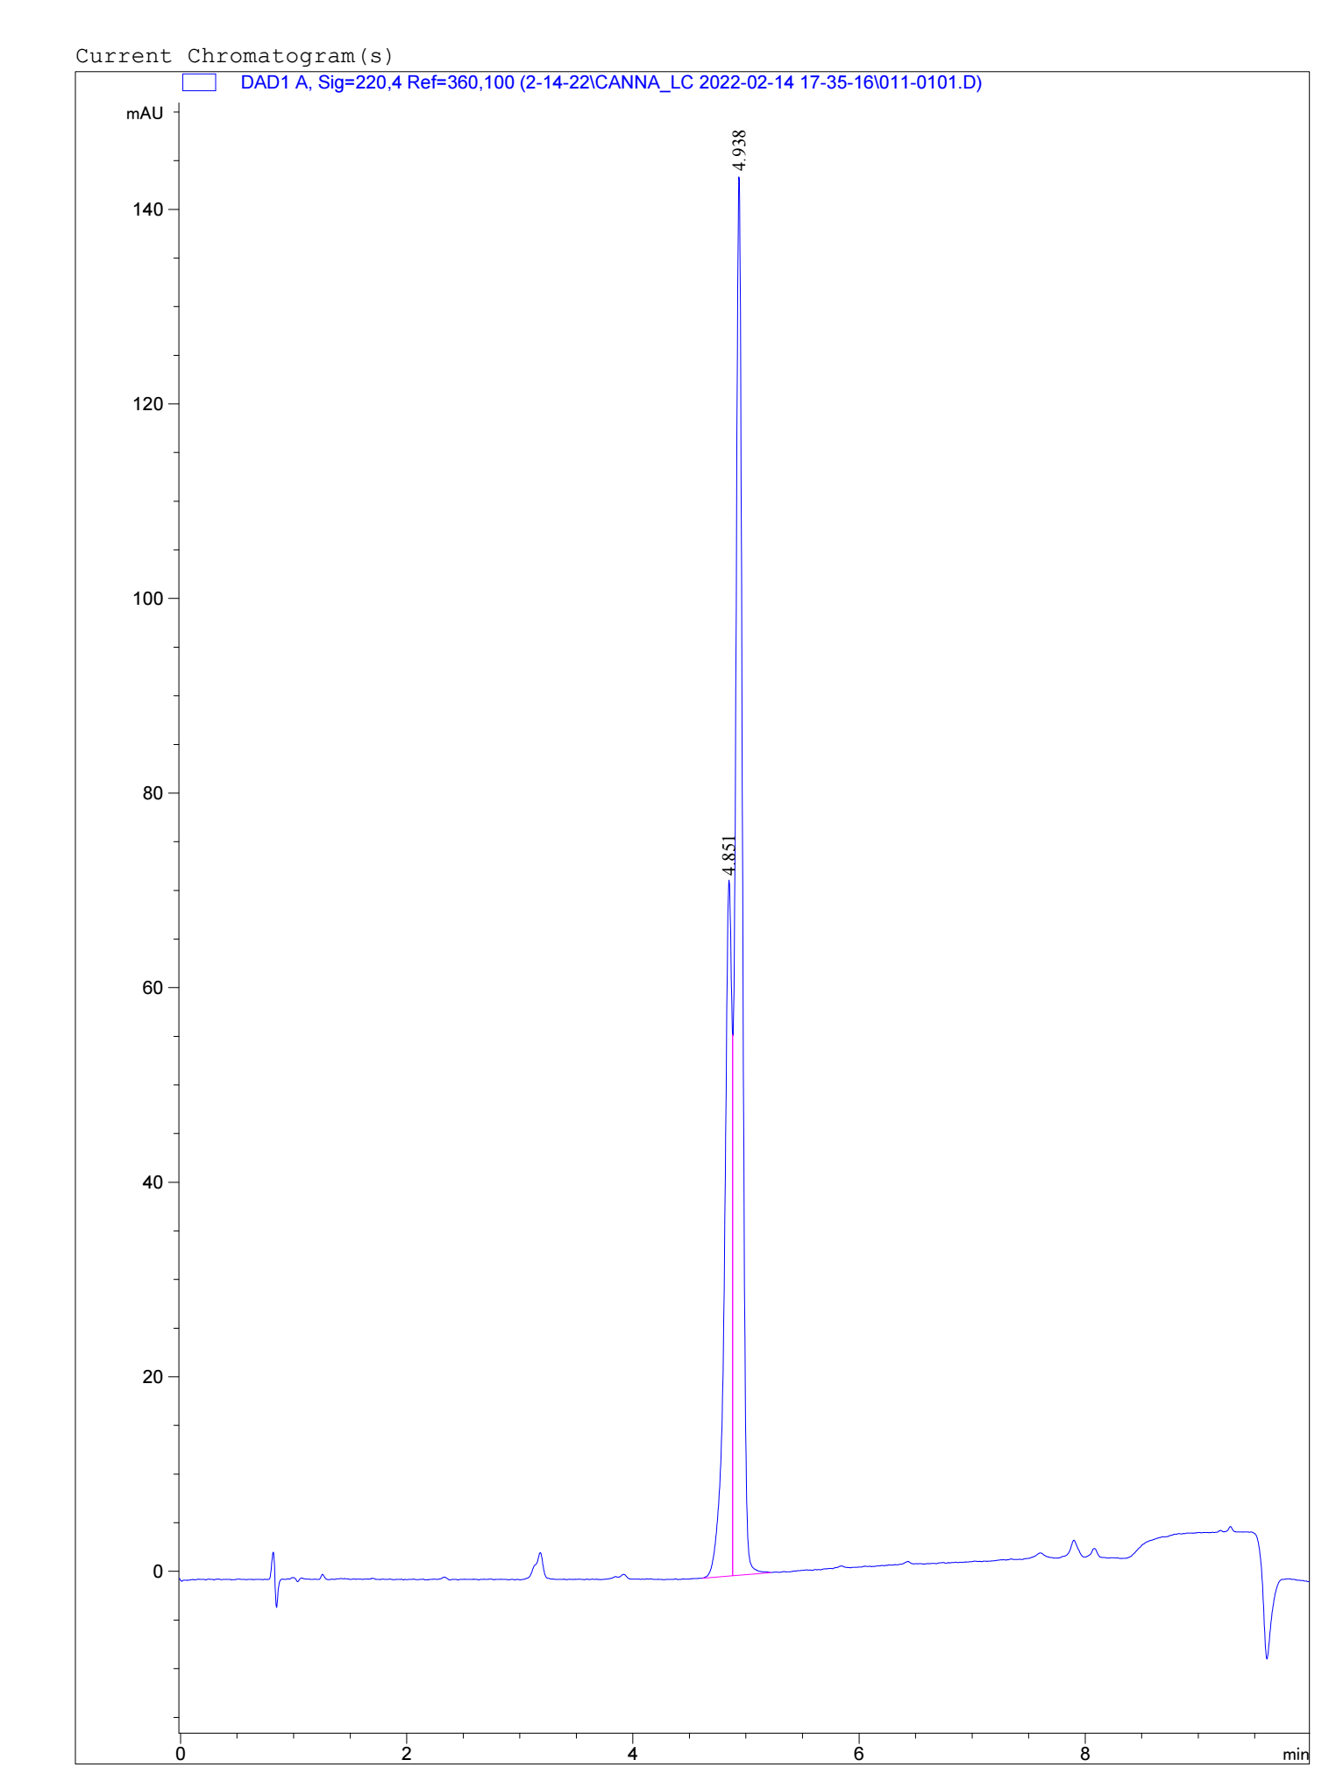
HPLC
(R)-H4-CBD
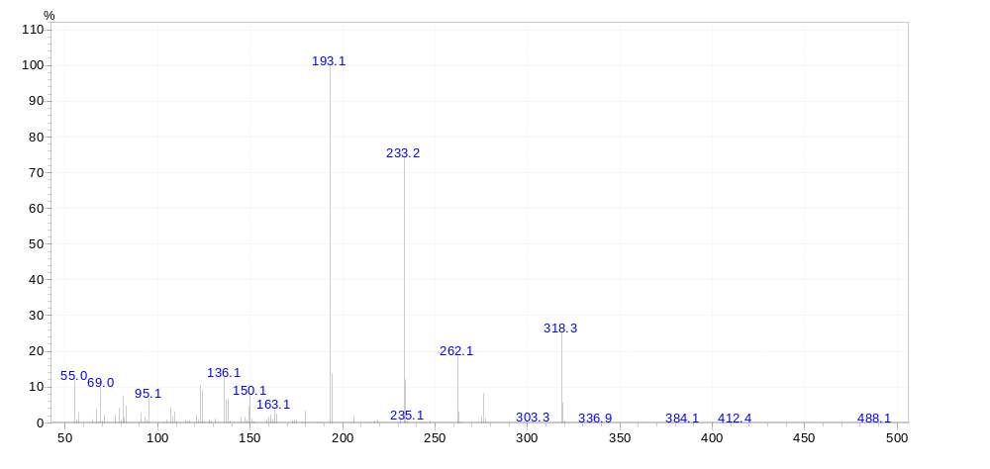
(S)-H4-CBD
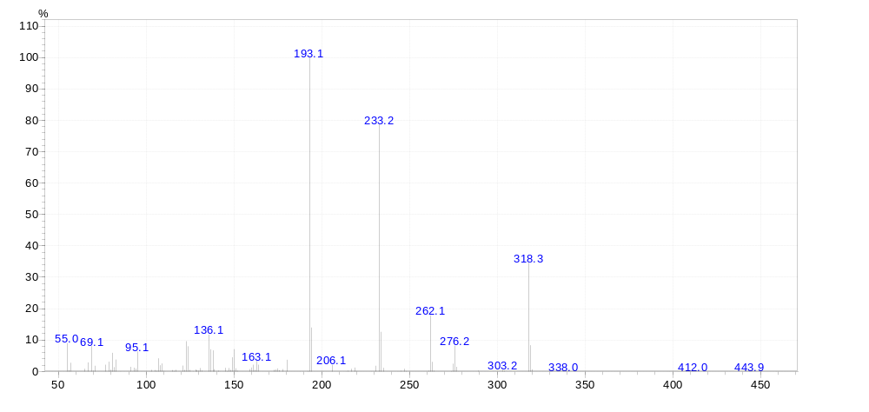

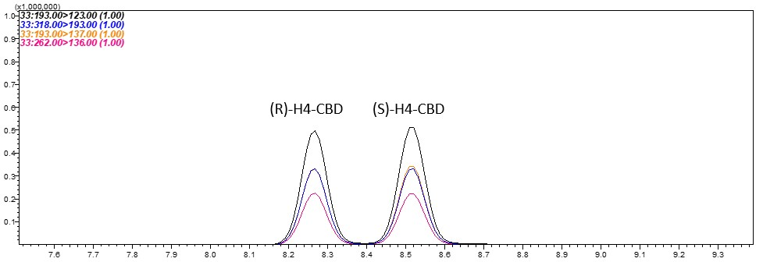
GCMS of H₄CBD

Ames Data Tables
Strain | Test Item | Dose Level Per Plate | Mean Revertants Per Plate | Standard Deviation | Ratio Treated/Solvent | Individual Revertant Colony Counts
TA98 | DMSO | - | 14.0 | 2.8 | - | 12,16
 | H4CBD | 1 | 15.0 | 4.2 | 1.1 | 18,12
 |  | 5 | 8.5 | 0.7 | 0.6 | 9,8
 |  | 10 | 9.0 | 0.0 | 0.6 | 9 SR,9 SR
 |  | 50 | - | - | - | - R,- R
 |  | 100 | - | - | - | - R,- R
 |  | 500 | - | - | - | - P R,- P R
 |  | 1000 | - | - | - | - P R,- P R
 |  | 5000 | - | - | - | - P R,- P R
 | 2NF | 2.5 | 663.5 | 96.9 | 47.4 | 595,732

Strain | Test Item | Dose Level Per Plate | Mean Revertants Per Plate | Standard Deviation | Ratio Treated/Solvent | Individual Revertant Colony Counts
TA100 | DMSO | - | 115.0 | 9.9 | - | 122,108
 | H4CBD | 1 | 99.0 | 8.5 | 0.9 | 93,105
 |  | 5 | - | - | - | - R,- R
 |  | 10 | - | - | - | - R,- R
 |  | 50 | - | - | - | - R,- R
 |  | 100 | - | - | - | - R,- R
 |  | 500 | - | - | - | - P R,- P R
 |  | 1000 | - | - | - | - P R,- P R
 |  | 5000 | - | - | - | - P R,- P R
 | SA | 1 | 472.0 | 22.6 | 4.1 | 456,488

Strain | Test Item | Dose Level Per Plate | Mean Revertants Per Plate | Standard Deviation | Ratio Treated/Solvent | Individual Revertant Colony Counts
TA1535 | DMSO | - | 10.0 | 8.5 | - | 16,4
 | H4CBD | 1 | 9.0 | 0.0 | 0.9 | 9,9
 |  | 5 | - | - | - | - R,- R
 |  | 10 | - | - | - | - R,- R
 |  | 50 | - | - | - | - R,- R
 |  | 100 | - | - | - | - R,- R
 |  | 500 | - | - | - | - P R,- P R
 |  | 1000 | - | - | - | - P R,- P R
 |  | 5000 | - | - | - | - P R,- P R
 | SA | 1 | 436.0 | 69.3 | 43.6 | 387,485

Strain | Test Item | Dose Level Per Plate | Mean Revertants Per Plate | Standard Deviation | Ratio Treated/Solvent | Individual Revertant Colony Counts
TA1537 | DMSO | - | 3.5 | 2.1 | - | 5,2
 | H4CBD | 1 | 3.0 | 1.4 | 0.9 | 4,2
 |  | 5 | - | - | - | - R,- R
 |  | 10 | - | - | - | - R,- R
 |  | 50 | - | - | - | - R,- R
 |  | 100 | - | - | - | - R,- R
 |  | 500 | - | - | - | - P R,- P R
 |  | 1000 | - | - | - | - P R,- P R
 |  | 5000 | - | - | - | - P R,- P R
 | ICR | 0.5 | 133.5 | 19.1 | 38.1 | 120,147

Strain | Test Item | Dose Level Per Plate | Mean Revertants Per Plate | Standard Deviation | Ratio Treated/Solvent | Individual Revertant Colony Counts
WP2uvrA | DMSO | - | 46.5 | 2.1 | - | 48,45
 | H4CBD | 1 | 52.0 | 17.0 | 1.1 | 64,40
 |  | 5 | 49.0 | 5.7 | 1.1 | 53,45
 |  | 10 | 48.0 | 11.3 | 1.0 | 40,56
 |  | 50 | 43.5 | 4.9 | 0.9 | 47,40
 |  | 100 | 42.0 | 0.0 | 0.9 | 42,42
 |  | 500 | 25.5 | 4.9 | 0.5 | 22 P,29 P
 |  | 1000 | 27.0 | 2.8 | 0.6 | 29 P,25 P
 |  | 5000 | 14.0 | 2.8 | 0.3 | 16 P,12 P
 | NQNO | 2 | 254.5 | 13.4 | 5.5 | 245,264

Vehicle & Positive Controls | Postfixes
 | Dose Level Per Plate=µg/plate
  2NF | 2-Nitrofluorene
  DMSO | Dimethylsulfoxide
  ICR | ICR-191 Acridine
  NQNO | 4-nitroquinoline-N-oxide
  SA | Sodium azide
  P | Precipitate
  R | Reduced
  SR | Slightly Reduced

