Supplemental Material for “Family-based analysis of the contribution of rare and common genetic variants to school performance in schizophrenia”
Contents
Supplemental Figure S1: Distribution of school scores among probands included in the current study. 2
Supplemental Figure S2. Principal Component Analysis Plot 3
Supplemental Table S1: Association between different classes of de novo coding variant and school performance 4
Supplemental Table S2: Transmission disequilibrium test of ultra-rare coding variants. 5
Supplemental Table S3: Transmission disequilibrium test of rare CNVs 6
Supplemental Table S4: Phenotypic description of de novo DD rare variant carriers 7
Supplemental Table S5: PRS results for different p-value thresholds in the source GWAS. 8
Supplemental Table S6: pTDT results for different p-value thresholds in the source GWAS. 9
Supplemental Table S7: Univariable logistic regression of mean parental PRS by proband scholastic performance 9
Supplemental Figure S3: Univariable logistic regressions of PRS for offspring and parents 10

Supplemental Figure S1: Distribution of school scores among probands included in the current study.

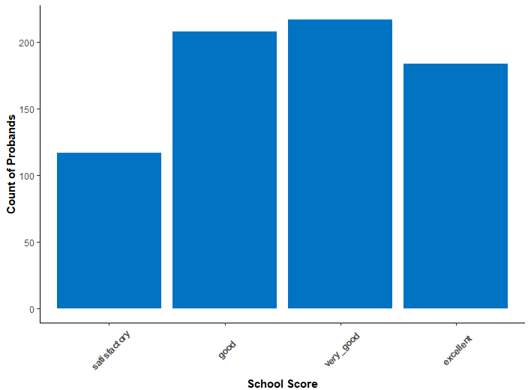
School grade classification: 6 (excellent), 5 (very good), 4 (good) or 3 (satisfactory), which is equivalent to the American system as A, B, C and D, respectively.

Supplemental Figure S2. Principal Component Analysis Plot
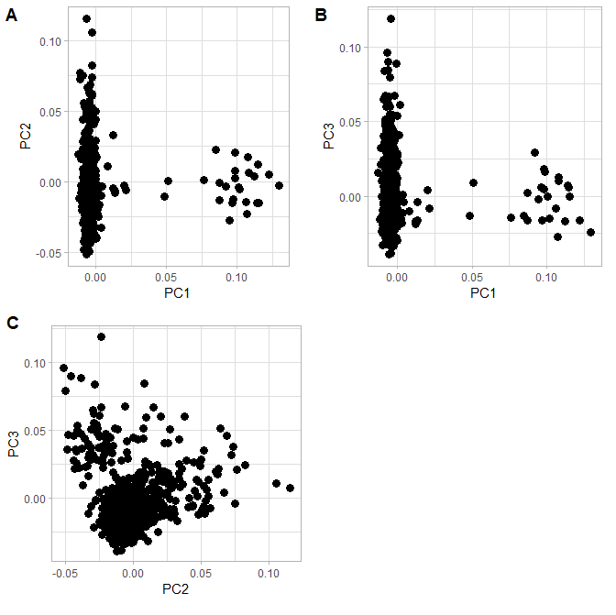

Supplemental Table S1: Association between different classes of de novo coding variant and school performance

Gene set | Variant class | Odds ratio (95% CI) | P | N variants |  | Average number of variants carried by probands
 |  |  |  | Lower school scores | Higher school scores | Lower school scores | Higher school scores
LoF intolerant genes | Damaging PTVs | 2.27 (1.05, 5.15) | 0.038 | 17 | 10 | 0.058 | 0.027
LoF intolerant genes | Damaging missense variants | 1.86 (0.988, 3.62) | 0.0547 | 23 | 16 | 0.078 | 0.043
LoF intolerant genes | Synonymous variants | 1.2 (0.571, 2.53) | 0.628 | 13 | 14 | 0.044 | 0.038
LoF intolerant genes | Damaging coding variants | 2.07 (1.25, 3.5) | 0.00454 | 40 | 26 | 0.14 | 0.07
DD genes | Damaging PTVs | 19.1 (2.21, 2500) | 0.00373 | 6 | 0 | 0.02 | 0
DD genes | Damaging missense variants | 5.5 (1.13, 53.4) | 0.0333 | 6 | 1 | 0.02 | 0.0027
DD genes | Synonymous variants | 0.962 (0.296, 2.94) | 0.946 | 5 | 7 | 0.017 | 0.019
DD genes | Damaging coding variants | 11.6 (2.74, 107) | 0.000263 | 12 | 1 | 0.041 | 0.0027
Probands with low and high school scores are coded as 1 and 0 in the regression models, respectively. The sequencing analysis of coding variants involved 293 and 369 probands with low and high school scores, respectively.

Supplemental Table S2: Transmission disequilibrium test of ultra-rare coding variants.

Gene set | Variant | School grade | Transmissions | Non-transmissions | Rate ratio | P
LoF intolerant genes | Damaging PTVs | Low | 50 | 48 | 1.04 | 0.84
LoF intolerant genes | Damaging PTVs | High | 57 | 62 | 0.919 | 0.65
LoF intolerant genes | Damaging missense variants | Low | 397 | 371 | 1.07 | 0.35
LoF intolerant genes | Damaging missense variants | High | 525 | 491 | 1.07 | 0.29
LoF intolerant genes | Damaging PTVs and missense variants | Low | 447 | 419 | 1.07 | 0.34
LoF intolerant genes | Damaging PTVs and missense variants | High | 582 | 553 | 1.05 | 0.39
DD genes | Damaging PTVs | Low | 13 | 10 | 1.3 | 0.53
DD genes | Damaging PTVs | High | 12 | 20 | 0.6 | 0.16
DD genes | Damaging missense variants | Low | 101 | 84 | 1.2 | 0.21
DD genes | Damaging missense variants | High | 140 | 130 | 1.08 | 0.54
DD genes | Damaging PTVs and missense variants | Low | 114 | 94 | 1.21 | 0.17
DD genes | Damaging PTVs and missense variants | High | 152 | 150 | 1.01 | 0.91
Probands with low and high school scores are coded as 1 and 0 in the regression models, respectively. The sequencing analysis of coding variants involved 293 and 369 probands with low and high school scores, respectively.

Supplemental Table S3: Transmission disequilibrium test of rare CNVs

Gene set | School grade | Mutation Type | Transmitted | Non-Transmitted | Rate ratio | p-value
LoF intolerant genes | Low Grade | All | 40 | 39 | 1.02 | 0.9
LoF intolerant genes | Low Grade | Deletions | 11 | 6 | 1.83 | 0.22
LoF intolerant genes | Low Grade | Duplications | 29 | 33 | 0.88 | 0.61
LoF intolerant genes | High Grade | All | 46 | 53 | 0.87 | 0.48
LoF intolerant genes | High Grade | Deletions | 10 | 14 | 0.7 | 0.4
LoF intolerant genes | High Grade | Duplications | 36 | 39 | 0.92 | 0.72
DD genes | Low Grade | All | 8 | 12 | 0.72 | 0.49
DD genes | Low Grade | Deletions | 2 | 2 | 1 | 1
DD genes | Low Grade | Duplications | 6 | 10 | 0.6 | 0.3
DD genes | High Grade | All | 8 | 11 | 0.66 | 0.37
DD genes | High Grade | Deletions | 4 | 4 | 1 | 1
DD genes | High Grade | Duplications | 4 | 7 | 0.57 | 0.36
Probands with low and high school scores are coded as 1 and 0 in the regression models, respectively. The TDT analysis of CNVs involved 310 and 383 probands with low and high school scores, respectively.

Supplemental Table S4: Phenotypic description of de novo DD rare variant carriers

See separate Excel document “Supplemental_Table_S4.xlsx”

Supplemental Table S5: PRS results for different p-value thresholds in the source GWAS.

GWAS | Type | P-value Threshold | OR | OR lower 95% CI | OR upper 95% CI | p-val | % Variance Explained
EA | Proband PRS | 0.001 | 1.26 | 1.07 | 1.49 | 0.005 | 1.43
EA | Proband PRS | 0.05 | 1.37 | 1.17 | 1.62 | 0.00015 | 2.63
EA | Proband PRS | 0.5 | 1.36 | 1.15 | 1.60 | 0.00026 | 2.43
EA | ntPRS | 0.001 | 1.10 | 0.94 | 1.30 | 0.23 | 0.26
EA | ntPRS | 0.05 | 1.07 | 0.91 | 1.25 | 0.42 | 0.12
EA | ntPRS | 0.5 | 1.06 | 0.90 | 1.24 | 0.48 | 0.09
SZ | Proband PRS | 0.001 | 0.99 | 0.85 | 1.17 | 0.93 | 0
SZ | Proband PRS | 0.05 | 1.01 | 0.86 | 1.18 | 0.94 | 0
SZ | Proband PRS | 0.5 | 1.07 | 0.91 | 1.26 | 0.42 | 0.12
SZ | ntPRS | 0.001 | 0.94 | 0.80 | 1.10 | 0.43 | 0.11
SZ | ntPRS | 0.05 | 1.00 | 0.85 | 1.17 | 0.98 | 0
SZ | ntPRS | 0.5 | 0.96 | 0.81 | 1.13 | 0.61 | 0.05
IQ | Proband PRS | 0.001 | 1.18 | 1.01 | 1.39 | 0.04 | 0.78
IQ | Proband PRS | 0.05 | 1.39 | 1.18 | 1.64 | 0.00009 | 2.80
IQ | Proband PRS | 0.5 | 1.39 | 1.18 | 1.64 | 0.00007 | 2.88
IQ | ntPRS | 0.001 | 1.18 | 1.00 | 1.38 | 0.045 | 0.71
IQ | ntPRS | 0.05 | 1.10 | 0.94 | 1.30 | 0.23 | 0.26
IQ | ntPRS | 0.5 | 1.08 | 0.92 | 1.27 | 0.34 | 0.16

Lower school score probands coded = 0, higher school score probands coded = 1 ~ PRS + sex + PC 1-10; Threshold = p-value threshold of the polygenic score. PRS = polygenic risk score; ntPRS = non-transmitted Polygenic Risk Score; EA = Educational Attainment; SZ = Schizophrenia; IQ = Intelligence; OR = Odds Ratio.

Supplemental Table S6: pTDT results for different p-value thresholds in the source GWAS.

PRS source GWAS | P-value Threshold | OR | OR lower 95% CI | OR upper 95% CI | p-value  (uncorrected) | % Variance Explained
EA | 0.001 | 1.06 | 0.91 | 1.24 | 0.43 | 0
EA | 0.05 | 1.18 | 1.01 | 1.39 | 0.04 | 0.65
EA | 0.5 | 1.19 | 1.01 | 1.41 | 0.03 | 0.72
SZ | 0.001 | 1.06 | 0.90 | 1.24 | 0.51 | 0
SZ | 0.05 | 1.02 | 0.87 | 1.19 | 0.82 | 0
SZ | 0.5 | 1.11 | 0.94 | 1.32 | 0.21 | 0.16
IQ | 0.001 | 0.97 | 0.84 | 1.14 | 0.74 | 0
IQ | 0.05 | 1.15 | 0.98 | 1.36 | 0.10 | 0.39
IQ | 0.5 | 1.19 | 1.01 | 1.41 | 0.04 | 0.67

Low school score parent coded = 0, High school score parent coded = 1 ~ ptDT + sex + PC 1-10; Threshold = p-value threshold of the polygenic risk score. pTDT = polygenic transmission disequilibrium test; EA = Educational Attainment; SZ = Schizophrenia; IQ = Intelligence; OR = Odds Ratio

Supplemental Table S7: Univariable logistic regression of mean parental PRS by proband scholastic performance

GWAS | P-value Threshold | Lower_CI | OR | Upper_CI | p-val | % Variance Explained
EA | 0.001 | 1.08 | 1.28 | 1.51 | 0.004 | 1.49
EA | 0.05 | 1.11 | 1.31 | 1.55 | 0.0015 | 1.83
EA | 0.5 | 1.09 | 1.29 | 1.53 | 0.003 | 1.64
SZ | 0.001 | 0.81 | 0.95 | 1.12 | 0.54 | 0
SZ | 0.05 | 0.85 | 1.00 | 1.18 | 0.97 | 0
SZ | 0.5 | 0.86 | 1.02 | 1.21 | 0.83 | 0
IQ | 0.001 | 1.08 | 1.27 | 1.49 | 0.0038 | 1.50
IQ | 0.05 | 1.15 | 1.35 | 1.60 | 0.0004 | 2.31
IQ | 0.5 | 1.13 | 1.33 | 1.57 | 0.0006 | 2.11

Low school score parent coded = 0, High school score parent coded = 1 ~ PRS + sex + PC 1-10; Threshold = p-value threshold of the polygenic risk score. EA = Educational Attainment; SZ = Schizophrenia; IQ = Intelligence; OR = Odds Ratio.

Supplemental Figure S3: Univariable logistic regressions of PRS for offspring and parents

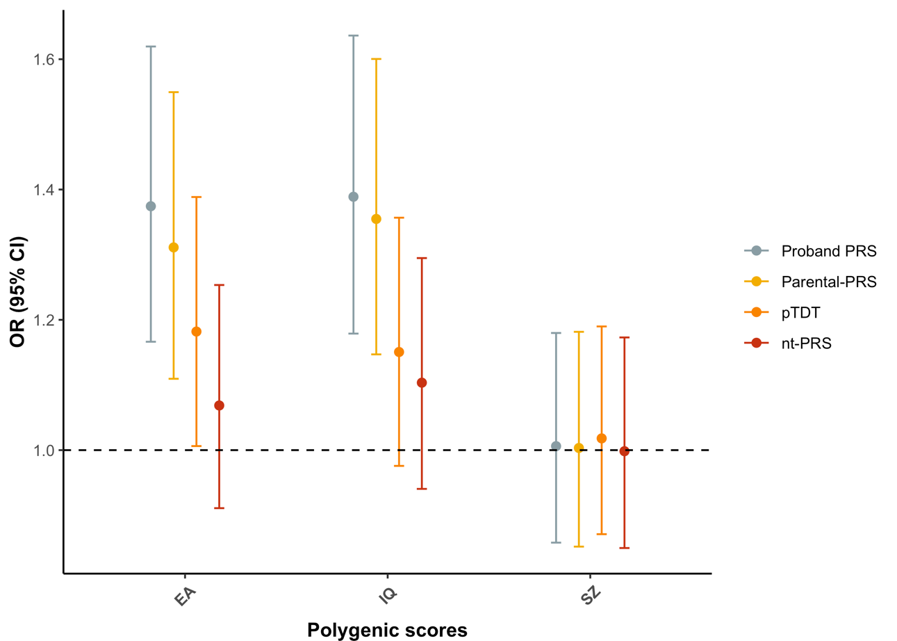
In the regression model, the outcome variable is a binary measure of school performance, where probands with lower school scores are coded = 0, and probands with higher school scores are coded = 1. The regression models covary for proband sex + PC 1-10; PRS scores were generated from the source GWAS using a p-value threshold of 0.05.

