Supplementary Material for online publication only
Biochar and legumes improve pastures in Brazil: environmental and socioeconomic analysis of three forage grasses in a field experiment
Latawiec et al.

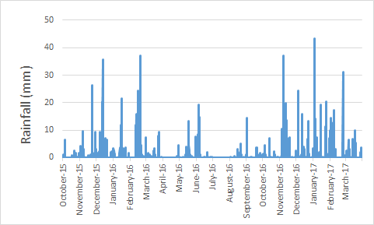
Supplementary figure 1. Rainfall and solar radiation during the field experiment

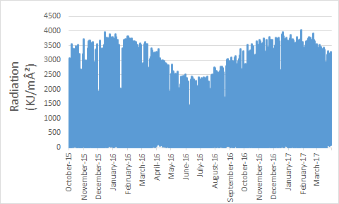

Supplementary table 1. Grass and soil collection dates

Grass collection | Soil collection
February 25th 2016 | November 25th 2015
July 03rd 2017 | February 26th 2016
September 19th & November 11th 2016 | July 14th 2016
March 13th 2017 | March 21st 2017

Supplementary figure 2. Simple kiln used to produce biochar

Supplementary methods 1. Methods of laboratory analysis of soil for water retention capacity
Soil water retention curves were determined for the 32 samples while using seven matric potential points to fit the curves. Initially, the soil samples were saturated by capillary rise for 24 hours, weighed and subjected to water drainage at the following matric potentials: -2, -3, -6, -10, -30, -100, and -1000 kPa on pressure plate extractors (Richards´ chambers). After reaching equilibrium at each water tension, the soil samples were weighed to quantify the volumetric soil water content (m³/ m⁻³). Subsequently, all soil sample were oven-dried at 105°C for 72 hours to quantify dry soil mass to determine the soil bulk density (mg/ m⁻³). Details about the procedures are given in Teixeira and Behring (2017).
The moisture at 1500 kPa were estimated using the psychrometer WP4-C (Meter, USA) using disturbed samples measured at two potential and the gravimetric soil moisture at 1500 kPa were estimated using linear regression. The volumetric soil moistures were obtained by multiplying by soil bulk density the gravimetric moisture.
Soil water retention curvs were fitted to the measured dataset (soil water content and matric potential) while using the RETC software (van Genuchten et al. 1991) by fitting the parameters (α, n and m) using a non-linear model that was proposed by van Genuchten (van Genuchten, 1980 / Equation (1)), while assuming the Mualem restriction (m = 1 -1/n).
θ=θr+θs−θr[1+(αh)n]m Equation 1
where: θ (m3 m−3) is a water content estimate; θr (m3 m−3) is the residual water content; θs (m3 m−3) is saturated water content; α (kPa−1) and n are adjustment parameters; m = 1 − 1/n and h are the positive values of matric potential.

Supplementary table 2. Results for data normality and homogeneity of variance given by Shapiro-Wilk and Bartlett tests, respectively; F and p values of analysis of variance, and coefficient of variation (CV) for dry biomass produced by different Brachiaria brizantha cultivars over four harvests. Significant p-values (α = 0.05) are in bold
B. brizantha cultivar | Shapiro-Wilk test p value | Bartlett test  p value | F | ANOVA  p value | CV (%)
Marandu | 0.33 | 0.689 | 2.55 | 0.047 | 16.8
Paiaguás | 0.12 | 0.025 | 0.92 ª | 0.550 ª | 11.9
Piatã | 0.75 | 0.505 | 2.03 | 0.102 | 17.5
ª Values from Welch’s ANOVA

Supplementary table 3. Dry matter (t/ha) produced over four harvests by three cultivars of Brachiaria brizantha submitted to different soil amendments.
Treatment | Marandu |  | Paiaguás |  | Piatã
Treatment | Dry matter | SD | Dry matter | SD | Dry matter | SD
Control | 8.37 NS₁ | 1.1 | 10.70 NS₂ | 0.7 | 10.14 NS₂ | 1.7
Moinha | 8.59 | 0.9 | 10.55 | 1.4 | 10.18 | 1.8
Limestone | 11.34 | 2.0 | 10.70 | 1.4 | 11.87 | 2.7
Limestone+NPK | 9.31 | 1.3 | 11.08 | 1.0 | 11.67 | 1.5
Biochar 15 t/ha | 12.23 | 1.0 | 10.83 | 0.6 | 13.87 | 3.9
Peanut Forage | 10.17 | 1.8 | 11.69 | 0.6 | 12.86 | 2.2
Peanut Forage+limestone | 12.13 | 3.5 | 10.41 | 0.6 | 9.33 | 1.6
Peanut Forage+biochar 15 t/ha | 9.85 | 1.5 | 12.44 | 3.3 | 12.93 | 0.9
Biochar 30 t/ha | 12.68 | 1.4 | 11.27 | 0.1 | 14.07 | 0.6
Mean | 10.52 |  | 11.07 |  | 11.88
SD: standard deviation; NS₁: nonsignificant by Tukey test (p<0.05); NS₂: nonsignificant by F test (p<0.05).

Supplementary Table 4. Loadings of the variables included in a Principal Components Analysis based on leaf nutrient parameters measured in a field experiment with three forage grasses (Brachiaria Brizantha, Brachiaria Piatã and Brachiaria Paiaguás). Larger values indicate variables that are most strongly correlated with the principal components.
Variable | PC1 | PC2 | PC3
N | -0.483 | 0.014 | -0.053
P | -0.066 | -0.273 | -0.445
K | -0.453 | 0.129 | -0.146
Ca | -0.037 | -0.586 | -0.237
Mg | -0.146 | -0.571 | 0.009
S | 0.270 | -0.398 | 0.148
Cu | -0.454 | 0.096 | 0.155
Fe | -0.422 | -0.165 | 0.250
Mn | -0.236 | -0.174 | 0.397
Zn | 0.150 | -0.121 | 0.675

Supplementary table 5. Results of generalized linear models showing the effects of biochar, Peanut Forage, Limestone and Milled biochar (and their interactions) on nutrient leaf content measured in the experiments with three cultivars of Brachiaria brizantha – Mandaru, Paiaguás and Piatã. PC1 and PC2 are the first two axes of a Principal Components Analysis summarizing the variation in nutrient content of leafs, explaining 35.03% and 18.97% of the original variation in nutrient parameters, respectively. Est – estimated coefficient; SE – Standard error of the estimate. Significant p-values are highlighted in bold.

Treatment | PC1 |  |  |  | PC2
Treatment | Est. | SE | t | p | Est. | SE | t | p
Brachiaria Marandu
(Intercept) | -0.508 | 0.545 | -0.932 | 0.355 | -0.343 | 0.514 | -0.667 | 0.507
Peanut Forage | 0.096 | 0.770 | 0.124 | 0.902 | 0.893 | 0.727 | 1.228 | 0.223
Peanut Forage + Biochar 15 t | 0.321 | 0.770 | 0.417 | 0.678 | 0.903 | 0.727 | 1.242 | 0.218
Peanut Forage + Limestone | 0.308 | 0.770 | 0.400 | 0.690 | 1.405 | 0.727 | 1.933 | 0.057
Biochar 15 t | -0.203 | 0.770 | -0.264 | 0.793 | 0.210 | 0.727 | 0.289 | 0.774
Biochar 30 t | 0.088 | 0.770 | 0.114 | 0.909 | 0.832 | 0.727 | 1.144 | 0.256
Limestone | 0.357 | 0.770 | 0.463 | 0.644 | 0.367 | 0.727 | 0.505 | 0.615
Limestone + NPK | 0.280 | 0.770 | 0.363 | 0.718 | 0.927 | 0.727 | 1.275 | 0.206
Milled biochar | 0.094 | 0.770 | 0.122 | 0.903 | 0.112 | 0.727 | 0.153 | 0.878
Brachiaria Paiagua
(Intercept) | -0.089 | 0.819 | -0.108 | 0.914 | -0.272 | 0.471 | -0.578 | 0.565
Peanut Forage | -0.029 | 1.159 | -0.025 | 0.980 | 0.002 | 0.666 | 0.003 | 0.997
Peanut Forage + Biochar 15 t | -0.193 | 1.159 | -0.166 | 0.868 | -0.026 | 0.666 | -0.038 | 0.969
Peanut Forage + Limestone | 0.070 | 1.159 | 0.060 | 0.952 | 0.457 | 0.666 | 0.686 | 0.495
Biochar 15 t | 0.475 | 1.159 | 0.410 | 0.683 | -0.207 | 0.666 | -0.310 | 0.757
Biochar 30 t | 0.227 | 1.159 | 0.196 | 0.845 | 0.519 | 0.666 | 0.780 | 0.438
Limestone | -0.190 | 1.159 | -0.164 | 0.870 | -1.195 | 0.666 | -1.794 | 0.077
Limestone + NPK | 0.131 | 1.159 | 0.113 | 0.910 | -0.207 | 0.666 | -0.311 | 0.757
Milled biochar | 0.255 | 1.159 | 0.220 | 0.826 | 0.124 | 0.666 | 0.187 | 0.852
Brachiaria Piatã
(Intercept) | 0.285 | 0.543 | 0.525 | 0.601 | -0.353 | 0.358 | -0.984 | 0.328
Peanut Forage | -0.200 | 0.768 | -0.260 | 0.795 | 0.439 | 0.507 | 0.866 | 0.389
Peanut Forage + Biochar 15 t | 0.167 | 0.768 | 0.217 | 0.829 | 1.187 | 0.507 | 2.343 | 0.022
Peanut Forage + Limestone | 0.138 | 0.768 | 0.180 | 0.858 | 0.925 | 0.507 | 1.826 | 0.072
Biochar 15 t | 0.058 | 0.768 | 0.076 | 0.940 | 0.276 | 0.507 | 0.545 | 0.587
Biochar 30 t | 0.285 | 0.768 | 0.371 | 0.712 | 0.142 | 0.507 | 0.280 | 0.780
Limestone | -0.157 | 0.768 | -0.204 | 0.839 | 0.282 | 0.507 | 0.557 | 0.580
Limestone + NPK | 0.318 | 0.768 | 0.413 | 0.681 | 0.114 | 0.507 | 0.225 | 0.822
Milled biochar | 0.105 | 0.768 | 0.136 | 0.892 | 0.229 | 0.507 | 0.452 | 0.652

Supplementary figure 3. Variation of selected foliar nutrients based on the PCA results through time in the field experiment for three different Brachiaria brizantha cultivars: a) Marandú; b) Paiaguá; and c) Piatã
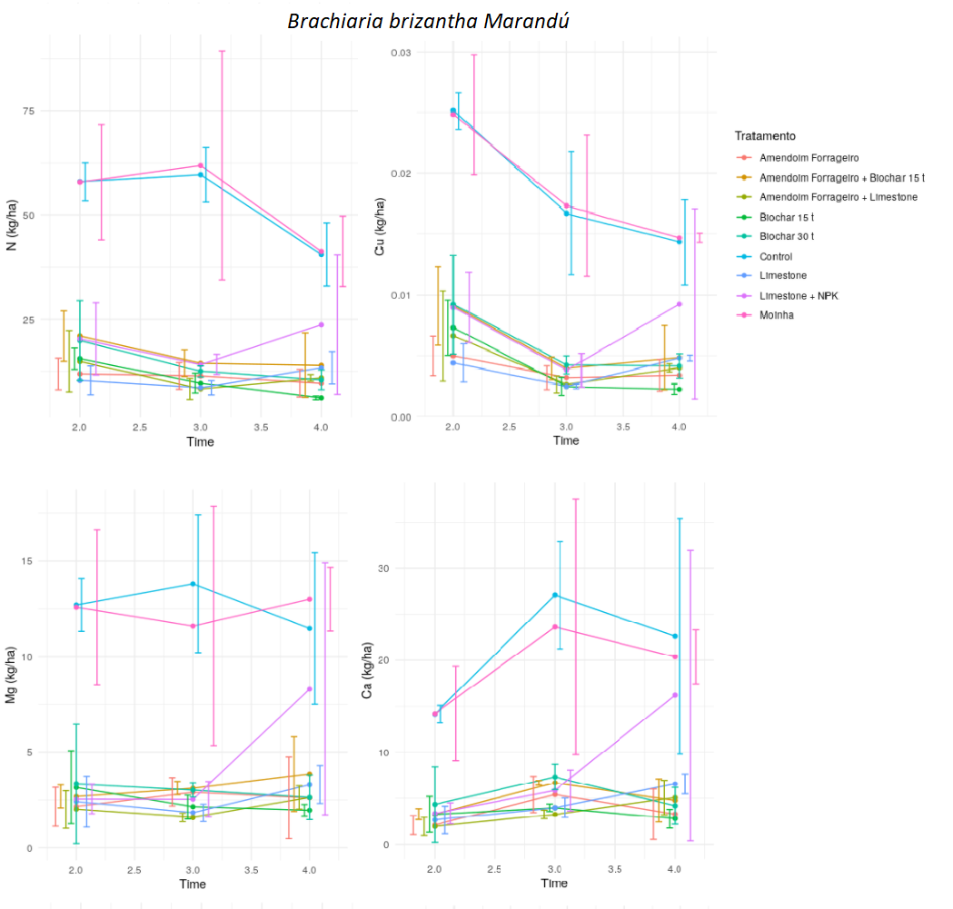

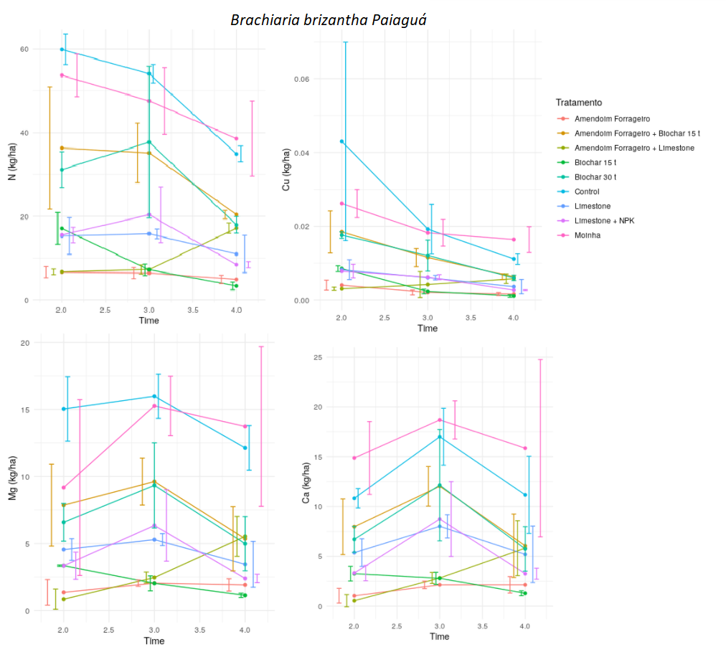

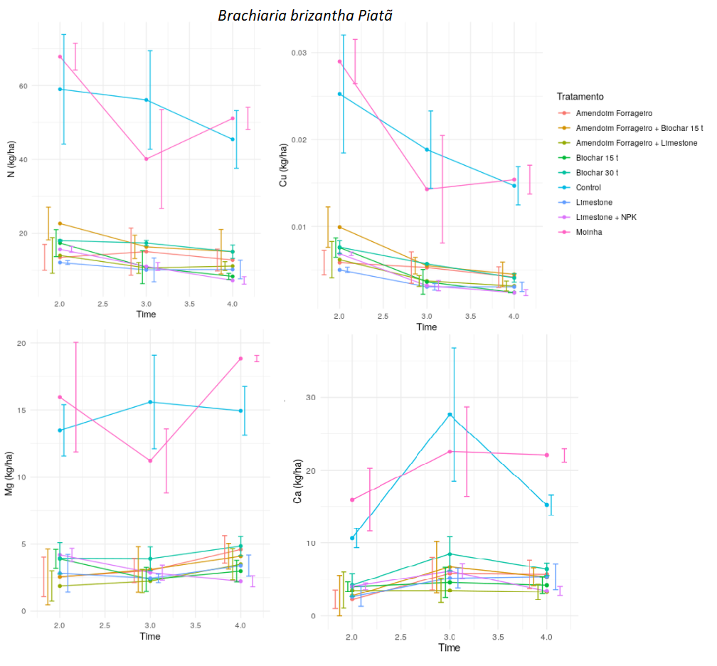

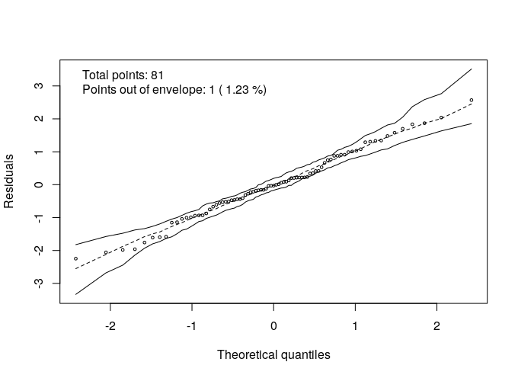

Supplementary table 6. Loadings of the variables included in a Principal Components Analysis based on soil chemical parameters measured in a field experiment with three different Brachiaria brizantha cultivars (Brachiaria brizantha cv. Paiguás, Marandú and Piatã). Larger values indicate variables that are most strongly correlated with the principal components.

Variable | PC1 | PC2 | PC3
pHKCl | 0.303 | 0.015 | -0.025
pHH₂O | 0.320 | -0.019 | -0.043
pHCaCl₂ | 0.311 | 0.015 | 0.036
Pres | 0.044 | -0.092 | -0.112
N | -0.108 | -0.162 | -0.340
Umid | 0.032 | -0.221 | 0.336
Curve0.10 | -0.036 | -0.318 | 0.190
Curve15 | -0.056 | -0.218 | 0.286
K | 0.110 | -0.132 | -0.398
P | -0.026 | 0.080 | -0.571
Na | -0.060 | -0.229 | -0.115
Ca | 0.245 | -0.210 | -0.031
Mg | 0.116 | -0.334 | 0.043
Al | -0.327 | -0.037 | 0.020
H+Al | -0.298 | -0.142 | -0.059
SB | 0.217 | -0.267 | -0.040
t | -0.029 | -0.330 | -0.148
T | -0.228 | -0.246 | -0.107
V | 0.327 | -0.062 | -0.020
m | -0.320 | 0.089 | 0.035
OM | -0.102 | -0.315 | -0.169
Prem | 0.197 | 0.121 | -0.206
Zn | 0.015 | -0.285 | 0.043
Fe | -0.065 | -0.171 | 0.041
Mn | 0.199 | -0.108 | 0.124
Cu | -0.037 | -0.154 | -0.078
Supplementary table 7. Results of generalized linear models showing the effects of biochar, Peanut Forage, Limestone and Milled biochar (and their interactions) on soil measured in the experiments with three cultivars of Brachiaria brizantha – Mandaru, Paiaguás and Piatã. PC1 and PC2 are the first two axes of a Principal Components Analysis summarizing the variation on soil, explaining 34.03% and 27.04% of the original variation on soil parameters, respectively. Est – estimated coefficient; SE – Standard error of the estimate. Significant p-values are highlighted in bold
Treatment | PC1 |  |  |  | PC2
Treatment | Est. | SE | t | p | Est. | SE | t | p
Brachiaria Marandu
(Intercept) | -2.427 | 1.519 | -1.598 | 0.127 | 1.638 | 1.464 | 1.118 | 0.278
Peanut Forage | 0.409 | 2.148 | 0.190 | 0.851 | 0.062 | 2.071 | 0.030 | 0.977
Peanut Forage + Biochar 15 t | 2.392 | 2.148 | 1.114 | 0.280 | 1.304 | 2.071 | 0.629 | 0.537
Peanut Forage + Limestone | 0.978 | 2.148 | 0.455 | 0.654 | 2.127 | 2.071 | 1.027 | 0.318
Biochar 15 t | 0.681 | 2.148 | 0.317 | 0.755 | -0.572 | 2.071 | -0.276 | 0.786
Biochar 30 t | 4.993 | 2.148 | 2.325 | 0.032 | 2.375 | 2.071 | 1.147 | 0.267
Limestone | 3.947 | 2.148 | 1.838 | 0.083 | 0.801 | 2.071 | 0.387 | 0.703
Limestone + NPK | 6.135 | 2.148 | 2.856 | 0.010 | 3.168 | 2.071 | 1.530 | 0.143
Milled biochar | 1.499 | 2.148 | 0.698 | 0.494 | -0.290 | 2.071 | -0.140 | 0.890
Brachiaria Paiaguas
(Intercept) | 0.002 | 1.183 | 0.001 | 0.999 | -1.088 | 1.055 | -1.031 | 0.316
Peanut Forage | 2.392 | 1.673 | 1.430 | 0.170 | -1.941 | 1.492 | -1.300 | 0.210
Peanut Forage + Biochar 15 t | 1.296 | 1.673 | 0.775 | 0.449 | 0.598 | 1.492 | 0.401 | 0.693
Peanut Forage + Limestone | -2.323 | 1.673 | -1.388 | 0.182 | -0.250 | 1.492 | -0.168 | 0.869
Biochar 15 t | 1.695 | 1.673 | 1.013 | 0.324 | -0.615 | 1.492 | -0.412 | 0.685
Biochar 30 t | 4.397 | 1.673 | 2.628 | 0.017 | -1.988 | 1.492 | -1.332 | 0.200
Limestone | 4.074 | 1.673 | 2.435 | 0.026 | 0.454 | 1.492 | 0.304 | 0.765
Limestone + NPK | 2.570 | 1.673 | 1.536 | 0.142 | 0.221 | 1.492 | 0.148 | 0.884
Milled biochar | 0.415 | 1.673 | 0.248 | 0.807 | -0.200 | 1.492 | -0.134 | 0.895
Brachiaria Piatã
(Intercept) | -2.962 | 0.887 | -3.340 | 0.004 | -0.817 | 0.741 | -1.103 | 0.285
Peanut Forage | 0.511 | 1.254 | 0.407 | 0.689 | 0.065 | 1.048 | 0.062 | 0.951
Peanut Forage + Biochar 15 t | 2.000 | 1.254 | 1.594 | 0.128 | -0.969 | 1.048 | -0.925 | 0.367
Peanut Forage + Limestone | -1.819 | 1.254 | -1.450 | 0.164 | 0.696 | 1.048 | 0.665 | 0.515
Biochar 15 t | 0.436 | 1.254 | 0.348 | 0.732 | -0.033 | 1.048 | -0.031 | 0.976
Biochar 30 t | 2.990 | 1.254 | 2.383 | 0.028 | -1.428 | 1.048 | -1.363 | 0.190
Limestone | 3.021 | 1.254 | 2.408 | 0.027 | -0.847 | 1.048 | -0.808 | 0.430
Limestone + NPK | 5.457 | 1.254 | 4.350 | < 0.001 | -0.168 | 1.048 | -0.161 | 0.874
Milled biochar | 0.346 | 1.254 | 0.276 | 0.786 | -0.164 | 1.048 | -0.156 | 0.877

Supplementary table 8. Van Genuchten (VG) equation parameters and goodness of fit parameters coefficient of determination (r2) and the root mean square error (RMSE) for the A horizon of a Planosol with addition of 0, 15 and 30 T/ha of Gliricidia Biochar

Treatment | θs | θr | alpha | n | m | r2 | RMSE
Control | 0,514 | 0,000 | 0,5855 | 1,1799 | 0,1524 | 0,9842 | 0,0175
Biochar 15 t/h | 0,551 | 0,000 | 0,6549 | 1,1898 | 0,1586 | 0,9868 | 0,017
Biochar 30t/h | 0,519 | 0,000 | 0,2969 | 1,2154 | 0,176 | 0,9921 | 0,0127

Supplementary table 9. Water holding capacity in soil with 0, 15, 30 Mg ha⁻¹ addition of biochar estimated at the potentials of 0, 3, 6, 10, 33 and 1500 kPa and available soil water (AW)
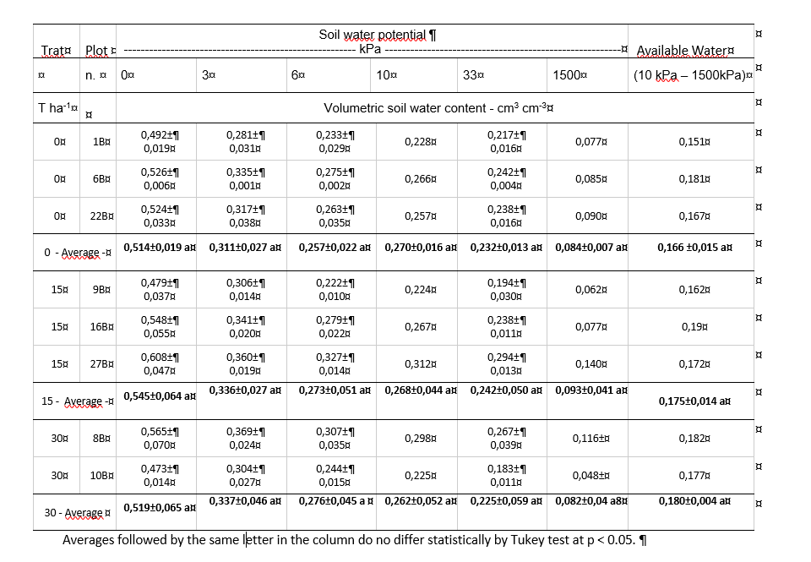

Supplementary figure 4. Soil characteristics and repeated ANOVA

Repeated Anova for soil paramenter
Parameter | Forage | pValueLB_H1 (between cycles) | pValueLB_H2 (between treatments)
pHKCl | brizantha | 0.083260226 | 0.049057838
pHKCl | paiagua | 0.00028584 | 0.265648612
pHKCl | piata | 0.058262774 | 0.69262417
pHH2O | brizantha | 8.83953E-06 | 0.029591697
pHH2O | paiagua | 6.34261E-05 | 0.189449737
pHH2O | piata | 0.009701364 | 0.237700375
pHCaCl2 | brizantha | 3.55984E-06 | 0.02008326
pHCaCl2 | paiagua | 6.53676E-05 | 0.272438156
pHCaCl2 | piata | 0.004617516 | 0.567338275
Pres | brizantha | 6.93276E-08 | 0.122041308
Pres | paiagua | 2.71262E-05 | 0.046984075
Pres | piata | 0.325560593 | 0.523370462
Ntot | brizantha | 2.37271E-07 | 0.257912053
Ntot | paiagua | 4.65779E-06 | 0.317677587
Ntot | piata | 0.000202266 | 0.237511276
Umid | brizantha | 1.61946E-07 | 0.499291265
Umid | paiagua | 7.95691E-09 | 0.127394496
Umid | piata | 2.0544E-08 | 0.215908738
Curva0__10 | brizantha | 3.08368E-13 | 0.467863564
Curva0__10 | paiagua | 1.42777E-14 | 0.67266795
Curva0__10 | piata | 2.67666E-16 | 0.481713382
Curva15 | brizantha | 1.02824E-12 | 0.168540702
Curva15 | paiagua | 2.84225E-13 | 0.396827993
Curva15 | piata | 7.2528E-17 | 0.358717561
K | brizantha | 2.74463E-10 | 0.141548421
K | paiagua | 1.99724E-10 | 0.029884683
K | piata | 1.81805E-10 | 0.02632284
P | brizantha | 1.54426E-08 | 0.045095032
P | paiagua | 7.77176E-07 | 0.059074771
P | piata | 1.28991E-05 | 0.260676005
Na | brizantha | 5.87148E-07 | 0.072435042
Na | paiagua | 8.34399E-12 | 0.000191961
Na | piata | 7.83241E-10 | 0.012734668
Ca | brizantha | 5.22394E-08 | 0.016741123
Ca | paiagua | 1.78954E-06 | 0.371808616
Ca | piata | 4.04611E-05 | 0.376940593
Mg | brizantha | 1.40857E-10 | 0.892742837
Mg | paiagua | 2.97101E-11 | 0.969707662
Mg | piata | 3.71847E-11 | 0.663663476
Al | brizantha | 2.69963E-07 | 0.441985184
Al | paiagua | 9.90144E-05 | 0.676447816
Al | piata | 1.60092E-07 | 0.223956436
Hal | brizantha | 2.79319E-06 | 0.710437858
Hal | paiagua | 3.4348E-06 | 0.663681043
Hal | piata | 1.18382E-05 | 0.399184578
SB | brizantha | 1.28892E-09 | 0.109862319
SB | paiagua | 2.00413E-08 | 0.605174173
SB | piata | 1.94367E-07 | 0.381906142
tzinho | brizantha | 1.28369E-08 | 0.090376552
tzinho | paiagua | 1.53411E-08 | 0.38130749
tzinho | piata | 2.05114E-06 | 0.5841694
Tzao | brizantha | 5.53938E-06 | 0.669443795
Tzao | paiagua | 6.41413E-05 | 0.689249719
Tzao | piata | 0.000209993 | 0.404763459
V | brizantha | 3.53911E-10 | 0.100362256
V | paiagua | 7.15363E-08 | 0.48119033
V | piata | 4.64441E-07 | 0.366010384
m | brizantha | 1.46718E-09 | 0.526496679
m | paiagua | 2.41042E-06 | 0.92238139
m | piata | 1.1132E-08 | 0.16277043
MO | brizantha | 0.003232582 | 0.64694397
MO | paiagua | 0.008888146 | 0.440299509
MO | piata | 1.97723E-06 | 0.353531028
Prem | brizantha | 3.85407E-07 | 0.598938441
Prem | paiagua | 7.54659E-10 | 0.230579281
Prem | piata | 2.18916E-08 | 0.480576814
Zn | brizantha | 1.31376E-08 | 0.884406635
Zn | paiagua | 0.001561165 | 0.632479262
Zn | piata | 4.43774E-05 | 0.85466578
Fe | brizantha | 1.65077E-12 | 0.73897694
Fe | paiagua | 2.98229E-12 | 0.341645496
Fe | piata | 1.90576E-12 | 0.659590753
Mn | brizantha | 1.4588E-10 | 0.559694623
Mn | paiagua | 1.729E-10 | 0.635480791
Mn | piata | 1.77751E-13 | 0.306696736
Cu | brizantha | 0.001774065 | 0.621961878
Cu | paiagua | 0.019107342 | 0.537283062
Cu | piata | 0.08958698 | 0.63672227
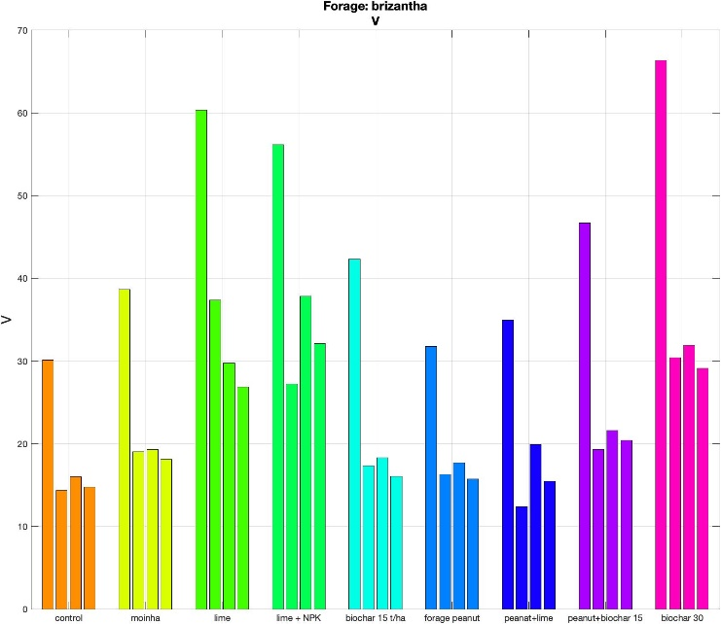

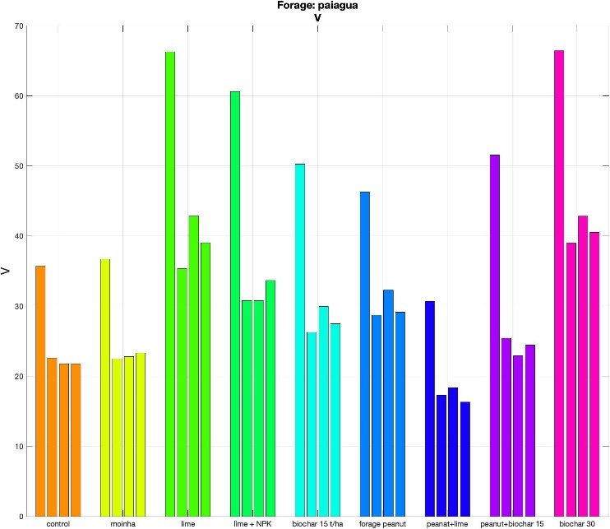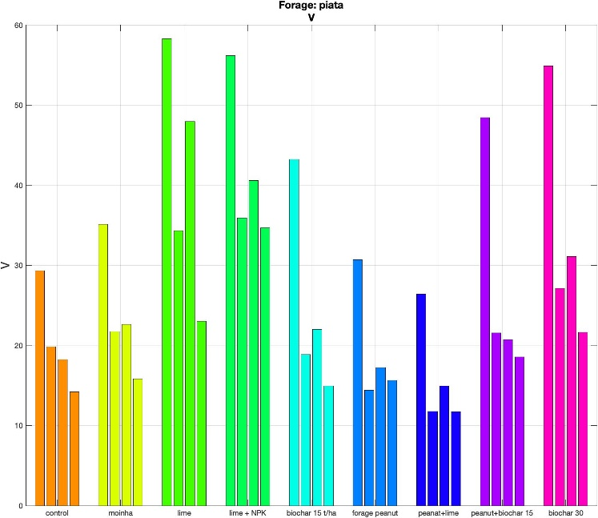
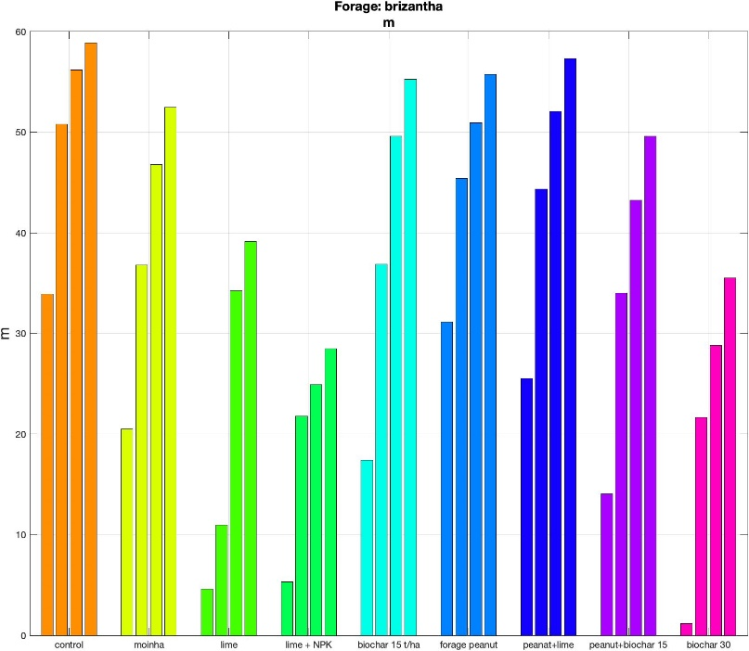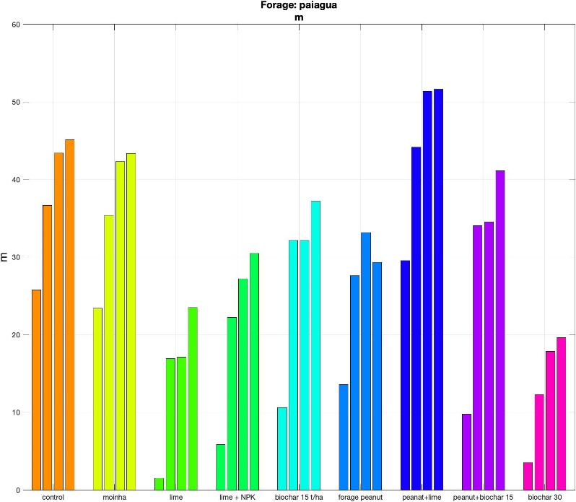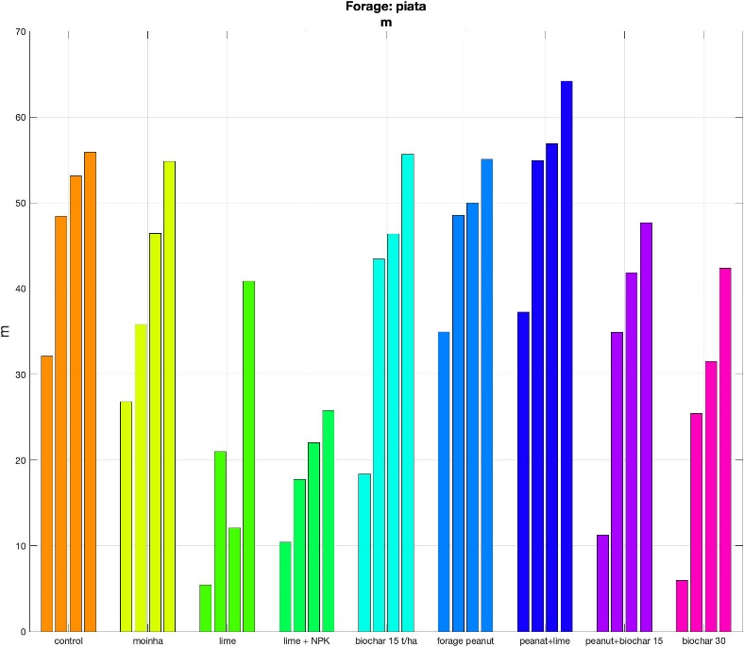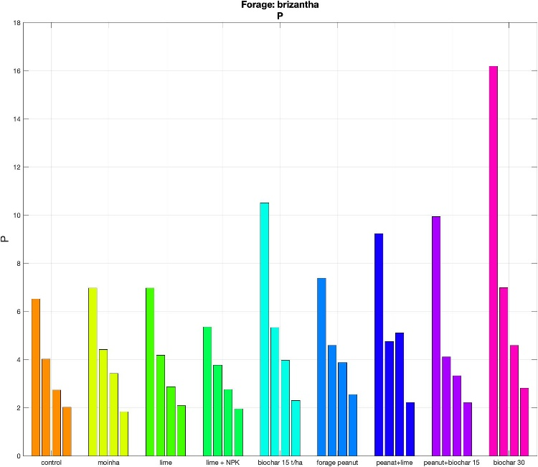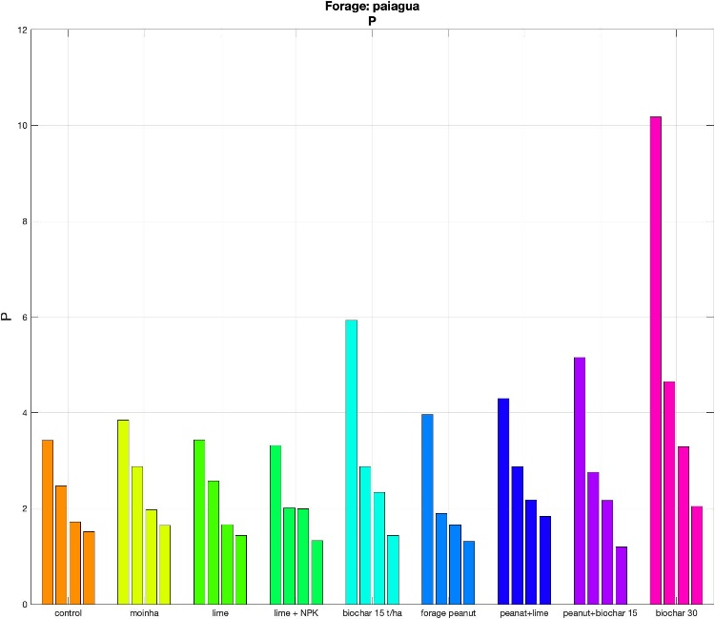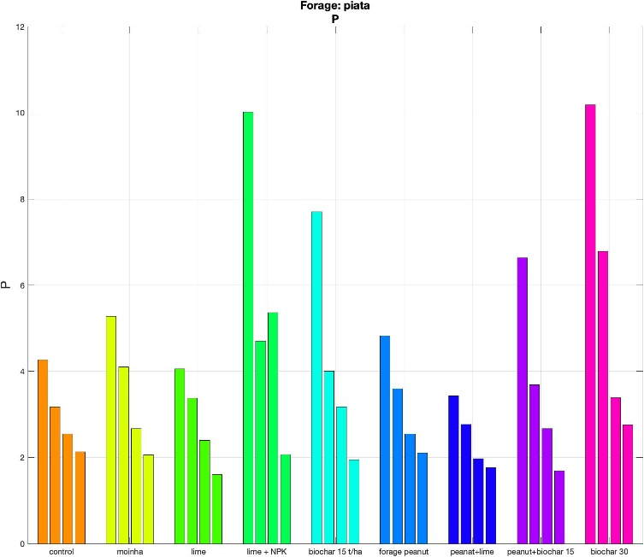

Supplementary table 10. Correlation between biomass increase and soil properties.
The CORR Procedure
Pearson Correlation Coefficients, N = 81
Prob > |r| under H0: Rho=0

K P Na Ca Mg Al Hal SB Al_sat_t

biomass 0.35144 0.11244 0.25435 0.11148 0.13236 -0.10276 -0.02256 0.14779 0.09663
0.0013 0.3176 0.0219 0.3218 0.2388 0.3613 0.8416 0.1879 0.3908

pHKCl 0.31732 -0.05348 -0.24387 0.79093 0.41375 -0.85863 -0.74511 0.71697 0.15661
0.0039 0.6354 0.0282 <.0001 0.0001 <.0001 <.0001 <.0001 0.1626

pHH2O 0.47163 -0.02608 -0.15435 0.74413 0.53337 -0.90720 -0.77590 0.73558 0.13789
<.0001 0.8172 0.1689 <.0001 <.0001 <.0001 <.0001 <.0001 0.2196

pHCaCl 0.31902 0.00404 -0.20419 0.81908 0.49893 -0.89849 -0.76708 0.76554 0.18308
0.0037 0.9715 0.0675 <.0001 <.0001 <.0001 <.0001 <.0001 0.1018

Pres 0.16541 0.25311 0.09466 0.01505 -0.02116 0.03073 0.01390 0.01519 0.04572
0.1400 0.0226 0.4006 0.8939 0.8513 0.7854 0.9019 0.8929 0.6852

Ntot 0.13676 0.13942 0.33467 0.04665 0.11760 0.34848 0.43563 0.08191 0.40496
0.2234 0.2145 0.0023 0.6792 0.2958 0.0014 <.0001 0.4673 0.0002

Umid 0.07265 -0.38453 0.28721 0.20028 0.42386 -0.00028 0.12364 0.28839 0.36210
0.5192 0.0004 0.0093 0.0730 <.0001 0.9980 0.2715 0.0090 0.0009

Curva10 0.17046 -0.25014 0.48708 0.28874 0.54801 0.18208 0.35689 0.39840 0.65839
0.1281 0.0243 <.0001 0.0089 <.0001 0.1038 0.0011 0.0002 <.0001

Curva15 0.00846 -0.25042 0.30277 0.18975 0.30945 0.23561 0.27156 0.23734 0.50242
0.9402 0.0241 0.0060 0.0898 0.0049 0.0342 0.0142 0.0329 <.0001

K 1.00000 0.25208 0.16250 0.32611 0.51513 -0.29520 -0.13914 0.47418 0.33991
0.0232 0.1472 0.0030 <.0001 0.0075 0.2154 <.0001 0.0019

P 0.25208 1.00000 0.04411 -0.05531 -0.10459 -0.00237 0.01601 -0.05558 -0.07188
0.0232 0.6958 0.6238 0.3528 0.9833 0.8872 0.6221 0.5237

Na 0.16250 0.04411 1.00000 0.05751 0.34663 0.20550 0.35010 0.16747 0.38853
0.1472 0.6958 0.6101 0.0015 0.0657 0.0014 0.1351 0.0003

Ca 0.32611 -0.05531 0.05751 1.00000 0.70539 -0.65495 -0.43933 0.96169 0.64062
0.0030 0.6238 0.6101 <.0001 <.0001 <.0001 <.0001 <.0001

Mg 0.51513 -0.10459 0.34663 0.70539 1.00000 -0.38601 -0.11200 0.86760 0.75551
<.0001 0.3528 0.0015 <.0001 0.0004 0.3195 <.0001 <.0001

Al -0.29520 -0.00237 0.20550 -0.65495 -0.38601 1.00000 0.90879 -0.61059 0.09958
0.0075 0.9833 0.0657 <.0001 0.0004 <.0001 <.0001 0.3764

Supplementary tables 11-Extraction of macronutrients by biomass

Table 11a. Extraction of micronutrients by Brachiaria brizantha cultivar Paiaguás over four harvests
Treatment | N | P | K | Ca ª | Mg ª | S
Treatment | kg/ha
Control | 98.1±6.76 ^{ns} | 11.72±0.32 ^{ns} | 138.19±14.5 ^{ns} | 78.05±4.25 ^{ns} | 94.08±2.57 ^{ns} | 15.8±2.42 ^{ns}
moinha | 90.57±9.15 | 12.04±0.42 | 135.42±18.62 | 58.63±34.85 | 60.68±40.73 | 14.99±3.41
lime | 94.79±28.06 | 14.04±3.53 | 138.61±26.9 | 83.56±4.32 | 80.35±4.9 | 14.55±3.47
calcario+NPK | 113.24±7.03 | 12.73±2.32 | 141.32±21.62 | 77.26±36.25 | 85.68±44.44 | 17.11±4.58
biochar15 | 89.9±15.3 | 14.47±0.83 | 140.26±6.55 | 74.71±0.92 | 74.43±8.39 | 16.71±2.45
peanut | 111.25±1.85 | 14.68±2.19 | 155.38±9.61 | 69.18±20.71 | 79.1±23.64 | 16.94±1.24
Peanut+Lime | 103.73±14.72 | 11.79±1.65 | 131.16±9.65 | 84.74±23.48 | 89.81±16.92 | 16.77±0.95
peanute+biochar15 | 113.64±29.6 | 15.13±3.26 | 167.74±41.9 | 62.31±54.49 | 63.73±61.76 | 17.05±6.76
biochar30 | 88.6±9.69 | 16.13±3.98 | 154.27±16.54 | 80.94±10.7 | 76.5±6.08 | 13.12±3.43
ª Data did not meet the assumption of homogeneity of variance
ª Non-significant by Tukey test (p ≤ 0.05)

Table S11b. Extraction of micronutrients by Brachiaria brizantha cultivar Paiaguás over four harvests
Treatment |  | Fe | Mn | Cu | Zn
Treatment |  | ------- kg/ha ------- |  | ------- g/ha -------
Control |  | 2.25±0.20 ^{ns} | 2.13±0.30 ^{ns} | 36.15±9.03 ^{ns} | 533.78±44.37 ^{ns}
Moinha |  | 2.33±0.23 | 1.74±0.43 | 33.82±6.37 | 478.8±89.74
Lime |  | 2.48±0.94 | 1.85±0.30 | 33.79±9.14 | 477.76±170.54
Lime+NPK |  | 2.27±0.42 | 1.70±0.33 | 37.97±4.52 | 495.42±60.61
Biochar 15 t/ha |  | 2.09±0.73 | 1.83±0.14 | 29.2±2.18 | 470.26±49.05
Peanut |  | 2.81±0.37 | 1.97±0.17 | 40.9±2.49 | 585.03±82.26
Peanut+Lime |  | 2.66±1.16 | 2.10±0.20 | 35.24±4.07 | 519.11±24.73
Peanut+Biochar 15 t/ha |  | 2.77±0.97 | 2.01±0.81 | 40.4±14.01 | 519.43±179.38
Biochar 30 t/ha |  | 2.48±0.31 | 1.54±0.50 | 35.67±4.72 | 443.67±45.76
^{ns} Non-significant by Tukey test (p ≤ 0.05)

Table S11c. Extraction of macronutrients by Brachiaria brizantha cultivar Piatã over four harvests

Treatment | N | P | K | Ca | Mg | S
Treatment | kg/ha
Control | 99.52+19.67 ^{ns} | 15.54+1.89 bc | 116.43+17.40 ^{ns} | 70.19+15.12 ^{ns} | 102.21+28.69 ^{ns} | 8.79+2.19 ^{ns}
Moinha | 98.42+31.88 | 14.89+1.12 bc | 120.51+28.23 | 70.37+8.11 | 92.68+8.93 | 8.79+2.73
Lime | 116.33+40.05 | 14.49+2.43 bc | 151.24+52.70 | 120.21+39.76 | 136.48+32.54 | 12.68+6.45
Lime+NPK | 121.89+14.31 | 14.98+1.24 bc | 141.32+33.68 | 115.43+1.12 | 117.55+18.91 | 13.97+1.79
biochar15 | 112.25+5.51 | 20.29+3.44 ab | 184.85+44.67 | 118.63+26.68 | 136.41+31.92 | 16.54+5.27
peanut | 131.63+15.80 | 17.68+3.18 abc | 158.15+41.77 | 77.33+14.45 | 88.15+33.55 | 15.36+5.20
Peanut+Lime | 99.31+21.67 | 12.47+1.09 c | 115.46+18.94 | 68.42+28.61 | 95.53+36.75 | 12.10+3.87
Peanut+biochar15 | 121.05+10.03 | 19.86+1.29 ab | 177.06+20.46 | 109.64+28.85 | 102.25+40.21 | 15.32+1.27
biochar30 | 131.15+14.81 | 22.05+1.80 a | 176.58+11.64 | 139.11+39.99 | 148.67+14.09 | 14.51+5.34
Table S11d. Extraction of micronutrients by Brachiaria brizantha cultivar Piatã over four harvests
Treatment | Mn | Fe | Cu | Zn
Treatment | ------- kg/ha ------- |  | ------- g/ha -------
Control | 1.82+0.37 ^{ns} | 1.70+0.59 ^{ns} | 35.79+7.79 ^{ns} | 400.34+59.29 ^{ns}
Moinha | 1.61+0.31 | 1.89+0.16 | 33.95+8.07 | 385.78+88.36
Lime | 2.09+0.53 | 2.12+0.41 | 42.68+10.76 | 472.62+120.57
Lime+NPK | 1.83+0.28 | 1.89+0.40 | 39.76+4.92 | 464.58+28.50
biochar15 | 2.48+0.39 | 2.36+0.44 | 52.60+13.49 | 593.44+176.67
peanut | 2.57+0.52 | 2.05+0.38 | 46.26+6.00 | 556.53+105.65
Peanut+Lime | 1.71+0.51 | 1.48+0.40 | 35.02+9.14 | 419.28+97.15
peanute+biochar15 | 2.18+0.44 | 2.12+0.37 | 48.88+2.44 | 514.17+51.71
biochar30 | 2.44+0.53 | 2.72+0.43 | 47.76+5.31 | 512.37+45.39

Table S11e. Extraction of macronutrients by Brachiaria brizantha cultivar Marandu over four harvests
Treatment | N | P | K | Ca ª | Mg ª | S
Treatment | kg/ha
Control | 98,10+6,76 ^{ns} | 11,72+0,32 ^{ns} | 138,19+14,50 ^{ns} | 78,05+4,25 ^{ns} | 94,08+2,57 ^{ns} | 15,80+2,42 ^{ns}
Moinha | 90,57+9,15 | 12,04+0,42 | 135,42+18,62 | 58,63+34,85 | 60,68+40,73 | 14,99+3,41
Lime | 94,79+28,06 | 14,04+3,53 | 138,61+26,90 | 83,56+4,32 | 80,35+4,90 | 14,55+3,47
Lime+NPK | 113,24+7,03 | 12,73+2,32 | 141,32+21,62 | 77,26+36,25 | 85,68+44,44 | 17,11+4,58
biochar15 | 89,90+15,30 | 14,47+0,83 | 140,26+6,55 | 74,71+0,92 | 74,43+8,39 | 16,71+2,45
peanut | 111,25+1,85 | 14,68+2,19 | 155,38+9,61 | 69,18+20,71 | 79,10+23,64 | 16,94+1,24
Peanut+Lime | 103,73+14,72 | 11,79+1,65 | 131,16+9,65 | 84,74+23,48 | 89,81+16,92 | 16,77+0,95
peanute+biochar15 | 113,64+29,60 | 15,13+3,26 | 167,74+41,90 | 62,31+54,49 | 63,73+61,76 | 17,05+6,76
biochar30 | 88,60+9,69 | 16,13+3,98 | 154,27+16,54 | 80,94+10,70 | 76,50+6,08 | 13,12+3,43
ª Data did not meet the assumption of homogeneity of variance
ª Non-significant by Tukey test (p ≤ 0.05)

Table S11f. Extraction of micronutrients by Brachiaria brizantha cultivar Marandu over four harvests
Treatment | Mn | Fe | Cu | Zn
Treatment | ------- kg/ha ------- |  | ------- g/ha -------
Control | 2,13+0,30 ^{ns} | 2,25+0,20 ^{ns} | 36,15+9,03 ^{ns} | 533,78+44,37 ^{ns}
Moinha | 1,74+0,43 | 2,33+0,23 | 33,82+6,37 | 478,80+89,74
Lime | 1,85+0,30 | 2,48+0,95 | 33,79+9,14 | 477,76+170,54
Lime+NPK | 1,70+0,33 | 2,27+0,42 | 37,97+4,52 | 495,42+60,61
biochar15 | 1,83+0,14 | 2,09+0,07 | 29,20+2,18 | 470,26+49,05
peanut | 1,97+0,17 | 2,81+0,37 | 40,90+2,49 | 585,03+82,26
Peanut+Lime | 2,10+0,20 | 2,66+1,16 | 35,24+4,07 | 519,11+24,73
peanute+biochar15 | 2,01+0,81 | 2,77+0,97 | 40,40+14,01 | 519,43+179,38
biochar30 | 1,54+0,50 | 2,48+0,31 | 35,67+4,72 | 443,67+45,76

Supplementary table12. Yield uplifts

Treatment | Marandu |  | Paiaguás |  | Piatã
Treatment | Dry matter | SD | Dry matter | SD | Dry matter | SD
Control | 8.37 c | 1.1 | 10.70 NS | 0.7 | 10.14 NS | 1.7
Moinha | 8.59 c | 0.9 | 10.55 | 1.4 | 10.18 | 1.8
Limestone | 11.34 ab | 2.0 | 10.70 | 1.4 | 11.87 | 2.7
Limestone+NPK | 9.31 bc | 1.3 | 11.08 | 1.0 | 11.67 | 1.5
Biochar 15 t/ha | 12.23 a | 1.0 | 10.83 | 0.6 | 13.87 | 3.9
Peanut Forage | 10.17 abc | 1.8 | 11.69 | 0.6 | 12.86 | 2.2
Peanut Forage+limestone | 12.13 ab | 3.5 | 10.41 | 0.6 | 9.33 | 1.6
Peanut Forage+biochar 15 t/ha | 9.85 abc | 1.5 | 12.44 | 3.3 | 12.93 | 0.9
Biochar 30 t/ha | 12.68 a | 1.4 | 11.27 | 0.1 | 14.07 | 0.6
Mean | 10.52 |  | 11.07 |  | 11.88
Biomass increase (34% for Marandu, 28 Piata and 14% for Paiaguaias).
Letter compare treatments by t-test (p≤0.05). NS: non-significant.

