Validation and Characterization of a Novel Blood-Brain Barrier Platform for Investigating Traumatic Brain Injury
Authors: Christopher T. Bolden, PhD^{1,2*} & Max A. Skibber, MS¹, Scott D. Olson, PhD¹, Miriam Zamorano Rojas, PhD¹, Samantha Milewicz¹, Brijesh S. Gill, MD³, Charles S. Cox Jr, MD^{1,2,4*}

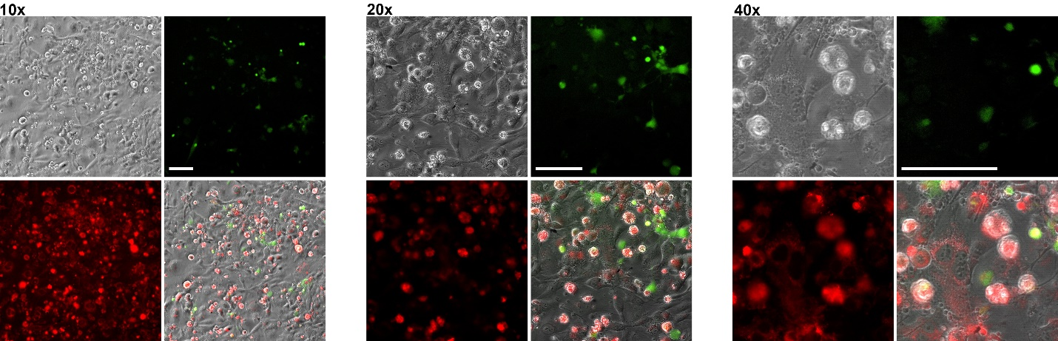
Supplemental Figure 1A. CellTracker staining of contact triculture. Contact triculture of HBEC-5i (unstained), primary human astrocytes (green, CMFDA), and BM-MSCs (red, CMFPTX) in Lab-tek chamber slides. Scale bar 100 µm.
Figure 1B. Immunostaining of contact triculture BBB model. Fluorescent cell marker expression of triculture model components including HBEC-5is (Phase, Gray), primary human astrocytes (GFAP, Green), and BM-MSCs (α-smooth muscle actin, red). Scale bar 100 µm.

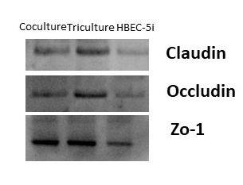
Supplemental Figure 1C. Western Blot of Tight Junction Proteins in model construct. Claudin-5, occludin, and zo-1 expression were evaluated in the HBEC-5i monoculture, coculture with primary human astrocytes, and contact triculture with BM-MSCs.

Supplemental Figure 2. cytochalasin-D (2.5 µg/ml) induced changes in barrier properties of endothelial cell constructs. (A.) Confluent cultures consisting of HUVEC (blue circle), HBEC-5i (red square), co-cultured HBEC-5i and primary human astrocytes (green triangle), and tricultured HBEC-5i, primary human astrocytes and BM-MSCs (purple inverted triangle) were grown to confluence on Matrigel coated Transwell filter inserts and added to platform. All endothelial cell monolayers were allowed to acclimate in platform under low flow condition for 20 hr. Following cD treatment at the 22 hr timepoint, TEER measurements were performed every hr for a total of 5 hr. (B.) Pre-insult corresponds to hr 20 after cultures were under low flow conditions. Post-insult corresponds to 5 hr after cytochalasin exposure (Hr 27). Data is presented as SD. *P<0.05; **P<0.01; ***P<0.001; ****P<0.0001 (Ordinary One-way Anova). N = 24 (3 repeated experiment of n =8 biological replicates)
Expressive Markers | Mesenchymal Stem Cells | Pericytes
NG2+ | X | X
PDGFRb+ | X | X
CD13+ | X | X
αSMA+ | X | X
CD146+ | X | X
Stable 1. Immunophenotype Similarities between Pericytes and Mesenchymal Stem Cells.

Methods
Reagents
HBEC-5i were initially cultured and maintained in Gibco Dulbecco's Modified Eagle Medium: Nutrient Mixture F-12 (DMEM/F-12) with 10% FBS, 40 µg/mL endothelial growth supplement (ECGS) and 1% penicillin/streptomycin (P/S; ScienCell Research Laboratories, Inc., Carlsbad, CA, USA) in 75 cm² flasks coated with 0.1% gelatin. Primary human astrocytes (PHA) were expanded and maintained in Astrocyte Medium, which contains 500 mL of basal medium, 10 mL of FBS, 5 mL of astrocyte growth supplement (AGS), and 5 ml of P/S in 75 cm² flasks containing a solution of poly-L-Lysine (2 μg/cm²). PHA were used between passages 3-5. Bone marrow derived MSCs (BM MSCs) were isolated from commercially available fresh human bone marrow aspirates (AllCells, Emeryville, CA) or obtained from fresh bone marrow through the approved IRB protocol HSC‐MS‐08‐0393 and expanded following established procedures (PMID: 28233425). Donor 5204, used in the current study, was from a 28 years old male. Briefly, BM MSCs were cultured in complete culture medium that consisted of alpha‐minimal essential medium (Life Technologies, Grand Island, NY), 17% fetal bovine serum (FBS; lot‐selected for rapid growth of MSC; Atlanta Biologicals, Norcross, GA), 100 units/ml penicillin (Thermo Fisher Scientific, Waltham, MA), 100 mg/ml streptomycin (Life Technologies), and 2 mM l‐glutamine (Thermo Fisher Scientific, Waltham, MA). BM-MSCs were used between passages 4-5.
Contact Tri-culture (Chamber slide)
On day 1, Lab-tek chamber slides coated with attachment factor solution (250 μL) for 30 min.). A 500 μL cell suspension (1.15 x 10⁴) of HBEC-5i in endothelial cell medium (ScienCell) was added to the chamber slide and allowed to grow uninterrupted until day 3. On day 3, media was removed from the chamber slide, and 250 µL of primary human astrocyte cell suspension (2.5 x 10⁴). On day 3, a 100 μL (5.0 x 10³) cell suspension of BM-MSCs were added to the chamber in MSC medium (ScienCell).
Immunostaining - Celltracker staining
Contact Triculture were established in Lab-tek II chamber slides and fluorescently labeled to demonstrate cellular interactions. CellTracker ™ Red CMPTX was used to label BM-MSCs, CellTracker™ Green CMFDA (ThermoFisher Cat. C2925) was used for primary human astrocytes and HBEC-5is were left unstained. The CellTracker dyes were solubilized in DMSO to a concentration of 10 mM and then further diluted in serum free culture medium (DMEM) to create a working concentration of 2 µM. HBEC-5is were seeded on Lab-tek chamber sides for 48 hrs. before the addition of any other cell types. Primary human astrocytes and BM-MSCs in separate tubes were centrifuged at 1000 x g for 5 minutes to pellet the cells. The resulting pellets were reconstituted in 10 mL of the 2 µM working dye and added to a 6 well plate for incubation. The well plate was then incubated at 37°C in 5% CO₂ for 30 minutes. After incubation, the dye/cell suspensions was transferred into a tube, centrifuged at 1000 x g for 5 min, and the pellets were washed in 3 mL of DMEM.
Cytochalasin D Treatment
Cytochalasin D (cD) from Zygosporium mansonii was used to study effects on TEER. Stock solution of cD (5 mg/ml) was made with DMSO and diluted in EGM-Plus before addition to cells. The final concentration of DMSO did not exceed 0.01%. TEER was measured every hour for a total of 5 h after addition of cD (2.5 ug/ml).
Western Blot
Cell-seeded Transwells were removed from the dynamic platform and washed with ice-cold PBS to remove excess cell media. 300 uL RIPA Lysis buffer with 1x Halt Cocktail Protease Inhibitor (ThermoFisher) was added to the Transwell on ice for 30 minutes. Samples were diluted with 4x LDS sample buffer (Invitrogen, Carlsbad, CA), 1x reducing buffer and then boiled at 85 °C for 10 min. Each sample was loaded into the wells of a NuPAGE Novex 4-12% Bis-Tris gel (Invitrogen, Carlsbad, CA) for gel electrophoresis. Proteins were transferred onto nitrocellulose membranes. Membranes were blocked for 1 h at room temperature with either 5% BSA in TBST. Membranes were then incubated with either occludin (1:50,000), claudin-5 (1:5,000), or GAPDH (1:10,000) in their respective blocking buffer for approximately 2 h at 4 °C. After primary antibody incubation, membranes were washed with TBST and incubated with secondary antibody goat anti-rabbit HRP (ThermoFisher) for 1 hr at room temperature
The following antibodies were used: anti-claudin-5 (Thermo Fisher, 35-2500), anti-occludin (Thermo Fisher, 33-1500), anti-zo1(Thermo Fisher, 61-7300), goat anti-rabbit AlexaFluor 488 (Thermo Fisher, A11008), and goat anti-rabbit AlexaFluor HRP (A21428, ThermoFisher).

