Supplementary Information to

“Effect of Nb cationic substitution on the microstructure and Raman spectra of SrBi₂(Ta,Nb)₂O₉ thin films”
By
O. M. Fesenko¹, A. D. Yaremkevich¹, T.V. Tsebrienko ¹, O.P. Budnyk¹, Lei Wang², A. V. Semchenko², V. V. Sidski², and A. N. Morozovska¹

¹Institute of Physics, National Academy of Sciences of Ukraine, 46, pr. Nauky, 03028 Kyiv, Ukraine
² Nanjing University of Science and Technology, China, Jiangsu, Nanjing, Xuanwu, Xiaolingweijie.

For better understanding of this mode nature in SBT and SBTN films, we perform the deconvolution of Raman band with maximum at about 810 cm⁻¹ (for SBT) and about 826 cm⁻¹ (for SBTN) using the Gaussian fit. Appeared that the band at 810 cm⁻¹ for undoped SBT films decomposes into a single maximum, which corresponds to TaO₆ mode. An example of deconvolutions of the Raman bands at about 810 cm⁻¹ and at about 826 cm⁻¹ with and without Nb doping are shown in Figure S1. The Raman band at about 826 cm⁻¹ decomposes into two maxima, at ~(809-813) cm⁻¹ and at ~(830 - 837) cm⁻¹, which correspond to TaO₆ and NbO₆ modes, respectively.

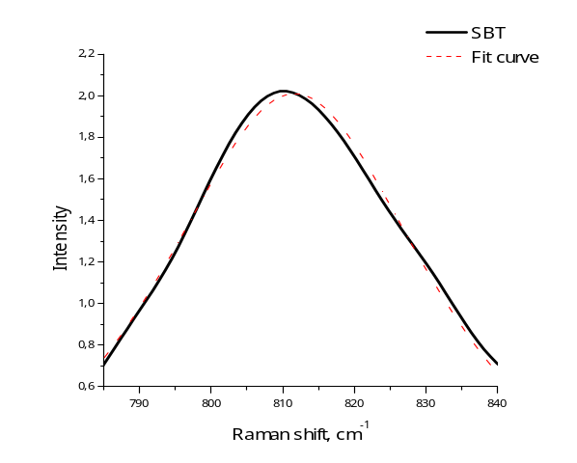 | 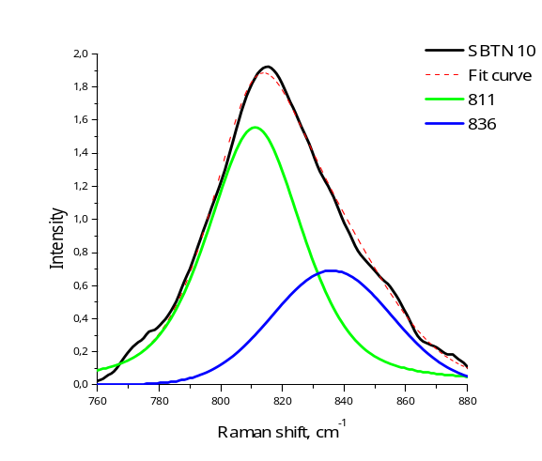
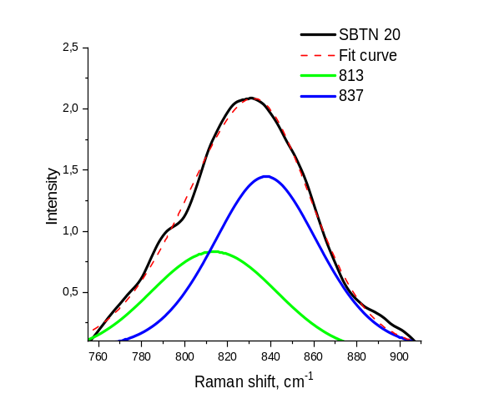 | 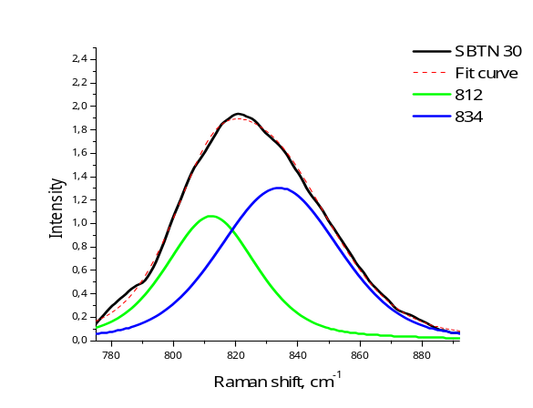
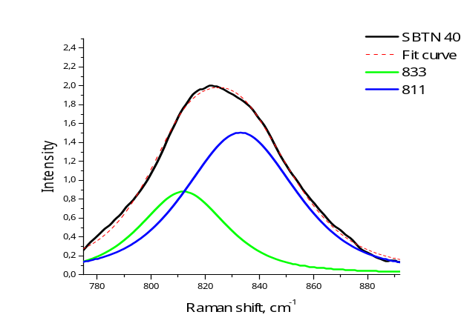 | 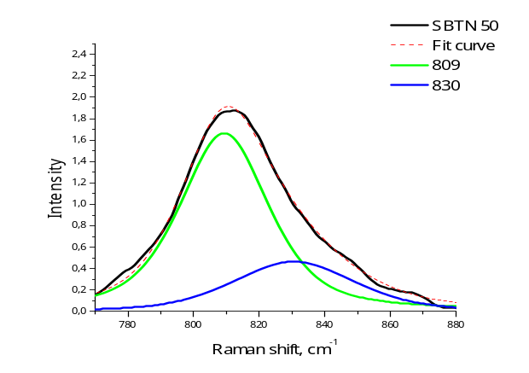
Figure S1. Deconvolution of the Raman bands with peak maximum around 810-830 cm⁻¹ into Gaussian components for SrBi₂(Ta_{1-x}Nb_{1-x})₂O₉ films annealed at 700°С. Six plots correspond to x=0, 0.1, 0.2, 0.3, 0.4 and 0.5 (see legends). Black solid curves are experimental Raman spectra, dashed red curves are fit, green and blue curves are the components corresponding to the TaO₆ and NbO₆ tilting modes, respectively.

Figures sources, files, made in Origin, which can be opened by double-click

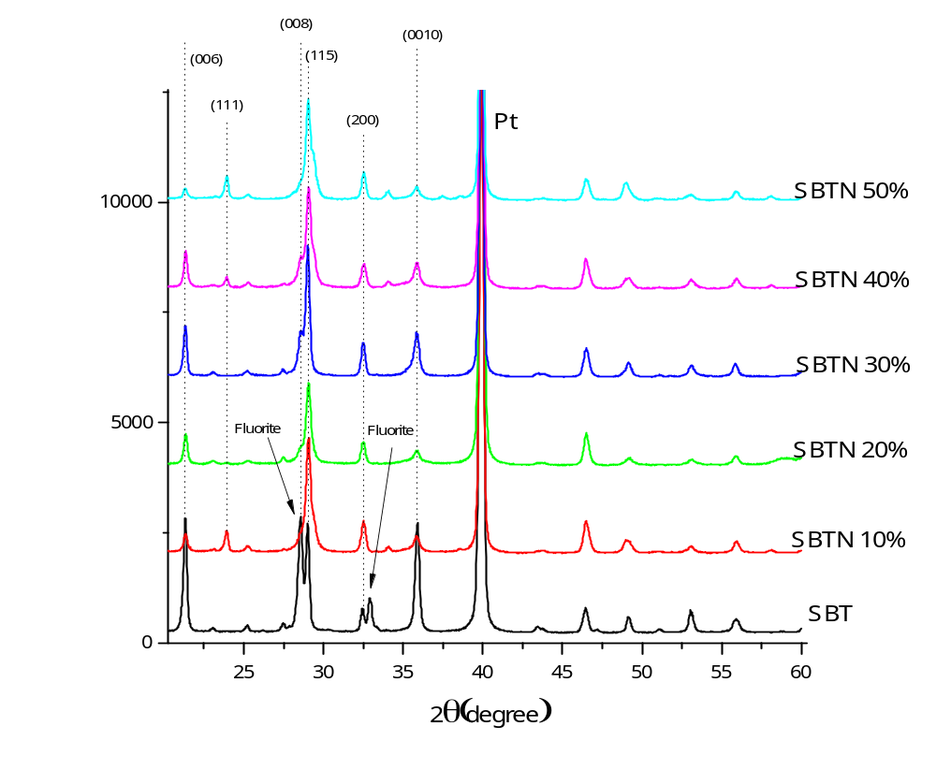
Figure 2.
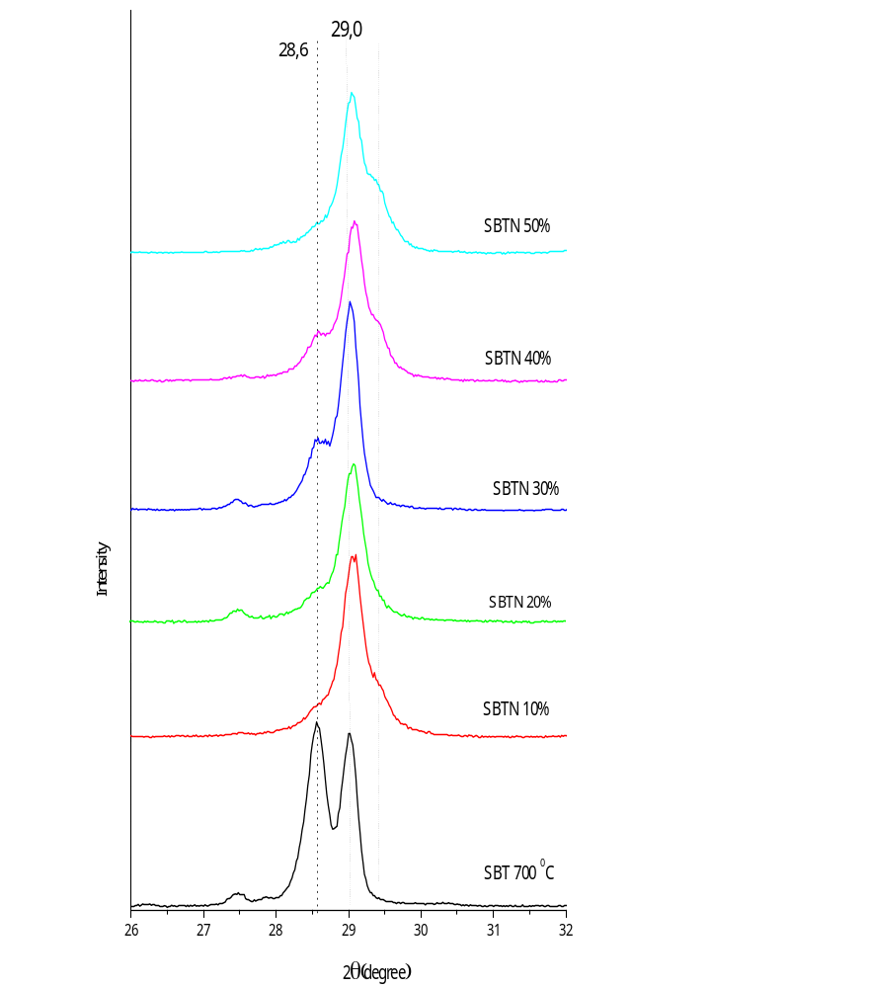(a)
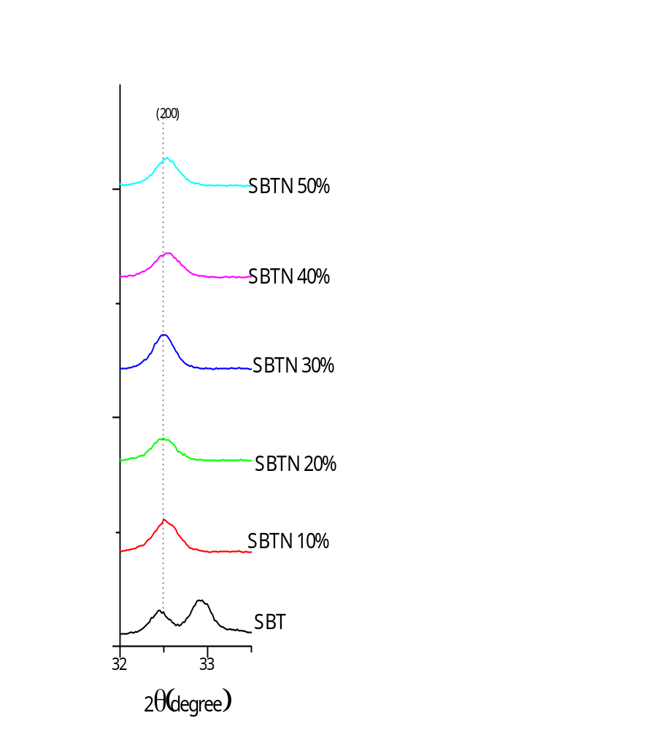(b)
Figure 3.
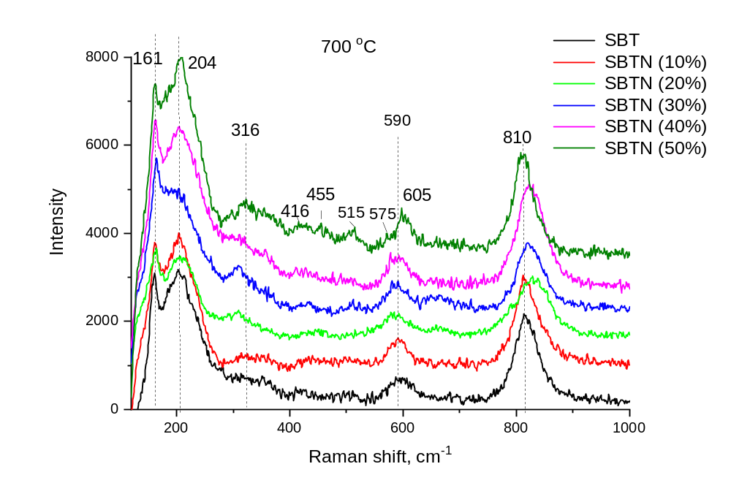
Figure 5.

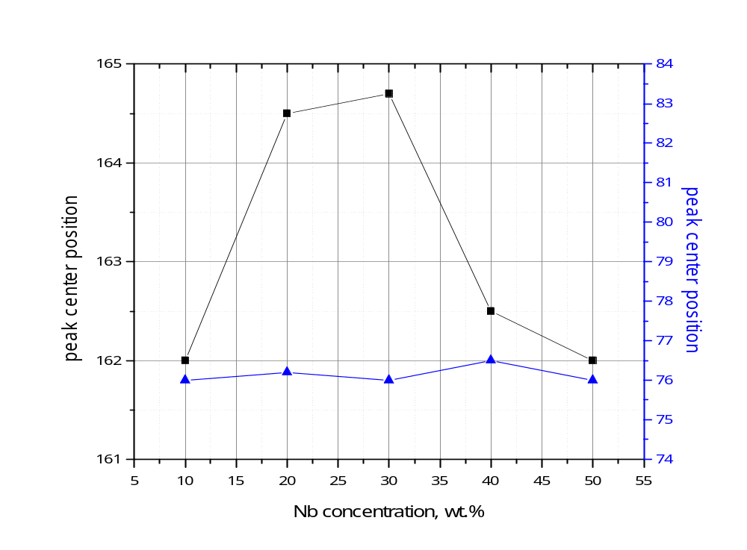
Figure 6.

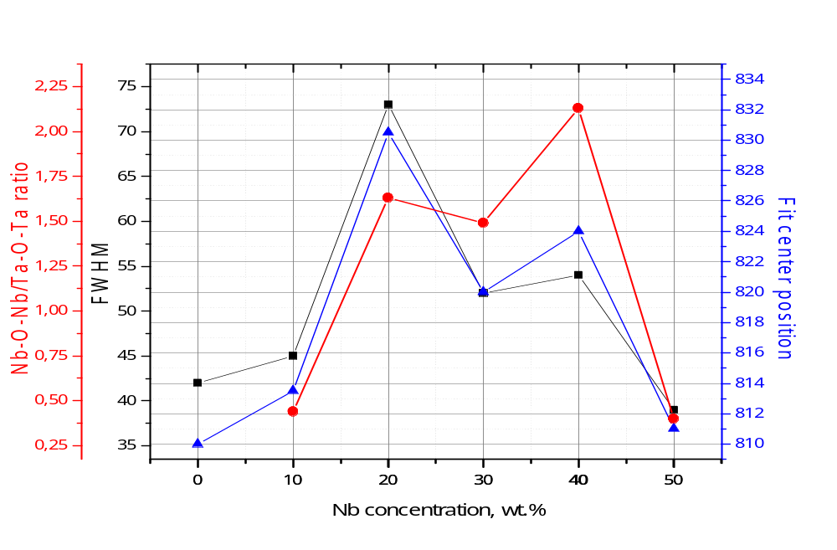
Figure 8.

corresponding author, e-mail: fesenko.olena@gmail.com

