Supplementary Information

Sonoprinting Nanoparticles on Cellular Spheroids via Surface Acoustic Waves for Enhanced Nanotherapeutics Delivery

Reza Rasouli,¹ Radu Alexandru Paun ¹ and Maryam Tabrizian*^{1, 2}
¹ Department of Biomedical Engineering, Faculty of Medicine, McGill University, Montreal, QC, Canada
² Faculty of Dental Medicine and Oral Health Sciences McGill University, Montreal, QC, Canada
Correspondence
*Dr. Maryam Tabrizian,
Email: Maryam.Tabrizian@McGill.ca

Video captions:

Video S1. Eckart microstreams formation in the presence of 13.7 MHz focused SAW, demonstrated by streak lines of fluorescent polystyrene microparticles (video is in 2x speed).

Video S2. Aggregation of microparticles around cellular spheroids upon activation of SAW,
(video is in 2x speed).

Characterization of liposomal CuET nanoparticles:
Size and size distribution of LP-CuET nanoparticles measured with Nanoparticle tracking analysis, showing the mean particle size of 110.7 +/-1.0 nm.

Stats: Mean +/- Standard Error
Mean: | 110.7 +/-1.0 nm
Mode: | 94.0 +/-5.0 nm
SD: | 40.7 +/- 0.9 nm
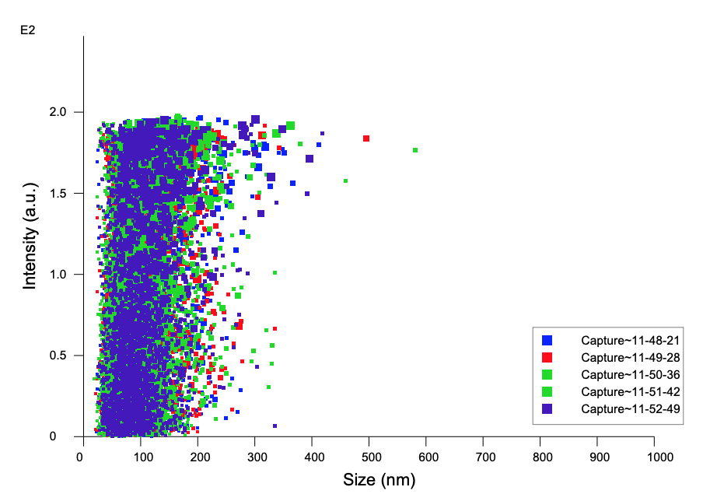
Figure S 1: Nanoparticle tracking analysis of LP-CuET, Showing the size and size distribution A) averaged concentration / size for experiments, B) intensity / size graph.
A
B

.

Delta Ct values of RT-qPCR experiments of different treatment groups in YUMM 1.7 spheroids normalized to GAPDH.
NSAW is the control group, SAW is spheroids only exposed to the acoustic waves without liposomal CuET nanoparticles, LP-CuET is the group exposed to the nanoparticles but without SAW and finally SAW+ LP-CuET is the group exposed to LP-CuET nanoparticle in the presence of acoustic stimulation. Welch’s one-way ANOVA with Dunnett’s 3T correction (n=3). These were used to graph the significance of the results from the last figure.

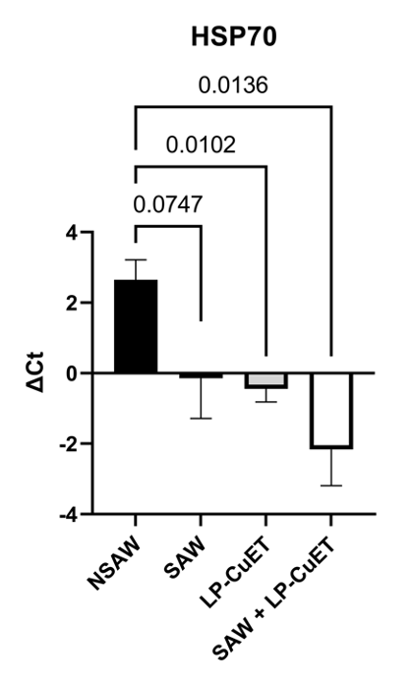
Figure S2 Delta Ct values of RT-qPCR experiments of different treatment groups in YUMM 1.7 spheroids normalized to GAPDH A) CD90 B) HSP70.

A
B

Toxicity analysis of LP-CuET for both cell types
Half maximal inhibitory concentration (IC50) of LP-CuET was measured for both MCF-7 and YUMM-1.7 cells in 2D to analyze the cellular survival and their sensitivity to the drug.

IC50 was calculated by using the Sulforhodamine B assay. 10000 Cells were seeded at each well of 96-well plates and incubated overnight before treating with various concentrations of LP-CuET for 72h. Cells were fixed with 50% TCA, stained with 0.4% suflorhodamine B, and resuspended in TRIS buffer (10 mM) at a final volume of 200 µL per well.
A
B

Figure S3 A) Representative IC50 curve of an individual experiment for MCF7 treated with LP-CuET. B) Representative IC50 curve of an individual experiment for YUMM 1.7 treated with LP-CuET C). IC50 difference between MCF 7 and YUMM 1.7 showing increased sensitivity of MCF 7 cells to LP-CuET. Student’s t-test with Welch’s correction of 3 individual experiments (n=3) derived from the previous curves in A) and B).
C

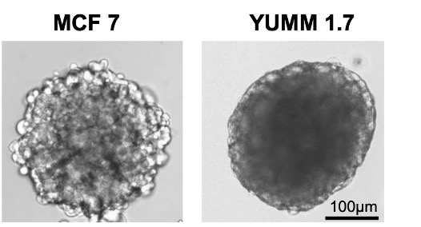
Figure S4 Brightfield microscope images of A) MCF 7 and B) YUMM 1.7 spheroids after 3 days of culture. YUMM 1.7 spheroids show more coherent structure and opaqueness which is a common indicator of compactness.
B
A
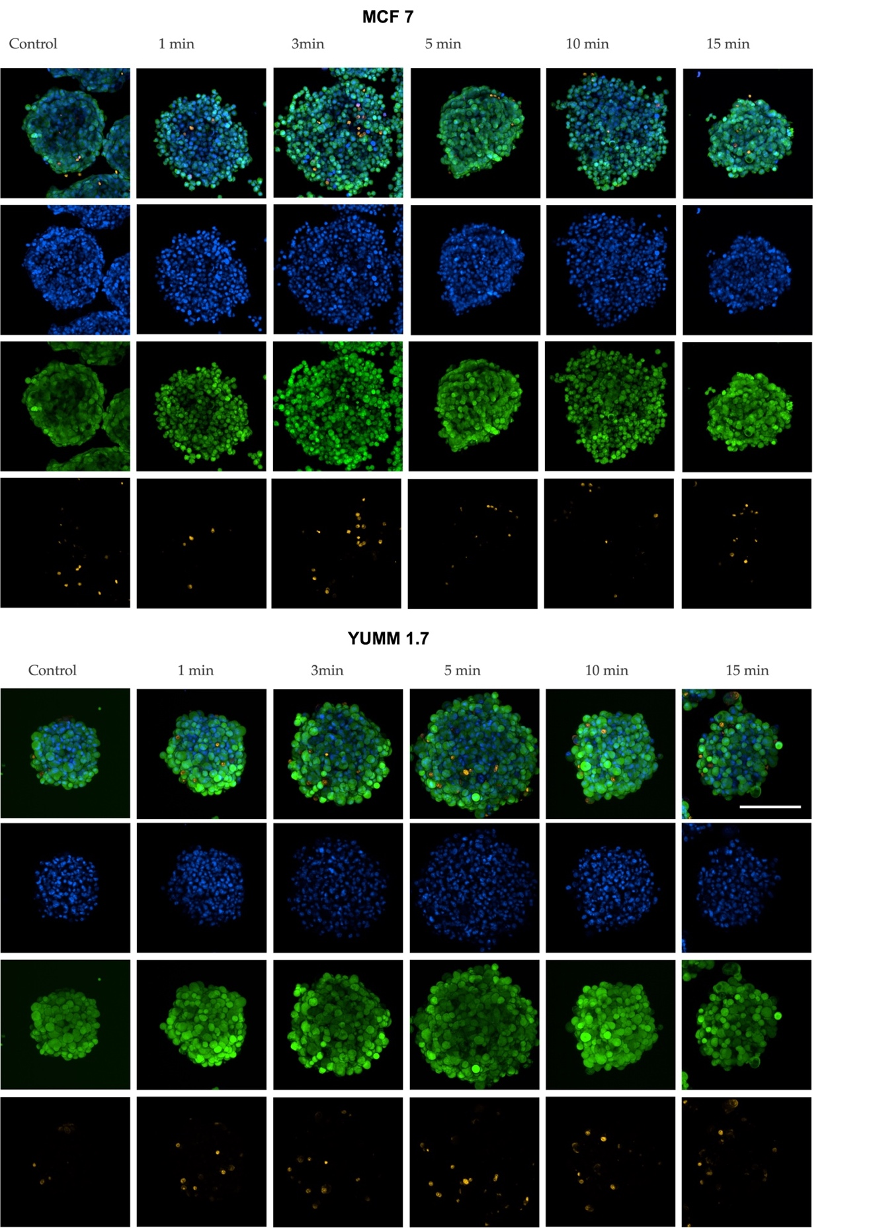
Figure S5 The cell viability in the A) MCF 7 and B) YUMM 1.7 spheroids after different exposure times to 10 Vpp SAW. Spheroids were stained with green Calcein AM for live cells, orange ethidium homodimer III for dead cells, and Hoechst 33342 for nuclei. Scale bar is 200 μm.
B
A

Calculations for the penetration depth of the device
The frequency used in our platform is within the range of many high-resolution ultrasound systems which are commonly operational up to 20 MHz. (Ihnatsenka and Boezaart 2010; Levy et al. n.d.). The critical depth or penetration depth is approximately two to three times the relaxation depth where the amplitude of the acoustic wave attenuates by a factor 1/e (Panneton 2019). As such, the loss of acoustic pressure at length L is calculatable by p = p₀e^{−αL}, where p₀ is the initial pressure and α is the attenuation coefficient. The attenuation coefficient is equal to a = 8.7α where a is a function of frequency and calculatable by a(f) = a₀f^{γ}, 0 < γ ≤ 2, where γ is 1 for polymers and tissues. The average reported “a” for soft tissue equals to 0.54-0.58 (db/cm) at 1 MHz (Athanassiadis et al. 2022). Using the above equation for the frequency of 13.7 MHz, the amount a=0.58* 13.7=7.4 (db/cm) and α=0.85. putting α in p = p₀e^{−αL}, the relaxation length equals to L= 1.17 cm and therefore the penetration depth is anticipated to be in the range of 2.34 -3.54 cm.

