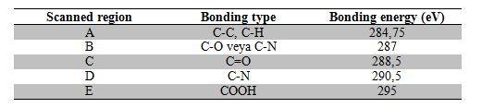

Table 1. C (1s) XPS spectrum measurements
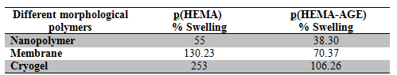
Table 2. Swelling of different morphological polymers
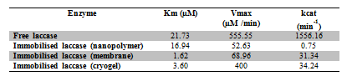

Table 3. Kinetic constants of free and immobilized laccase enzyme

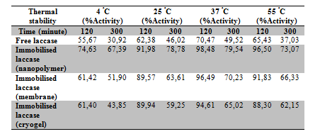
Table 4. The thermal stability of free and immobilized enzymes at 4, 25, 37 and 55 ºC

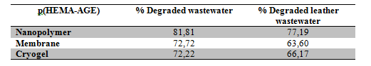
Table 5. Degradation efficiency

