Variables | CKD273 high risk  No Retinopathy | CKD273 high risk  Retinopathy | p | CKD273 low risk  No retinopathy | CKD273 low risk  Retinopathy | p
N | 175 | 41 |  | 1279 | 263
Age, years | 63.2 (6.7) | 63.3 (5.7) | 0.960 | 61.2 (8.5) | 62.7 (8.0) | 0.009
Male, n (%) | 115 (65.7) | 34 (82.9) | 0.050 | 784 (61) | 164 (62.4) | 0.801
Non-White, n (%) | 2 (1.1) | 2 (4.9) | 0.340 | 44 (3.4) | 12 (4.6) | 0.481
Diabetes duration, years | 12.7 (7.9) | 17.7 (8.7) | <0.001 | 10.2 (6.8) | 17.7 (8.3) | <0.001
Retinopathy grade, n (%) |  |  | N/A |  |  | N/A
Non-proliferative | - | 31 (77.5) |  | - | 200 (76.3)
Proliferative | - | 8 (20.0) |  | - | 48 (18.3)
Maculopathy, n (%) | - | 10 (24.4) |  | - | 69 (27.2)
History of laser therapy, n (%) | - | 10 (25.6) |  | - | 66 (25.8)
HbA1c, mmol/mol | 58 (13) | 62 (14) | 0.075 | 56 (11) | 62 (12) | <0.001
eGFR ml/min/1.73m2 | 82 (17) | 79 (18) | 0.208 | 88 (15) | 86 (16) | 0.031
UACR, mg/g | 7 [4, 11] | 10 [6, 14] | 0.007 | 5 [3, 8] | 6 [4, 9] | 0.007
CKD273, arbitrary unit | 0.34 (0.17) | 0.34 (0.17) | 0.913 | -0.44 (0.34) | -0.36 (0.30) | <0.001
Systolic BP, mmHg | 136 (12) | 132 (14) | 0.134 | 133 (12) | 134 (12) | 0.628
Diastolic BP, mmHg | 79 (9) | 76 (9) | 0.024 | 79 (8) | 76 (10) | <0.001
BMI, kg/m2 | 30.7 (5.1) | 31.2 (6.7) | 0.560 | 30.3 (5.0) | 30.5 (5.0) | 0.628
LDL cholesterol, mmol/l | 2.43 (1.08) | 2.29 (0.84) | 0.441 | 2.45 (0.92) | 2.21 (0.83) | <0.001
Smoker, n (%) | 81 (46.3) | 16 (39.0) | 0.505 | 575 (45.1) | 110 (42.1) | 0.420
RAAS-inhibitor treatment, n (%) | 152 (86.9) | 39 (95.1) | 0.223 | 757 (59.2) | 193 (73.4) | <0.001
Metformin treatment, n (%) | 145 (83.3) | 37 (90.2) | 0.388 | 947 (77.9) | 203 (78.1) | 1.000
Insulin treatment, n (%) | 51 (29.3) | 22 (53.7) | 0.005 | 314 (25.8) | 145 (55.8) | <0.001
GLP1-RA treatment, n (%) | 30 (17.2) | 7 (17.1) | 1.000 | 170 (14.0) | 64 (24.6) | <0.001
SGLT2 inhibitor treatment, n (%) | 13 (7.5) | 7 (17.1) | 0.108 | 78 (6.4) | 23 (8.8) | 0.203
History of IHD, n (%) | 26 (14.9) | 10 (24.4) | 0.214 | 131 (10.2) | 48 (18.3) | <0.001
History of stroke, n (%) | 12 (6.9) | 1 (2.4) | 0.480 | 50 (3.9) | 12 (4.6) | 0.750
Supplementary Table 1: Baseline characteristics stratified by presence of diabetic retinopathy (DR) and CKD273 risk status at baseline. Data are presented as mean (standard deviation), median [inter-quartile range], or n (%). P-values were calculated using Student’s t-test, Kruskal-Wallis rank sum test, and the χ2-test for continuous, non-normal continuous, and categorical variables, respectively. HbA1c: glycated hemoglobin; eGFR: estimated glomerular filtration rate; UACR: urinary albumin-creatinine rate; CKD273: urinary proteomics classifier; BP: blood pressure, BMI: body mass index, RAAS: renin-angiotensin-aldosterone system; GLP1-RA: glucagon like peptide 1 receptor agonist; SGLT2: sodium-glucose co-transporter 2; IHD: ischemic heart disease.

Variables | No DR | DR | p
N | 1373 | 274
Age, years | 61.15 (8.38) | 62.24 (7.85) | 0.047
Male, n (%) | 854 (62) | 182 (66) | 0.210
Non-White | 43 (3) | 13 (5) | 0.245
Diabetes duration, years | 10.33 (6.80) | 17.47 (8.49) | <0.001
Low-risk CKD273 pattern, n (%) | 1219 (89) | 240 (88) | 0.644
Retinopathy grade, n (%) |  |  | N/A
Non-proliferative | - | 207 (76)
Proliferative | - | 51 (19)
Maculopathy, n (%) | - | 72 (27)
History of laser therapy, n (%) | - | 66 (25)
HbA1c, mmol/mol | 56 (12) | 62 (13) | <0.001
HbA1c, % | 7.3 (1.1) | 7.8 (1.2) | <0.001
eGFR, mL/min/1.73m² | 89 (14) | 88 (13) | 0.210
UACR, mg/g | 5 [3, 8] | 6 [4, 10] | <0.001
CKD273, arbitrary unit | -0.36 (0.41) | -0.28 (0.37) | 0.004
Systolic BP, mmHg | 133 (12) | 134 (12) | 0.124
Diastolic BP, mmHg | 79 (8) | 76 (10) | <0.001
BMI, kg/m2 | 30.3 (5.0) | 30.4 (5.2) | 0.611
LDL, mmol/l | 2.45 (0.94) | 2.22 (0.83) | <0.001
Smoker, n (%) | 619 (45) | 117 (43) | 0.549
RAAS-inhibitor treatment, n (%) | 846 (62) | 205 (75) | <0.001
Metformin treatment, n (%) | 1041 (79) | 221 (82) | 0.397
Insulin treatment, n (%) | 343 (26) | 142 (52) | <0.001
GLP1-RA treatment, n (%) | 184 (14) | 65 (24) | <0.001
SGLT2-inhibitor treatment, n (%) | 83 (6) | 27 (10) | 0.042
History of IHD, n (%) | 145 (11) | 51 (19) | <0.001
History of stroke, n (%) | 56 (4) | 11 (4) | 1.000
Supplementary Table 2: Baseline characteristics for all participants with estimated glomerular filtration rate (eGFR) >60 mL/min/1.73m² at baseline, stratified by presence of diabetic retinopathy (DR) at baseline. Data are presented as mean (standard deviation), median [inter-quartile range], or n (%). P-values were calculated using Student’s t-test, Kruskal-Wallis rank sum test, and the χ2-test for continuous, non-normal continuous, and categorical variables, respectively. HbA1c: glycated hemoglobin; UACR: urinary albumin-creatinine rate; CKD273: urinary proteomics classifier; BP: blood pressure, BMI: body mass index, RAAS: renin-angiotensin-aldosterone system; GLP1-RA: glucagon like peptide 1 receptor agonist; SGLT2: sodium-glucose co-transporter 2; IHD: ischemic heart disease.

 | Microalbuminuria  n=198  HR (95% CI) | p | CKD G3  n=166  HR (95% CI) | p | CVE  n=64  HR (95% CI) | p |  | eGFR slope, ml/min/1.73m²  Mean yearly change:  -1.01 (-1.27, -0.76) | p
Unadjusted
Non-proliferative (n=231) | 1.78 (1.26, 2.53) | 0.001 | 0.77 (0.47, 1.28) | 0.319 | 2.67 (1.52, 4.69) | <0.001 |  | 0.29 (-0.35, 0.95) | 0.367
Proliferative  (n=52) | 1.85 (1.00, 3.42) | <0.050 | 1.74 (0.91, 3.30) | 0.093 | 2.96 (1.17, 7.49) | 0.022 |  | -0.24 (-1.46, 0.97) | 0.694
Adjusted
Non-proliferative | 1.53 (1.06, 2.22) | 0.024 | 0.69 (0.41, 1.17) | 0.173 | 2.49 (1.33, 4.67) | 0.004 |  | 0.13 (-0.53, 0.79) | 0.702
Proliferative | 1.20 (0.63, 2.29) | 0.584 | 1.64 (0.84, 3.19) | 0.146 | 2.65 (0.95, 7.38) | 0.063 |  | -0.38 (-1.57, 0.81) | 0.528
Supplementary Table 3: Unadjusted and adjusted analyses of baseline presence of diabetic retinopathy, stratified by non-proliferative and proliferative DR, in relation to development of dichotomous outcomes (microalbuminuria, chronic kidney disease (CKD), and cardiovascular events (CVE)) and difference in yearly estimated glomerular filtration (eGFR) slope, all compared to no retinopathy. Association to dichotomous outcomes were estimated using Cox proportional hazards models, and association to yearly eGFR slope with linear regression. Adjustment included sex, baseline age, diabetes duration, HbA1c, systolic blood pressure, eGFR, urinary albumin-creatinine rate, and urinary proteomic risk classifier status. Adjustment for the CVE endpoint also included baseline LDL cholesterol, body mass index, and history of ischemic heart disease and stroke.

 | Microalbuminuria  n=198  HR (95% CI) | p | CKD G3  n=166  HR (95% CI) | p | CVE  n=64  HR (95% CI) | p |  | Difference in eGFR slope, ml/min/1.73m²  Mean yearly change:  -1.01 (-1.27, -0.76) | p
Unadjusted
No DR/Low Risk (n=1279) | Reference
No DR/High Risk (n=175) | 3.68 (2.57, 5.26) | <0.001 | 3.41 (2.34, 4.95) | <0.001 | 1.34 (0.57, 3.2) | 0.503 |  | -0.63 (-1.36, 0.10) | 0.092
DR/Low Risk (n=263) | 1.67 (1.14, 2.46) | 0.009 | 0.87 (0.52, 1.43) | 0.578 | 2.58 (1.46, 4.56) | 0.001 |  | 0.10 (-0.52, 0.71) | 0.761
DR/High Risk (n=41) | 7.46 (4.57, 12.18) | <0.001 | 3.43 (1.79, 6.59) | <0.001 | 4.53 (1.77, 11.59) | 0.002 |  | -0.22 (-1.64, 1.20) | 0.760
Adjusted (limited)
No DR/Low Risk (n=1279) | Reference
No DR/High Risk (n=175) | 3.46 (2.41, 4.98) | <0.001 | 3.45 (2.36, 5.05) | <0.001 | 1.28 (0.53, 3.06) | 0.581 |  | -0.63 (-1.37, 0.10) | 0.092
DR/Low Risk (n=263) | 1.46 (0.97, 2.21) | 0.072 | 0.90 (0.53, 1.53) | 0.710 | 2.30 (1.22, 4.31) | 0.010 |  | 0.09 (-0.57, 0.76) | 0.780
DR/High Risk (n=41) | 6.40 (3.81, 10.73) | <0.001 | 3.55 (1.81, 6.94) | <0.001 | 4.04 (1.52, 10.70) | 0.005 |  | -0.23 (-1.67, 1.21) | 0.757

Supplementary Table 4: Unadjusted analyses of baseline presence of diabetic retinopathy and CKD273 risk status in relation to development of dichotomous outcomes (microalbuminuria, chronic kidney disease (CKD) G3, and cardiovascular events (CVE)) and yearly estimated glomerular filtration (eGFR) slope. Association to dichotomous outcomes were estimated using Cox proportional hazards models, and association to yearly eGFR slope with linear regression. Limited adjustment was performed including baseline values of glycated hemoglobin and diabetes duration.

 | Unadjusted  HR (95% CI) | p | Adjusted  HR (95% CI) | p
Full cohort  n=1758 | 1.37 (0.55, 3.39) | 0.500 | 1.28 (0.49, 3.30) | 0.615
Subset all developing CKD G3  n=166 | 1.35 (0.54, 3.34) | 0.522 | 1.77 (0.58, 5.42) | 0.320
Subset all developing microalbuminuria  n=198 | 0.71 (0.28, 1.76) | 0.455 | 0.79 (0.29, 2.18) | 0.650
Supplementary Table 5: Unadjusted and adjusted analyses of baseline presence of diabetic retinopathy in association with a combined endpoint of microalbuminuria and CKD G3 (n=27). This is stratified into populations of the full cohort, a subset of only participants experiencing the CKD G3 event, and finally a subset of only participants experiencing the microalbuminuria event. Adjustment included sex, baseline age, diabetes duration, HbA1c, systolic blood pressure, eGFR, urinary albumin-creatinine rate, and urinary proteomic risk classifier status.
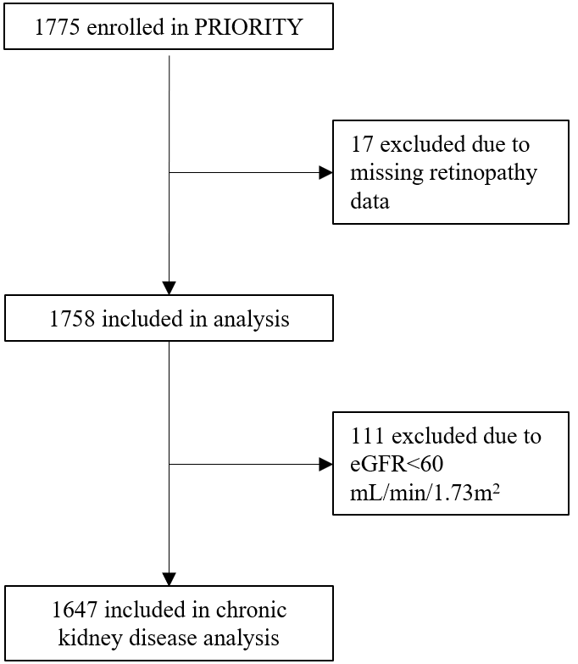
Supplementary Figure 1: Flowchart describing participants included in the present study. eGFR: Estimated glomerular filtration rate.

Supplementary Figure 2: Cumulative event plot illustrating the development of microalbuminuria, chronic kidney disease G3, and cardiovascular events stratified by presence of diabetic retinopathy (DR) and CKD273 risk status at baseline. Presence/non-presence of DR and high/low risk are presented as +/-, respectively. The plots showing the cumulative events for chronic kidney disease and cardiovascular events are presented with complete y-axes as well as with minor embedded plots with broken y-axes. P-value is derived from log-rank test.

