Supporting Information
Highly efficient D-type photonic crystal fiber surface plasmon resonance sensor for same space-time temperature and refractive index detection
Shan Zhang¹· Ping Zhang²· Zhaoyong Dong²· Dongfu Xu³· Dong Wang^{1, *}· Jing Li^{4, *}
¹ School of Chemical Engineering, Northeast Electric Power University, Jilin 132012, China
² PetroChina Jilin Petrochemical Company, Jilin 132012, China
³ School of Automation Engineering, Northeast Electric Power University, Jilin 132012, China
⁴ College of Petrochemical Engineering, Jilin Institute of Chemical Technology, Jilin 132012, China
*Corresponding authors: Dong Wang (dong.wang@neepu.edu.cn), Jing Li (lijing@jlict.edu.cn).
The transmission loss spectrum for detection at the temperature of 0°C and the analyte RI of 1.30 to 1.40 is shown in Fig. S1. As the refractive index changes from 1.33 to 1.40, the transmission loss curve gradually shifts red and the loss intensity gradually increases. The transmission loss curve in the temperature detection wavelength range does not change because the temperature remains constant at 0℃.
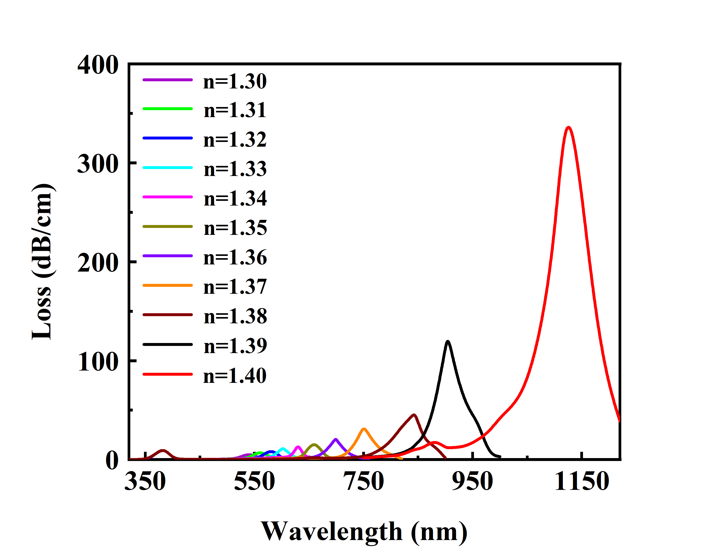
Fig. S1 Transmission loss spectra for the detection of analytes with RI of 1.30 to 1.40 when the temperature is 0°C

