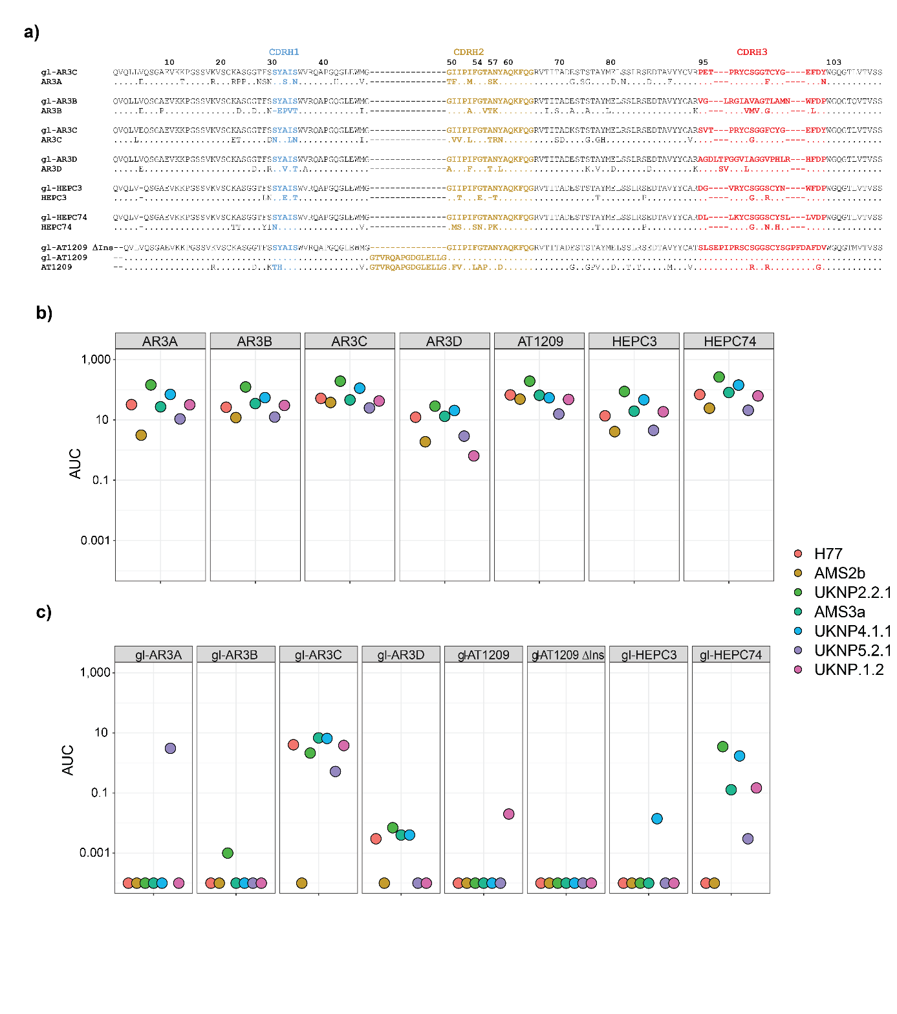
Supplementary Figure 1. Binding levels of AR3C-class bNAbs (a) Sequences of the HC of the different antibodies aligned. CDRs are color-labelled. Sequences are numbered using Kabat numbering. (b) Binding of mature AR3C-class bNAbs and (c) their inferred germline predecessors against seven different strains of HCV (genotypes 1-6). ELISA binding signals are represented as area under the curve (AUC) normalized to AP33 loading control (y-axis) for both germline and mature bNAbs (x-axis).

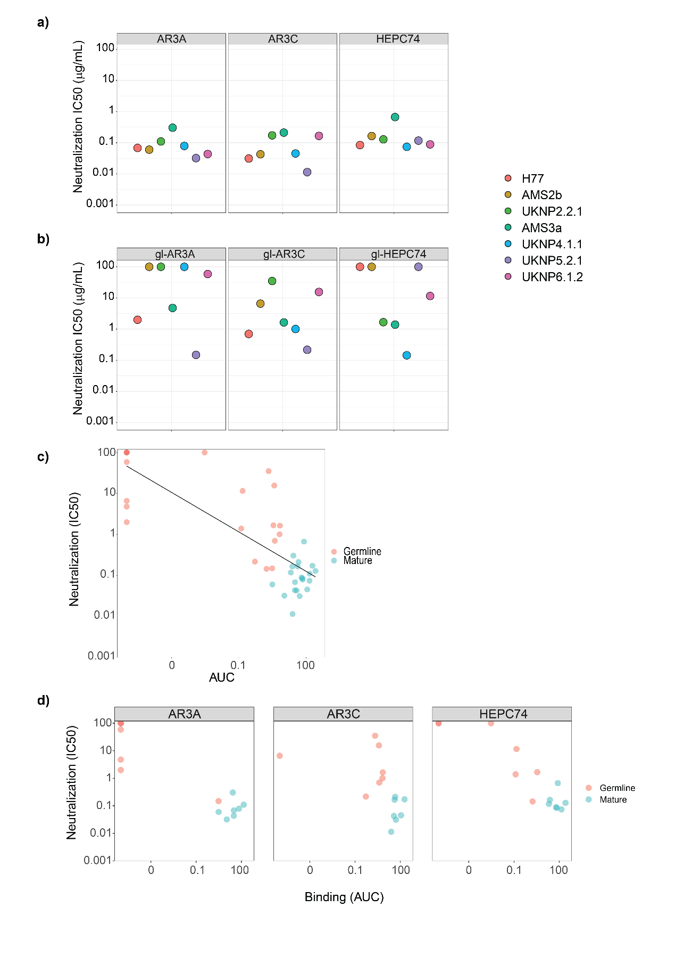
Supplementary Figure 2. Neutralization capacity of AR3C-class bNAbs. Neutralization IC₅₀ titers of AR3A, AR3C and HEPC74 (a) and gl-AR3A, gl-AR3C and gl-HEPC74 (b) against HCVpp clones derived from seven different strains (genotypes 1-6). (c) A scatter plot of neutralization titer (IC₅₀) of AR3A, AR3C and HEPC74 and their germline precursors against HCVpp clones (y-axis) vs. binding (AUC) against the sequence-matched E2E1 trimers (x-axis). Spearman correlation (r) and P values were computed in Rstudio (R version 4.0.4). (d) Individual cross-comparisons grouped per antibody from c.
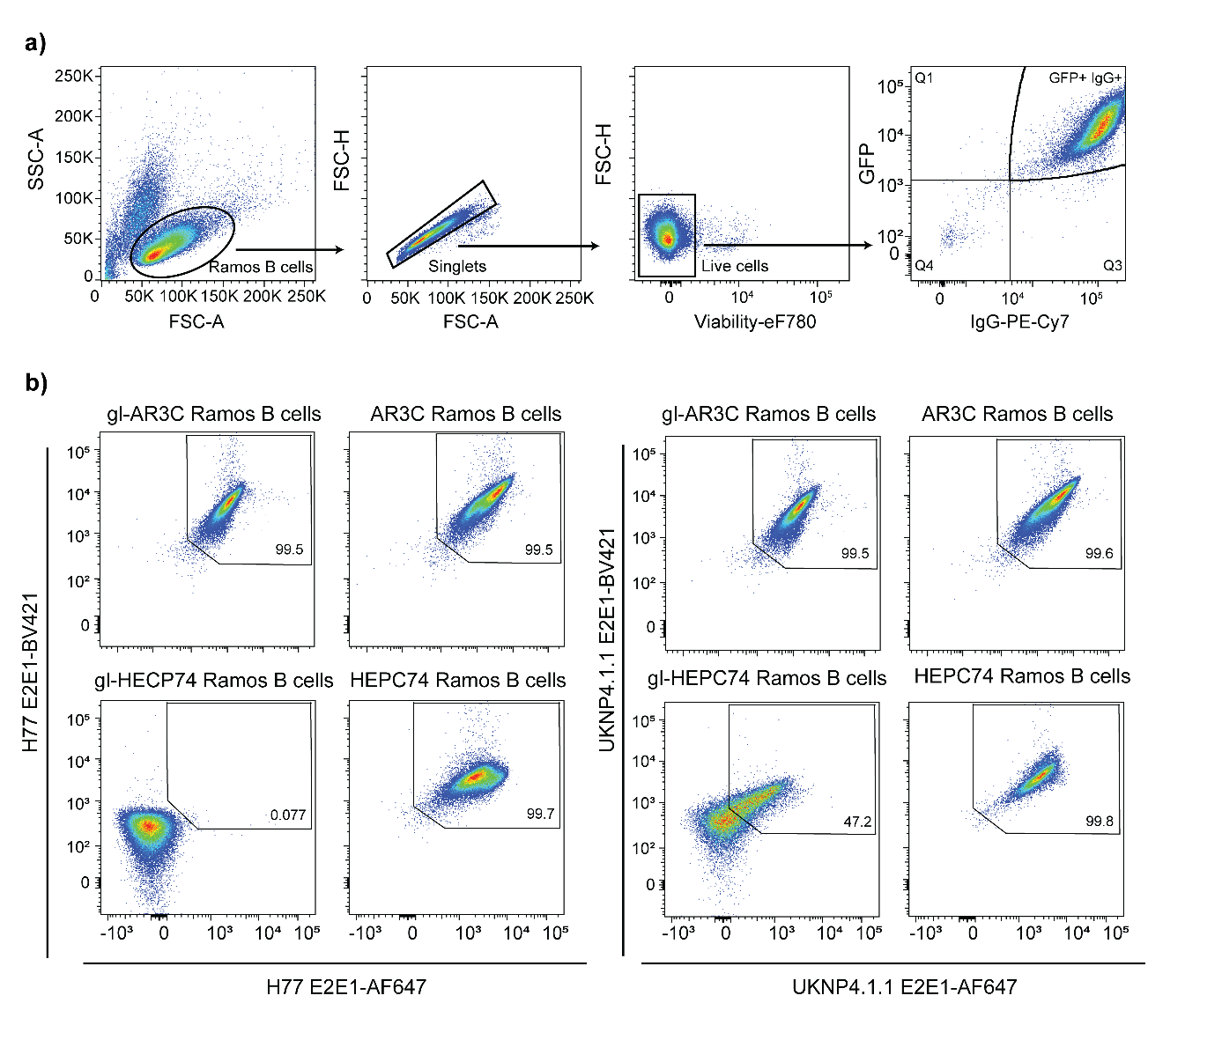
Supplementary Figure 3. Selection and binding of generated (gl-)AR3C and (gl-)HEPC74 B cells to HCV E2E1 trimers. (a) Gating strategy to identify live (via-) B cells expressing the transduced BCR (GFP+/IgG+). Same as in Sliepen et al, accepted. (b) Antigen specificity of Ramos B cells designed to express AR3C, gl-AR3C, HEPC74, or gl-HEPC74 to H77 (left) and UKNP4.1.1 (right) E2E1. The numbers inside the boxes represent the frequency (%) of cells in a gate.

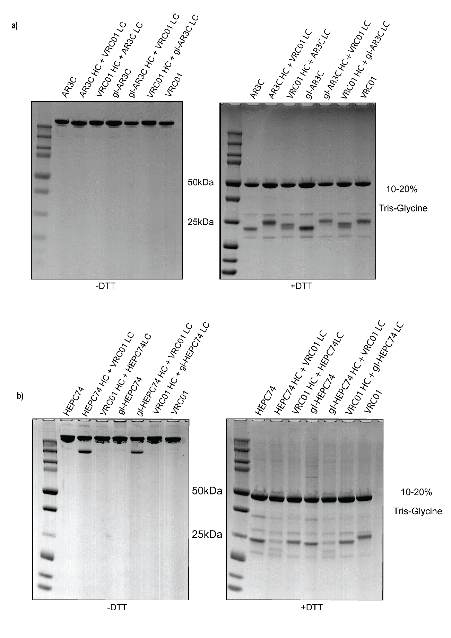
Supplementary Figure 4. Chimeric antibody gels. Non-reducing SDS-PAGE gel (left) and reducing SDS-PAGE gel (right) analysis of (a) AR3C and (b) HECP74 antibodies and their chimeric versions combinations with VRC01 HC or LC. PageBlue Protein Staining Solution was used to visualize the purified antibodies. The 50 kDa and 25 kDa marks indicate the approximate apparent molecular weight of HC and LC, respectively.
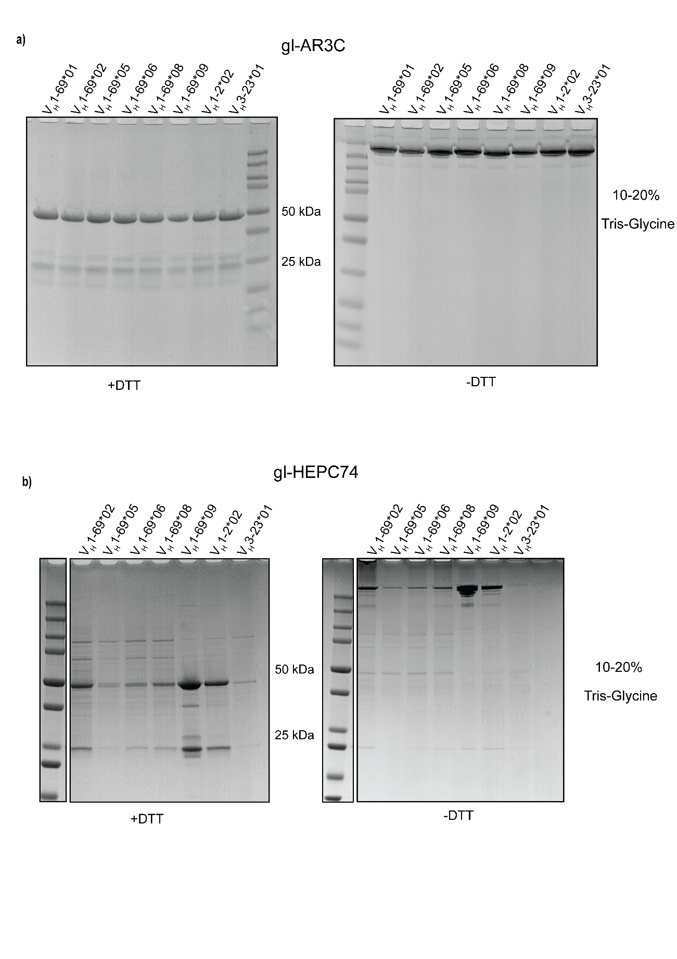
Supplementary Figure 5. Reducing SDS-PAGE gel (left) and non-reducing SDS-PAGE gel analysis (right) of antibodies consisting of (a) gl-AR3C and (b) gl-HECP74 CDRH3 engrafted in different VH backgrounds. PageBlue Protein Staining Solution was used to visualize the purified antibodies. The 50 kDa and 25 kDa marks indicate the approximate apparent molecular weight of HC and LC, respectively.

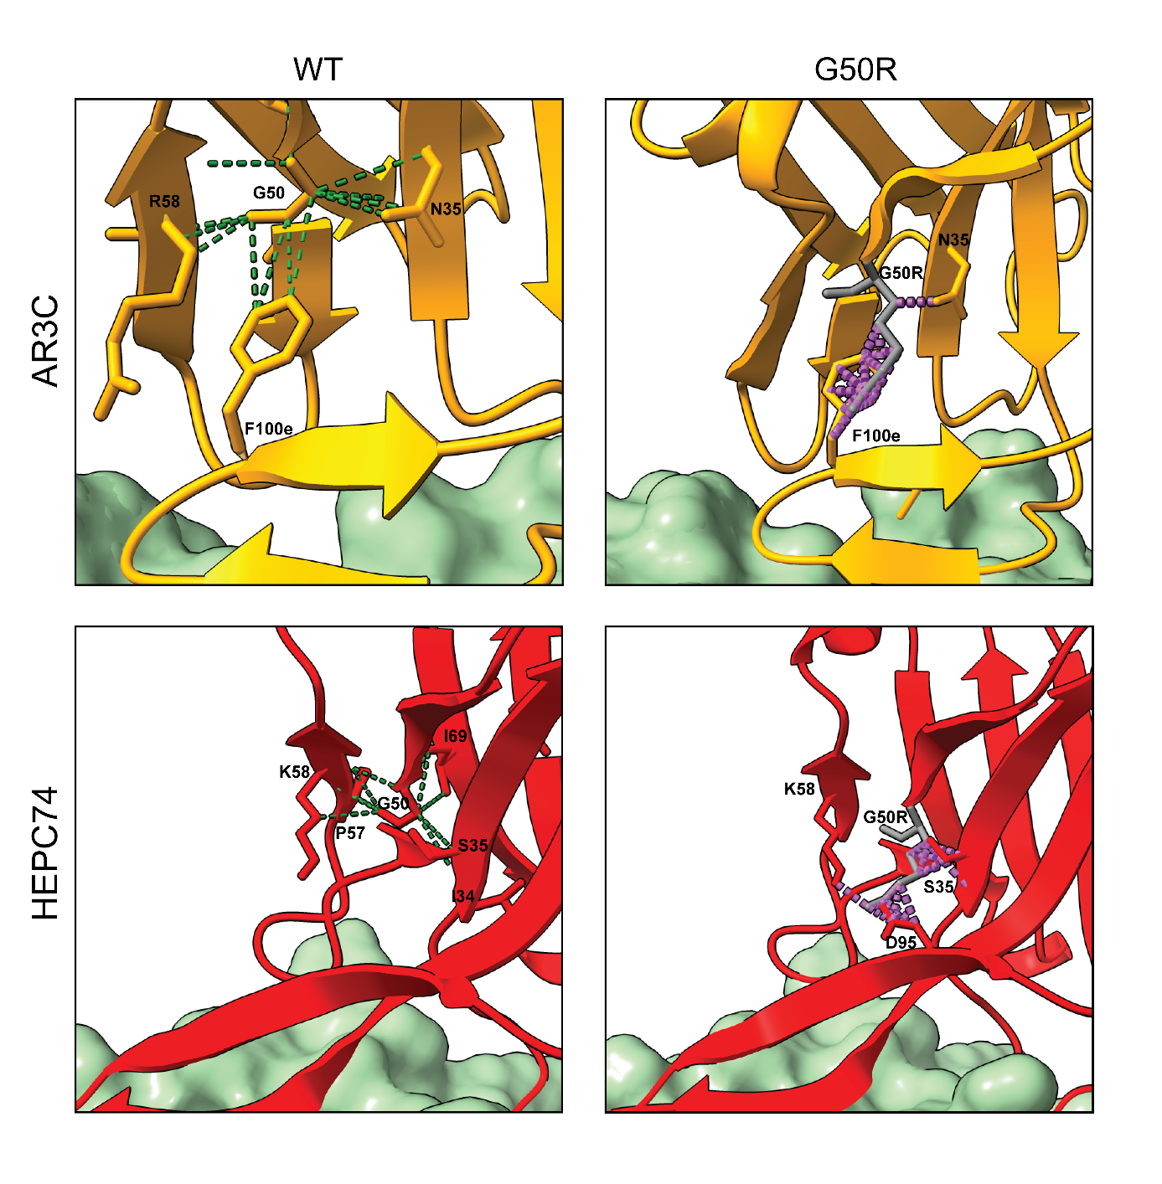
Supplementary Figure 6. Modelled effect of G50R mutation on AR3C and HEPC74. Representation of interactions and clashes of G50R in AR3C (top, PDB: 4MWF) and HEPC74 (bottom, PDB:6MEH) Potential interactions between residues are shown in dotted green lines and in grey the mutation G50R is modelled with possible clashes in purple. Residues are labelled according to Kabat numbering.

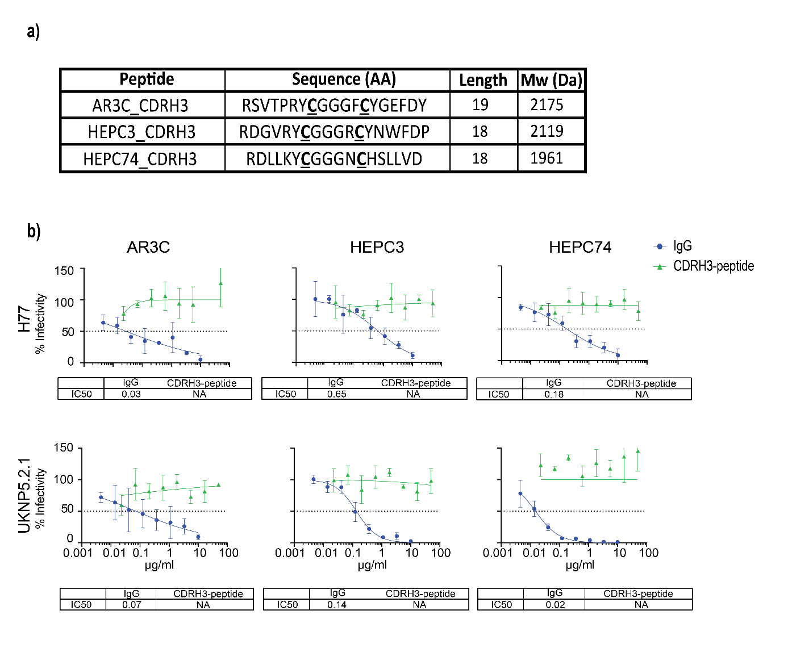
Supplementary Figure 7. CDRH3 soluble peptides. (a) Amino acid sequence, length and predicted molecular weight of of the AR3C, HEPC3 and HEPC74 CDRH3 peptides. In bold and underlined, the residues (cysteines) involved in disulfide bridge. (b) HCVpp neutralization by AR3C-class CRH3-based peptides. The prototypical lab strain H77 (top) and the clinical isolate UKNP5.2.1 (bottom) were incubated with a serial dilution of IgG or CDRH3 prior to infection. Data are expressed as percent infectivity relative to the wells not preincubated with antibody or peptide and each point is the mean of three replicate values. Error bars indicate the standard deviations between replicate wells. Data were fitted using the log(inhibitor) vs. response (four parameters) function on GraphPad Prism. The dotted line shows the 50% of infectivity (IC₅₀) value which are compiled under each graph. NA, not applicable (no curve could be fitted).

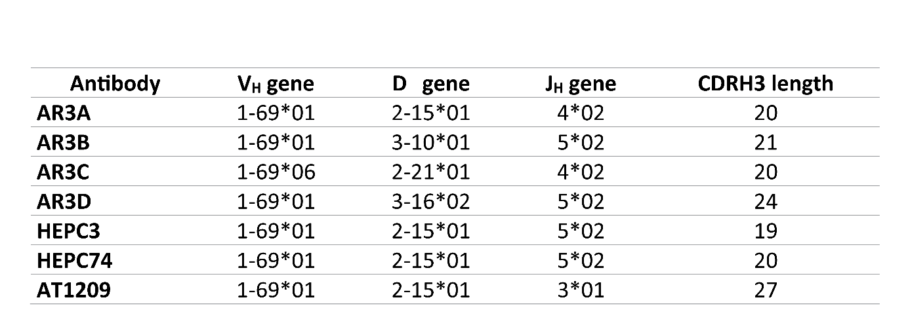

Supplementary Table 1. Genetic characteristics of AR3C-class bNAbs. VH, D and JH gene usage and CDRH3 length for AR3A, AR3B, AR3C, AR3D, HEPC3, HEPC74, AT1209.

