Supplementary Table S1 Example of literature search strategy using PubMed database
# | Search Terms
1 | (((("diabetes mellitus, type 2"[MeSH Terms]) OR (diabetes mellitus, type 2[Title/Abstract])) OR (type 2 diabetes mellitus[Title/Abstract])) OR (diabetes mellitus[Title/Abstract])) OR (diabet*[Title/Abstract])
2 | ((((((((((((mild cognitive impairment[Title/Abstract]) OR (mild cognitive disorder[Title/Abstract])) OR (mild neurocognitive disorder*[Title/Abstract])) OR (cognitive dysfunction[Title/Abstract])) OR (cognitive impairment*[Title/Abstract])) OR (cognitive decline*[Title/Abstract])) OR (dementia[Title/Abstract])) OR (Alzheimer's disease[Title/Abstract])) OR (Alzheimer Disease[Title/Abstract])) OR (Alzheim*[Title/Abstract])) OR (cognitive dysfunction[MeSH Terms])) OR (dementia[MeSH Terms])) OR (Alzheimer Disease[MeSH Terms])
3 | #1 AND #2
4 | ((((((((((((((((((((((fasting blood glucose[Title/Abstract]) OR (fasting plasma glucose[Title/Abstract])) OR (glycemic control[Title/Abstract])) OR (insulin resistance[Title/Abstract])) OR (glycated hemoglobin A1c[Title/Abstract])) OR (HbA1c[Title/Abstract])) OR (glycated hemoglobin[Title/Abstract])) OR (Glycated Hemoglobin A[Title/Abstract])) OR (2-h postload glucose[Title/Abstract])) OR (lipid metabolism[Title/Abstract])) OR (triglycerides[Title/Abstract])) OR (total cholesterol[Title/Abstract])) OR (low-density lipoprotein[Title/Abstract])) OR (Lipoproteins, LDL[Title/Abstract])) OR (high-density lipoprotein[Title/Abstract])) OR (Lipoproteins, HDL[Title/Abstract])) OR ("Lipoproteins, HDL"[MeSH Terms])) OR ("Lipoproteins, LDL"[MeSH Terms])) OR (triglycerides[MeSH Terms])) OR (lipid metabolism[MeSH Terms])) OR ("Glycated Hemoglobin A"[MeSH Terms])) OR ("insulin resistance"[MeSH Terms])) OR ("glycemic control"[MeSH Terms])
5 | ((("Montreal Cognitive Assessment"[Title/Abstract]) OR (MoCA[Title/Abstract])) OR ("Mini-Mental State Examination"[Title/Abstract])) OR (MMSE[Title/Abstract])
6 | #4 OR #5
7 | (((((((((((((((((((((((inflammatory factor[Title/Abstract]) OR (inflammation[Title/Abstract])) OR (inflammatory[Title/Abstract])) OR (cytokines[Title/Abstract])) OR (chemokines[Title/Abstract])) OR (neuroinflammation[Title/Abstract])) OR (interleukin[Title/Abstract])) OR (interferon[Title/Abstract])) OR ("tumor necrosis factor"[Title/Abstract])) OR (C-reactive protein[Title/Abstract])) OR ("transforming growth factor"[Title/Abstract])) OR ("macrophage colony stimulating factor"[Title/Abstract])) OR (M-CSF[Title/Abstract])) OR ("granulocyte-colony stimulating factor"[Title/Abstract])) OR (G-CSF[Title/Abstract])) OR ("granulocyte macrophage colony stimulating factor"[Title/Abstract])) OR (GM-CSF[Title/Abstract])) OR ("monocyte chemotactic protein-1"[Title/Abstract])) OR (MCP-1[Title/Abstract])) OR (inflammation[MeSH Terms])) OR (cytokines[MeSH Terms])) OR (chemokines[MeSH Terms])) OR (interleukin[MeSH Terms])) OR (interferon[MeSH Terms])
8 | #3 AND #6 AND #7

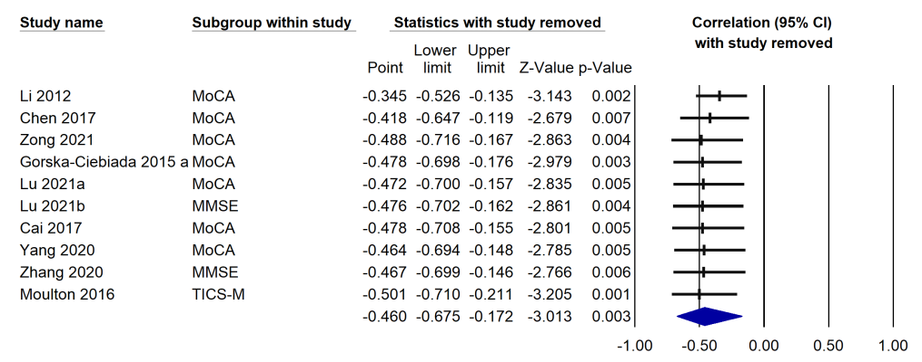
Supplemental Fig. S1 Sensitivity analysis using the leave-one-out strategy on the correlation between IL-6 and neuropsychological test scores

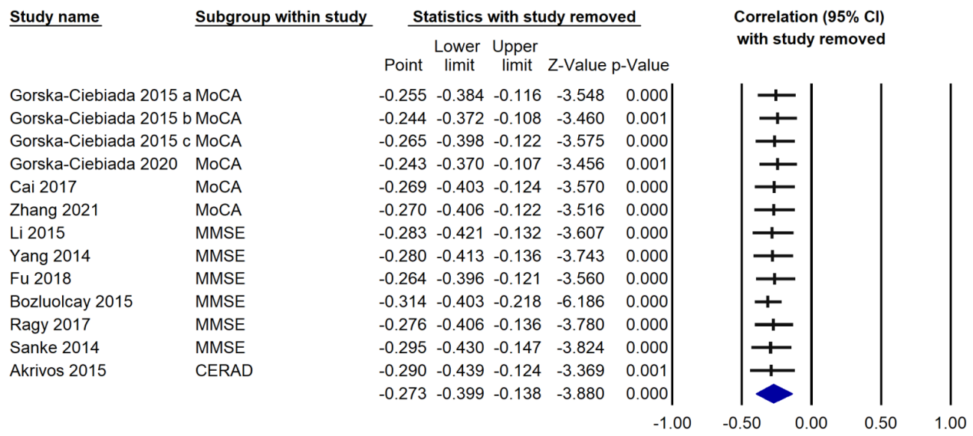
Supplemental Fig. S2 Sensitivity analysis using the leave-one-out strategy on the correlation between CRP and neuropsychological test scores

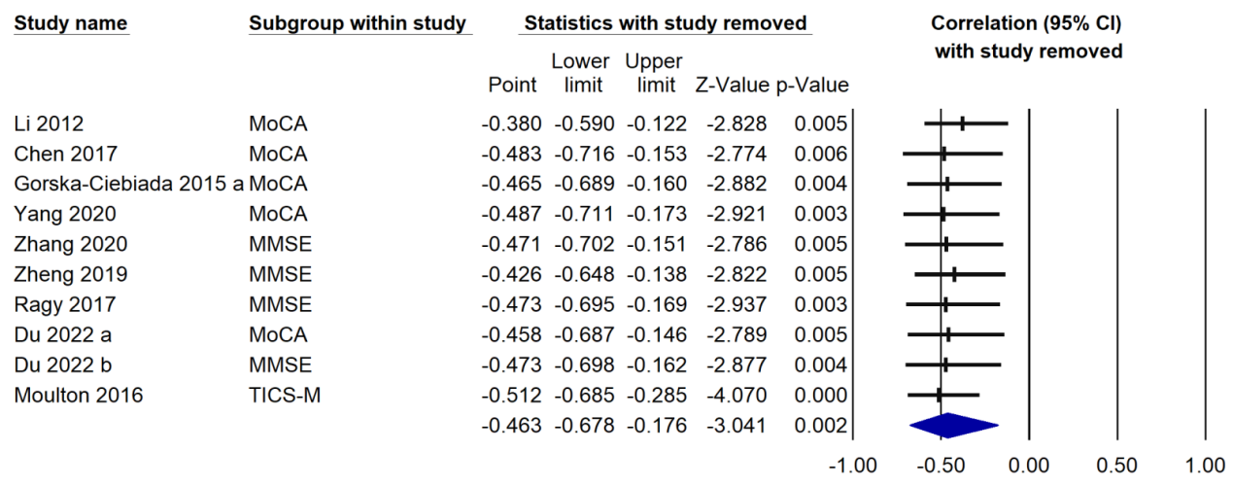
Supplemental Fig. S3 Sensitivity analysis using the leave-one-out strategy on the correlation between TNF-α and neuropsychological test scores

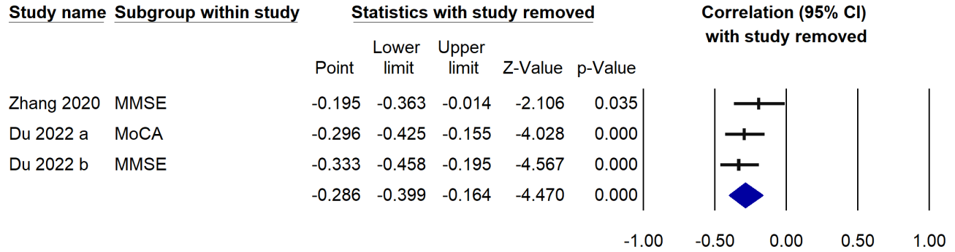
Supplemental Fig. S4 Sensitivity analysis using the leave-one-out strategy on the correlation between IL-8 and neuropsychological test scores

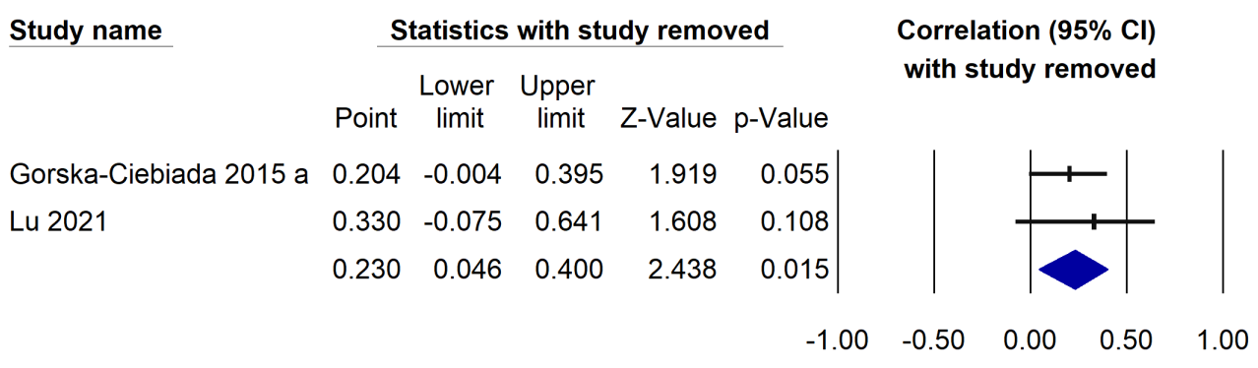
Supplemental Fig. S5 Sensitivity analysis using the leave-one-out strategy on the correlation between IL-6 and TG

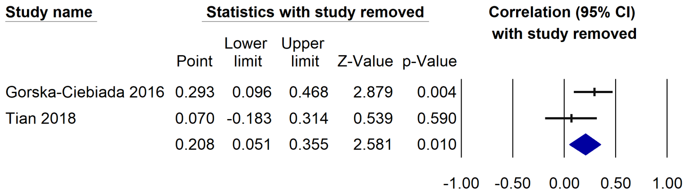
Supplemental Fig. S6 Sensitivity analysis using the leave-one-out strategy on the correlation between IL-1β and HbA1c

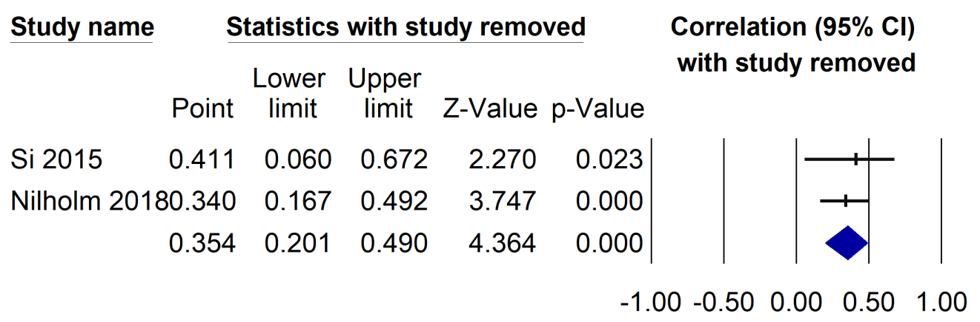
Supplemental Fig. S7 Sensitivity analysis using the leave-one-out strategy on the correlation between IL-18 and HbA1c

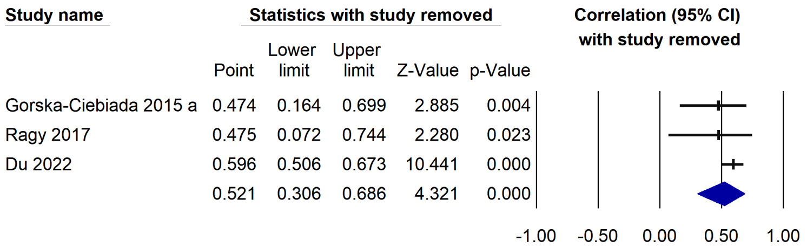
Supplemental Fig. S8 Sensitivity analysis using the leave-one-out strategy on the correlation between TNF-α and HbA1c

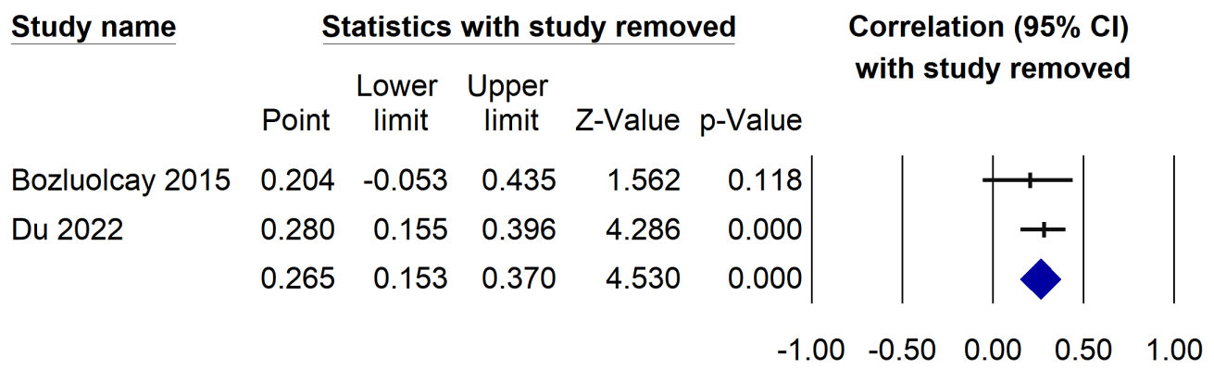
Supplemental Fig. S9 Sensitivity analysis using the leave-one-out strategy on the correlation between TNF-α and FBG

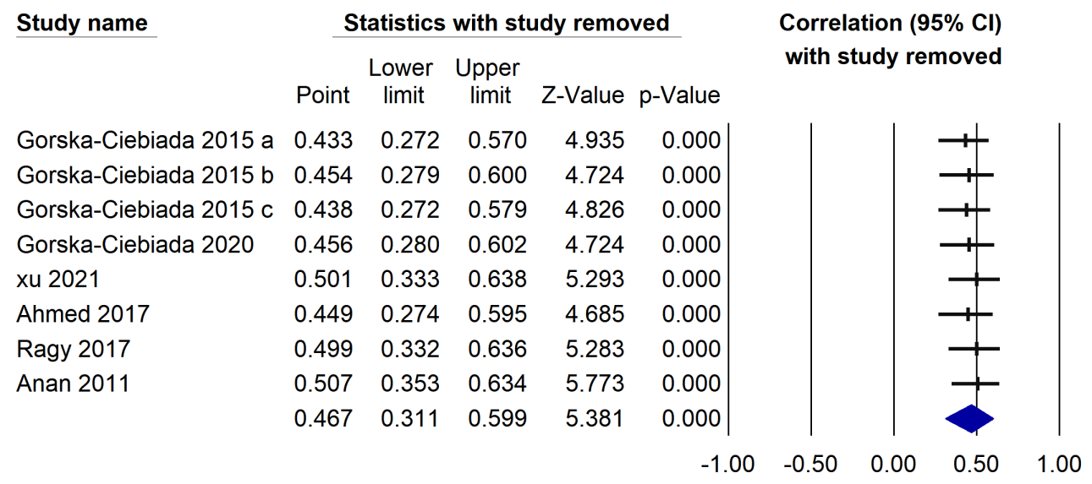
Supplemental Fig. S10 Sensitivity analysis using the leave-one-out strategy on the correlation between CRP and HbA1c

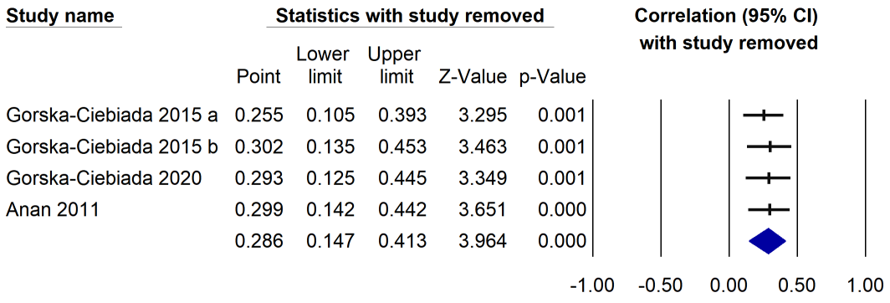
Supplemental Fig. S11 Sensitivity analysis using the leave-one-out strategy on the correlation between CRP and TC

