INFLUENCE OF EXPEDITION LIQUEUR ON THE FORMATION OF FROTHY PROPERTIES OF SPARKLING WINES

*Expedition liquor, as an added component of exogenous origin, is traditionally considered "Similia similibus curantur", because it is prepared from the same wine material

Visual assessment
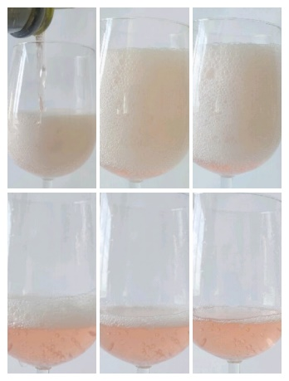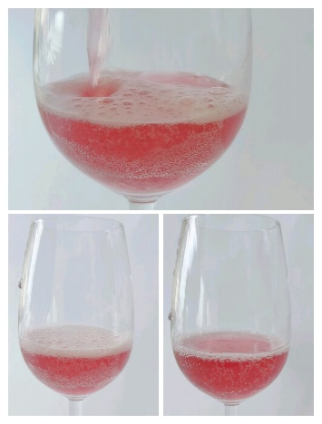
Control samples into which expedition liquor was added were characterized by a denser ring of bubbles, which remained stable for at least 30 minutes after foam stabilization.
It was found experimentally that the foaming ability of the reference sample directly depended on the pressure in the bottle: when the pressure in the bottle dropped due to the addition of expedition liquor from 7 to 4 atmospheres, the reduction of sparkling properties and activation of cavitation processes were observed.
Foaming capacity in sample No. 1 Foaming capacity in sample No. 6

