Supplementary 2. Figures: Safety outcomes
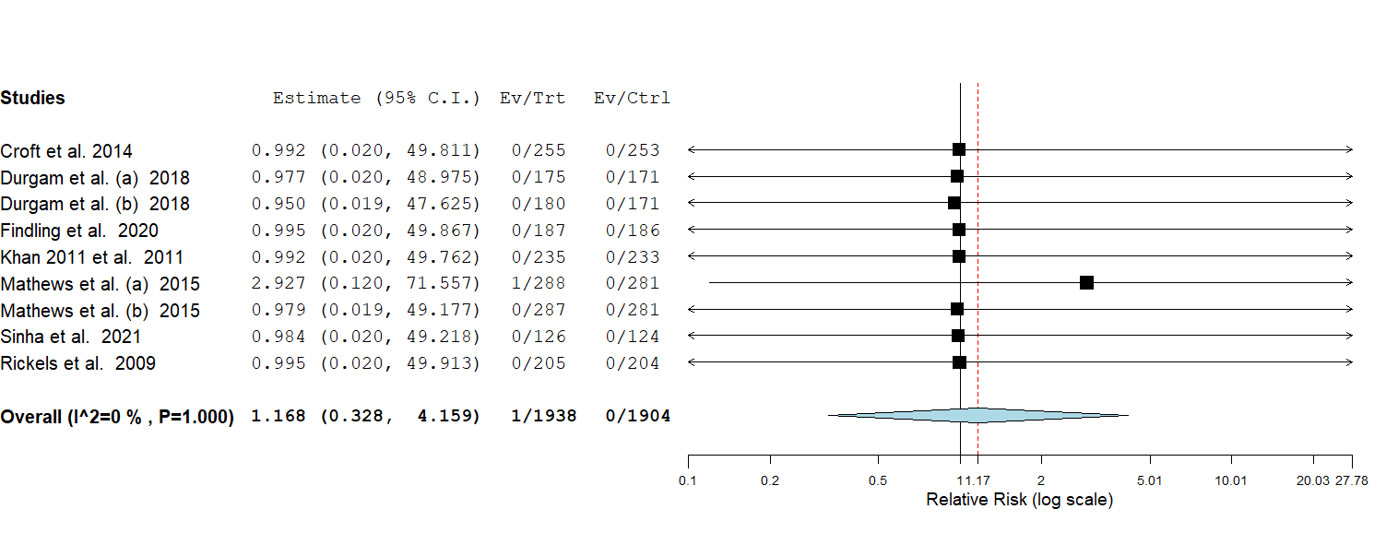
Figure 1. Forest plot of risk ratio (RR) in mortality rates (P = 0.811)

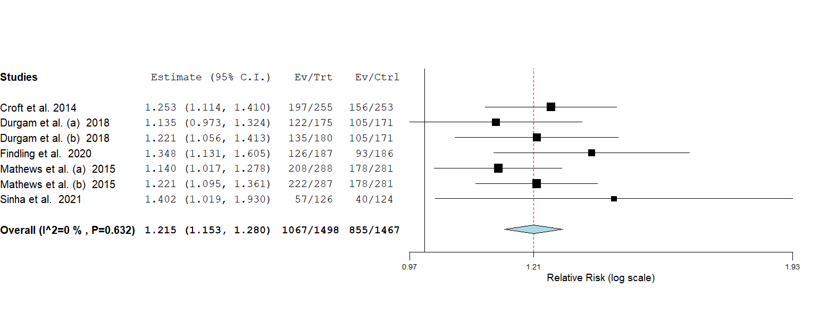
Figure 2. Forest plot of risk ratio (RR) in any treatment-emergent adverse event (TEAE)
(P < 0.001)

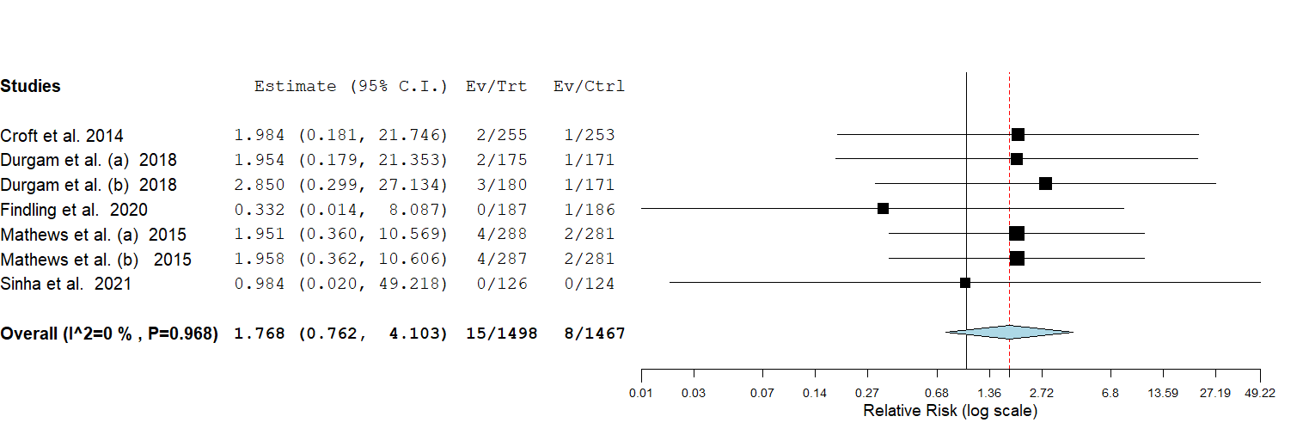
Figure 3. Forest plot of risk ratio (RR) in any Serious Adverse Event (SAE) (P = 0.185)

Figure 4. Forest plot of risk ratio (RR) in discontinuations due to AEs (P < 0.001)
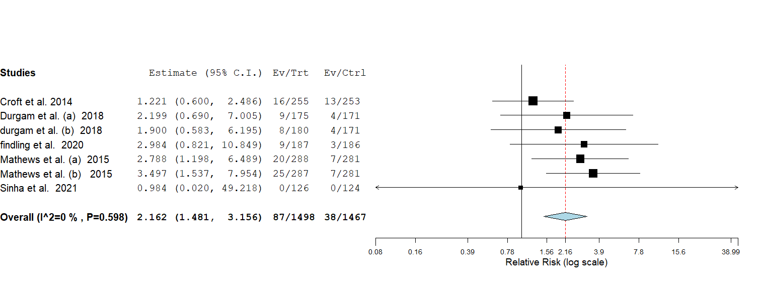

Figure 5. Forest plot of risk ratio (RR) in Nausea (P < 0.001)
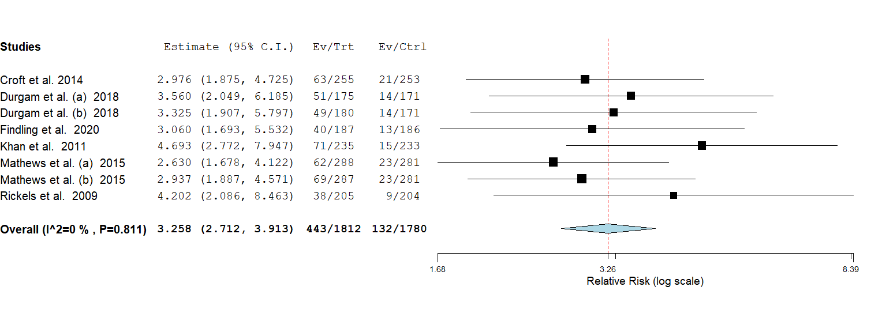

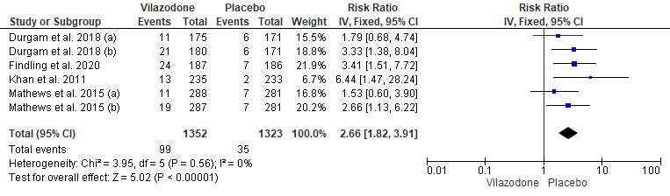
Figure 6. Forest plot of risk ratio (RR) in vomiting.

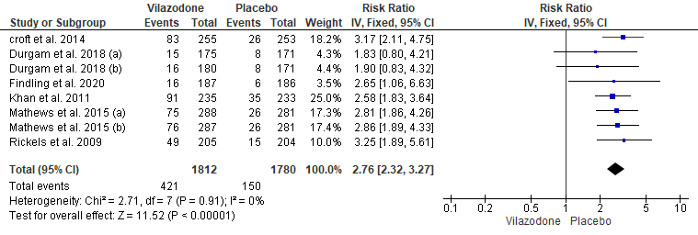
Figure 7. Forest plot of risk ratio (RR) in diarrhea.

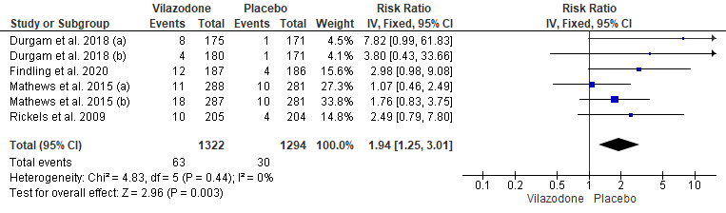
Figure 8. Forest plot of risk ratio (RR) in somnolence.

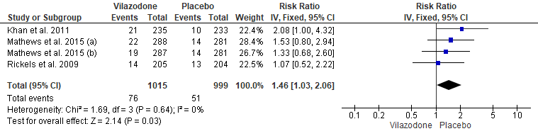
Figure 9. Forest plot of risk ratio (RR) in dry mouth.

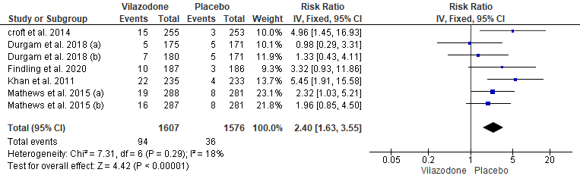
Figure 10. Forest plot of risk ratio (RR) in insomnia.

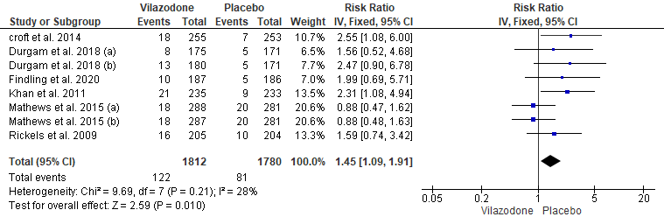
Figure 11. Forest plot of risk ratio (RR) in dizziness.

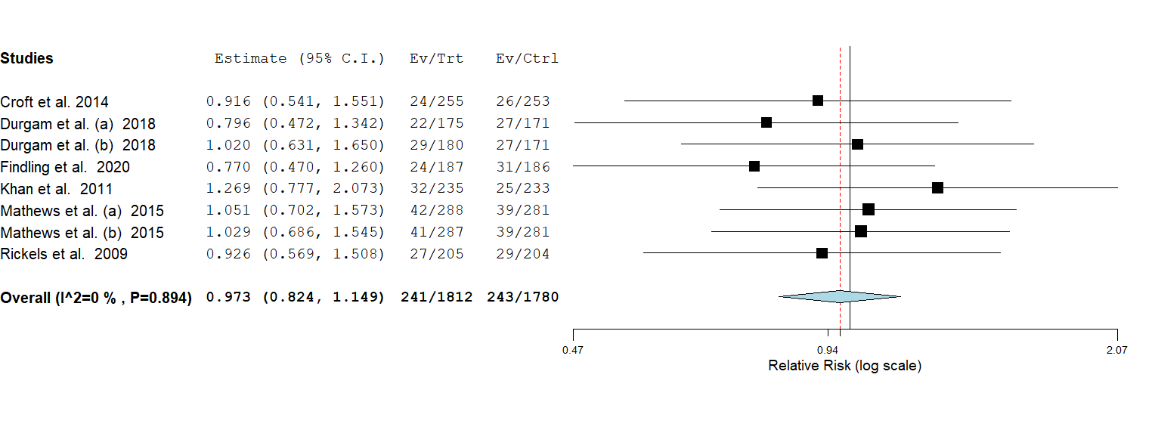
Figure 12. Forest plot of risk ratio (RR) in headache

Figure 13. Forest plot of risk ratio (RR) in upper abdominal pain
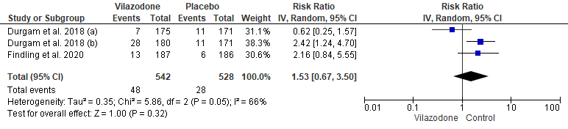

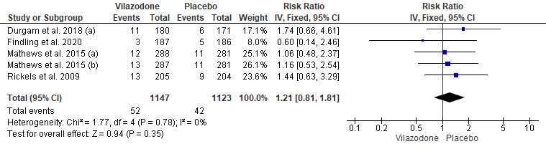
Figure 14. Forest plot of risk ratio (RR) in nasopharyngitis

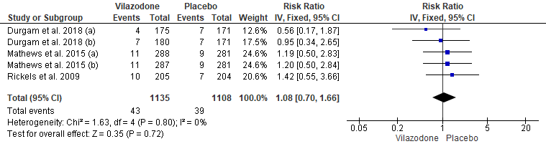
Figure 15. Forest plot of risk ratio (RR) in fatigue

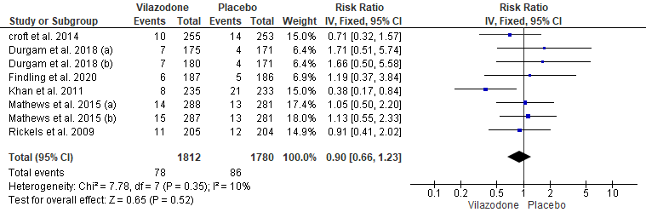
Figure 16. Forest plot of risk ratio (RR) in URTI

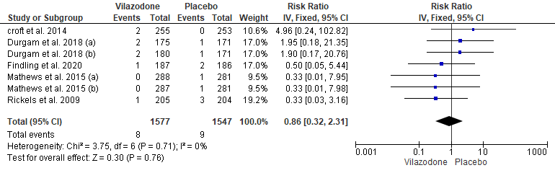
Figure 17. Forest plot of risk ratio (RR) in suicidal ideation

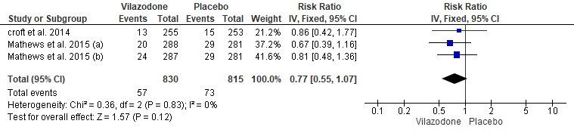
Figure 18. Forest plot of risk ratio (RR) in orthostatic hypotension

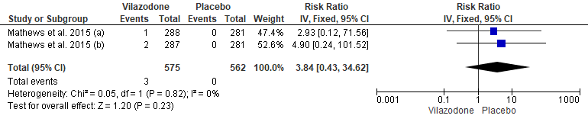
Figure 19. Forest plot of risk ratio (RR) in delayed ejaculation

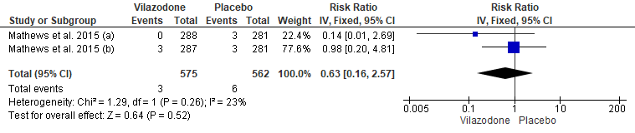
Figure 20. Forest plot of risk ratio (RR) in erectile dysfunction.

