Supplementary 1.
Figure 1. Risk of bias graph of the included studies.
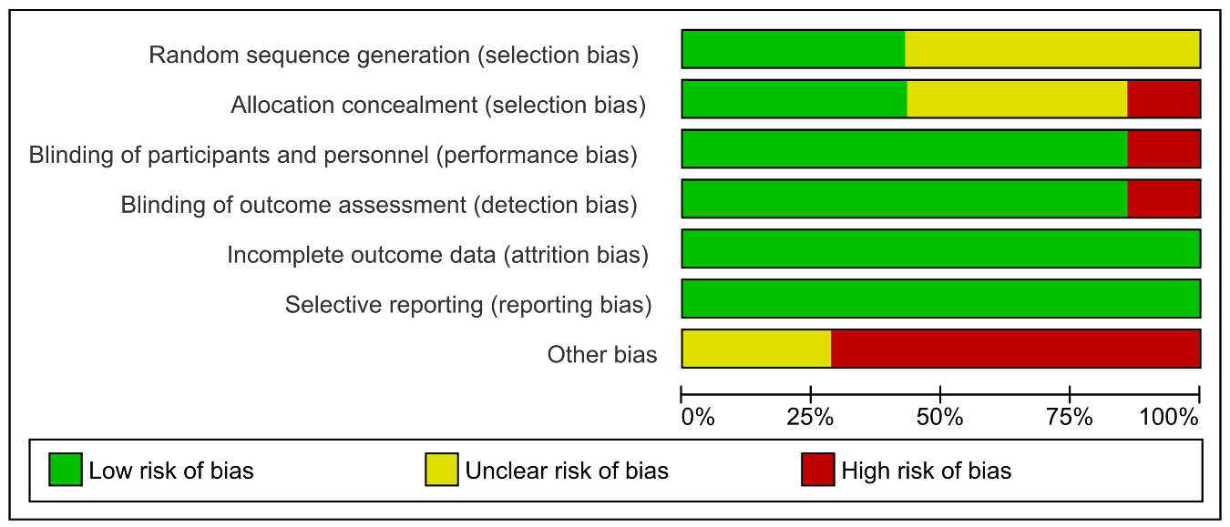
Figure 2. Forest plot of mean difference (MD) in CDRS-R total score improvement (15-30 mg/day)
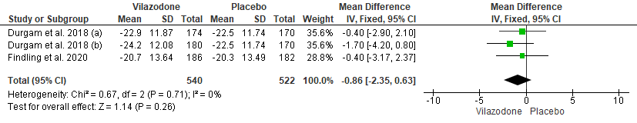
Figure 3. Forest plot of mean difference (MD) in HAMD17 total score improvement
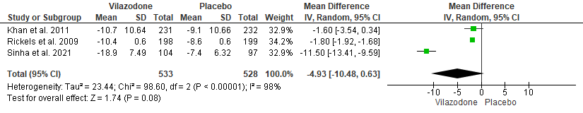

Figure 4. Forest plot of risk ratio (RR) in MADRS sustained response
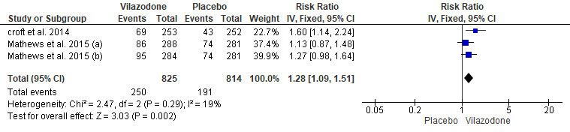
Figure 5. Forest plot of risk ratio (RR) in CDRS-R remission
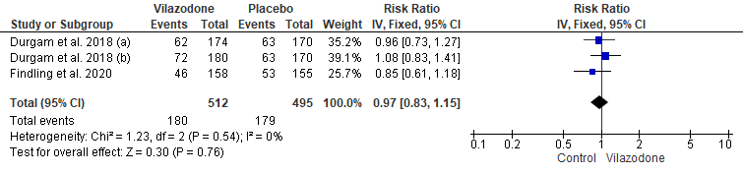
Figure 6. Forest plot of risk ratio (RR) in CDRS-R response
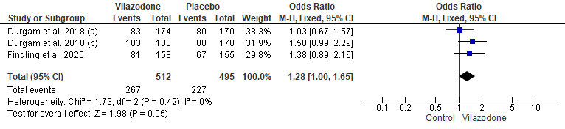

Figure 7. Forest plot of risk ratio (RR) in CGI-I response ≤ 2
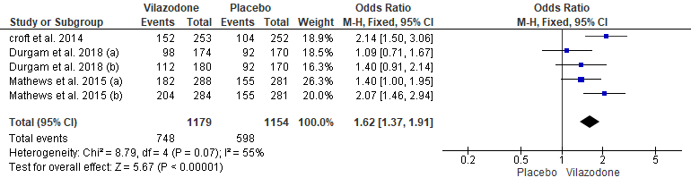
Figure 8. Forest plot of risk ratio (RR) in MADRS response ≥ 50%
