Supporting Information

Table S1 Mean absolute relative differences (MARD) in samples with no cells and 1-2 cells 1
Table S2 Linear regression analysis performed on Mean absolute relative differences (MARD) vs CSF total proteins. 1
Figure S1 Bland-Altman Plot of differences between fresh and frozen CSF aliquots of the same samples vs. the mean of the two measurements 2
Table S3 raw biomarker measurements in fresh and frozen samples 3

Table S1 Mean absolute relative differences (MARD) in samples with no cells and 1-2 cells. The measured MARD are higher for samples with 1-2 cells but this difference is significant only for Aβ42.
Biomarker | MARD (95%CI) 0 cells | MARD (95%CI) 1-2 cells | p-values Wilcoxon test
Aβ40 | 0.088 (0.068, 0.108) | 0.111 (0.089, 0.135) | 0.12
Aβ42 | 0.064 (0.041, 0.089) | 0.097 (0.068, 0.127) | 0.03
Aβ42/Aβ40 | 0.068 (0.050, 0.086) | 0.065 (0.043, 0.088) | 0.53
t-tau | 0.097 (0.054, 0.141) | 0.122 (0.69, 0.175) | 0.58
p-tau | 0.047 (0.031, 0.062) | 0.043 (0.027, 0.058) | 0.59

Table S2 Linear regression analysis performed on Mean absolute relative differences (MARD) vs CSF total proteins. No significant correlations were found.
MARD vs CSF proteins | Intercept (95%CI) | Slope (95%CI) × 10⁻⁴ (dL/mg) | Pearson's r
Aβ40 | 0.08 (0.04, 0.11) | 4.7 (2.5, 11.9) | 0.17
Aβ42 | 0.06 (0.01, 0.11) | 4.6 (-4.5, 14) | 0.13
Aβ42/Aβ40 | 0.07 (0.03, 0.10 | 0.3 (-6.4, 7.0) | 0.01
t-tau | 0.05 (-0.03, 0.14) | 11.6 (-4.1, 27.4) | 0.19
p-tau | 0.05 (0.02, 0.08) | -1.3 (-6.5, 3.9) | -0.07

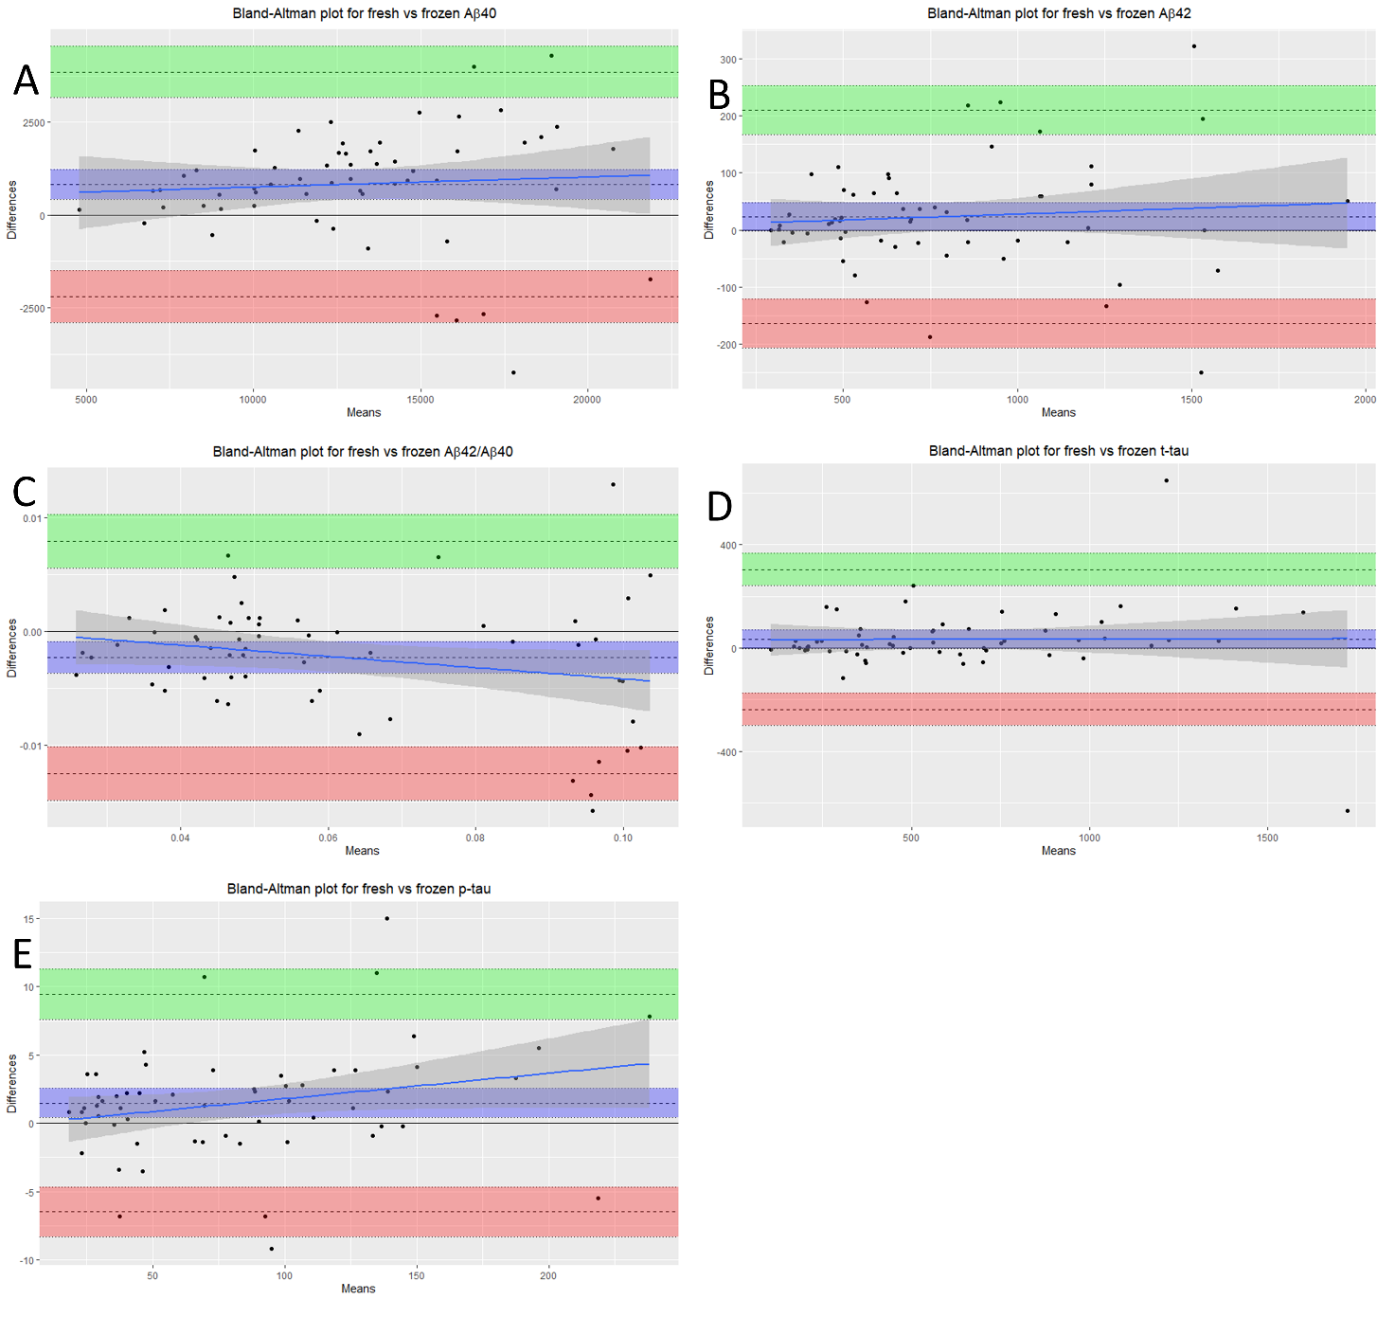Figure S1 Bland-Altman Plot of differences between fresh and frozen CSF aliquots of the same samples vs. the mean of the two measurements (data from table 1). Shaded areas present 95% confidence interval limits for mean and agreement limits.

Table S3 raw biomarker measurements in fresh and frozen samples. Two aliquots relative to the same CSF sample were measured with Lumipulse G-600 II, one by fresh and the other one after 30 days of storage at -80°C.
 |  | Fresh |  |  |  |  | After 1 month freezing
ID | Date LP | Aβ40 (pg/mL) | Aβ42 (pg/mL) | Aβ42/Aβ40 | t-tau (pg/mL) | p-tau (pg/mL) | Aβ40 (pg/mL) | Aβ42 (pg/mL) | Aβ42/Aβ40 | t-tau (pg/mL) | p-tau (pg/mL)
2776 | 16/05/2019 | 15536.00 | 773.00 | 0.05 | 376.00 | 49.20 | 18203.00 | 818.00 | 0.04 | 326.00 | 44.00
2783 | 24/05/2019 | 14650.00 | 1540.00 | 0.11 | 392.00 | 41.10 | 17480.00 | 1611.00 | 0.09 | 320.00 | 38.90
2791 | 05/06/2019 | 14108.00 | 703.00 | 0.05 | 590.00 | 100.20 | 16830.00 | 726.00 | 0.04 | 527.00 | 96.70
2792 | 06/06/2019 | 9251.00 | 783.00 | 0.08 | 103.00 | 18.60 | 8703.00 | 744.00 | 0.09 | 109.00 | 17.80
2795 | 07/06/2019 | 17467.00 | 1536.00 | 0.09 | 344.00 | 43.40 | 14812.00 | 1536.00 | 0.10 | 394.00 | 44.90
2799 | 14/06/2019 | 21632.00 | 935.00 | 0.04 | 615.00 | 90.30 | 19858.00 | 985.00 | 0.05 | 677.00 | 99.50
2805 | 24/06/2019 | 20995.00 | 504.00 | 0.02 | 673.00 | 89.20 | 22724.00 | 631.00 | 0.03 | 727.00 | 96.00
2810 | 01/07/2019 | 15425.00 | 1403.00 | 0.09 | 1410.00 | 35.30 | 16140.00 | 1653.00 | 0.10 | 2040.00 | 38.70
2824 | 17/07/2019 | 15647.00 | 655.00 | 0.04 | 761.00 | 126.50 | 19898.00 | 842.00 | 0.04 | 742.00 | 125.40
2830 | 25/07/2019 | 13535.00 | 689.00 | 0.05 | 467.00 | 65.20 | 12974.00 | 652.00 | 0.05 | 485.00 | 66.50
2834 | 02/08/2019 | 13510.00 | 1099.00 | 0.08 | 344.00 | 44.40 | 12865.00 | 1040.00 | 0.08 | 401.00 | 47.90
2835 | 07/08/2019 | 15345.00 | 1629.00 | 0.11 | 205.00 | 24.60 | 14170.00 | 1434.00 | 0.10 | 211.00 | 24.60
2844 | 29/08/2019 | 12779.00 | 1000.00 | 0.08 | 249.00 | 34.00 | 11906.00 | 854.00 | 0.07 | 365.00 | 40.80
2846 | 09/09/2019 | 21058.00 | 966.00 | 0.05 | 1670.00 | 242.20 | 16759.00 | 748.00 | 0.04 | 1534.00 | 234.40
2849 | 10/09/2019 | 16330.00 | 1668.00 | 0.10 | 366.00 | 29.70 | 13566.00 | 1346.00 | 0.10 | 215.00 | 29.20
2852 | 12/09/2019 | 18578.00 | 1063.00 | 0.06 | 697.00 | 89.80 | 14581.00 | 839.00 | 0.06 | 623.00 | 87.50
2853 | 13/09/2019 | 18812.00 | 1151.00 | 0.06 | 472.00 | 70.00 | 15980.00 | 979.00 | 0.06 | 429.00 | 68.70
2854 | 17/09/2019 | 14744.00 | 537.00 | 0.04 | 1169.00 | 152.00 | 12797.00 | 467.00 | 0.04 | 1006.00 | 147.90
2857 | 18/09/2019 | 14344.00 | 676.00 | 0.05 | 593.00 | 89.70 | 12629.00 | 585.00 | 0.05 | 527.00 | 87.20
2859 | 19/09/2019 | 10909.00 | 540.00 | 0.05 | 1086.00 | 132.80 | 9160.00 | 430.00 | 0.05 | 984.00 | 133.70
2860 | 19/09/2019 | 15953.00 | 620.00 | 0.04 | 1488.00 | 215.80 | 15018.00 | 555.00 | 0.04 | 1336.00 | 221.30
2862 | 20/09/2019 | 13587.00 | 677.00 | 0.05 | 1541.00 | 128.80 | 11934.00 | 580.00 | 0.05 | 893.00 | 124.90
2866 | 26/09/2019 | 13374.00 | 686.00 | 0.05 | 972.00 | 140.10 | 12406.00 | 621.00 | 0.05 | 840.00 | 137.80
2867 | 27/09/2019 | 10143.00 | 991.00 | 0.10 | 174.00 | 21.90 | 9895.00 | 1010.00 | 0.10 | 167.00 | 24.10
2869 | 30/09/2019 | 19406.00 | 1094.00 | 0.06 | 824.00 | 90.30 | 18700.00 | 1035.00 | 0.06 | 682.00 | 90.20
2875 | 07/10/2019 | 13569.00 | 457.00 | 0.03 | 705.00 | 140.20 | 11059.00 | 359.00 | 0.03 | 715.00 | 129.20
2940 | 06/12/2019 | 7400.00 | 351.00 | 0.05 | 572.00 | 46.10 | 7196.00 | 356.00 | 0.05 | 392.00 | 43.90
2941 | 09/12/2019 | 11857.00 | 497.00 | 0.04 | 1061.00 | 144.50 | 11293.00 | 481.00 | 0.04 | 1025.00 | 144.70
2942 | 10/12/2019 | 19652.00 | 506.00 | 0.03 | 1376.00 | 198.90 | 17551.00 | 484.00 | 0.03 | 1349.00 | 193.40
2943 | 11/12/2019 | 4875.00 | 316.00 | 0.06 | 184.00 | 24.50 | 4725.00 | 315.00 | 0.07 | 184.00 | 23.40
2944 | 11/12/2019 | 11882.00 | 1133.00 | 0.10 | 263.00 | 30.40 | 10902.00 | 1154.00 | 0.11 | 274.00 | 28.50
2945 | 12/12/2019 | 10385.00 | 321.00 | 0.03 | 874.00 | 120.60 | 9768.00 | 313.00 | 0.03 | 902.00 | 116.70
2948 | 13/12/2019 | 9099.00 | 395.00 | 0.04 | 632.00 | 68.30 | 8944.00 | 401.00 | 0.04 | 541.00 | 69.70
2949 | 13/12/2019 | 6622.00 | 318.00 | 0.05 | 261.00 | 35.40 | 6846.00 | 339.00 | 0.05 | 233.00 | 35.50
2950 | 16/12/2019 | 12204.00 | 1189.00 | 0.10 | 311.00 | 38.40 | 12564.00 | 1323.00 | 0.11 | 323.00 | 37.30
2951 | 17/12/2019 | 8509.00 | 471.00 | 0.06 | 571.00 | 74.60 | 9041.00 | 525.00 | 0.06 | 585.00 | 70.70
2953 | 23/12/2019 | 12978.00 | 1245.00 | 0.10 | 627.00 | 40.60 | 13882.00 | 1341.00 | 0.10 | 385.00 | 40.30
2956 | 09/01/2020 | 11798.00 | 494.00 | 0.04 | 1178.00 | 108.10 | 11953.00 | 573.00 | 0.05 | 1169.00 | 105.30
2957 | 09/01/2020 | 14936.00 | 700.00 | 0.05 | 446.00 | 77.20 | 13492.00 | 685.00 | 0.05 | 431.00 | 78.10
2958 | 15/01/2020 | 8452.00 | 505.00 | 0.06 | 496.00 | 82.20 | 7385.00 | 508.00 | 0.07 | 497.00 | 83.70
2960 | 17/01/2020 | 14381.00 | 486.00 | 0.03 | 624.00 | 111.00 | 13003.00 | 500.00 | 0.04 | 648.00 | 110.60
2963 | 20/01/2020 | 11274.00 | 464.00 | 0.04 | 570.00 | 100.20 | 10010.00 | 453.00 | 0.05 | 550.00 | 101.60
2964 | 21/01/2020 | 13382.00 | 864.00 | 0.06 | 212.00 | 37.30 | 11709.00 | 846.00 | 0.07 | 205.00 | 35.30
2965 | 22/01/2020 | 13628.00 | 1205.00 | 0.09 | 195.00 | 29.50 | 11696.00 | 1202.00 | 0.10 | 205.00 | 28.20
2970 | 23/01/2020 | 7321.00 | 634.00 | 0.09 | 246.00 | 30.30 | 6662.00 | 664.00 | 0.10 | 221.00 | 26.70
2974 | 28/01/2020 | 10942.00 | 293.00 | 0.03 | 962.00 | 152.20 | 10110.00 | 294.00 | 0.03 | 1003.00 | 145.80
2976 | 30/01/2020 | 12854.00 | 1251.00 | 0.10 | 339.00 | 27.00 | 11521.00 | 1171.00 | 0.10 | 181.00 | 23.40
2977 | 31/01/2020 | 12466.00 | 559.00 | 0.04 | 451.00 | 74.80 | 10197.00 | 498.00 | 0.05 | 442.00 | 64.10
2978 | 31/01/2020 | 13578.00 | 1267.00 | 0.09 | 208.00 | 31.60 | 12228.00 | 1155.00 | 0.09 | 205.00 | 30.00
2979 | 04/02/2020 | 14644.00 | 738.00 | 0.05 | 985.00 | 136.60 | 13799.00 | 701.00 | 0.05 | 954.00 | 136.80
2980 | 04/02/2020 | 8634.00 | 811.00 | 0.09 | 188.00 | 23.50 | 8384.00 | 780.00 | 0.09 | 160.00 | 22.70
2982 | 05/02/2020 | 10378.00 | 473.00 | 0.05 | 702.00 | 102.40 | 9651.00 | 460.00 | 0.05 | 703.00 | 100.80
2984 | 06/02/2020 | 15074.00 | 848.00 | 0.06 | 374.00 | 51.70 | 14147.00 | 869.00 | 0.06 | 372.00 | 50.10
2986 | 07/02/2020 | 8901.00 | 487.00 | 0.05 | 773.00 | 101.60 | 7694.00 | 468.00 | 0.06 | 747.00 | 98.90
2991 | 13/02/2020 | 19083.00 | 704.00 | 0.04 | 1239.00 | 189.10 | 17130.00 | 685.00 | 0.04 | 1208.00 | 185.80
2999 | 20/02/2020 | 20252.00 | 1972.00 | 0.10 | 366.00 | 49.60 | 17875.00 | 1922.00 | 0.11 | 354.00 | 45.30
3000 | 20/02/2020 | 7539.00 | 359.00 | 0.05 | 336.00 | 58.50 | 6871.00 | 332.00 | 0.05 | 360.00 | 56.40
3001 | 21/02/2020 | 16938.00 | 598.00 | 0.04 | 909.00 | 146.20 | 15226.00 | 616.00 | 0.04 | 843.00 | 131.20

