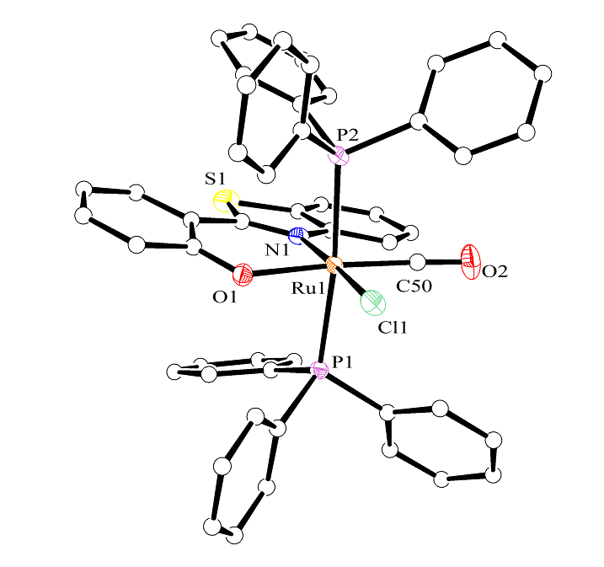
The cleavage of Ru−C(aryl) bond promoted by 2-(2-hydroxyphenyl)benzothiazole and 2-(2-hydroxyphenyl)benzoxazole in a four-membered ruthenium(II) organometallic complex has been studied.

