Table 6 Main calculated optical transitions for 2 with composition in terms of molecular orbital contribution of the transition, computed vertical excitation energies and oscillator strength
Excitation | Composition | E (eV) | oscillator strength (f) | λ_{theo} (nm) | Assign | λ_{exp}  (nm) | EDDMs  [loss (purple) and gain (green)]
3 | H −1→L +1  H→L +1 | 2.865 | 0.013094972 | 433 | d→d/MLCT/ILCT/LMCT | 454 | 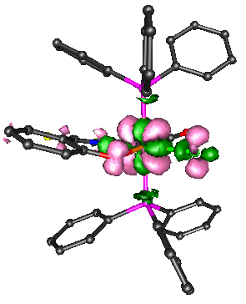
5 | H −1→L +1  H→L | 2.913 | 0.126694300 | 426 | MLCT  /ILCT |  | 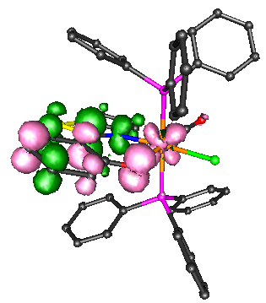
13 | H −2→L  H −2→L +1 | 3.505 | 0.014706954 | 354 | d→d/MLCT/ILCT/LMCT | 357 | 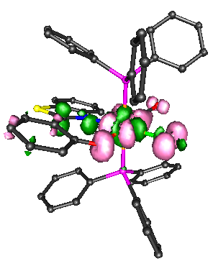
31 | H −4→L  H −1→L +3 | 3.934 | 0.015460742 | 315 | d→d/MLCT/ILCT/LMCT | 325 | 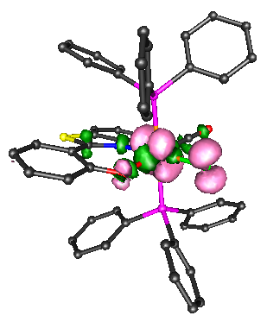
37 | H −5→L  H −3→L | 4.019 | 0.074545631 | 309 | ILCT |  | 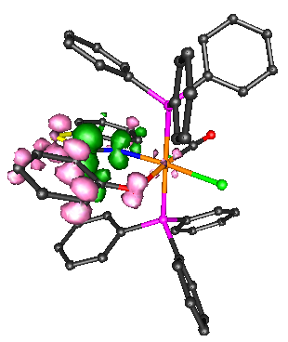

Table 7 Main calculated optical transitions for 3 with composition in terms of molecular orbital contribution of the transition, computed vertical excitation energies and oscillator strength

Excitation | Composition | E (eV) | oscillator strength (f) | λ_{theo} (nm) | Assign | λ_{exp}  (nm) | EDDMs  [loss (purple) and gain (green)]
3 | H −1→L +1  H→L +1 | 2.892 | 0.010491497 | 429 | d→d/MLC/ LMCT/ILCT | 436 | 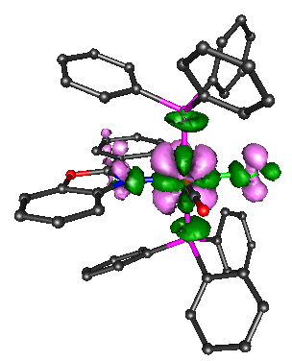
5 | H→L | 3.047 | 0.148942169 | 407 | MLCT/ILCT | 415 | 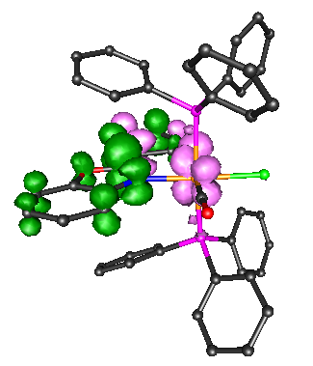
9 | H −1→L +1  H→L +1 | 3.248 | 0.037435558 | 381 | d→d/MLCT/LMCT/LLCT | 347 | 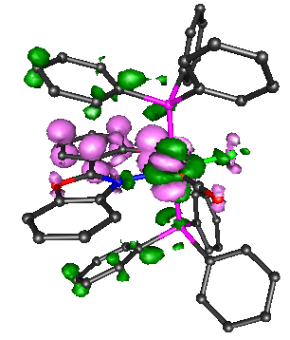
11 | H −1→L | 3.413 | 0.039560340 | 363 | MLCT/LLCT |  | 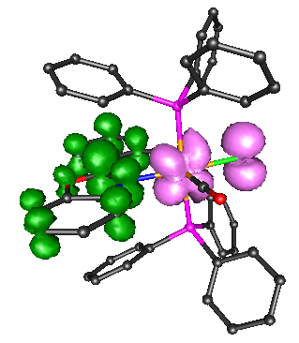
29 | H→L +5 | 3.841 | 0.003142108 | 322 | MLCT/LLCT | 306 | 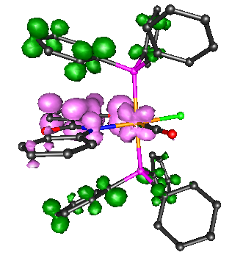
36 | H −2→L +1  H −2→L +2 | 4.038 | 0.008457073 | 307 | LMCT /LLCT |  | 