Supporting Information

for
Benzothiazole and benzoxazole promoted cleavage of Ru─C(aryl) bond in four-membered ortho-metalated Ruthenium(II) organometallics

Jagannath Chowdhury∙Mrinal Kanti Ghosh∙Purnananda Garu∙Swarup Chattopadhyay*
Department of Chemistry, University of Kalyani, Kalyani, Nadia 741235, WB, India

Contents of Supporting Information
Figure S1: IR spectrum of 2.
Figure S2: IR spectrum of 3.
Figure S3: ¹H NMR spectrum of 2.
Figure S4: ¹H NMR spectrum of 3.
Figure S5: HOMO−LUMO energy gaps of 2 and 3.
Figure S6: Experimental and TD-DFT calculated UV-vis absorption spectra of 2 and 3.
Table S1: Mulliken atomic charges for the complexes 2 and 3
Table S2: Cartesian coordinates (Å) for DFT energy-minimized model of 2.
Table S3: Cartesian coordinates (Å) for DFT energy-minimized model of 3.

Figures
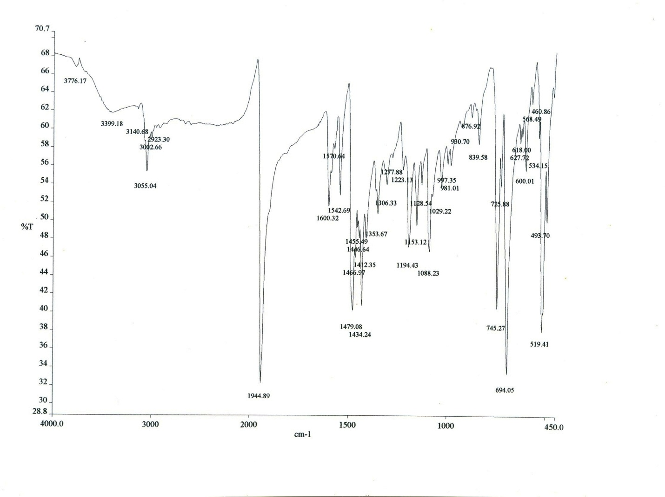
Figure S1: IR spectrum of 2

Figure S2: IR spectrum of 3
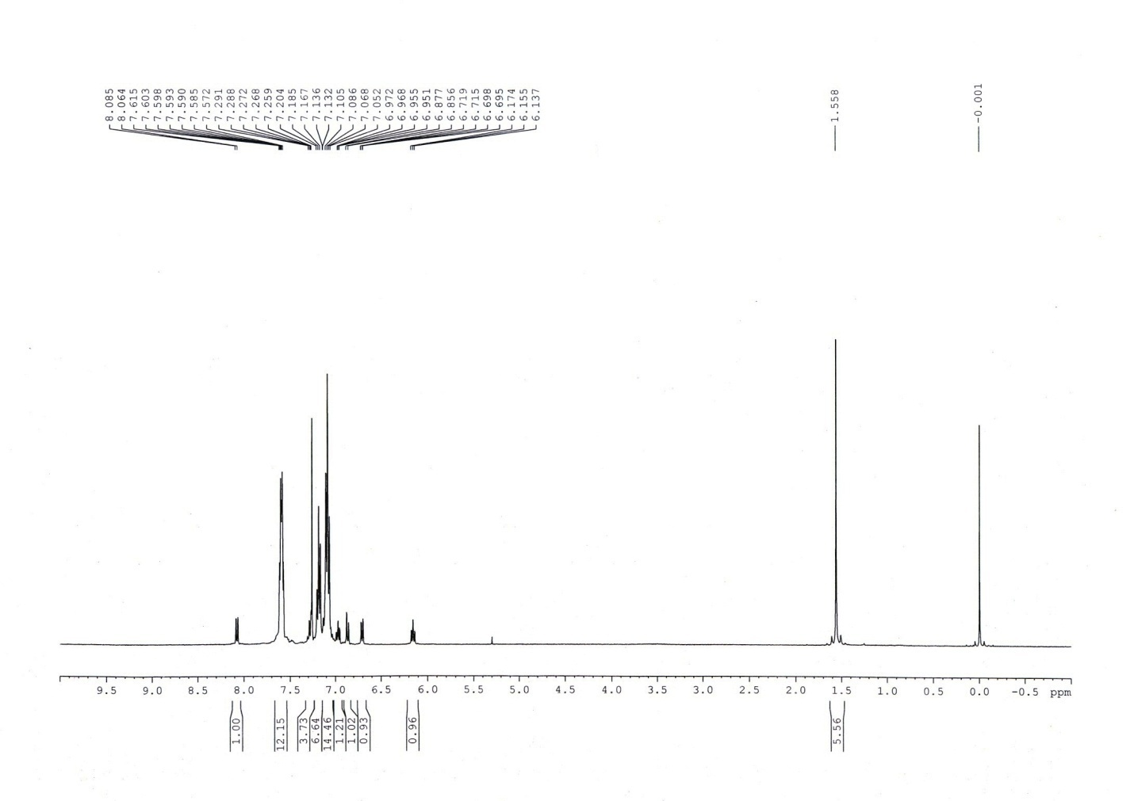
Figure S3: ¹H NMR spectrum of 2.

Figure S4: ¹H NMR spectrum of 3.

Figure S5: HOMO−LUMO energy gaps of 2 and 3.

Figure S6: Experimental and TD-DFT calculated UV-vis absorption spectra of 2 and 3.

Tables

Table S1: Mulliken Atomic Charges for 2 and 3.
Complex | Ru | P1 | P2 | Cl | O | N
2 | -0.1176 | 0.4291 | 0.4199 | -0.3163 | -0.4397 | -0.2179
3 | -0.1146 | 0.4457 | 0.4479 | -0.3225 | -0.4676 | -0.2630

Table S2: Cartesian coordinates (Å) for DFT energy-minimized model of 2.
Atom x y z
Ru 6.603987 2.527622 13.594559
C 6.326663 7.314502 11.321129
H 6.122036 7.284042 10.242427
C 6.785927 6.155097 11.967352
H 6.941926 5.230529 11.393034
C 7.048207 6.169944 13.356146
C 6.849809 7.366753 14.079661
H 7.056777 7.405969 15.156102
C 6.385736 8.523597 13.427142
H 6.231640 9.445621 14.005008
C 6.121889 8.501208 12.047417
H 5.757891 9.405259 11.540145
C 7.741878 5.024367 15.942591
C 8.913276 4.982865 16.728829
H 9.875126 4.728973 16.267371
C 8.857366 5.268158 18.105472
H 9.779757 5.235528 18.701283
C 7.633034 5.593080 18.713971
H 7.592668 5.822447 19.787371
C 6.457246 5.617896 17.941279
H 5.493051 5.860984 18.407373
C 6.508978 5.327590 16.568019
H 5.582358 5.348800 15.977780
C 9.537057 4.797932 13.642188
C 10.227173 3.751878 12.997384
H 9.706778 2.810728 12.788170
C 11.568113 3.928525 12.608353
H 12.093983 3.108309 12.101078
C 12.228205 5.142722 12.856278
H 13.273918 5.276865 12.547879
C 11.540334 6.193279 13.492740
H 12.044716 7.150982 13.682419
C 10.201306 6.025155 13.877271
H 9.669381 6.859277 14.354185
C 6.582347 -0.629264 11.650704
C 7.984227 -0.518524 11.525928
H 8.524901 0.193121 12.160177
C 8.672406 -1.311930 10.590670
H 9.762869 -1.211063 10.496076
C 7.974494 -2.214305 9.768828
H 8.516555 -2.825181 9.033438
C 6.578268 -2.326174 9.888748
H 6.020954 -3.025331 9.249925
C 5.884893 -1.538190 10.823795
H 4.793769 -1.631527 10.902319
C 3.961040 0.418976 12.194507
C 3.779017 1.328743 11.126271
H 4.616903 1.959714 10.797412
C 2.539451 1.415175 10.471870
H 2.414153 2.125933 9.643956
C 1.465470 0.600909 10.875694
H 0.494325 0.675393 10.367549
C 1.643566 -0.313908 11.927494
H 0.814438 -0.962761 12.241879
C 2.886694 -0.411896 12.580141
H 3.016975 -1.148016 13.382754
C 5.553738 -0.870468 14.340910
C 6.511155 -1.903176 14.459301
H 7.281868 -2.027785 13.688150
C 6.484630 -2.781834 15.556443
H 7.239886 -3.576626 15.630121
C 5.499756 -2.648386 16.549418
H 5.478200 -3.337342 17.405279
C 4.543361 -1.622873 16.442377
H 3.768380 -1.504734 17.212360
C 4.574181 -0.735966 15.352618
H 3.826029 0.064877 15.296646
C 10.329050 0.696547 15.017557
H 10.732236 0.475979 14.021315
C 11.094314 0.504957 16.161358
H 12.121430 0.125062 16.071933
C 10.559402 0.812853 17.438275
H 11.164123 0.688287 18.345286
C 9.251799 1.277204 17.526272
H 8.849224 1.521751 18.519006
C 8.421839 1.466893 16.378467
C 8.989543 1.209468 15.074267
C 7.027923 1.822237 16.566071
C 4.842560 2.397134 16.245033
C 4.811559 2.209125 17.654715
C 3.642309 2.375063 18.416859
H 3.658512 2.222719 19.504079
C 2.457606 2.724792 17.752786
H 1.529950 2.860473 18.324386
C 2.456968 2.882521 16.349933
H 1.523545 3.132013 15.828787
C 3.627962 2.715649 15.596487
H 3.583296 2.809420 14.510062
C 5.146633 3.525008 13.070186
N 6.108905 2.200301 15.660201
O 8.364537 1.403684 13.944135
O 4.267944 4.185776 12.657512
P 5.660088 0.350229 12.942137
P 7.749563 4.623344 14.129843
S 6.382035 1.709899 18.222722
Cl 7.378998 2.735257 11.272958
________________________________________________

Table S3: Cartesian coordinates (Å) for DFT energy-minimized model of 3.
Atom x y z
Ru -0.421999 0.035713 -0.609800
C -0.384058 -2.941178 -4.942693
C -0.604099 -2.486612 -3.632401
C 0.168397 -2.995306 -2.562538
C 1.152942 -3.972114 -2.828050
C 1.372781 -4.419136 -4.144133
C 0.607399 -3.904321 -5.203941
C 1.028734 -3.163727 0.247679
C 0.653444 -3.904588 1.390283
C 1.631629 -4.424167 2.256632
C 2.995901 -4.214014 1.993777
C 3.379388 -3.471714 0.861378
C 2.403999 -2.943156 -0.001118
C -1.767022 -3.411425 -0.481327
C -2.807302 -2.902488 0.324035
C -3.918905 -3.709178 0.629193
C -4.006917 -5.020515 0.132467
C -2.974516 -5.529269 -0.676556
C -1.861521 -4.729357 -0.984386
C -2.528016 2.953065 0.300975
C -3.423232 2.030864 0.881343
C -4.677343 2.466789 1.347991
C -5.049251 3.817200 1.238575
C -4.160372 4.739554 0.656060
C -2.908515 4.310423 0.186317
C -0.662710 3.481647 -1.814340
C -1.342288 3.054027 -2.978330
C -1.303252 3.833341 -4.146080
C -0.587233 5.043836 -4.170409
C 0.084424 5.477498 -3.014844
C 0.044842 4.703905 -1.839954
C 0.284417 3.212743 0.958426
C -0.185632 3.560581 2.244194
C 0.694149 4.087410 3.206607
C 2.052161 4.276199 2.898778
C 2.531242 3.925694 1.622820
C 1.656752 3.389519 0.662327
C -1.871094 -0.569496 3.540342
C -1.461653 -0.635021 4.868538
C -0.093440 -0.485372 5.210975
C 0.837981 -0.273354 4.200006
C 0.451831 -0.201247 2.827506
C -0.940255 -0.349420 2.471632
C 1.466061 0.014589 1.829979
C 2.705176 0.332975 0.047032
C 3.544288 0.325028 1.178910
C 4.927429 0.496288 1.138710
C 5.488905 0.686486 -0.138570
C 4.673973 0.697159 -1.293327
C 3.279189 0.521795 -1.225034
C 0.274310 0.323776 -2.286274
N 1.386464 0.133983 0.496600
O -1.406586 -0.297454 1.250063
O 0.673102 0.495554 -3.377682
P -0.841638 2.429220 -0.291694
P -0.251387 -2.393987 -0.854120
O 2.763965 0.124327 2.290875
Cl -2.631222 -0.125872 -1.664495
H -0.990128 -2.534955 -5.763335
H -1.384814 -1.738409 -3.433003
H 1.747664 -4.396616 -2.009780
H 2.143625 -5.178463 -4.336981
H 0.780372 -4.254784 -6.230617
H -0.408383 -4.078796 1.605064
H 1.320283 -4.995586 3.141669
H 3.758615 -4.623146 2.669862
H 4.442770 -3.296236 0.647792
H 2.721485 -2.360596 -0.876202
H -2.741108 -1.876012 0.702134
H -4.726690 -3.301484 1.252582
H -4.879871 -5.644564 0.369490
H -3.036074 -6.550330 -1.076526
H -1.067767 -5.133510 -1.626366
H -3.133947 0.977040 0.958972
H -5.370716 1.738727 1.790421
H -6.031543 4.151393 1.599429
H -4.444288 5.796430 0.557847
H -2.229538 5.037122 -0.278643
H -1.908172 2.111453 -2.963892
H -1.833857 3.487626 -5.043330
H -0.555402 5.648586 -5.087265
H 0.638937 6.425743 -3.020172
H 0.562757 5.063645 -0.941955
H -1.244143 3.420015 2.496789
H 0.311577 4.350443 4.201819
H 2.737388 4.689622 3.651271
H 3.591431 4.064114 1.371920
H 2.048519 3.112314 -0.325180
H -2.928042 -0.683556 3.266474
H -2.208749 -0.804349 5.657155
H 0.229386 -0.536851 6.258709
H 1.898181 -0.155959 4.452133
H 5.532698 0.483142 2.052994
H 6.573142 0.829399 -0.236480
H 5.138470 0.847888 -2.276662
H 2.678219 0.534798 -2.137669

