Fig.S1 Molecular cloning of target gene GmSUT4 by using polymerase chain reaction amplification and the product length of GmSUT4 is 1542bp
Fig. S2 The bio information analysis of GmSUT4 gene. A Topology prediction of GmSUT4. Note: Peaks greater than zero are hydrophobic, and peaks less than zero are hydrophilic. B Hydrophobicity plot calculated from GmSUT4 amino acids. C Putative conserved domain of GmSUT4. D Analysis of motif compositions of GmSUT4.
Fig. S3 Multiple sequence alignment of GmSUT4 with other soybean SUTs proteins. Sequence alignment of GmSUT4 proteins. The blue indicates conserved amino acids, the pink, cyan, yellow and white indicate conserved amino acid not more than 75%, 50%, 33%, and 33% respectively.
Fig.S4 A phylogenetic tree of GmSUT4 and it was constructed with MEGA 7.0 software using the neighbor-joining method based on amino acid sequence of GmSUT4. The GenBank accession numbers for the peptide sequences of other SUTs were listed in Table S4.
Fig.S5 Identification of GmSUT4 transgenic plants of generation T1 Arabidopsis. A PCR amplification of specific primers PC1301-F/GmSUT4-R, PC1301-R/GmSUT4-F. B qRT-PCR analysis of the expression level of GmSUT4 in transgenic lines.
Fig.S6 Identification of mutant materials. A DNA sequence traces for the pooled PCR amplicons. A red arrow indicates a possible novel allele of GmSUT4 gene from one of pooled PCR amplicons. B. Amino acid alignment of the GmSUT4 new allele and GmSUT4.

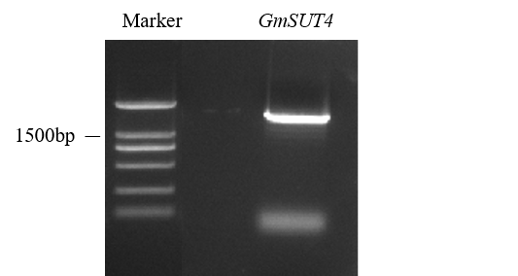
Fig.S1

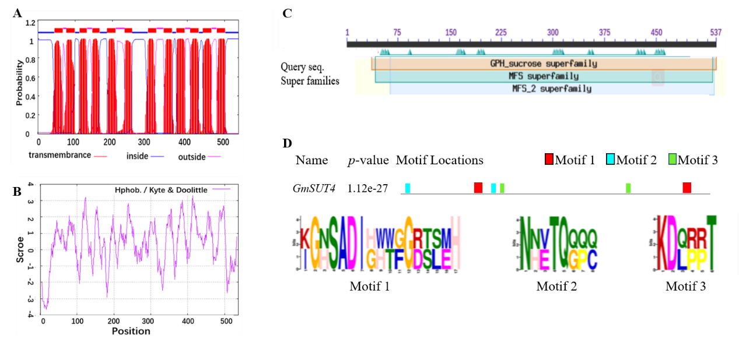
Fig. S2
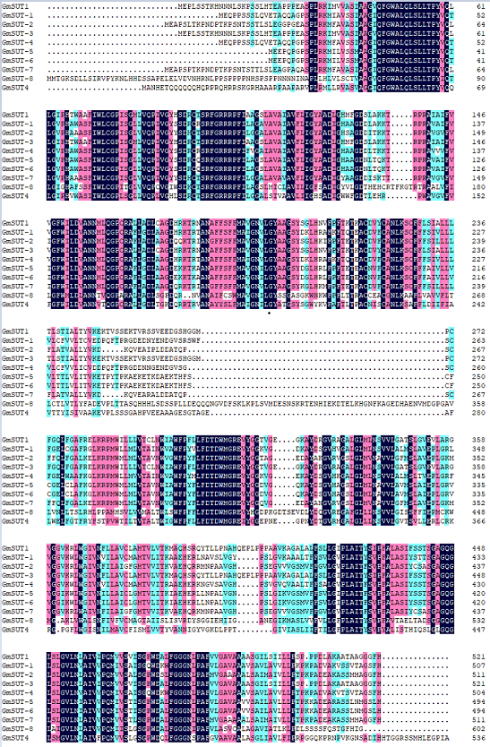
Fig. S3
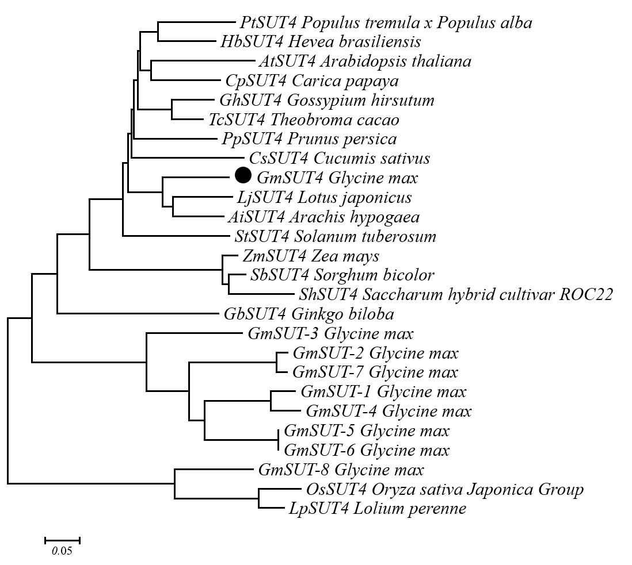
Fig.S4

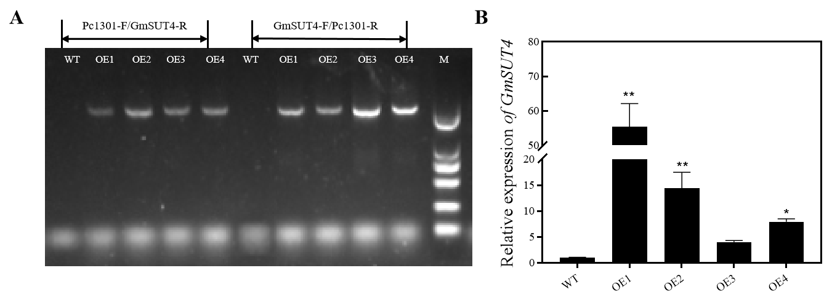
Fig.S5

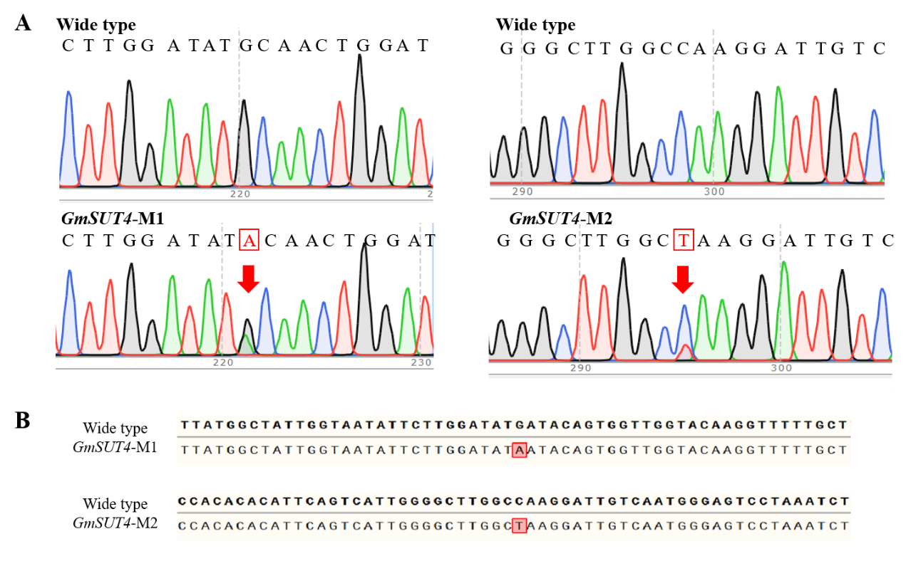
Fig.S6

