Differential Alterations in topology property of resting state networks associated with mental health and childhood trauma

Supplementary Material

Table of Contents
Supplementary table s1: Local efficiency of the brain networks between childhood trauma group and health control group. 2
Supplementary Table S2: Average path length of the brain networks between childhood trauma group and health control group. 3
Supplementary Table S3: Clustering coefficient of the brain networks between childhood trauma group and health control group. 4
Supplementary Table S4: Degree of the brain networks between childhood trauma group and health control group. 5
Supplementary Table S5: Collinearity of model including neglect, abuse, BDI, TPQ, STAI 6
Supplementary Figure S1: the role of global efficiency changing as a mediator between TPQ-NS and abuse 7
Supplementary Figure S2: the role of global efficiency changing as a mediator between trait anxiety and neglect 8
Supplementary Figure S3: the role of global efficiency changing as a mediator between trait anxiety and abuse 9
Supplement Figure S4 & Table S6: The simple slope graph of neglect to global efficiency of Salience.ainsula.R for different genders. 10
Supplement Figure S5 & Table S7: The simple slope graph and table of neglect to global efficiency of DMN.LP for different genders. 11
Supplement Figure S6 & Table S8: The simple slope graph and table of abuse to global efficiency of Salience.ainsula.R for different genders. 12
Supplement Figure S7 & Table S9: The simple slope graph and table of abuse to global efficiency of Salience.ainsula.L for different genders. 13
Supplement Figure S8 & Table S10: The simple slope graph and table of abuse to global efficiency of DMN.LP for different genders. 14

Table S1 Local efficiency of the brain networks between childhood trauma group and health control group.
 | MNI coordinate  (x, y, z) | Local Efficiency  (Mean ± SE) |  | P value
 |  | Childhood trauma group | Health control group
networks.DefaultMode.MPFC | 1;55;-3 | 0.074±0.022 | 0.11±0.036 | 0.43
networks.DefaultMode.LP (L) | -39;-77;33 | 0.22±0.056 | 0.19±0.059 | 0.69
networks.DefaultMode.LP (R) | 47;-67;29 | 0.23±0.046 | 0.36±0.081 | 0.15
networks.DefaultMode.PCC | 1;-61;38 | 0.20±0.049 | 0.14±0.041 | 0.37
networks.SensoriMotor.Lateral (L) | -55;-12;29 | 0.21±0.057 | 0.15±0.038 | 0.33
networks.SensoriMotor.Lateral (R) | 56;-10;29 | 0.19±0.051 | 0.11±0.049 | 0.31
networks.SensoriMotor.Superior | 0;-31;67 | 0.11±0.039 | 0.25±0.047 | 0.035
networks.Salience.ACC | 0;22;35 | 0.28 ± 0.055 | 0.11 ± 0.044 | 0.022
networks.Salience.AInsula (L) | -44;13;1 | 0.18±0.055 | 0.17±0.036 | 0.90
networks.Salience.AInsula (R) | 47;14;0 | 0.14±0.042 | 0.18±0.044 | 0.59
networks.Salience.RPFC (L) | -32;45;27 | 0.14±0.046 | 0.21±0.043 | 0.29
networks.Salience.RPFC (R) | 32;46;27 | 0.17±0.039 | 0.18±0.054 | 0.86
networks.Salience.SMG (L) | -60;-39;31 | 0.17±0.049 | 0.19±0.056 | 0.86
networks.Salience.SMG (R) | 62;-35;32 | 0.27 ± 0.053 | 0.10 ± 0.028 | 0.011
networks.DorsalAttention.FEF (L) | -27;-9;64 | 0.13±0.039 | 0.16±0.049 | 0.67
networks.DorsalAttention.FEF (R) | 30;-6;64 | 0.096±0.032 | 0.17±0.034 | 0.10
networks.DorsalAttention.IPS (R) | 39;-42;54 | 0.14±0.038 | 0.22±0.049 | 0.21
networks.FrontoParietal.LPFC (L) | -43;33;28 | 0.10±0.018 | 0.19±0.040 | 0.044
networks.FrontoParietal.PPC (L) | -46;-58;49 | 0.078±0.029 | 0.15±0.042 | 0.18
networks.FrontoParietal.LPFC (R) | 41;38;30 | 0.17±0.070 | 0.20±0.09 | 0.79
networks.FrontoParietal.PPC (R) | 52;-52;45 | 0.20±0.038 | 0.22±0.048 | 0.75

Abbreviation: MPFC: Medial prefrontal cortex; LP: Lateral precuneus; PCC: Posterior cingulate cortex; ACC: Anterior cingulate cortex; AInsula: Anterior insula; RPFC: Rostral lateral prefrontal cortex; SMG: Supramarginal gyrus; FEF: Frontal eye fields
IPS: Intraparietal sulcus; LPFC: Lateral prefrontal cortex; L: Left; R: Right

 | MNI coordinate  (x, y, z) | Average Path Length  (Mean ± SE) |  | P value
 |  | Childhood trauma group | Health control group
networks.DefaultMode.MPFC | 1;55;-3 | 2.58±0.16 | 2.66±0.16 | 0.74
networks.DefaultMode.LP (L) | -39;-77;33 | 2.52±0.16 | 2.82±0.22 | 0.28
networks.DefaultMode.LP (R) | 47;-67;29 | 2.48±0.14 | 2.88±0.25 | 0.16
networks.DefaultMode.PCC | 1;-61;38 | 2.27±0.12 | 2.69±0.18 | 0.06
networks.SensoriMotor.Lateral (L) | -55;-12;29 | 2.87±0.23 | 2.68±0.21 | 0.54
networks.SensoriMotor.Lateral (R) | 56;-10;29 | 2.71±0.17 | 2.83±0.20 | 0.65
networks.SensoriMotor.Superior | 0;-31;67 | 2.31±0.15 | 2.44±0.16 | 0.53
networks.Salience.ACC | 0;22;35 | 2.61±0.17 | 2.71±0.17 | 0.71
networks.Salience.AInsula (L) | -44;13;1 | 2.50±0.12 | 2.39±0.11 | 0.52
networks.Salience.AInsula (R) | 47;14;0 | 2.67±0.18 | 2.50±0.12 | 0.40
networks.Salience.RPFC (L) | -32;45;27 | 2.37±0.11 | 2.59±0.12 | 0.18
networks.Salience.RPFC (R) | 32;46;27 | 2.32±0.16 | 2.43±0.13 | 0.57
networks.Salience.SMG (L) | -60;-39;31 | 2.68±0.19 | 2.32±0.18 | 0.18
networks.Salience.SMG (R) | 62;-35;32 | 2.49±0.21 | 2.45±0.099 | 0.88
networks.DorsalAttention.FEF (L) | -27;-9;64 | 2.39±0.13 | 2.59±0.18 | 0.36
networks.DorsalAttention.FEF (R) | 30;-6;64 | 2.46±0.13 | 2.49±0.15 | 0.88
networks.DorsalAttention.IPS (R) | 39;-42;54 | 2.66±0.12 | 2.13±0.16 | 0.012
networks.FrontoParietal.LPFC (L) | -43;33;28 | 2.52±0.14 | 1.98±0.12 | 0.0051
networks.FrontoParietal.PPC (L) | -46;-58;49 | 2.74±0.27 | 2.54±0.12 | 0.49
networks.FrontoParietal.LPFC (R) | 41;38;30 | 2.48±0.14 | 2.72±0.21 | 0.36
networks.FrontoParietal.PPC (R) | 52;-52;45 | 2.29±0.16 | 2.27±0.19 | 0.94

Table S2 Average path length of the brain networks between childhood trauma group and health control group.

Abbreviation: MPFC: Medial prefrontal cortex; LP: Lateral precuneus; PCC: Posterior cingulate cortex; ACC: Anterior cingulate cortex; AInsula: Anterior insula; RPFC: Rostral lateral prefrontal cortex; SMG: Supramarginal gyrus; FEF: Frontal eye fields
IPS: Intraparietal sulcus; LPFC: Lateral prefrontal cortex; L: Left; R: Right

 | MNI coordinate  (x, y, z) | Clustering Coefficient  (Mean ± SE) |  | P value
 |  | Childhood trauma group | Health control group
networks.DefaultMode.MPFC | 1;55;-3 | 0.065±0.019 | 0.1±0.034 | 0.35
networks.DefaultMode.LP (L) | -39;-77;33 | 0.20±0.046 | 0.17±0.057 | 0.74
networks.DefaultMode.LP (R) | 47;-67;29 | 0.19±0.041 | 0.33±0.080 | 0.10
networks.DefaultMode.PCC | 1;-61;38 | 0.19±0.048 | 0.13±0.039 | 0.33
networks.SensoriMotor.Lateral (L) | -55;-12;29 | 0.19±0.047 | 0.13±0.033 | 0.30
networks.SensoriMotor.Lateral (R) | 56;-10;29 | 0.16±0.046 | 0.094±0.036 | 0.25
networks.SensoriMotor.Superior | 0;-31;67 | 0.10±0.037 | 0.23±0.047 | 0.046
networks.Salience.ACC | 0;22;35 | 0.26±0.053 | 0.10±0.044 | 0.029
networks.Salience.AInsula (L) | -44;13;1 | 0.16±0.047 | 0.16±0.033 | 0.98
networks.Salience.AInsula (R) | 47;14;0 | 0.14±0.042 | 0.16±0.043 | 0.69
networks.Salience.RPFC (L) | -32;45;27 | 0.12±0.037 | 0.19±0.039 | 0.21
networks.Salience.RPFC (R) | 32;46;27 | 0.15±0.037 | 0.15±0.043 | 0.94
networks.Salience.SMG (L) | -60;-39;31 | 0.16±0.047 | 0.15±0.043 | 0.95
networks.Salience.SMG (R) | 62;-35;32 | 0.24±0.049 | 0.092±0.025 | 0.014
networks.DorsalAttention.FEF (L) | -27;-9;64 | 0.12±0.030 | 0.15±0.047 | 0.53
networks.DorsalAttention.FEF (R) | 30;-6;64 | 0.088±0.030 | 0.17±0.034 | 0.082
networks.DorsalAttention.IPS (R) | 39;-42;54 | 0.12±0.031 | 0.21±0.048 | 0.14
networks.FrontoParietal.LPFC (L) | -43;33;28 | 0.094±0.017 | 0.16±0.032 | 0.079
networks.FrontoParietal.PPC (L) | -46;-58;49 | 0.066±0.024 | 0.14±0.041 | 0.18
networks.FrontoParietal.LPFC (R) | 41;38;30 | 0.15±0.04 | 0.19±0.085 | 0.74
networks.FrontoParietal.PPC (R) | 52;-52;45 | 0.19±0.038 | 0.20±0.043 | 0.83
Table S3 Clustering coefficient of the brain networks between childhood trauma group and health control group.

Abbreviation: MPFC: Medial prefrontal cortex; LP: Lateral precuneus; PCC: Posterior cingulate cortex; ACC: Anterior cingulate cortex; AInsula: Anterior insula; RPFC: Rostral lateral prefrontal cortex; SMG: Supramarginal gyrus; FEF: Frontal eye fields
IPS: Intraparietal sulcus; LPFC: Lateral prefrontal cortex; L: Left; R: Right

 | MNI coordinate  (x, y, z) | Degree  (Mean ± SE) |  |  |  | P value
 |  | Childhood trauma group | Health control group
networks.DefaultMode.MPFC | 1;55;-3 | 3.55±0.62 | 3.35 ± 0.42 |  | 0.79
networks.DefaultMode.LP (L) | -39;-77;33 | 3.05±0.46 | 2.20 ± 0.37 |  | 0.16
networks.DefaultMode.LP (R) | 47;-67;29 | 2.25±0.31 | 4.05 ± 0.65 |  | 0.016
networks.DefaultMode.PCC | 1;-61;38 | 3.40±0.52 | 2.95±0.46 |  | 0.52
networks.SensoriMotor.Lateral (L) | -55;-12;29 | 2.70±0.54 | 3.35±0.60 |  | 0.43
networks.SensoriMotor.Lateral (R) | 56;-10;29 | 2.95±0.55 | 2.65±0.42 |  | 0.67
networks.SensoriMotor.Superior | 0;-31;67 | 3.20±0.58 | 3.35±0.47 |  | 0.84
networks.Salience.ACC | 0;22;35 | 2.45±0.40 | 3.15±0.41 |  | 0.22
networks.Salience.AInsula (L) | -44;13;1 | 3.70±0.38 | 2.50±0.39 |  | 0.035
networks.Salience.AInsula (R) | 47;14;0 | 3.4±0.50 | 2.15±0.43 |  | 0.012
networks.Salience.RPFC (L) | -32;45;27 | 3.45±0.67 | 3.45±0.38 |  | >0.99
networks.Salience.RPFC (R) | 32;46;27 | 3.60±0.63 | 3.45±0.42 | 0.84
networks.Salience.SMG (L) | -60;-39;31 | 2.40±0.49 | 3.40±0.68 | 0.24
networks.Salience.SMG (R) | 62;-35;32 | 3.25±0.51 | 3.40±0.39 | 0.82
networks.DorsalAttention.FEF (L) | -27;-9;64 | 2.70±0.44 | 4.30±0.49 | 0.019
networks.DorsalAttention.FEF (R) | 30;-6;64 | 2.80±0.38 | 3.5±0.39 | 0.21
networks.DorsalAttention.IPS (R) | 39;-42;54 | 3.15±0.54 | 2.85±0.36 | 0.65
networks.FrontoParietal.LPFC (L) | -43;33;28 | 3.80±0.47 | 3.40±0.63 | 0.61
networks.FrontoParietal.PPC (L) | -46;-58;49 | 2.75±0.53 | 3.45±0.63 | 0.40
networks.FrontoParietal.LPFC (R) | 41;38;30 | 3.1±0.65 | 2.75±0.64 | 0.70
networks.FrontoParietal.PPC (R) | 52;-52;45 | 3.15±0.49 | 3.25±0.58 | 0.90
Table S4 Degree of the brain networks between childhood trauma group and health control group.

Abbreviation: MPFC: Medial prefrontal cortex; LP: Lateral precuneus; PCC: Posterior cingulate cortex; ACC: Anterior cingulate cortex; AInsula: Anterior insula; RPFC: Rostral lateral prefrontal cortex; SMG: Supramarginal gyrus; FEF: Frontal eye fields
IPS: Intraparietal sulcus; LPFC: Lateral prefrontal cortex; L: Left; R: Right

Collinearity of model including neglect, abuse, BDI, TPQ, STAI

Parameter | VIF
Abuse | 1.734
Neglect | 2.085
BDI | 1.02
TPQ-NS | 1.381
TPQ-HA | 1.320
TPQ-RD | 1.252
STAI-Y1 | 4.215
STAI-Y2 | 4.963

Supplementary Figure S1: the role of global efficiency changing as a mediator between TPQ-NS and abuse
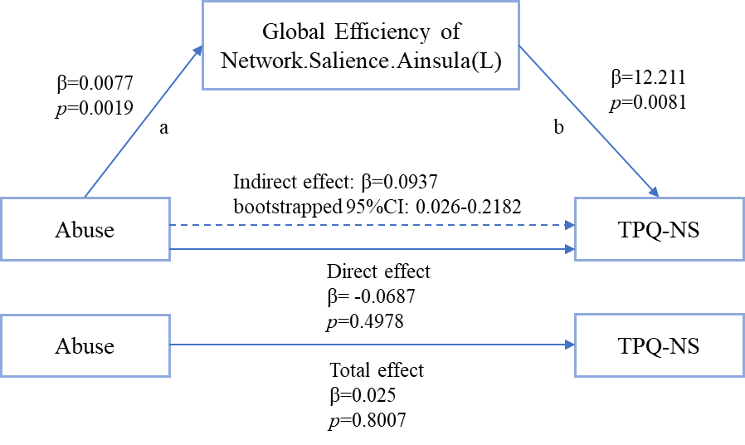

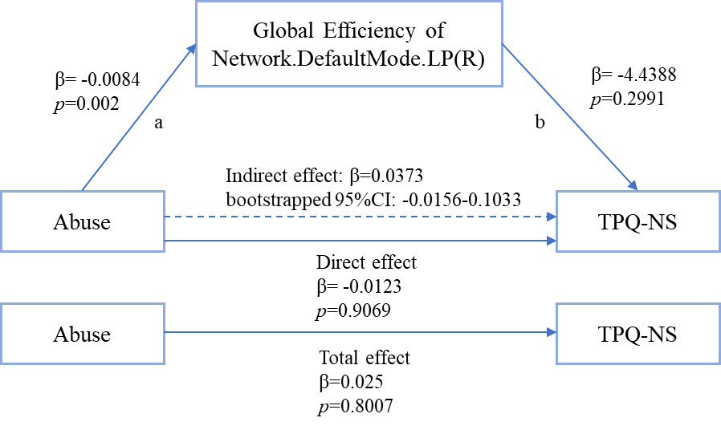
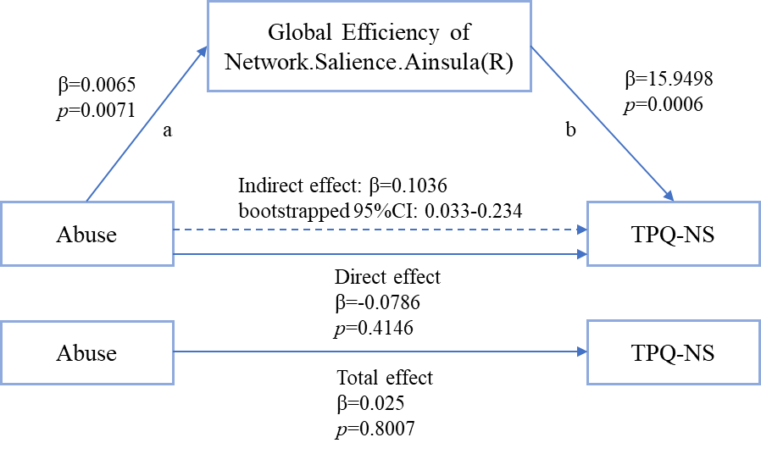
Supplementary Figure S2: the role of global efficiency changing as a mediator between trait anxiety and neglect
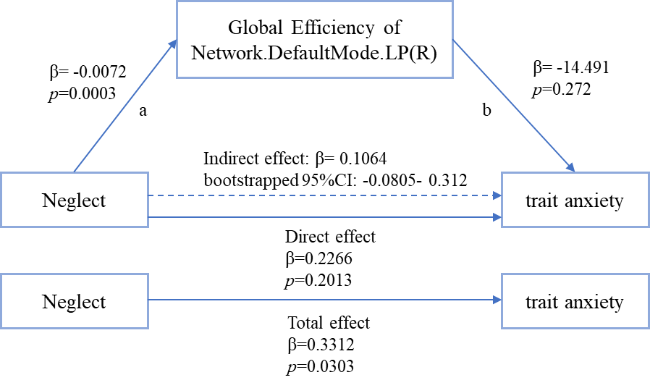
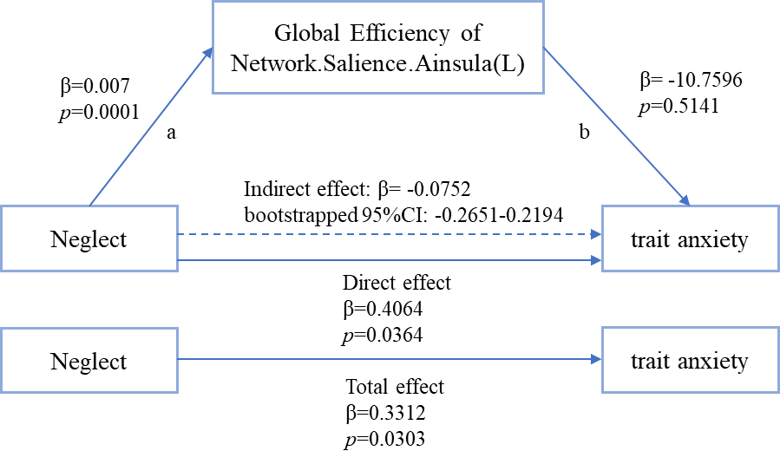
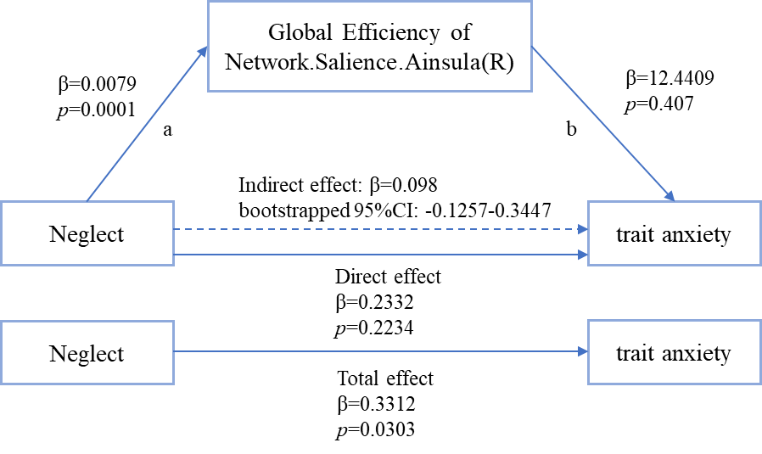
Supplementary Figure S3: the role of global efficiency changing as a mediator between trait anxiety and abuse

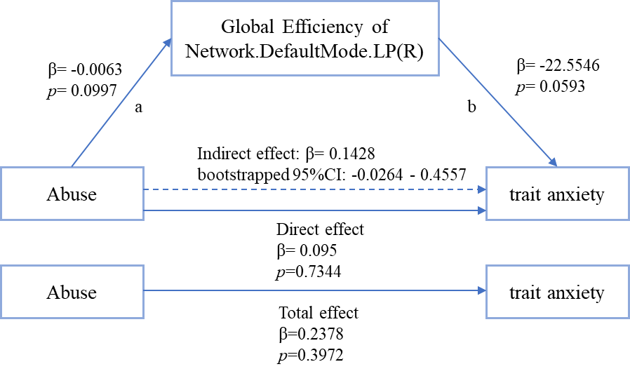
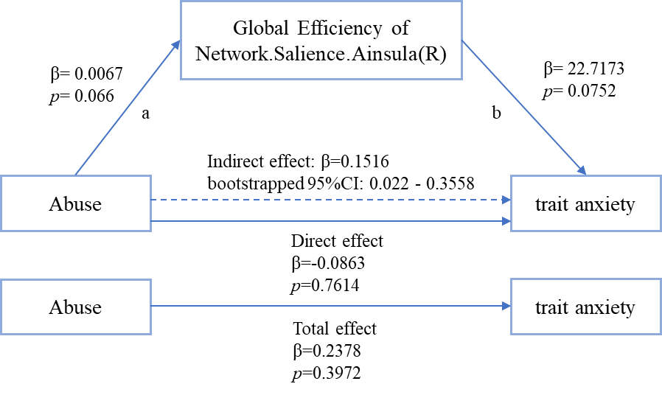
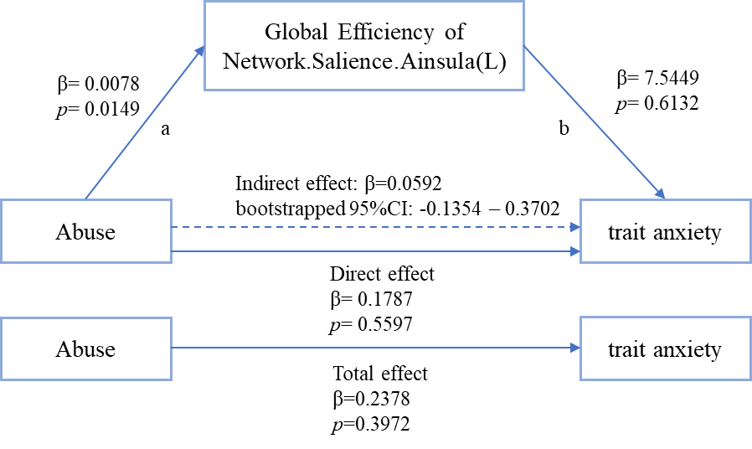
Supplement Figure S4 & Table S6: The simple slope graph of neglect to global efficiency of Salience.ainsula.R for different genders.
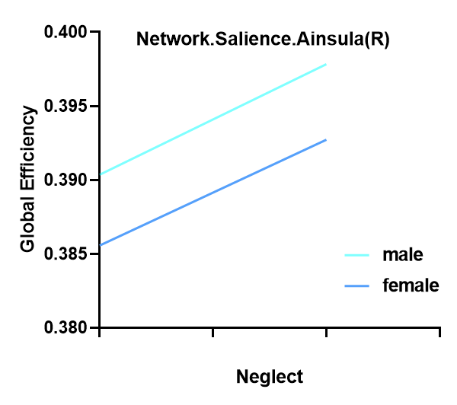
 | MODEL1 | MODEL2 | MODEL3
constant | 0.387** | 0.386** | 0.386**
constant | -43.448 | -33.976 | -33.749
neglect | 0.007** | 0.007** | 0.007**
neglect | -6.499 | -6.447 | -4.584
sex |  | 0.005 | 0.005
sex |  | -0.26 | -0.257
neglect*sex |  |  | 0
neglect*sex |  |  | -0.135
Sample size | 80 | 80 | 80
R ² | 0.351 | 0.352 | 0.352
Adjusted R ² | 0.343 | 0.335 | 0.326
F  | F (1,78)=42.238,p=0.000 | F (2,77)=20.900,p=0.000 | F (3,76)=13.762,p=0.000
△R ² | 0.351 | 0.001 | 0
△F  | F (1,78)=42.238,p=0.000 | F (1,77)=0.068,p=0.795 | F (1,76)=0.018,p=0.893
Dependent variable：Salience.ainsula.R
* p<0.05 ** p<0.01

Supplement Figure S5 & Table S7: The simple slope graph and table of neglect to global efficiency of DMN.LP for different genders.

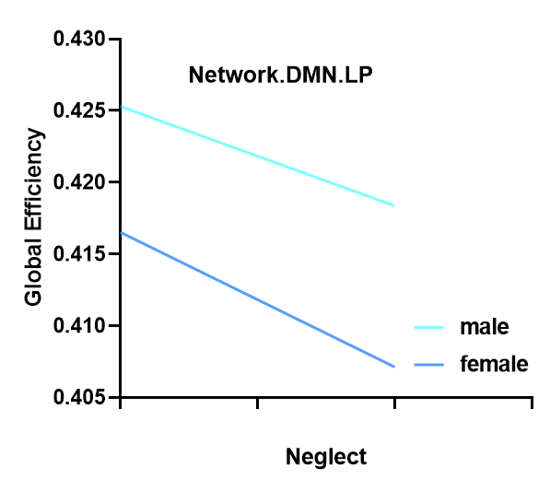
 | MODEL1 | MODEL2 | MODEL3
constant | 0.420** | 0.417** | 0.417**
constant | -41.268 | -32.186 | -32.139
neglect | -0.008** | -0.008** | -0.009**
neglect | (-6.405) | (-6.382) | (-5.302)
sex |  | 0.009 | 0.009
sex |  | -0.426 | -0.415
neglect*sex |  |  | 0.002
neglect*sex |  |  | (-0.946)
Sample size | 80 | 80 | 80
R ² | 0.345 | 0.346 | 0.354
Adjusted R ² | 0.336 | 0.329 | 0.328
F  | F (1,78)=41.027,p=0.000 | F (2,77)=20.389,p=0.000 | F (3,76)=13.872,p=0.000
△R ² | 0.345 | 0.002 | 0.008
△F  | F (1,78)=41.027,p=0.000 | F (1,77)=0.181,p=0.671 | F (1,76)=0.895,p=0.347
Dependent variable：DMN.LP
* p<0.05 ** p<0.01

Supplement Figure S6 & Table S8: The simple slope graph and table of abuse to global efficiency of Salience.ainsula.R for different genders.

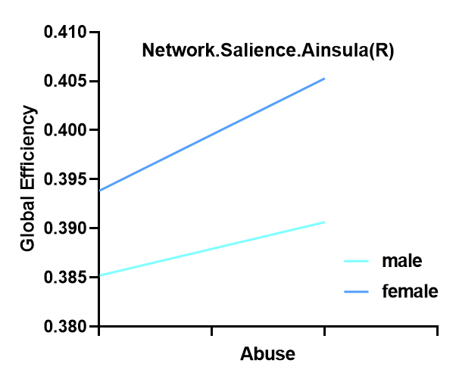
 | MODEL1 | MODEL2 | MODEL3
constant | 0.387** | 0.390** | 0.394**
constant | -36.671 | -28.651 | -27.687
abuse | 0.006** | 0.007** | 0.011*
abuse | -2.766 | -2.734 | -2.106
sex |  | -0.006 | -0.009
sex |  | (-0.277) | (-0.379)
abuse*sex |  |  | -0.006
abuse*sex |  |  | (-0.984)
Sample size | 80 | 80 | 80
R ² | 0.089 | 0.09 | 0.102
Adjusted R ² | 0.078 | 0.067 | 0.066
F  | F (1,78)=7.652,p=0.007 | F (2,77)=3.819,p=0.026 | F (3,76)=2.868,p=0.042
△R ² | 0.089 | 0.001 | 0.011
△F  | F (1,78)=7.652,p=0.007 | F (1,77)=0.077,p=0.783 | F (1,76)=0.969,p=0.328
Dependent variable：Salience.ainsula.R
* p<0.05 ** p<0.01

Supplement Figure S7 & Table S9: The simple slope graph and table of abuse to global efficiency of Salience.ainsula.L for different genders.

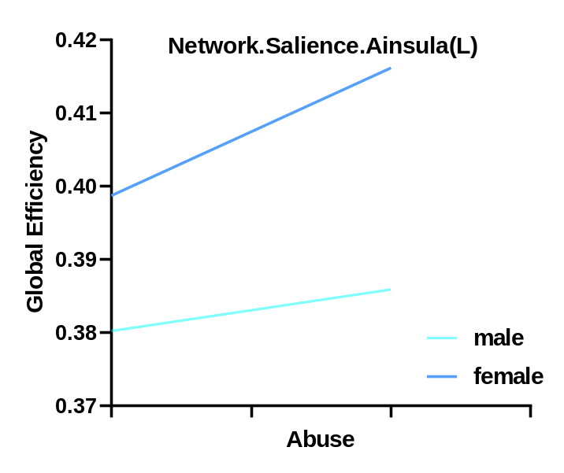
 | MODEL 1 | MODEL 2 | MODEL 3
constant | 0.386** | 0.391** | 0.399**
constant | -35.858 | -28.277 | -28.093
abuse | 0.008** | 0.008** | 0.017**
abuse | -3.211 | -3.249 | -3.217
sex |  | -0.014 | -0.019
sex |  | (-0.603) | (-0.816)
abuse*sex |  |  | -0.012
abuse*sex |  |  | (-1.939)
Sample size | 80 | 80 | 80
R ² | 0.117 | 0.121 | 0.162
Adjusted R ² | 0.105 | 0.098 | 0.129
F  | F (1,78)=10.313,p=0.002 | F (2,77)=5.297,p=0.007 | F (3,76)=4.911,p=0.004
△R ² | 0.117 | 0.004 | 0.041
△F  | F (1,78)=10.313,p=0.002 | F (1,77)=0.364,p=0.548 | F (1,76)=3.760,p=0.056
Dependent variable：salience.ainsula.L
* p<0.05 ** p<0.01

Supplement Figure S8 & Table S10: The simple slope graph and table of abuse to global efficiency of DMN.LP for different genders.

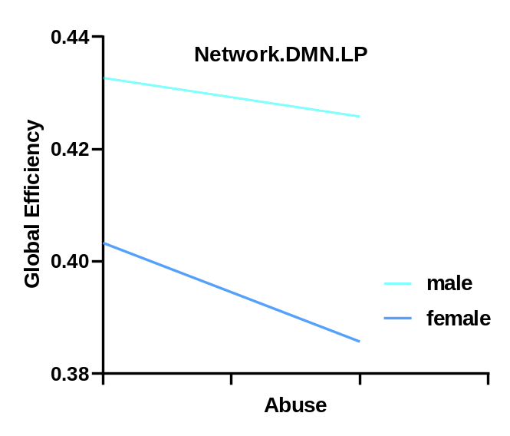
 | MODEL1 | MODEL2 | MODEL3
constant | 0.420** | 0.411** | 0.403**
constant | -35.525 | -27.131 | -25.749
abuse | -0.008** | -0.009** | -0.018**
abuse | (-3.194) | (-3.340) | (-2.952)
Sex |  | 0.025 | 0.029
Sex |  | -0.993 | -1.168
abuse*sex |  |  | 0.011
abuse*sex |  |  | (-1.609)
Sample size | 80 | 80 | 80
R ² | 0.116 | 0.127 | 0.156
Adjusted R ² | 0.104 | 0.104 | 0.122
F  | F (1,78)=10.203,p=0.002 | F (2,77)=5.594,p=0.005 | F (3,76)=4.669,p=0.005
△R ² | 0.116 | 0.011 | 0.029
△F  | F (1,78)=10.203,p=0.002 | F (1,77)=0.987,p=0.324 | F (1,76)=2.588,p=0.112
Dependent variable：DMN.LP
* p<0.05 ** p<0.01

