Supporting information for:
Nitrogen release and microbial community characteristics during the decomposition of field-incorporated corn straw in Northeast China
Chao Yanª#, Daocheng Yangª#, Yinghao Xue^{b}, Qiulai Song^{c}, Zhaofang Hou^{d}, Shuangshuang Yanª, Xiaochen Lyuª, Chunmei Maª, Zhiyu Xu^{b}, Zhenping Gong^{a,}*
ª College of Agriculture, Northeast Agricultural University, Harbin, 150030, China
^{b} Rural Energy and Environment Agency, Ministry of Agriculture and Rural Affairs, Beijing, 100125, China
^{c} Institute of Crop Cultivation and Tillage, Heilongjiang Academy of Agricultural Sciences, Harbin, 150086, China
^{d} KingAgroot, Qingdao, 266000, China
# Chao Yan and Daocheng Yang contributed equally to this work.
* Corresponding author.
E-mail address: gzpyx2004@163.com(ZP. Gong).

Table.S1 Topological properties of network diagrams in different years
 | 2018 | 2019 | 2020
Nodes | 53 | 75 | 93
Edges | 127 | 272 | 340
Average number of neighbors | 4.792 | 7.253 | 7.596
Clustering coefficient | 0.336 | 0.392 | 0.361

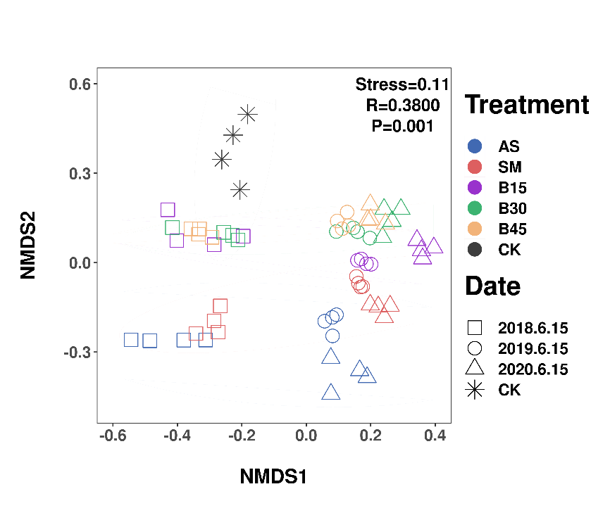
Fig.S1 Nonmetric multidimensional scaling (NMDS) analysis of bacterial communities with OTUs classified at 97% sequence similarity. ANOSIM, analysis of similarities based on Bray-Curtis distances calculated from relative OTU abundances with 9999 permutations (R=0.38,P<0.001). Different colours represent different sampling date, and different symbols indicate different treatments

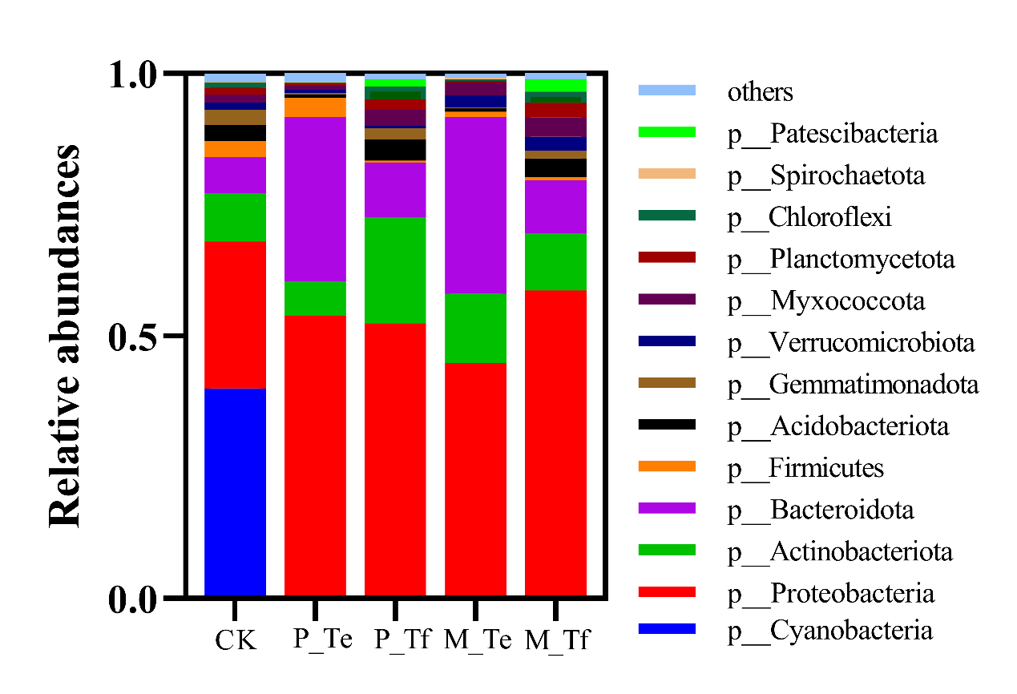
Fig.S2 Relative abundance of major phylums for bacterial communities

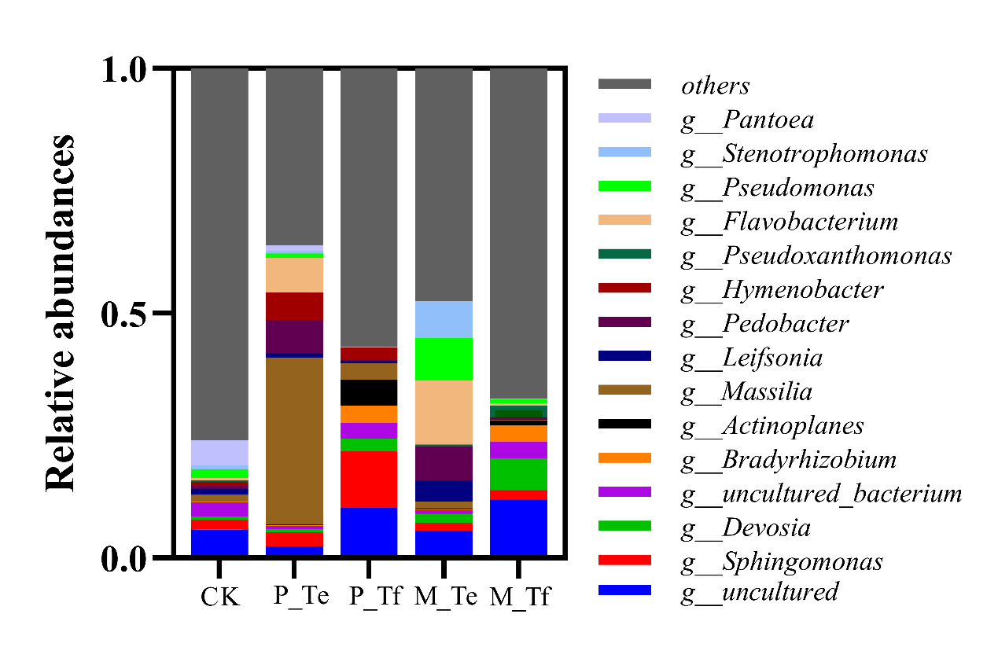
Fig.S3 Relative abundance of major genus for bacterial communities

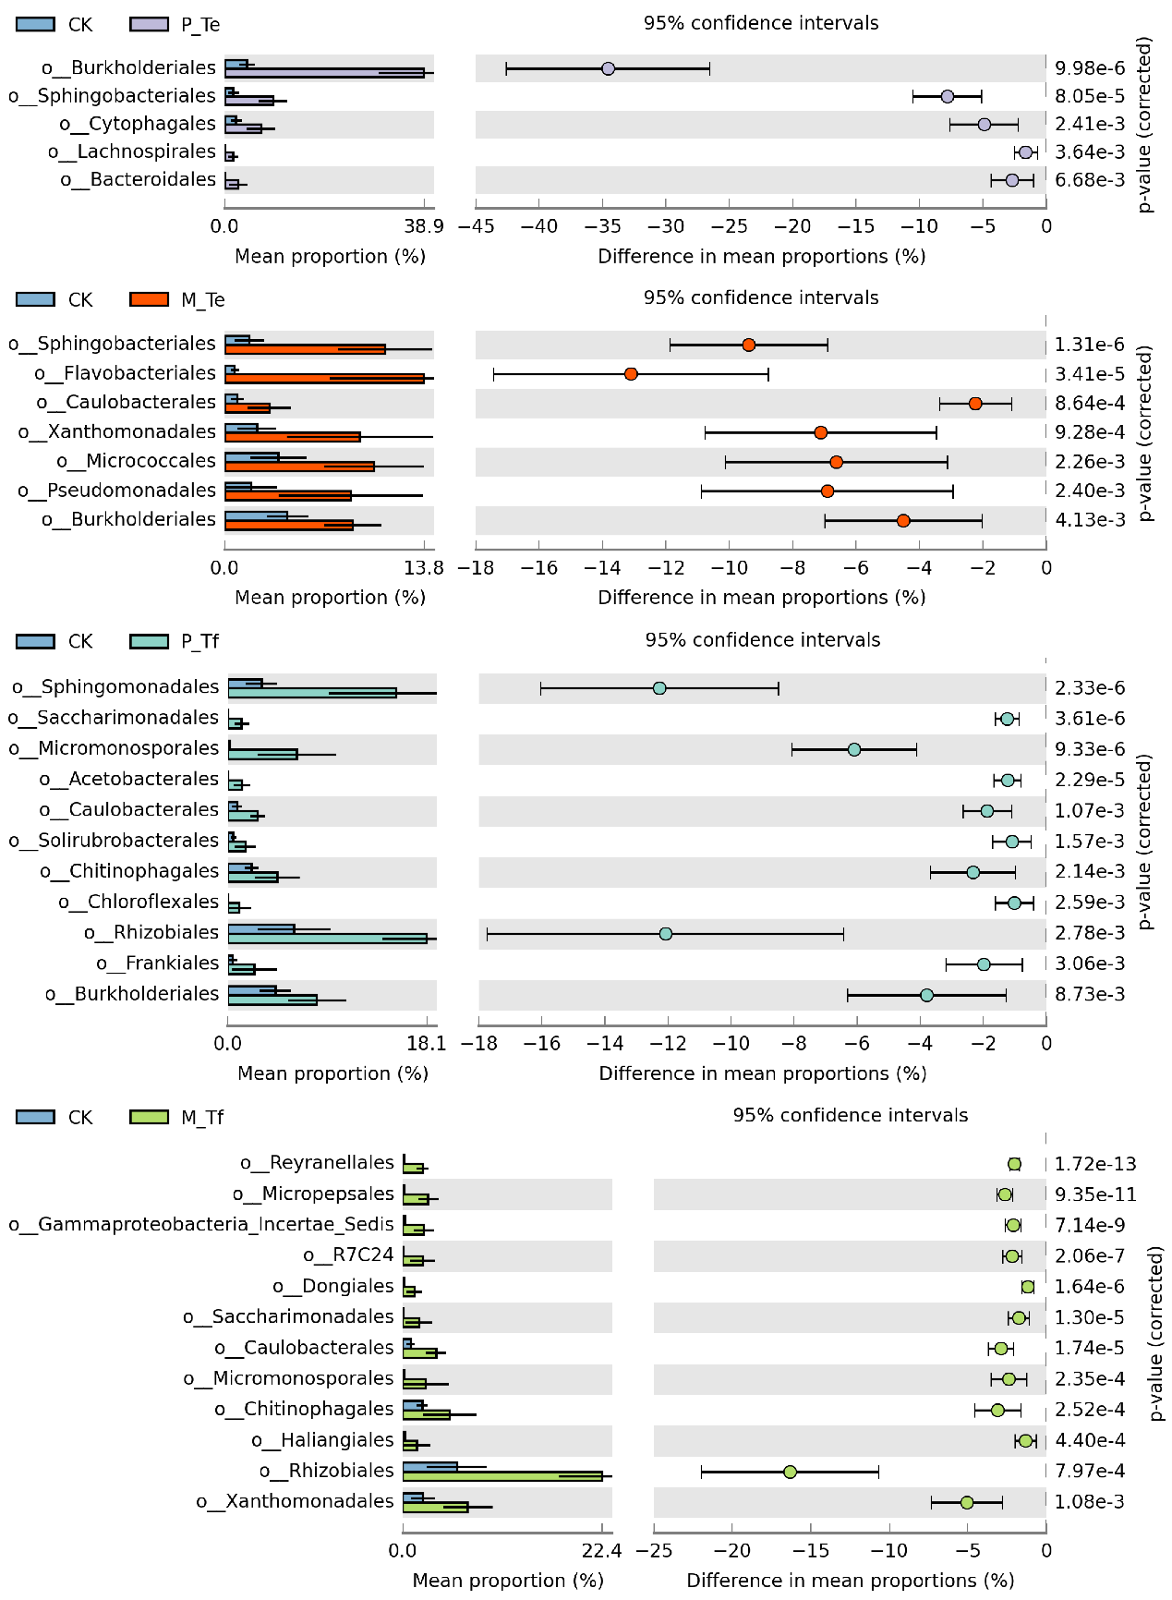
Fig.S4 STAMP Analysis of bacterial order of decomposing straw

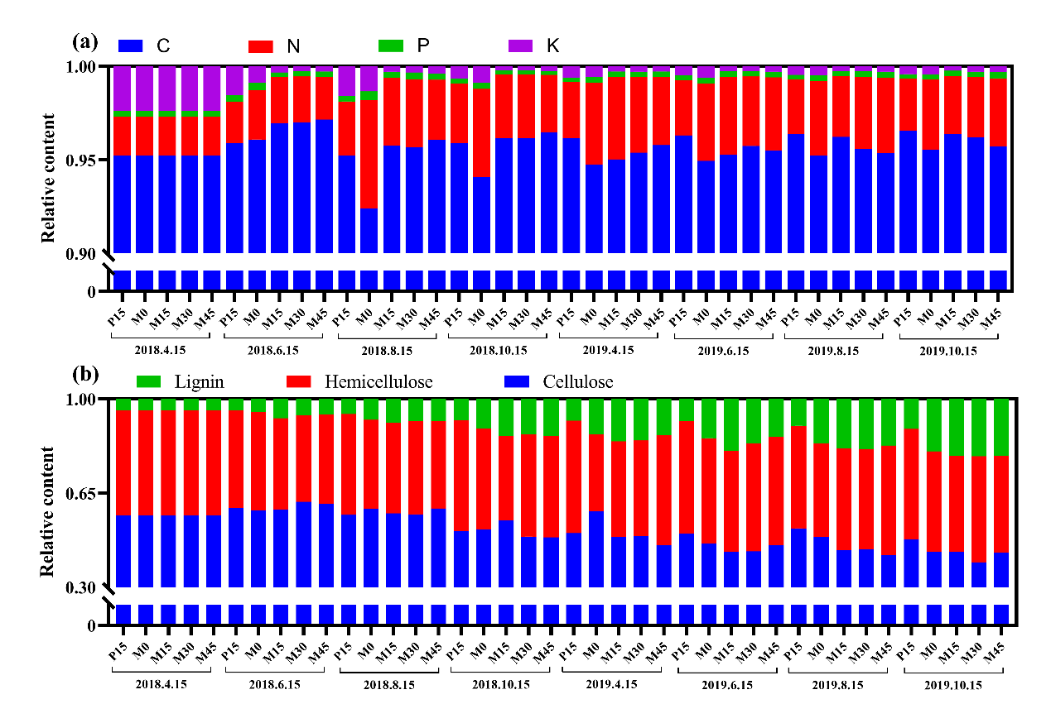
Fig.S5 Composition of straw. (a) The percentage of C, N, P, K, (b) the percentage of lignin, hemicellulose, and cellulose

