Supplementary information
Abnormal thickness-dependent magneto-transport properties of vdW magnetic semiconductor Cr₂Si₂Te₆
Yun Li ^{1,2,3}, Zheng Chen ³, Jie Wang ^{3,4}, Teng li ³, Mingliang Tian ^{3,5}, Julie Karel *^{1,2} and Kiyonori Suzuki *²
¹ ARC Centre of Excellence in Future Low-Energy Electronics Technologies (FLEET)
² Department of Materials Science and Engineering, Monash University, Clayton, Victoria 3800, Australia
³ Anhui Province Key Laboratory of Condensed Matter Physics at Extreme Conditions, High Magnetic Field Laboratory, Chinese Academy of Sciences, Hefei 230031, Anhui, China
KEYWORDS: Two-dimensional, magnetic semiconductor, thickness-dependent, magneto-transport
⁴ Department of Physics, University of Science and Technology of China, Hefei 230026, People’s Republic of China
⁵ School of Physics and Materials Science, Anhui University, Hefei, 230601, China;

Supplementary note 1: Characterization of single crystal
To confirm the structure, purity, and chemical composition of crystals, characterizations are taken by XRD with Cu Kα (λ = 0.1542 nm) radiation and EDS. EDS analysis spectrum of the platelet provides the average chemical ratio of Cr: Si: Te=18: 21: 60, to be nearly the ideal stoichiometry of CST (Fig. S1a). Comparing our crystal to the literature, the content of Cr is slightly smaller ^{1,2}, which means parts of Cr atoms are replaced by Si or Te. Fig.S1b shows the XRD pattern of the exfoliated crystal surface. The (006) and (0012) sharp peaks indicate that the detecting surface is ab-plane while the direction normal to the surface is the c-axis. Inserted photo of crystals shows a relatively big size with clean surface obtained after the surface cosolvent residual being exfoliated. The Raman spectra of single crystal are also adopted as shown in Fig.S1c, which indicates that the typical characteristic of molecular vibration is similar to literature. There are still three strong peaks in the low-frequency region located at 90 cm⁻¹, 118 cm⁻¹, and 139 cm⁻¹, in which the corresponded E_{g} (out-of-plane), A²_{g} (out-of-plane) have a slight shift to a small value (blue shift). However, the difference in Cr content and shift of Raman spectra implies that there might be some different properties resulting in structure difference. All these characterizations can prove the quality of CST crystals with a similar structure to previous literature. Therefore, these crystals are regarded as suitable for further device design and transport experiments.
Fig.S1d displays the magnetic field-dependent magnetization for both H//c-axis and H//ab-plane under 5 K. The saturation begins from 0.2 T with an out-of-plane magnetic field, while the final saturation value of magnetization is close to 2.8 μ_{B}. The slightly small value compared to idea 3 μ_{B} originates from the smaller percentage of Cr content in crystal, since it contributes to magnetism. Fig.S1e&1f illustrate the magnetization as the function of applied magnetic field for H//c-axis and H//ab-plane respectively, under various temperatures. Below T_{c}, the magnetization shows a typical soft ferromagnetism behavior. Interesting things happen at 40 K, there is still a trajectory-like curve deviating from a high-temperature linear relation for both out-plane and in-plane magnetic field conditions. It does not violate the affirmation of T_{c} but suggests the existence of short-range ferromagnetic correlations in temperature even higher than T_{c} ². This is also proved according to the previous neutron scattering and nonlinear optical polarimetry ^{3,4}. Both static and dynamic in-plane magnetic correlations persist till high temperature.
c)
b)
a)
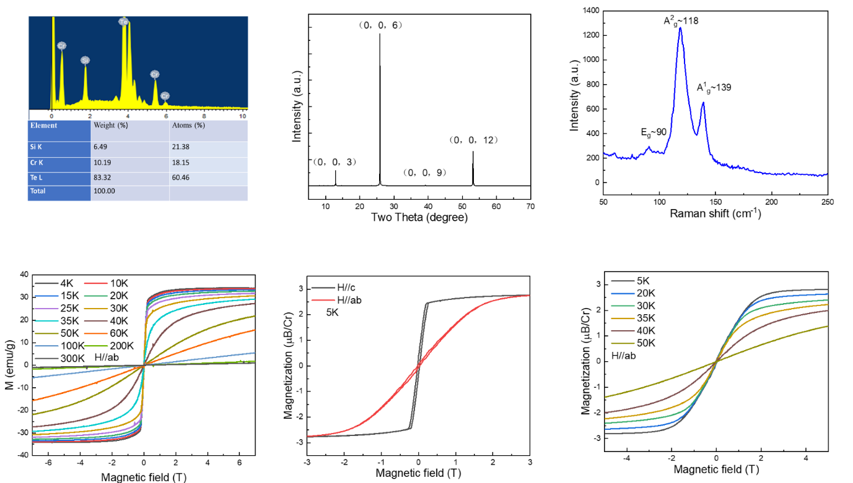
e)
d)
f)
Figure S1. Characterization of CST crystal (a) EDS spectra results show the elements intensity of CST single crystal. The contents of element compositions are shown in the insert table below EDS spectra. (b) XRD patterns of CST single crystal measured on the exfoliated surface. (c) Raman spectra for the CST crystal, with three different peaks corresponding to A¹_{g} (in-plane), A²_{g} (out-of-plane), and E_{g} (out-of-plane) Te vibrations. (d) The magnetization as a function of magnetic field under 5 K with H//c-axis and H//ab-plane. (e) The magnetization is a function of the magnetic field when H//c-axis. (f) The repeat magnetization is a function of the magnetic field when H//ab-plane.
Supplementary note 2: Magnetoresistance of CST single crystal
Field-dependent MR data of CST single crystal under various temperature conditions are displayed in Fig.S2a&b with applied magnetic field H parallel to the c-axis or ab-plane. The MR ratio is defined as $(R_{H}-R_{0})/R_{0}$, where R_{H} is the resistance as certain magnetic field H, R₀ is the resistance at zero magnetic fields. When magnetic field H//c-axis, MR experiences a change of sign from positive to negative when the temperature reduces below 15 K. The NMR absolute value enhances with decreasing temperature and increases linearly with increasing applied field. It can be explained by the fact that the ferromagnetic phase suppresses the fluctuation of spins causing a decrease in resistivity. The PMR at 20 K and 30K indicate that there is still not only one effect contributing to the resistivity change even below T_{c}. For example, the competition of ferromagnetic interaction and orbit scattering by valence band contribute to the varies from negative to positive MR results, respectively. In the low field region below 40 K, as an enlarged view shown in the figure in Fig.S2c, MR shows a sharp cusp that can be reminiscent of the weak localization (WL) effect, which has not been restrained by its ferromagnetism yet and contributes to the NMR. This WL is also detected in other 2D vdW ferromagnetic metals such as VSe₂ ⁵. Above 40 K, the MR ratio continually decreases with increasing temperature and finally disappears when the temperature warms up over 100 K. This temperature range (35 K<T<100 K) is similar to the reported temperature range of short-range ferromagnetic ordering ⁴. The MR remains negative under the H//ab-plane configuration (Fig.S2b). The NMR gradually increases with reducing temperature and increasing magnetic field while the highest MR ratio can reach beyond 50%. There is still a negative MR detected till 60 K which originates from maintaining a spin state at a higher temperature. Combined with the MR behavior under different magnetic field directions, it is a typical anisotropy magnetoresistance affected by both long-range ferromagnetic ordering and short-range ordering.
As shown in Fig.S2d, the temperature-dependent resistance is different from the literature. In literature, the resistance of crystal reaches 10⁹ ohms under liquid helium temperature, but our crystal has ultra-low resistance even less than 0.2 ohms under the same condition. However, the temperature-dependent resistance still shows the semiconductor behavior that resistance increases with temperature decreasing. The possible origin of this low resistivity comes from the impurity energy level generated when the Si or Te atoms replace Cr atoms and cause discrepant chemical ratio element composition. In this condition, electrons with enough energy can first move to the impurity level easily from the top of the valence band. The movement taking advance of this intermediary and the remaining positive free-moving holes in the valence band contribute to the low resistivity. Although normally the material with an impurity level is considered to have an imperfection in quality, it can play an extraordinary role in a particular situation. CST as a ferromagnetic semiconductor with ultrahigh resistance is limited in the transport study under low temperatures, especially for Hall effect measurement. This is because the large resistance also gives a large magnetoresistance signal covering up the signal from the Hall effect. In addition, as for a 2D material, the nanoflakes normally have higher resistance than bulk crystals due to the smaller cross-sectional area. Hence, based on the good maintenance of magnetization, these CST crystals with ultra-low resistance give the possibility to explore magneto-transport measurement even in nanoflakes.
b)
a)
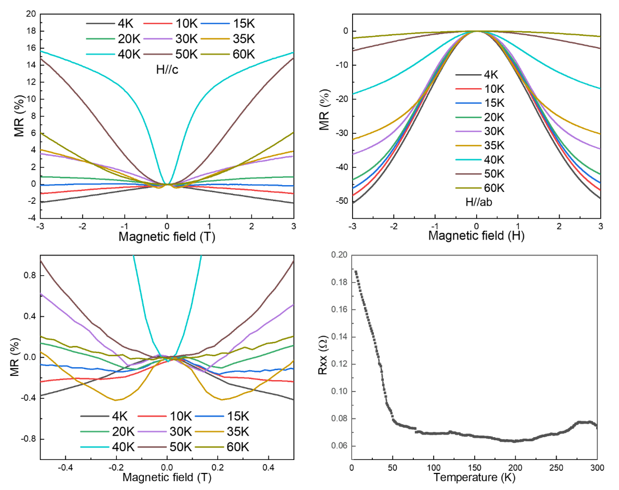
d)
c)
Figure S2. Magneto-transport measurement on CST crystal with applied constant 1 mA. Magnetoresistance is the function of applied magnetic fields under different temperatures with different orientations (a) H//c-axis (b) H//ab-plane of crystal and the magnetic field is also perpendicular to an applied current. (c) Zoom in the low field region of (a). (d) Temperature-dependent resistance measurement of crystal.
Supplementary note 3: Repeated measurement and domains variation
This section is aimed at explaining several unique characterizations in CST nanodevices. There are several reproducibility measurements, and the results are shown in Fig.S3. The raw data of longitudinal resistance for the 28 nm CST with multiple measurements (Fig.S3a), displays the clear hysteresis loop of magnetoresistance and obvious peaks appearing at 10 K. The peaks will always be found in the opposite direction of the magnetic field sweep, which is similar to the hysteresis loop of magnetization. The intensities of peaks also increase with the thickness of flakes decreasing, which can be explained by the domain variation in different samples. Theoretically, the formation of magnetic domain walls relates to two important parameters: thickness and energy. The domain wall thickness has been calculated as 10 nm, which means that the CST flakes with thickness below this value are difficult to form domain wall ⁶. Synchronously, thinner flakes have stray field energy lower than wall energy, also causing difficulties to support domain wall ⁶. As illustrated in Fig.S3b, the numbers of domains reduce with thinning the thickness of CST nanoflakes, providing different spin behavior in thin flakes of CST. The two sharp maxima in the resistance correspond to the coercive field value where the domain wall density reaches its maximum (i.e., the domains are all misaligned). As a result, the resistance is maximum due to increased scattering at domain boundaries. Hence, it is reasonable to notice that the positions of peaks shift to a higher magnetic field when the temperature goes down, due to the larger coercive field under lower temperature. Considering that CST is a ferromagnetic semiconductor, the resistance may change with applied current. Thereby, measurements under different applied currents are adopted. It helps to eliminate the influence of the magnitude of applied current on magnetoresistance. One example that 12 nm CST measured under 30 K is shown in Fig.S3c&d. It can be observed that there is the only difference in resistance results with applied current from 1 nA to 10 nA, but no difference in the magnitude of MR. It also provides reliability when the data of different devices is collected with the suitable but distinct current.
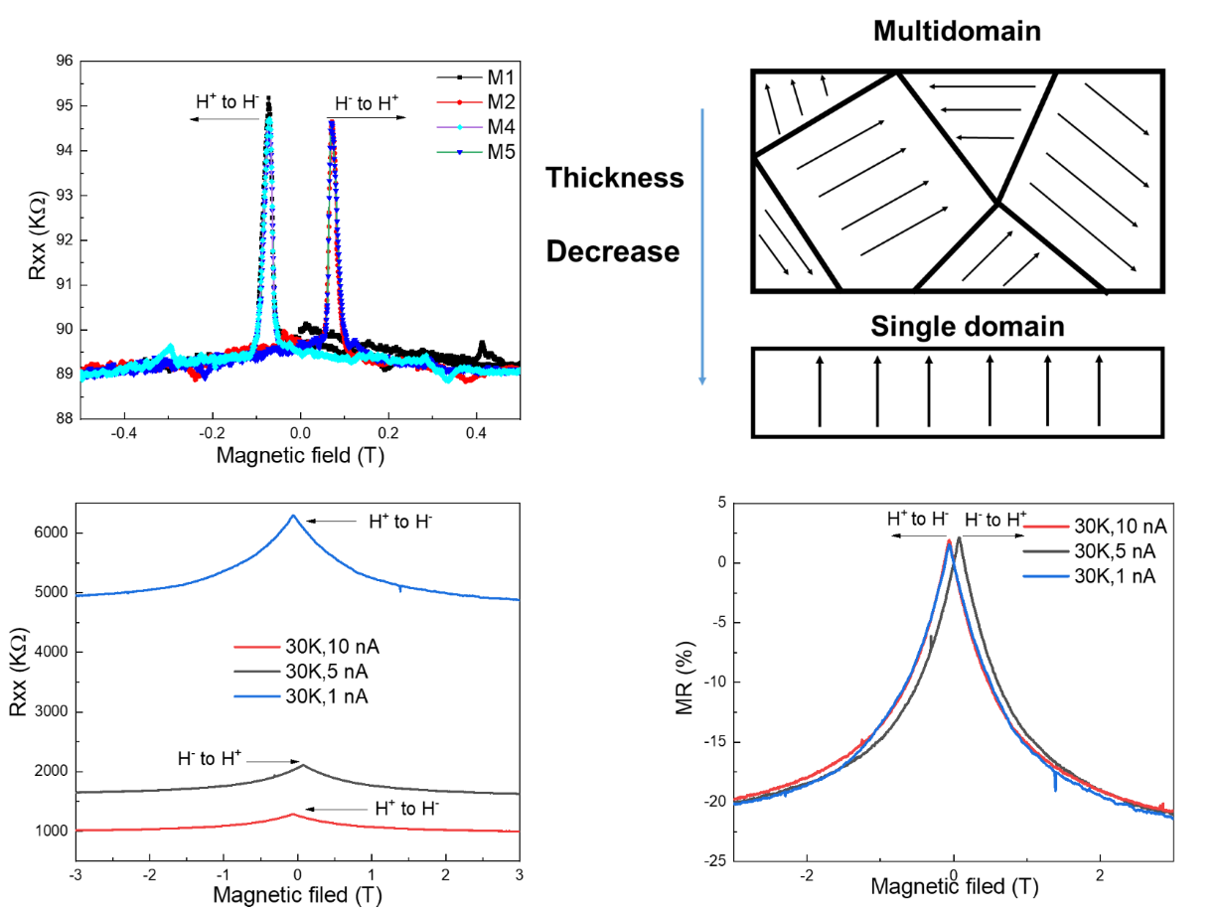
d)
b)
c)
a)
Figure S3. (a) The transverse resistance of D2 under multiple measurements in the same condition. M1 to M5 represents the measurement frequencies (b) Schematic diagram of the evolution of domain as thickness decreases. (c) The transverse resistance and (d) MR of D1 under 30 K with different applied currents from 1 nA, 5 nA, and 10 nA.
Supplementary note 4: Temperature-dependent MR in CST nanoflakes with different thickness
Fig.S4 summarizes the raw data of the magnetoresistance results of devices based on CST flakes with different thicknesses from over 100 nm (close to bulk crystal) to 12 nm. Figs.S4a-c represent the magnetoresistance measured when H//c-axis for device 1 (D1, 12 nm), device 2 (D2, 28 nm), and device 3 (D3, larger than 100 nm), respectively. In the following paragraphs, the CST flake in D3 will be mentioned as >100 nm CST for a smooth browse. While Fig.S4d-f are the magnetoresistance measured with H//ab-plane. According to the thickness-dependent magnetism and transition temperature obtained from magnetic circular dichroism, the Curie temperature of 12 nm thin layer CST is still larger than 30 K ⁶.
The MR of >100 nm CST has similar results to a single crystal, but the temperature point is different when negative MR changes to positive. As mentioned in the previous section, the MR curve of CST crystal starts to show a positive ratio, but the MR curve of >100 nm CST starts to show a positive ratio from 30 K. When the thickness the of flake reduces to 12 nm, negative MR appears even under 35 K. It mainly results from the predominant of ferromagnetic (FM) interaction in the competition between it and orbit scattering. The maximum absolute value of MR ratio has a slight increase from >100 nm CST (18%) to 28 nm CST (35%) under 50 K and 5 T, but a further decrease in 12 nm CST. The MR behavior in 12 nm CST with thin layer CST is quite different, which will be discussed later. In addition, in the low magnetic field region, sharp cusps are appearing in all devices when the temperature is below 30 K. The intensities of peaks become larger in a thinner flake. Different from the cusp in the MR curve of crystal originating from the WL effect, these peaks around zero field are associated with the domain variation. Detailed analysis and explanation of these peaks will be claimed in section 5.8.
Figs.S4d-f represent the magnetoresistance measured when H//ab-plane for D1, D2 and D3. The NMR appears in all thicknesses when temperature is below 60 K. This NMR in a large temperature range comes from the mentioned short-range magnetic order in ab-plane that exists in temperatures higher than T_{c}. The absolute ratio of NMR increases with decreasing temperature in 28 nm CST and >100 nm CST but exhibits a nonlinear variation in 12 nm CST. For instance, at10 K and 5 T applied fields, the NMR increases from 38% in >100 nm CST to 67% in 28 nm CST and finally to 43% in 12 nm CST. There are narrower MR curves appearing in devices with thinner flakes, especially when temperature is below T_{c}. MR curve under 30 K can be an obvious example (blue curve in Figs.S4d-f). This phenomenon also corresponds to the change of domains ⁶.
b)
f)
a)
d)
c)
e)
Figure S4. Magnetoresistance of CST nano-devices with different thicknesses. Applied constant current is 1 nA. (a-c) The MR behavior with external magnetic field H//c-axis for (a) Device 1 (D1) with CST flake about 12 nm. (b) Device 2 (D2) with CST flake about 28 nm. (c) Device 3 (D3) with CST flake larger than 100 nm. (d-f) The MR behavior with external magnetic field H//ab-plane for (d) D1 (e) D2 (f) D3.
Supplementary note 5: Fitting of the WAL effect
In order to deeply understand the weak antilocalization (WAL) effect in CST nanoflakes with different thickness, we fit the corresponding magnetoconductivity ${∆σ}_{xx}(B)=σ_{xx}(B)-σ_{xx}(0)$ using the Hikami–Larkin–Nagaoka (HLN) formula ⁷.
$${∆σ}_{xx}(B)=\frac{αe^{2}}{2π^{2}ℏ}[ψ\left(\frac{1}{2}+\frac{ℏ}{4eBL_{φ}}\right)-\ln\left(\frac{ℏ}{4eBL_{φ}}\right)]$$
where $e$ is electron charge; $ℏ$ is reduced Planck constant; $ψ$ is digamma function; α and $L_{φ}$ are the fitting parameters: prefactor and phase coherence length, respectively. The prefactor $α$ denotes the number of conduction channels, which is theoretically found to be -0.5 for each conductive channel in two-dimensional (2D) topological insulator ⁸. Fig.S5a&b displays the low field magnetoconductivity ${∆σ}_{xx}(B)$ from -0.4T to 0.4T at temperatures ranging above T_{c} for 12 nm CST and 28 nm CST. It can be observed that all three curves can be well fitted by the HLN model for 28 nm CST, but the fitting deviation become larger in 12 nm CST. Especially when the temperature decreases and close to T_{c}, the raw data points in ultra-low field range (purple points in Fig.S5a) cannot be well fitted by HLN model. There are two possible reasons. One is that the observed WAL behavior may originate from both 2D and 3D bulk contributions, indicates that the WAL effect become weaker with thickness decrease. Another is that when temperature close to T_{c}, there are not only WAL effect will contribute the magnetoconductivity. The complicated combined action will lead to the variation of ${∆σ}_{xx}(B)$.
The obtained phase coherence length $L_{φ}$ as a function of temperature for both 12 nm CST and 28 nm CST are shown in Fig.S5c. The relationship between different phase coherence length and thickness of CST flakes can also influence the expression of the WAL effect. Oddly, the value of α with an order of 10⁴ can be obtained for 28 nm. For example, it is about $-5.3*{10}^{4}$ at 50 K, which is much larger than the theoretical 2D electron system. This larger α value indicates that strong spin–orbit coupling of the three-dimensional (3D) bulk state will be the main contribution of 28 nm CST nanoflake.
c)
b)
a)
Figure S5. The normalized magnetoconductance ${∆σ}_{xx}(B)$ at different temperatures for the (a) 12 nm CST and (b) 28 nm CST. The colored lines are corresponding fitting curve. (c) Temperature dependence of the fitting parameter $L_{φ}$ phase coherence length deduced from the WAL fit for both 12 nm CST and 28 nm CST.
Supplementary note 6: Anisotropy magnetoresistance
The angle-dependent magnetoresistance indicates the anisotropy of magnetoresistance of CST from in-plane to out-of-plane. In Fig.S6a, the resistance of 12 nm CST is measured under a constant current of 10 nA and 5 T with changing the angle between magnetic field and flake plane. Resistance increases gradually when the ab-plane of flake rotates from vertical (0°) to parallel (90°) to magnetic field orientation, and finally vertical (180°) to magnetic field again with plane overturn. Fig.S6b shows the magnetoresistance of 28 nm CST under different temperatures when magnetic field forms a 45° angle with ab-plane of flake. The MR still shows a negative behavior below 30 K with obvious coercive peaks around zero field, while positive behavior above 30 K.
b)
a)
Figure S6. (a) Angle-dependent resistance change under 10 K to 40 K. It is measured under 10 nA with 5 T. (b) Magnetoresistance change under 45° and temperature range from 10 K to 50 K.
Supplementary note 7: Pt/CST devices morphology and thickness determination
The Pt layers in the Pt/CST devices were fabricated in PLD system with the laser energy setting as 150 mJ, and target distance setting as 7 cm. The total Pt deposition time was 110 s, which gives a Pt layer with a thickness of about 2.5 nm. The thickness of a single Pt layer was measured under an atomic force microscope (AFM) as shown in Fig.S7a. The thickness measurement of devices and CST flakes will be inaccurate after metal electrodes being deposited on the flakes. Hence, the thickness of measured flakes was determined by measuring similar flakes with the same optical contrast under optical microscopy, some of the examples are shown in Fig.S7b&c.
Figure S7. (a) AFM image of single Pt layer which is determined as 2.5 nm. (b) The optical diagram and (c) AFM image of the Pt/CST device. The underlying flake with blue colour is CST nanoflake. The Hall-bar shaped layers are Pt.
Supplementary note 8: Temperature-dependent MR in Pt/CST hybrid structure
The magnetoresistance of Pt/CST devices are also measured. The result from 35 nm CST is shown in Fig.S8a, which is defined as $MR=\frac{R_{H}-R_{0}}{R_{0}}×100\%$, where R_{H} and R₀ represent the resistance at certain magnetic field or zero field respectively. There is an obvious change from positive magnetoresistance (PMR) to negative magnetoresistance (NMR) at 35 K, due to the enhancement of ferromagnetic interaction below T_{c}. The magnitudes are also smaller than intrinsic CST nanoflakes, due to the proximity induced magnetic moment varying with Pt atomic layers ⁹. The magneto-transport results of 35 nm CST can be powerful evidence for the proximity induced magnetism in the Pt layer. In this case, the AHE hysteresis that occurs in the Pt layer not only reflects the magneto-transport properties of the underlying CST flake but also mirrors the ferromagnetic interaction existing in this hybrid structure.
Thinner CST flake also displays different MR properties with several fresh features (Fig.S8b). For example, the MR ratio at 40 K, 50 K and 60 K exhibit positive signals like 35 nm CST but are more than 10 times smaller in magnitude. The possible reason may come from the less induced magnetic moment in the Pt layer due to the thin thickness of the CST flake. When temperature decrease, the MR ratio changes from positive to negative in the temperature range from 30 K to 20 K, resulting from ferromagnetic interaction in CST nanoflake. However, below15 K, MR signals exhibit non-monotonic behavior and form downward humps. The MR ratio firstly decreases in the low magnetic field range and then increases with an increasing magnetic field. This MR ratio can even change from negative to positive at a high magnetic field range. Especially at 4 K, the MR ratio increases to the highest value comparing other temperatures. The weak NMR induced in this temperature range is also due to ferromagnetic interaction, while the PMR may derive from orbit scattering becoming the dominant with the increased applied magnetic field. The thin CST layer has an insulating behavior below 30 K with ultra-high resistivity. The electrons moving are suppressed. Therefore, the resistance change will only happen in the field range around zero field due to spin align reversal, then remain unchanged with the magnetic field further increasing. There is less ferromagnetic interaction induced magnetoresistance change in this low temperature range. Hence, when the temperature is below 30K, there are weak effects contributing to the NMR in this Pt/CST hybrid structure. In this case, the increase of MR with a gradual increased external magnetic field does not result from the imprinting of CST properties based on the proximity effect but originates from the magnetic field-dependent orbit scattering or magnetic scattering occurring in the Pt layer.
Fig.S8c&d exhibit the basic resistance measurement under temperature variation. The temperature-dependent resistance (RT) measurements of Pt/CST devices exhibit an increase in resistance with decreasing temperature, which is different from normal metal Pt thin layer. The initial resistivity of the Pt layer is calculated as 1.74$×$10⁻⁶ Ω·m at room temperature.
c)
b)
a)
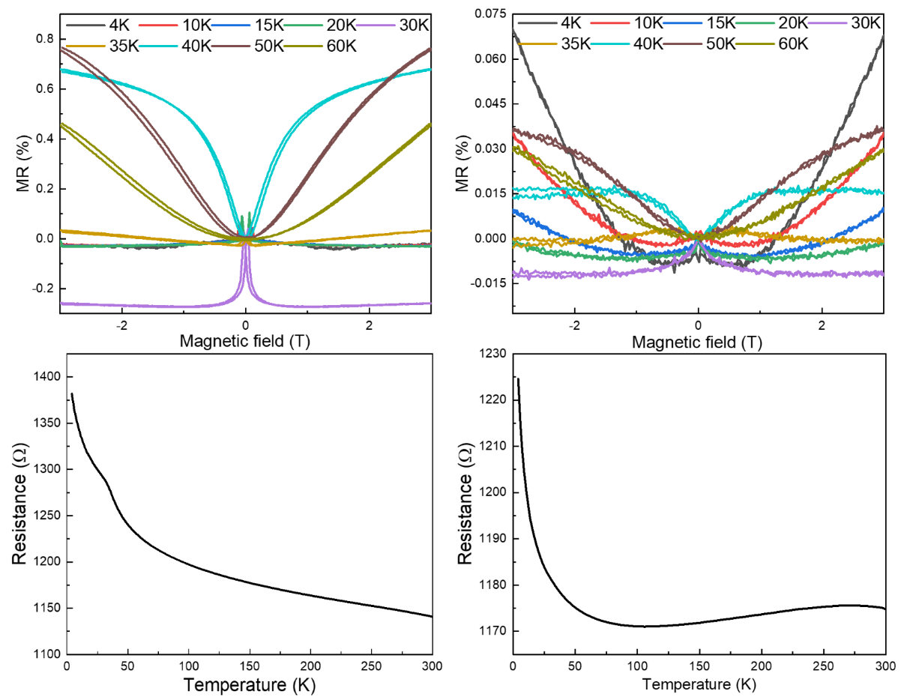
d)
Figure S8. Magnetoresistance of Pt/CST hybrid structure. (a) Magnetic field-dependent magnetoresistance of device 1 with CST thickness about 35 nm. Temperature ranges from 4 K to 60 K. (d) Magnetic field-dependent magnetoresistance of device 2 with CST thickness about 15 nm in selected temperature. (c) &(d) are the temperature-dependent longitudinal resistance for D4 and D5, respectively.
Supplementary note 9: Bandgap calculation from CST nanoflakes
Due to the ultra-low resistivity of single crystal CST and low resistance of nanoflakes with still semiconductor behavior, the bandgap of flakes with various thicknesses were calculated from temperature-dependent resistance curve. Bandgap value can be obtained according to the equation R_{T}=$e^{Eg/2kT}$, where R_{T} is electric resistance, Eg is energy gap, k is Boltzmann constant, T is the absolute temperature. The modified curves according to this equation are shown in Fig.S9d-f and Eg can be obtained from high temperature (low 1/T) region. The calculated values are from 0.02 eV to 0.09 eV which are more than ten times smaller than literatures.
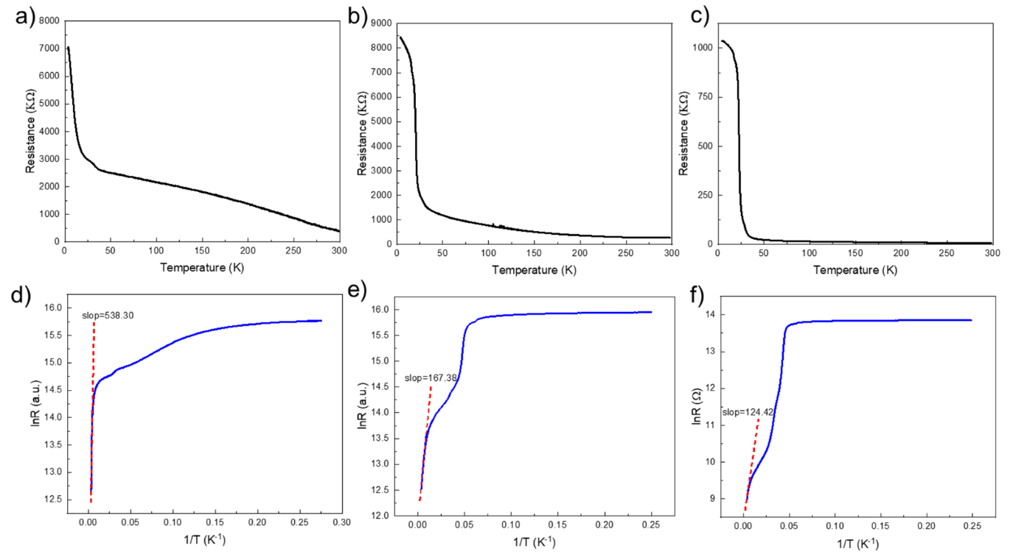
Figure S9. (a-c) Temperature-dependent resistance from flakes with various thicknesses. (d-f) The modified curves according to the equation.
Reference
1 Li, Z. et al. Coexistence of large positive and negative magnetoresistance in Cr₂Si₂Te₆ ferromagnetic semiconductor. Sci. China Mater. 65, 780–787 (2021).
2 Zhang, Z., Wang, Z. & Zhang, Z. Magneto-transport and weak anti-localization in ferromagnetic semiconductor CrSiTe₃ single crystal. Appl. Phys. Lett. 113 (2018).
3 Williams, T. J. et al. Magnetic correlations in the quasi-two-dimensional semiconducting ferromagnet CrSiTe₃. Phys. Rev. B 92 (2015).
4 Ron, A., Zoghlin, E., Balents, L., Wilson, S. D. & Hsieh, D. Dimensional crossover in a layered ferromagnet detected by spin correlation driven distortions. Nat. Commun. 10, 1654, (2019).
5 Cao, Q. et al. Defect introduced paramagnetism and weak localization in two-dimensional metal VSe₂. Nanotechnology 28, 475703 (2017).
6 Zhang, C. et al. Hard ferromagnetic behavior in atomically thin CrSiTe₃ flakes. Nanoscale 14, 5851-5858 (2022).
7 Hikami, S., Larkin, A. I. & Nagaoka, Y. Spin-Orbit Interaction and Magnetoresistance in the Two Dimensional Random System. Prog. Theor. Phys. 63, 707-710 (1980).
8 Zhang, Y. et al. Intrinsic V vacancy and large magnetoresistance in V_{1-δ}Sb₂ single crystal. Chin. Phys. B 31, 037102 (2022).
9 Lohmann, M. et al. Probing Magnetism in Insulating Cr₂Ge₂Te₆ by Induced Anomalous Hall Effect in Pt. Nano Lett. 19, 2397-2403 (2019).

